Rain Industries STORY

Background

Rain industries is listed on the indian stock market with majority of its operation across 8 countries.

It is a vertically integrated producer of carbon, Cement and Advanced material products, thus producing the raw materials for various industries. It is headquartered in Hyderabad, Telangana. Its Vice chairman, Jagan Mohan Reddy (Jagan) started a company called Rain Calcining Ltd in ’98 which was in the aluminium supply chain industry. His father Radhakrishna Reddy ran a company along with a few partners in the 70’s called Tadpatry Cements which later changed name to PriyaDarshini Cement Ltd. In 2007 both Father and Son joined together to purchase through all Debt LBO CII Carbon Ltd in USA which was the 2nd Largest Calciner in the world (after Oxbow). Later in 2012, Rain purchased RUTGERS, a Coal Distiller in Europe through the same route (LBO).

They are world’s largest producer of CTP and second largest producer of CPC.

Timeline:

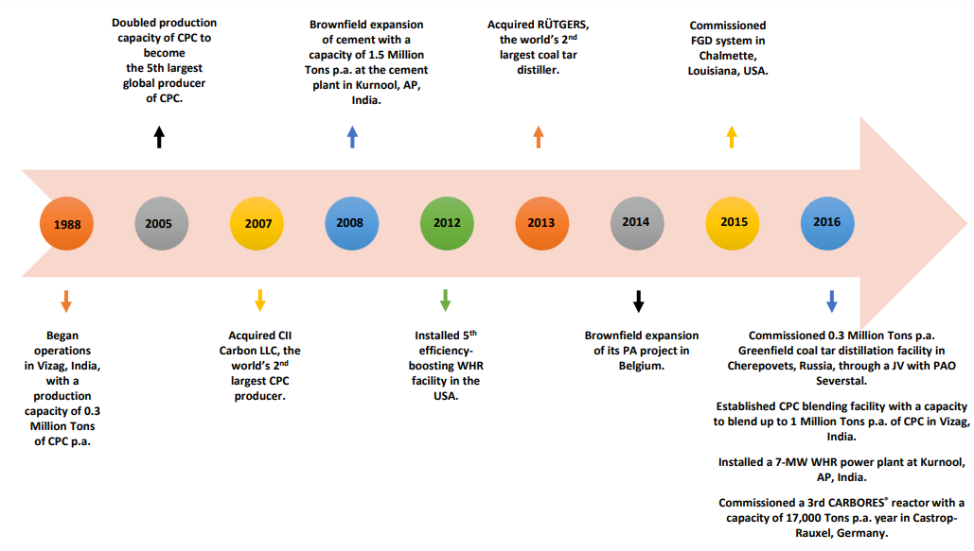

Main Products/Segments

Rain industries basically operates in 3 segments:
- Carbon (CTP and CPC) – (Contributes ~70% of the revenue)

Takes a commodity, which is by product of Oil and Steel industries and converts them to high value carbon materials which are raw materials for the Aluminium, Titanium Dioxide & Graphite Electrodes industries. Per the company presentation: Our Carbon business segment converts the by-products of oil refining and steel production into high-value carbon-based products that are critical raw materials for the aluminium, graphite, carbon black, wood preservation, titanium dioxide, refractory and several other global industries.
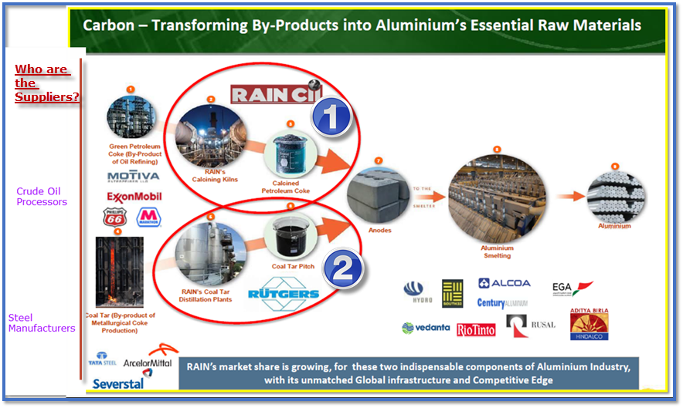.
What are the components in the Carbon Segment for Rain? (PS: minor modification of content from company presentation)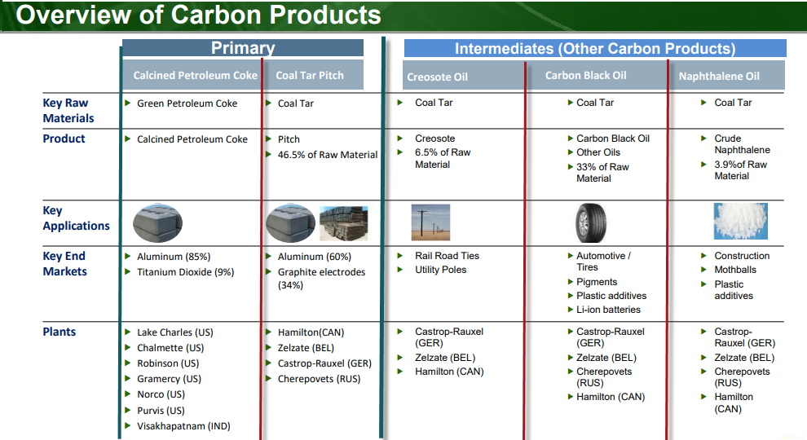

Advanced Material:
What are the components in the Advanced Material segment for Rain (PS: minor modification of content from company presentation)?
~Contributes 25% of the revenue, per 2018 AR published in H1 2019)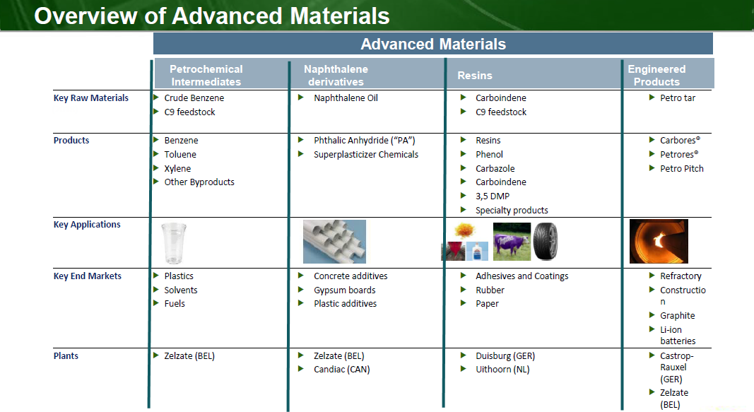
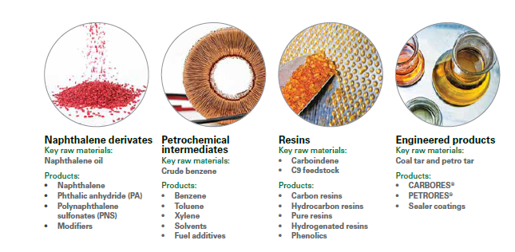
- Cement: (Contributes 6-5% of the revenue, per 2018 AR published in H1 2019)
They make OPC (Ordinary Portland Cement) and PPC (Portland Pozzolana Cement) types of cement. Owns a Packing Plant in Bellary, Karnataka and
Two integrated Cement plants in:
- Nalgonda, Telangana and
- Kurnool District, Andhra Pradesh &

S.No | Capacities | How much? | Why?
1 | Calcination Capacity | 2.1 Million Tonnes | To make CPC
2 | CPC Blending Capacity | 1.0 Million Tonnes | To blend various qualities of CPC to make according to Spec for Customers
3 | Coal Tar Distillation | 1.3 Million Tonnes | to make CTP
4 | Advanced Material Capacity | 0.7 Million Tonnes | to process by products of CTP distillation and make Adv. chemicals
5 | Cement capacity | 4.0 Million Tonnes | to make Cement

Main Markets/Customers
- For the Carbon products – Aluminum, Titanium Dioxide, Graphite Electrodes making industries
- For the Intermediates – Rail Road industry, Utility Companies, Automotive industry, Construction, etc.
- For the Advanced Materials – Plastic Industries, Refractory, Construction, Lithium Ion Batteries

Bullish Viewpoints
- For the Carbon business (majority revenue contributor) looking at the Porter’s 5 forces:
  - Buyer Power: Low-Medium
  - Supplier Power: Low
  - Competitive Rivalry: Low
  - Substitute threat: Low
  - Threat of entry: Low
- The Advanced Materials transform a portion of the carbon output, petrochemicals and other raw materials into high-value, high margin & eco-friendly products
  - higher demand - gaining traction
- Surplus in Anode Grade GPC is expected to decline steadily, thus leading to higher demand than supply;
  - a significant volume of existing anode-grade GPC quality has deteriorated due to increased use of sour crude by refineries; Rain has the capacity to cater to the higher/highest quality requirement of customers to make Anode grade CPC than any other players in the industry.
  - strategic investments in FGD (flue-gas desulphurisation) in a few plants (US) have enabled RAIN Group to utilise high-sulphur GPC more efficiently to serve the growing demand from aluminium smelters.
- Generate power of close to 132MW - Waste heat recovery - Energy saving - adding 2-3% back in margin - 5 out of 7 plants have this
- Aluminium continues to chip away at Steel’s position of being material of choice – more usage of AL across industries, means more demand for RAIN’s core products.
  - AL growth due to Electric Vehicles - Lithium ION battery coating, Body of auto parts.
- Company was and is profitable even in the current down cycle (before Pandemic); while all other players either earned losses or have closed multiple plants.
- From latest qtr Feb 2020 results – in spite of the AL down cycle and Coke ban restrictions, the company continues to generate Free Cash flow.

Bearish Viewpoints
- With cyclical periods of weak demand for AL could result in decreased primary AL production. RAIN Group’s sales have historically declined during such cyclical periods of weak global demand for aluminium.
- Indian Govt. introducing additional restrictions on import or blending of raw materials for the carbon biz.
- APC (substitute raw material for GPC ) is deemed equivalent of GPC from an import perspective by Ministry of Env & Forest and Climate change ( MoEF&CC)
- The end consumers like auto industry and plastic parts manufacturers are in a prolonged period of downturn, thus impacting the Adv. Carbon segment (which today contributes ~25% of the revenue for the company)
- In case of a prolonged recession playing out, ability to service debts might be of concerns ($550mm USD & 437mm Euros maturity in April and Jan of 2025 respectively), although the company has strong Cash flows and good cushion on servicing debts.
- If weakness in European automotive, Steel (and downstream graphite and refractory mkts), adhesives and North America’s construction industries are prolonged, the advance material segment might see slow growth and thus overall revenue growth can be impacted.

Interesting Viewpoints
- This company is treated as a cyclical company with its end consumer - AL industry contributing close to 40% of the revenue breakdown by industry, there is diversification in revenue generation from other industries.
  - 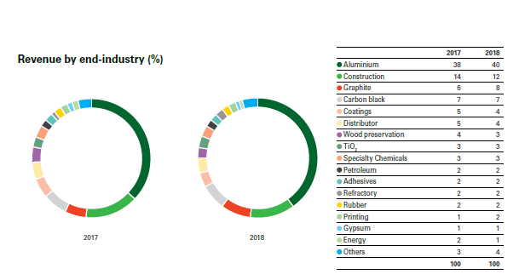
- With longstanding relationship with their customers, any upward revision in raw materials cost or downward pressure on end product cost, they are passed on upstream and downstream in their value chain respectively, keeping their margins in tact on the Carbon business.
- With China impacted due to the pandemic (GPC and CPC supplies), there can be shortages in the near to medium term, resulting in increase in cost for CPC and GPC. Since Rain can substitute lower grade materials and produce ACP instead of GPC, margins can expand.
- The advanced material segment is producing products which are niche and high margin products and this segment will contribute more
- C

Barriers to Entry
- Market leader in:
  - Pet coke Calcining, i.e., making CPC (2nd largest Oxbow)
  - Coal tar distilling, i.e, making CTP
- Oligopolistic market
- Transportation cost:
  - special requirements for the customers
  - Multiple ways to transport - river, truck, sea, rail - ownership and leasing - combo
- Long standing contract with their: (70% of supplier relationships exceed 25 years)
  - Suppliers -Plants are either near or integrated with the supplier, reducing significant transport cost
  - Customers
- CTP and CPC both by one player v/s one for each - Customers prefer going to one rather than two separate providers.
- Technological edge: on using non-anode grade (high Sulphur) input and still make high quality products per customer spec. (RAIN Group’s patented Isotropic Coke Experiment (ICE) technology is one method of utilising grades of GPC previously not considered acceptable to produce anode-grade CPC.)
- With its size and scale it has the ability to move shipments to areas with the strongest production of CTP.
- 8% global market share for CTP and additional 5% of global CTP from Russia’s JV

Business Model
Covered above.

Valuation Model

In a simplistic valuation, we have a company that is now available at just 2.5x its Free Cash flows.

Current Market/Industry Trends -

Corporate Governance Scan-

Forensic Scan/Red Flags-

Disclosure(s):

I hold this stock in my portfolio & have not traded in the stock for last 30 days and I might add in the near future given current stock market down turn.

