Talbros Automotive Components is into manufacturing of gaskets and forgings.

In gaskets, they are a market leader with a market share of over 50%

They have three JVs:

Nippon Leakless Talbros Private Limited (Joint venture with Nippon Leakless Corporation, Japan)- referred as NLK.

Marelli Talbros Chassis Systems Private Limited (Joint venture with Marelli Suspension Systems Italy S.P.A)- referred as MTC

Talbros Marugo Rubber Private Limited (Joint venture with Marugo Rubber Industries Limited, Japan)- referred as TMR

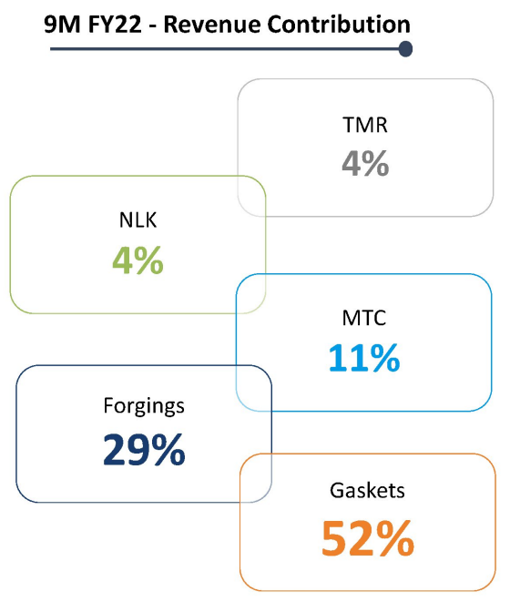

MTC is the sole supplier to Tata Motors’ EV

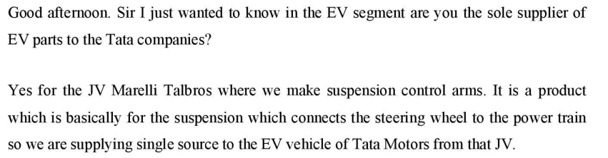

TMR is expected to grow at 30-40% CAGR

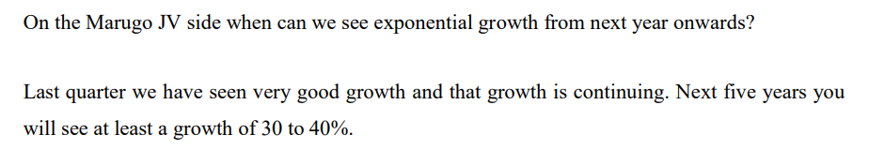

There is scope for improvement in capacity utilisation, leading to operating leverage

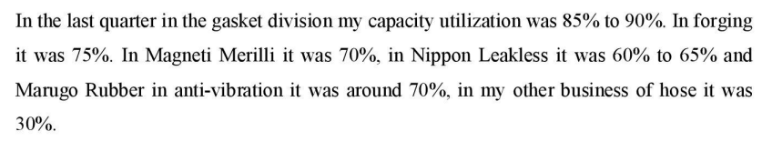

They are expecting 14% OPM

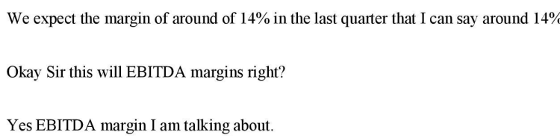

Promoters have been buying shares

