Bhagwati Autocast



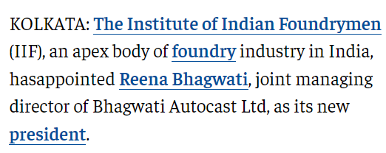

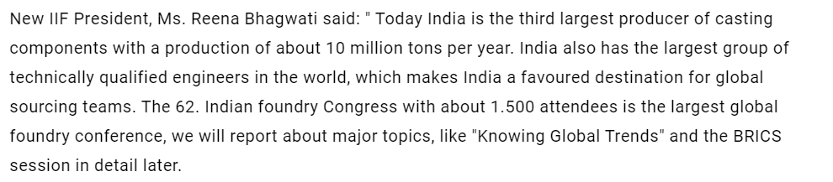

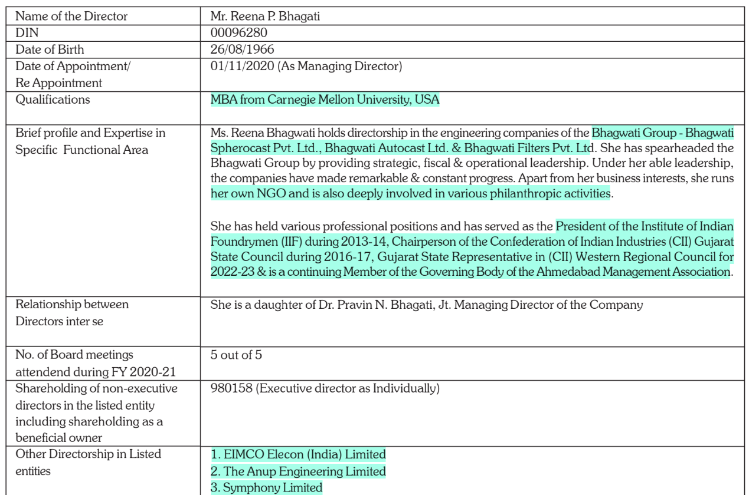

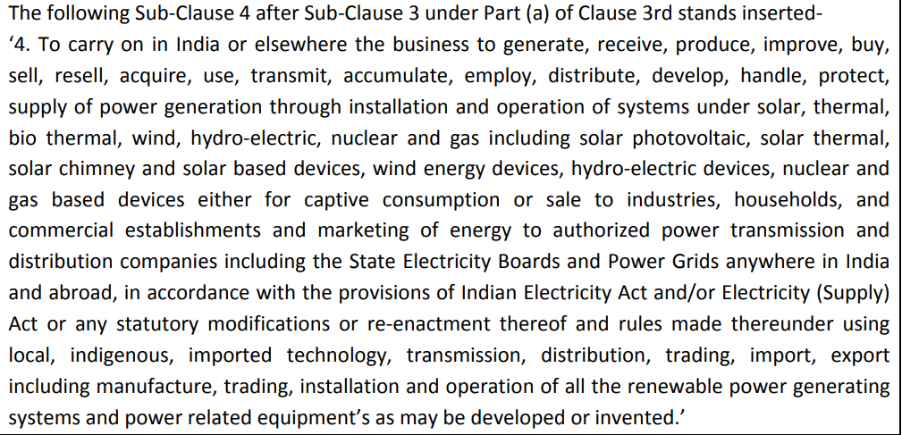

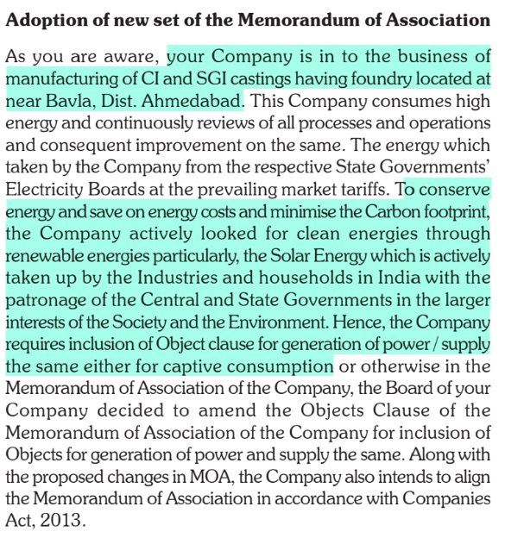











<https://www.deshgujarat.com/2015/03/10/devanshu-gandhi-takes-over-as-chairman-reena-bhagwati-as-vice-chair-of-cii-gujarat/>

<https://economictimes.indiatimes.com/reena-bhagwati-appointed-president-of-the-institute-of-indian-foundrymen/articleshow/27655311.cms>

<https://www.pressebox.com/pressrelease/fritsch-media-gmbh/IFEX-and-62nd-Indian-Foundry-Congress-in-Ahmedabad-Mahatma-Mandir-India/boxid/659361>

holds 30k shares worth 3 cr in anup engg

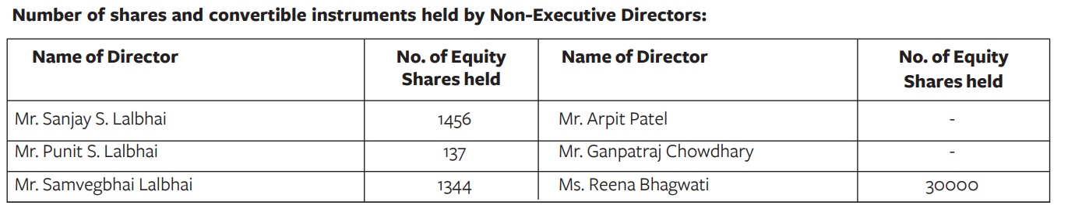

<http://www.accuprec.com/images/CV_Shri%20Padmin%20Buch.pdf>

other directors:

vimal ambani- sanrhea etc

Rajendra shah- archit organo