TCPL Packaging is one of India’s largest folding carton manufacturers and convertors of paperboard. They offer folding cartons and flexible packaging.

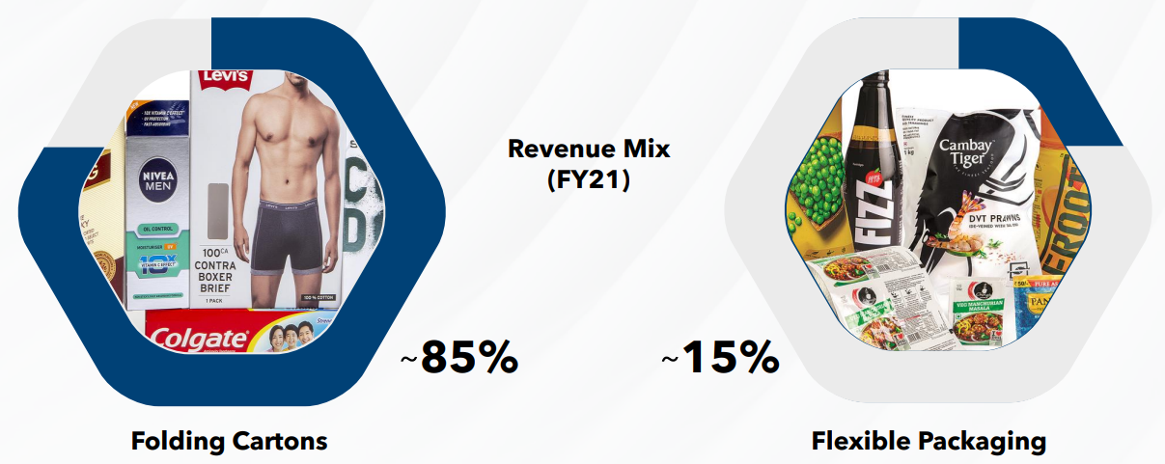

TCPL has several marquee clients

