Max India is into senior care under 4 services-

Retirement homes for ages 55+ (residential communities)

Care homes for seniors with medical conditions

Care at home for treatments at home

Medical equipment

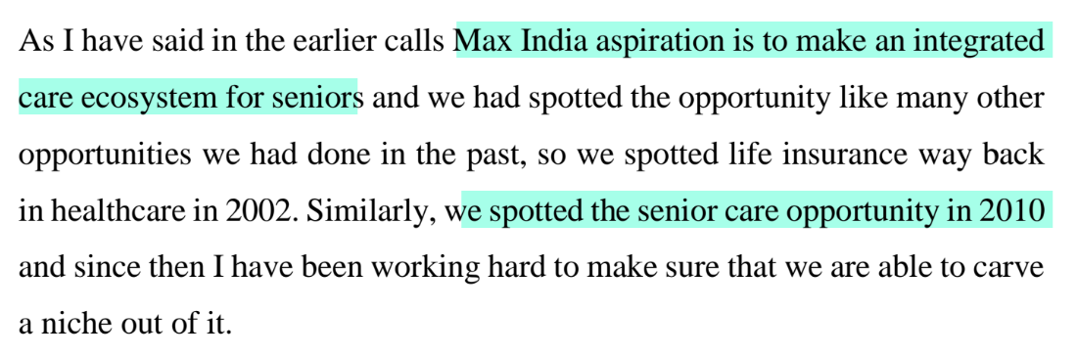

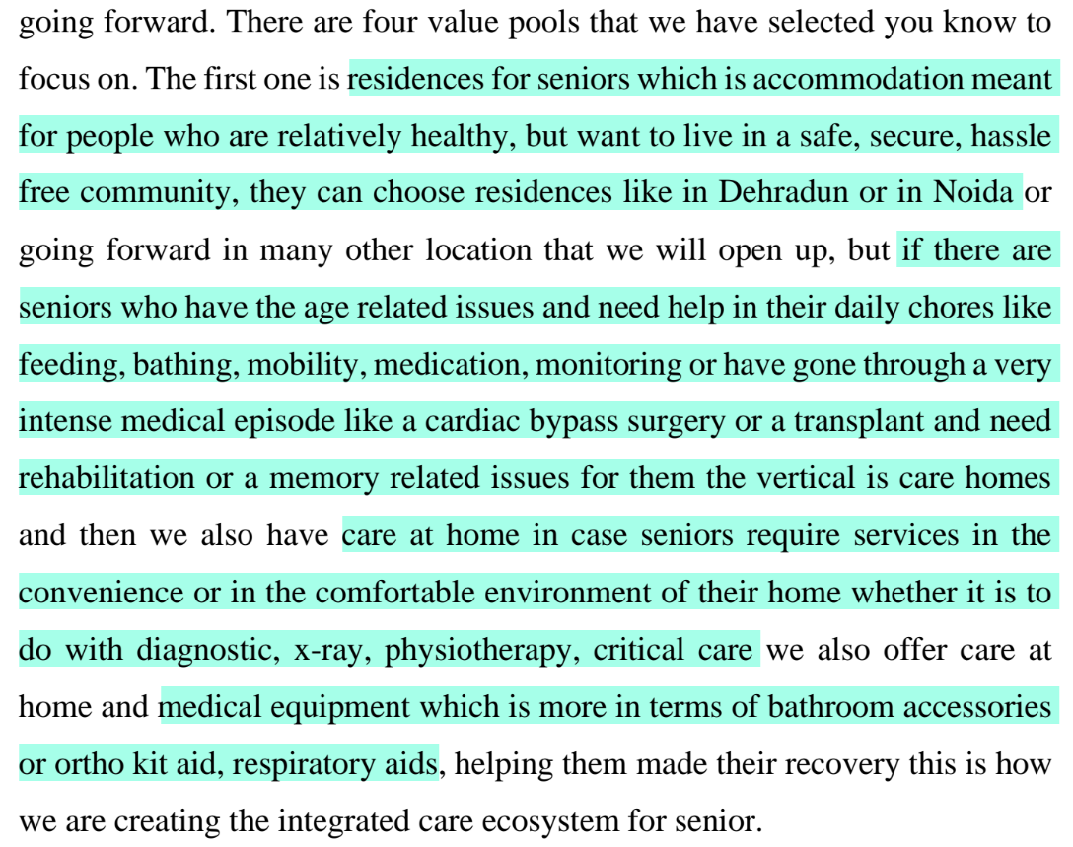

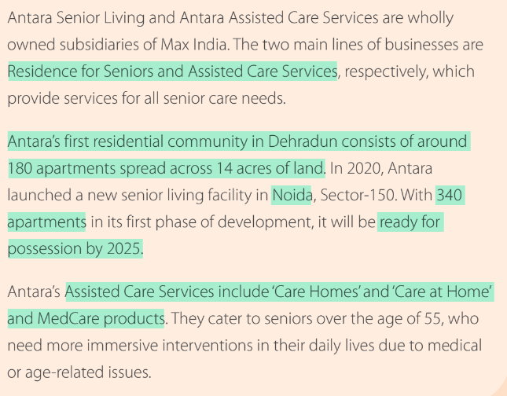

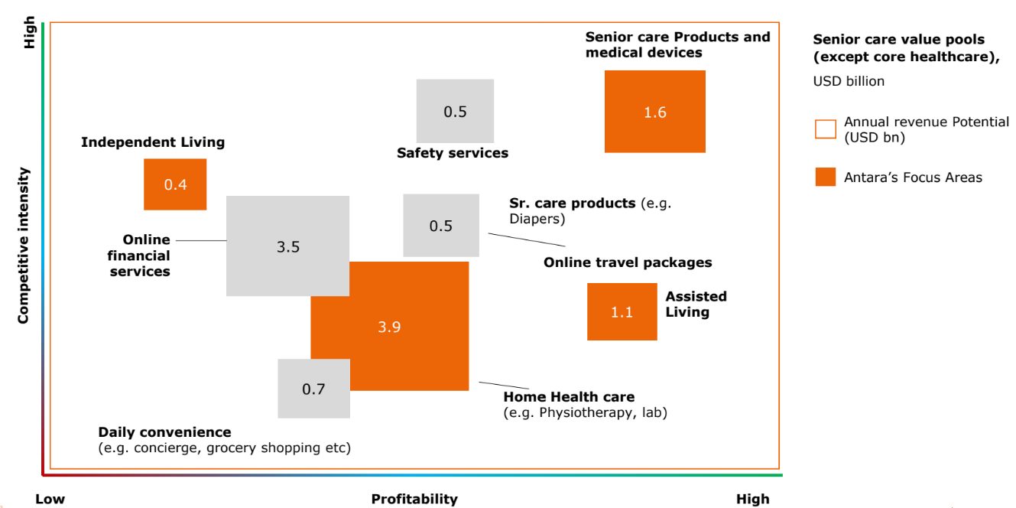

Senior residences segment (Antara Senior Living):

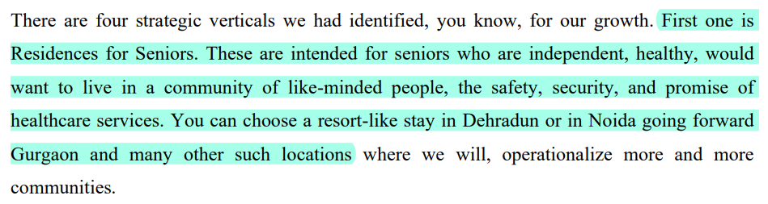

They have two projects currently- Dehradun and Noida (Phase I)



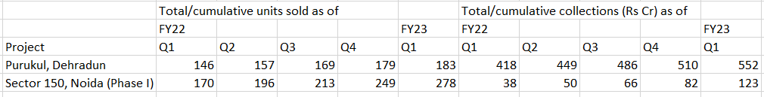

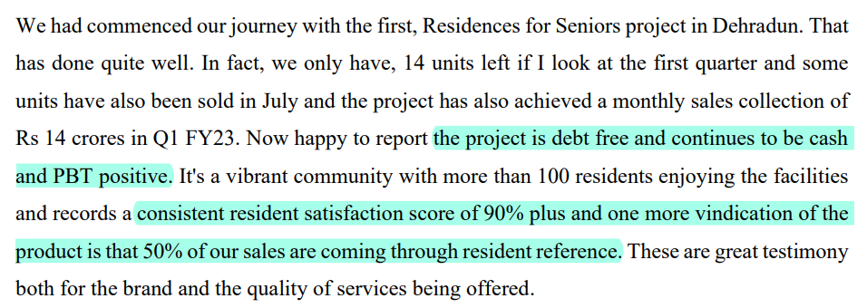

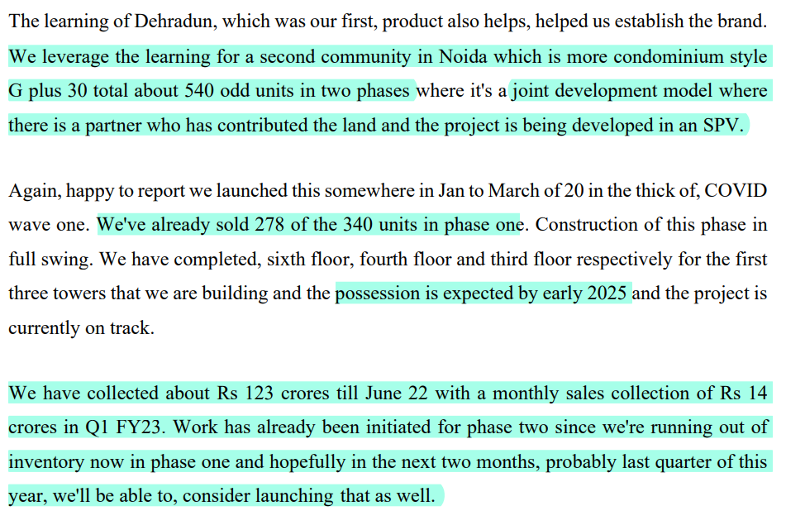

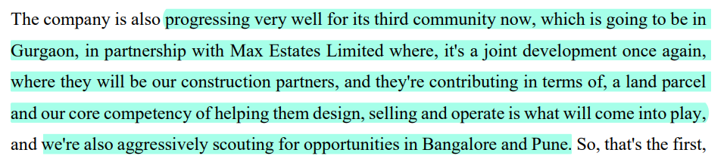

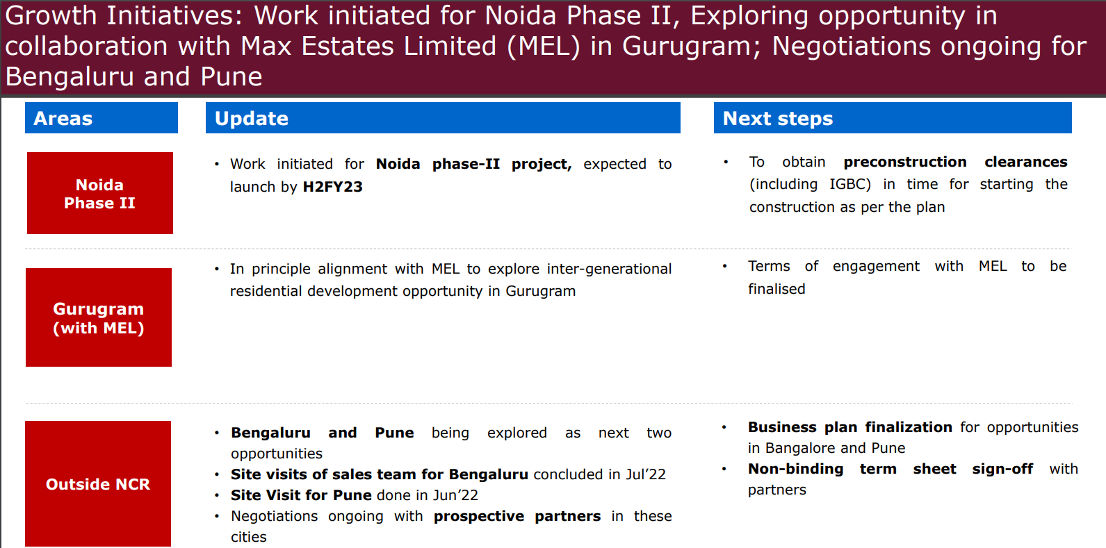

Care homes segment:

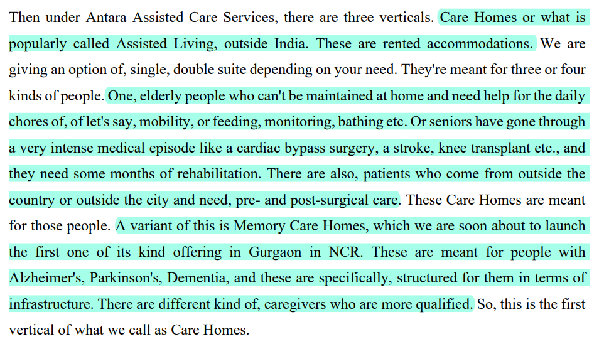

These are operated on a capex-light rental model rather than owned

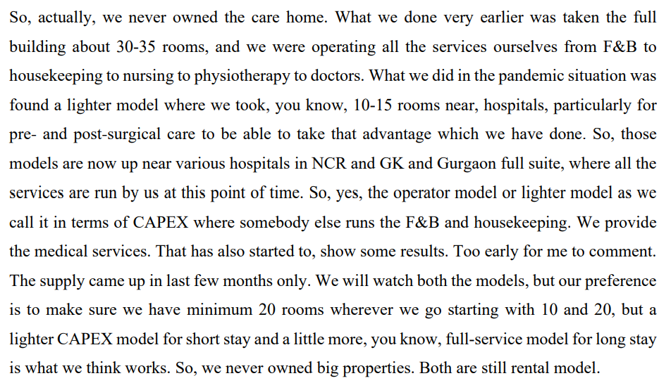

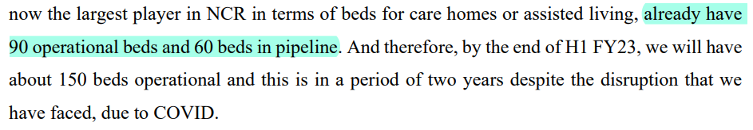

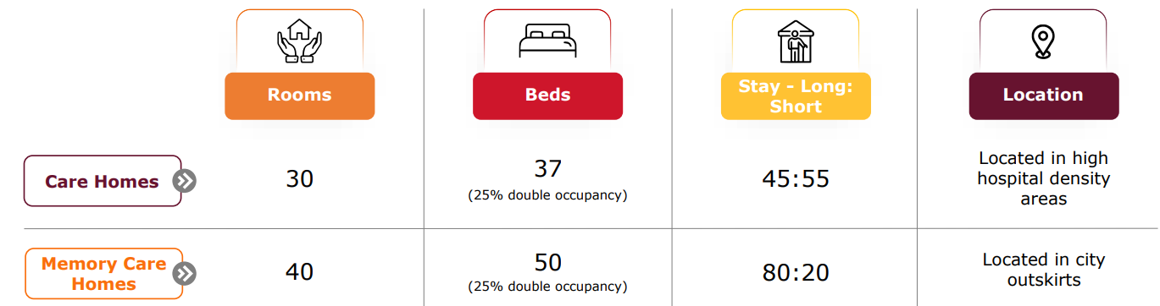

Their Gurugram care home has seen great growth and achieved break even at 45% occupancy vs the estimated 60%. They have said that they expect every care home to break even within 2 years

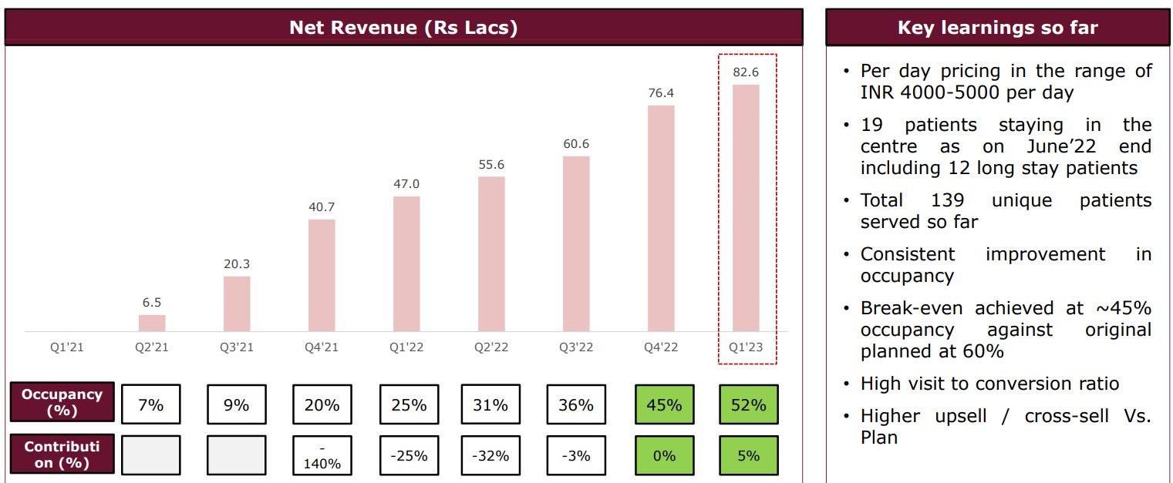

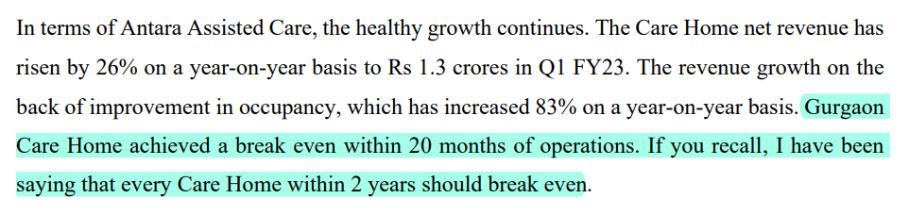

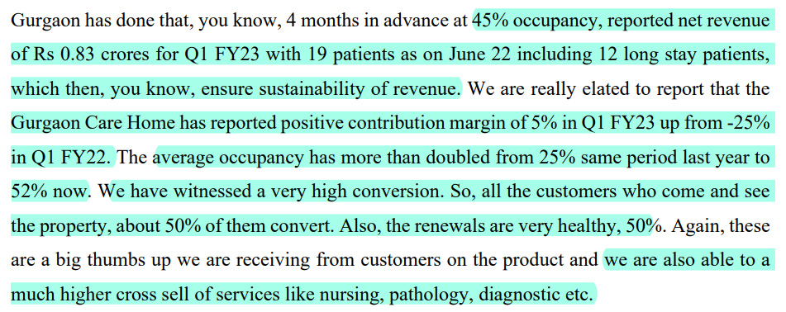

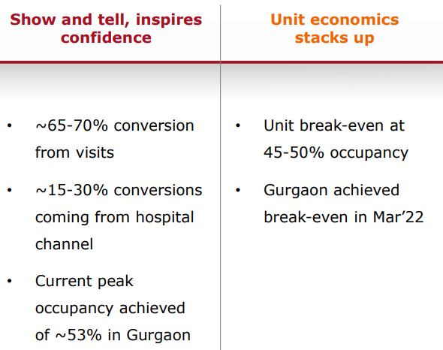

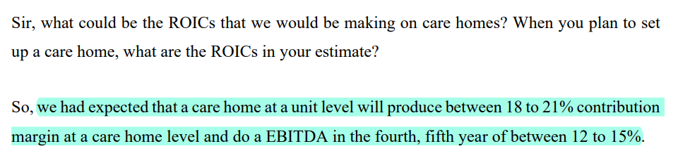

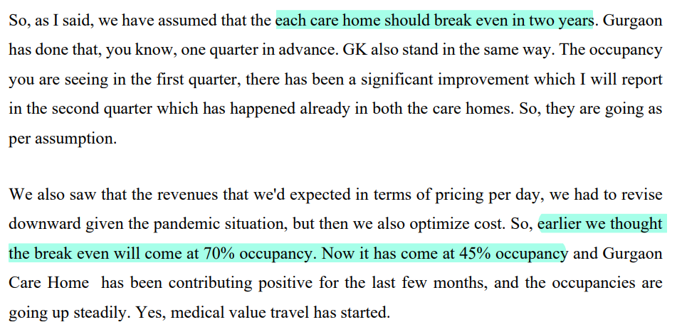

Care at home segment:

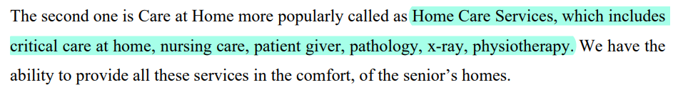

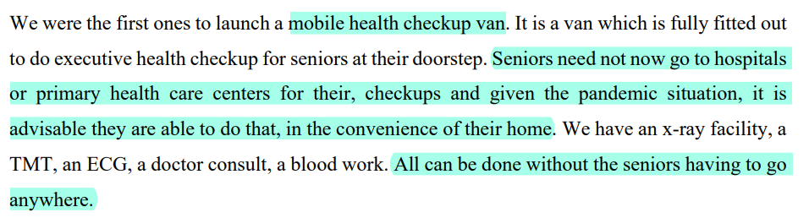

Medical equipment segment:

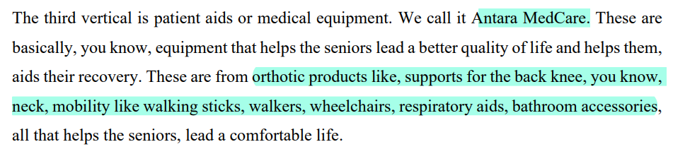

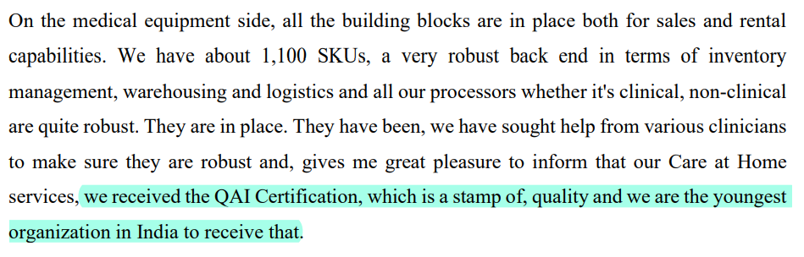

Due to their focus on an integrated senior care ecosystem, there is an opportunity for cross selling

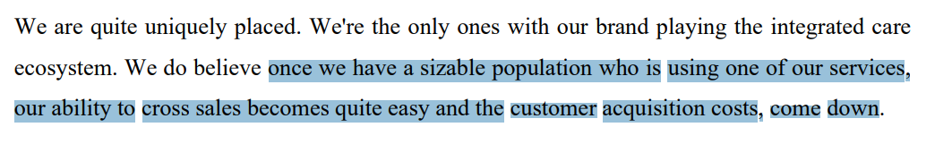

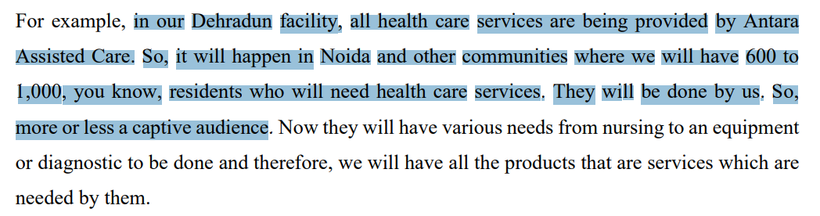

The MD & CEO is Mr Rajit Mehta

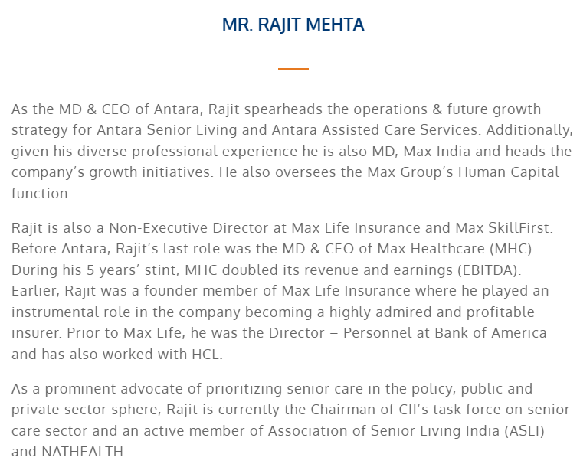

Promoters have increased their stake by over 10% through capital reduction scheme at Rs 85

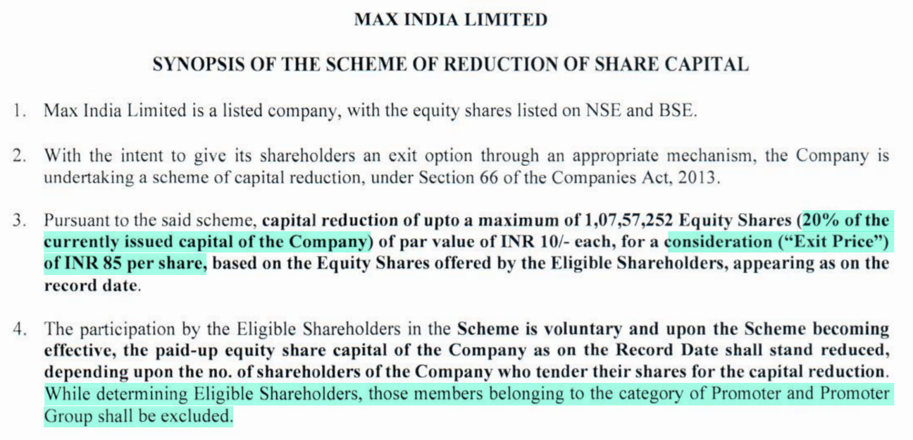

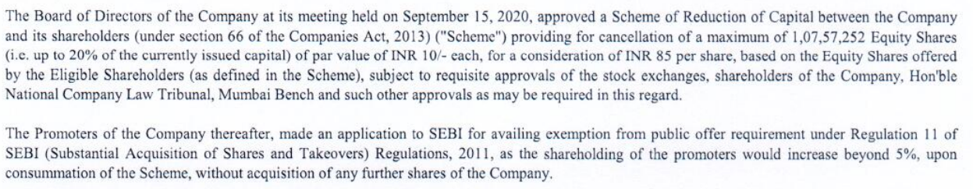

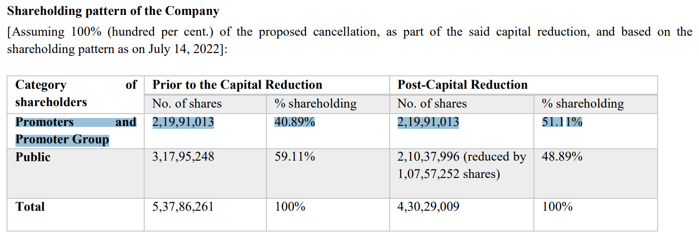



The market cap of Rs 400 Cr and enterprise value of Rs 440 Cr (as of November 2022) are comparable to the treasury corpus and monetizable assets. Price to book value is <0.8x

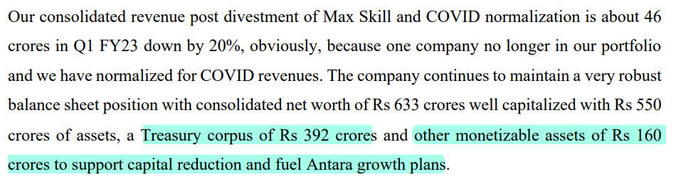

Disclaimer: Any content shared should not be construed as investment advice. Any content is not a buy/sell/hold recommendation. The writer is not a SEBI registered investment advisor. Please consult your financial advisor before taking any decision. The writer will not be liable for any losses incurred by readers. The writer may or may not have holdings in any companies mentioned. The content shared is for educational purposes only.

The writer can be reached at malhar.manek@gmail.com