One97 Communications (PayTM)



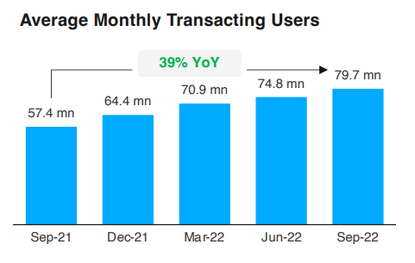

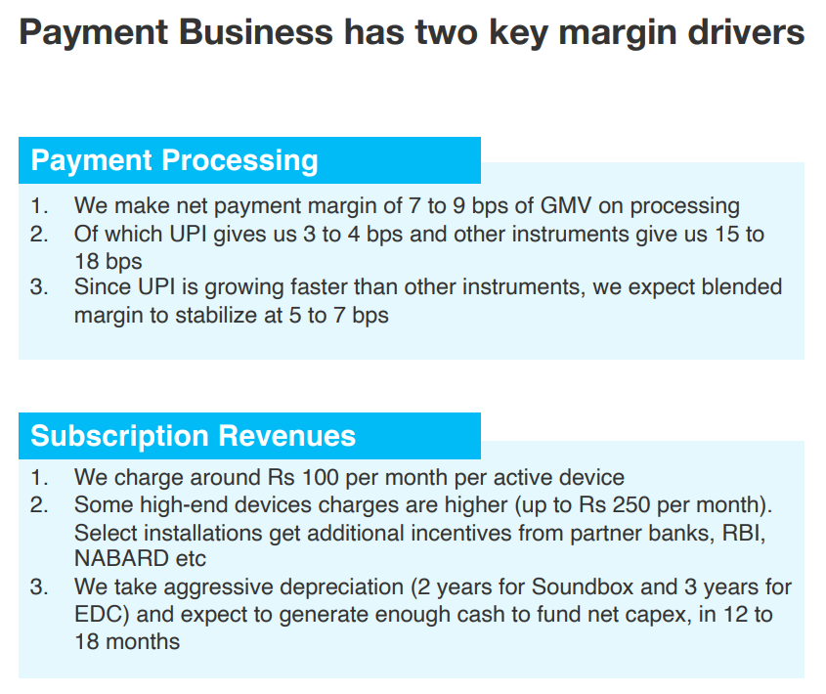

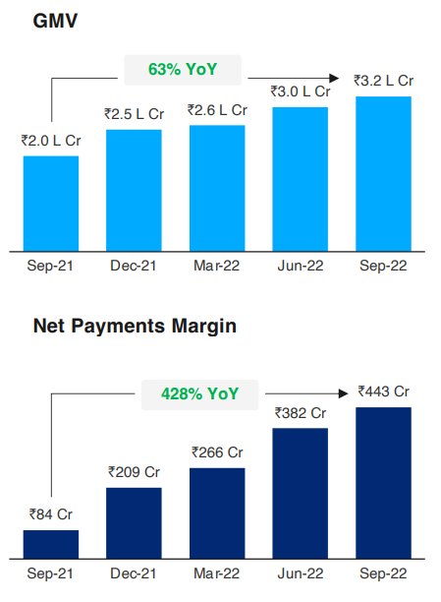

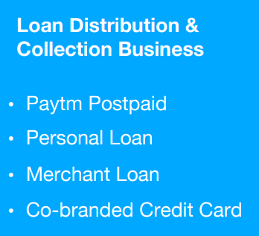

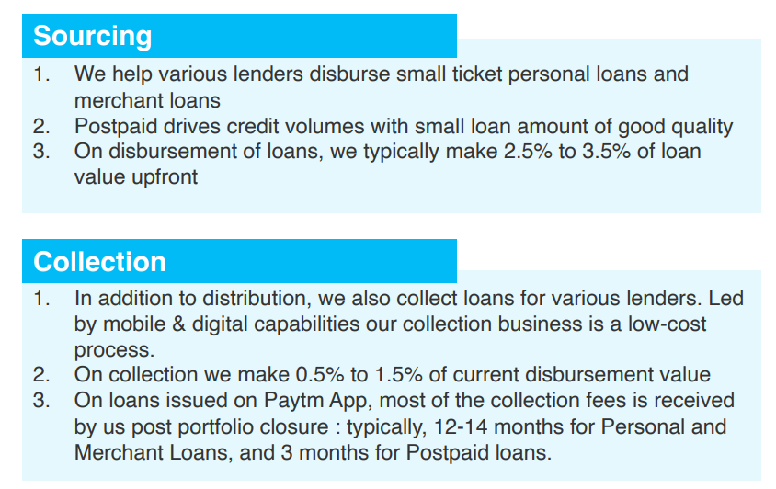

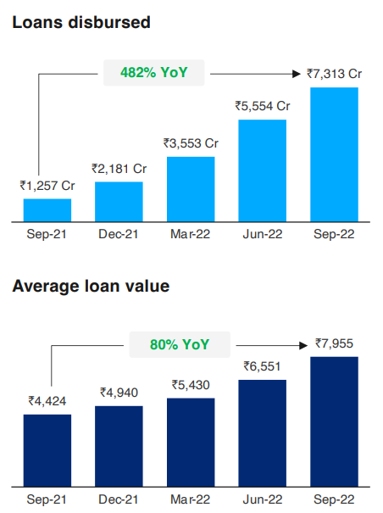

<https://www.bseindia.com/xml-data/corpfiling/AttachHis/342a3542-dce0-446f-a079-7b781f1ce604.pdf>

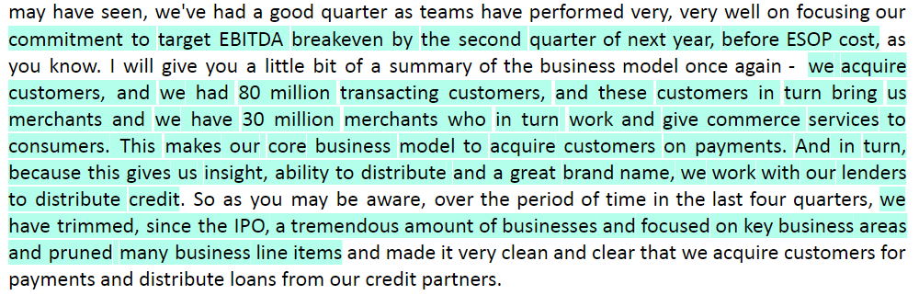

Peer comp/benchmarking:

<https://investor.mercadolibre.com/static-files/c62180cf-3674-4d96-b796-3686d1b532b9>