Modison Metals is into manufacturing electrical contacts for Low, Medium and High voltage switchgears. Electrical switchgear refers to a centralized collection of circuit breakers, fuses and switches (circuit protection devices). The switchgear market comprises of High Voltage (HV), Medium Voltage (MV) and Low Voltage (LV) segment. High voltage switchgear is a power system that deals with voltages greater than 36 kV. Medium voltage switchgear is a switchgear device that can handle voltages ranging from 3 to 36 kV. Examples of applications include arc furnaces, medium-voltage electrical transmission lines, SF6 gas-insulated, air magnetic, gas-insulated, vacuum, and electrical power generating stations. A power grid that operates at less than 1 kV is referred to as low voltage switchgear. Switches, LV circuit breakers, HRC fuses, earth leakage (EL), disrupting circuit breakers, offloading electrical insulators, MCBs, and MCCBs are among the most popular pieces of equipment.

Electrical Contacts are the most important components of any switching device. The life of a contact determines the life of the switching device. Electrical Contacts are a critical application product in T&D segment.

Modison is the only company in India to be present in all three segments: LV, MV, and HV.

Their clients include:

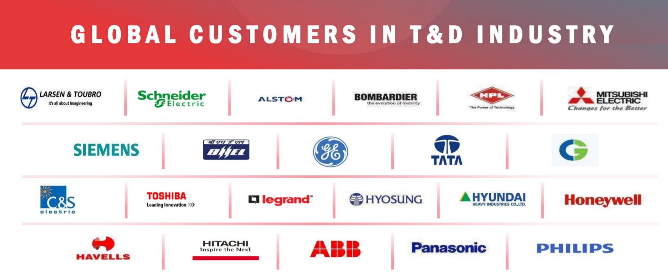

<https://threadreaderapp.com/thread/1434802105873625091.html>

<https://www.hp.co.in/business-we-have/electrical-contacts.php>