ISMT is into manufacturing of seamless tubes and engineering steels.

**Tubes (64% of revenue)**: ISMT produces both- hot finished as well as cold finished seamless tubes which are used for manufacturing of auto-components, bearing races, drill rods, boilers, heat exchangers, etc. The capacity is 4.5 lakh MTPA.

**Steel (34% of revenue):**ISMT produces Carbon, alloy and martensitic stainless steel bars, free machining steels, bearing steels etc at its integrated Steel Plant which uses Electric arc furnace technology. End users are mainly Bearing, Automotive, Engineering and Forgings. The capacity is 3.5 lakh MTPA.

They also have a 40 MW Captive Power Plant

They have done a one-time settlement for reduction of all debt

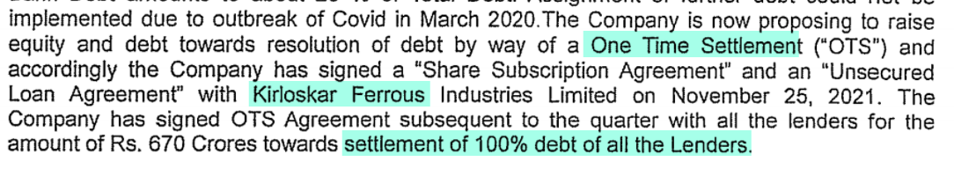

Due to negative net worth, they are losing out on large PSU business

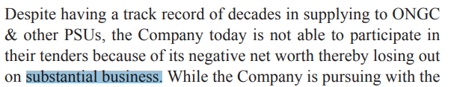

Once the net worth becomes positive, they will be eligible to participate in government tenders, creating large business opportunities

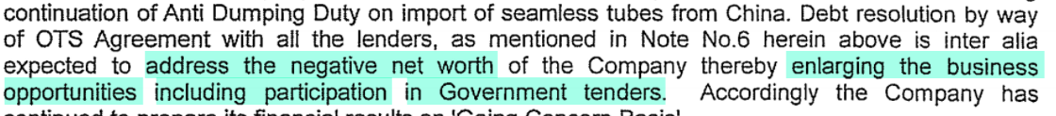

Kirloskar Ferrous has become promoter with 51.25% stake in ISMT.



They had done open offer



They have done significant debt reduction

