SBI CARDS
Source : Angel Broking
Screener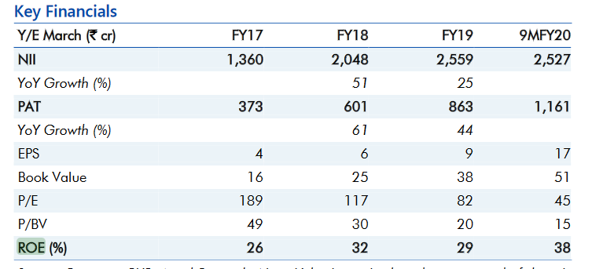
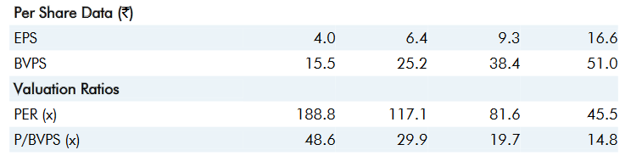
Screener:
BAJAJ FINANCE