A critical Business Analysis of Shreeji Translogistics Ltd
- Company Profile:
- Incorporated in 1976, Shreeji Translogistics Ltd provides freight management, logistic solutions, and warehousing services.
- They cater to a wide range of logistical requirements ranging from Export-Import Container movement to Bonded trucking movement. The Full Load Transport Service forms the core business at Shreeji, and in this sector Shreeji has earned its reputation of being a trusted name of Time-Bound Deliveries.
- Company owns and operates a fleet of 285 owned trucks and 4,500+ outsourced trucks of varying designs, sizes, and capabilities
- Company has 22+ branch offices in India including 4 additions in FY23. a) In June 2022, Co. had set up a new branch at Kokta, Bhopal, to meet the increasing demands of their customers. b) On 30th November 2023, company opened its new branch at Indore
- They have three subsidiaries: 1. STL Transworld Private Limited 2. TKD Digitrans Tech Private Limited 3. Mihani Trading Private Limited (not started operation as on 31st March, 2023)
- TKDost- Digital Freight Platform: for optimized freight management

- Industry Analysis:
  - The Indian logistics sector is divided into 4 segments:
    - Transportation (Road, Rail, Air, Water-ways)
    - Warehousing (Container Freight Stations and Inland Container Depots)
    - Freight Forwarding
    - Value Added Services
  - The logistics theme revolves around formalization of the Indian economy, with GST being a big driver. India targets dropping logistics costs to less than 10% of GDP from the current 14-15% in the next five years. recently implemented National Logistics Policy intends to reduce India’s logistics costs from the double digits of GDP to the single digits by 2030. The Government of India has taken many initiatives to strengthen the sector’s infrastructure, including the establishment of dedicated freight corridors and the extension of road and rail networks, to improve connectivity and decrease travel times.
  - The road transportation sector in India is expected to grow at a compounded annual growth rate of 8% in the next five years, to reach USD 330 billion by 2025. This growth will be fueled by factors such as the rapidly growing e-commerce sector and a growing retail sales market, infrastructure improvements, among others
  - Digital transformation, projects such as Digital India, Bharat Net, and the National Logistics Portal would aid in the industry’s digitization. Furthermore, the government has announced the establishment of logistics parks and warehouses across the country to provide appropriate storage facilities for enterprises.

.
- Business Verticals:
a) Full Truck Load
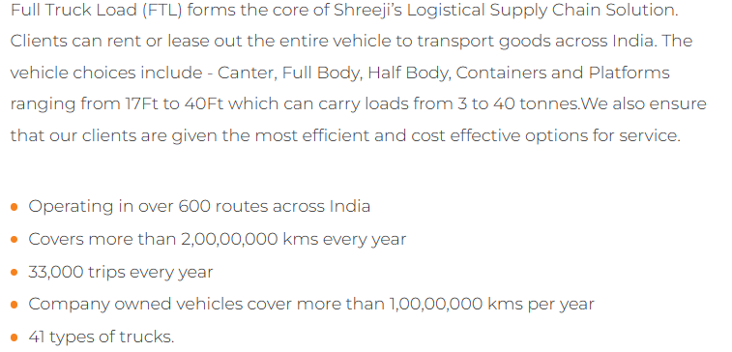
b) Parcel & Part Load
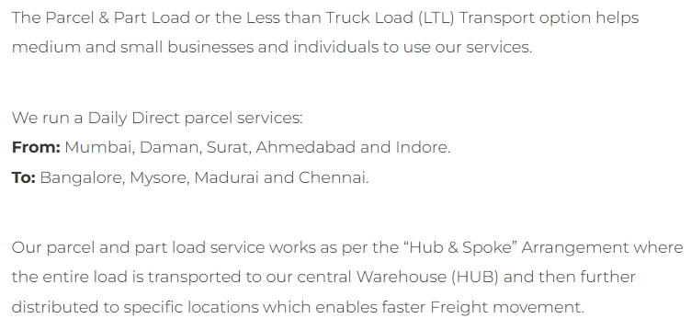

c) Bonded trucking
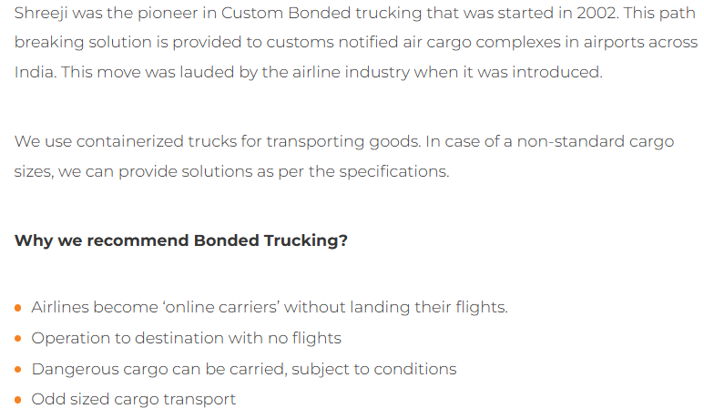
d) 3PL and Warehousing:
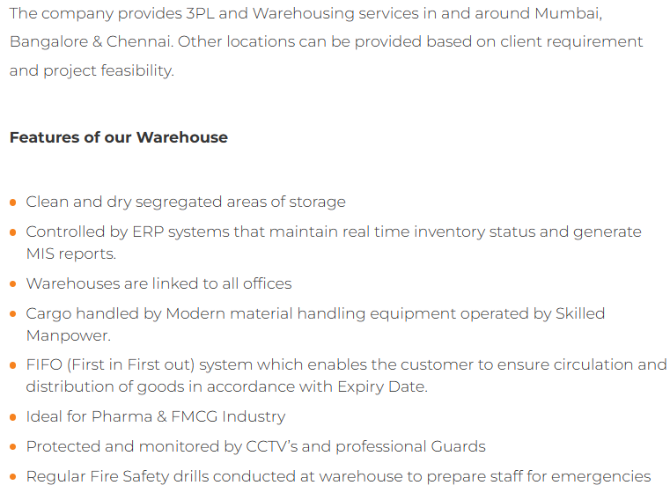
e) Shipping line container movement
The company’s vehicles are used to connect the 'Linehaul' Ocean and Rail segments of the Containerized Freight Movement. The company has services for both types of container loads catering to Import and Export segments. These are specialized trucking runs between ocean ports, rail terminals, ICD & CFS
f) Over Dimensional Cargo (ODC)
In FY23, the company entered into the ODC segment. ODC is a cargo that extends beyond the normal loading deck of a cargo to deliver oversized goods and it is a specialized service having good yields. ODC services will allow STL to carry heavy cargo materials for transportation.
g) EXIM:
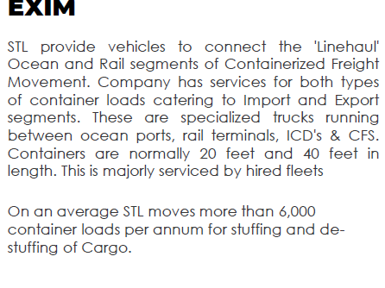
h) Railway Rake handling & Transportation:
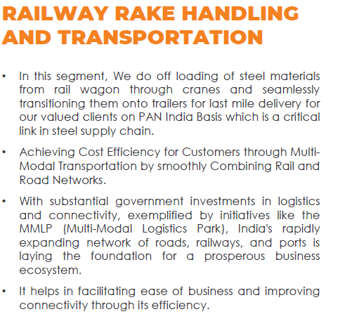
- Revenue Mix
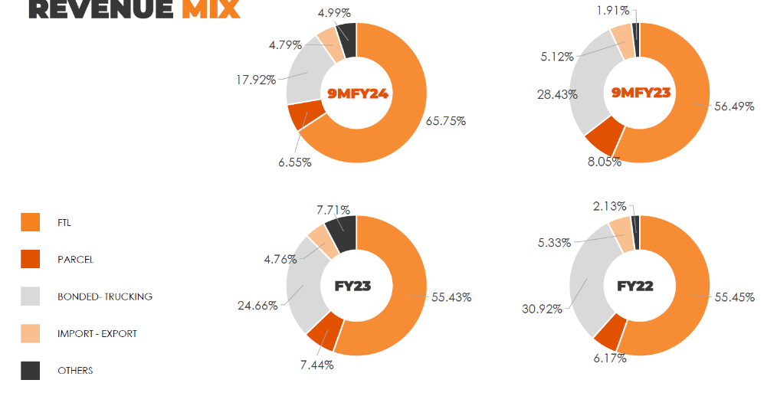
- Clientele:
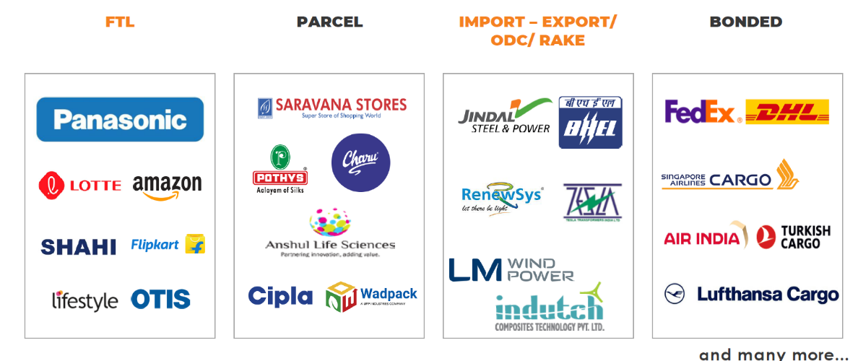

- Investment Thesis:
- Proactive approach to mitigate common industry risk:

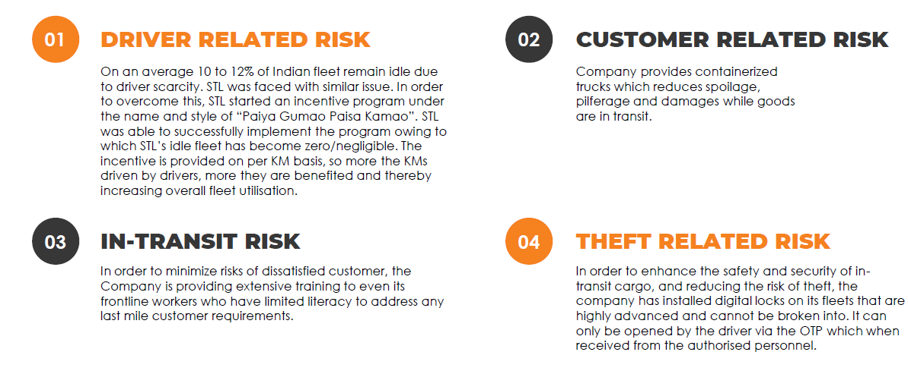

- Future Strategy:

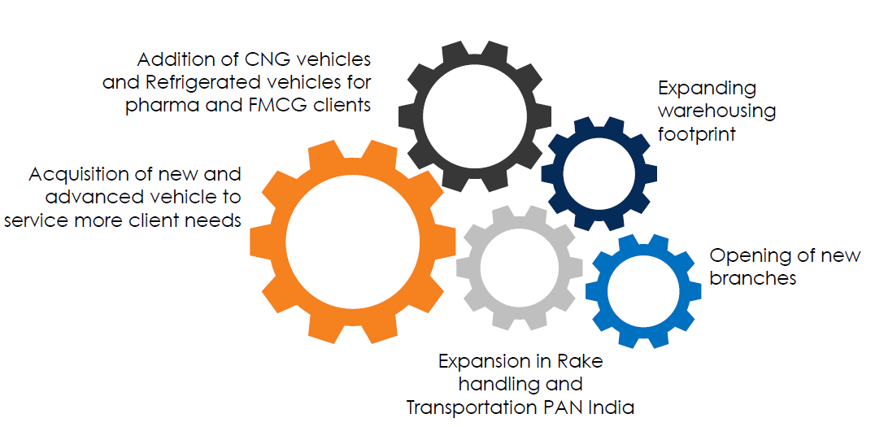
- Risk Factors:
  - Volatility of fuel price is one of the most prominent concern in transportation industry
  - Company diverting from its main business of freight movement to unrelated trading business:
Pursuant to a special resolution passed by the members of the Company on 6th January, 2023 by way of Postal Ballot, the Main Objects Clause of the Memorandum of Association of the Company was altered to enable the Company to diversify the scope of its existing business and commence new business of trading, importing, exporting and dealing in automobile accessories and batteries; or any other goods or merchandise.

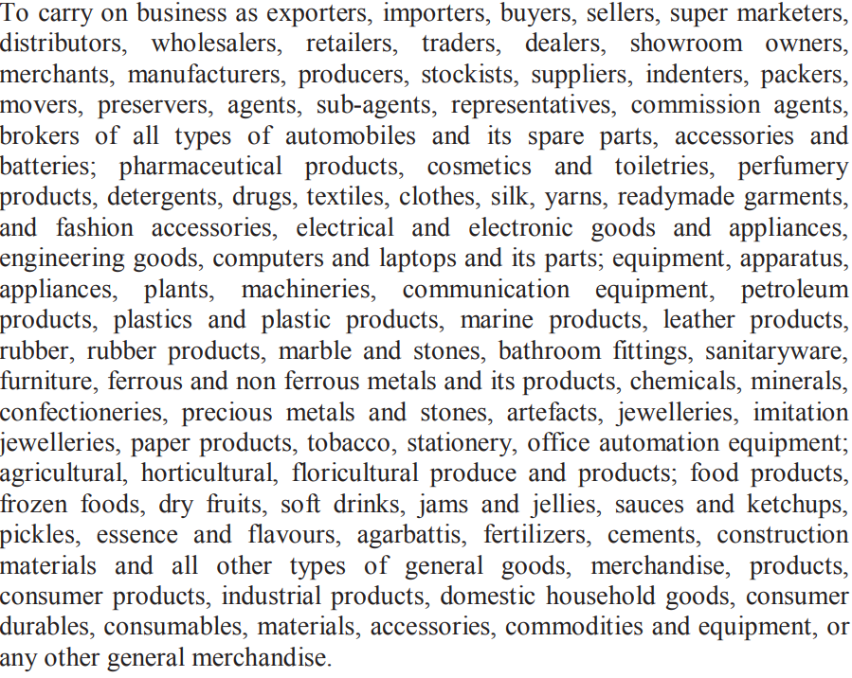

  - They Have given loans/advances/gurantees to parties other than subsidiaries for which balance outstandings is Rs 5.73 crores as on 31.01.23. (P-45 of AR of FY 23)
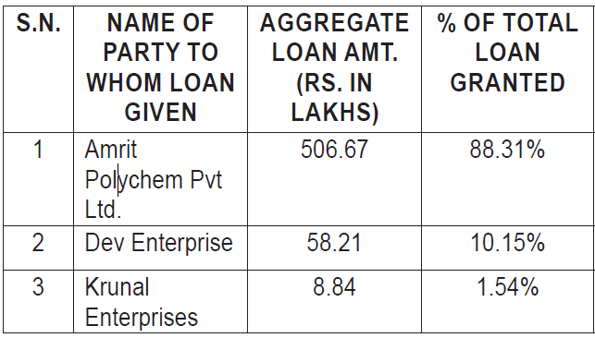

CRISIL vide their Rating Rationale dated 8th June, 2022 informed that Amrit Polychem did not respond to CRISIL’s communication for issuing rating. Accordingly CRISIL rated them as Issuer not operating.

  - In cash flow statement, it is shown company invested 10.59 cr for purchase of plant property & equipment. But the same can’t be verified form notes of financial statement.

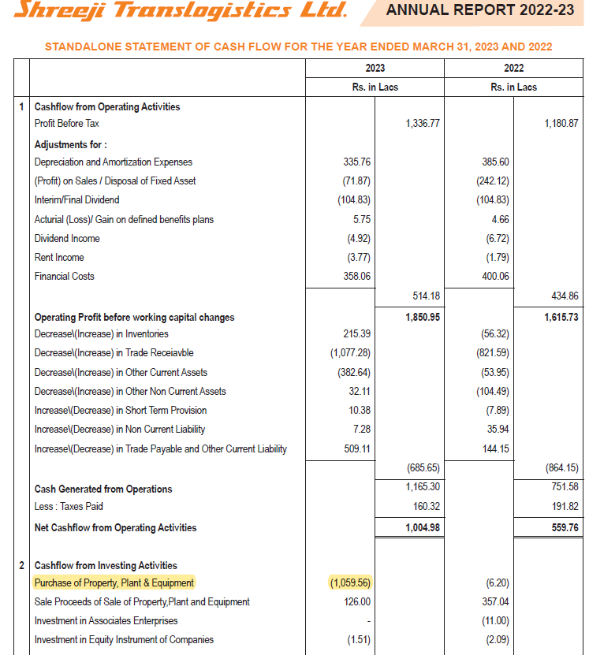

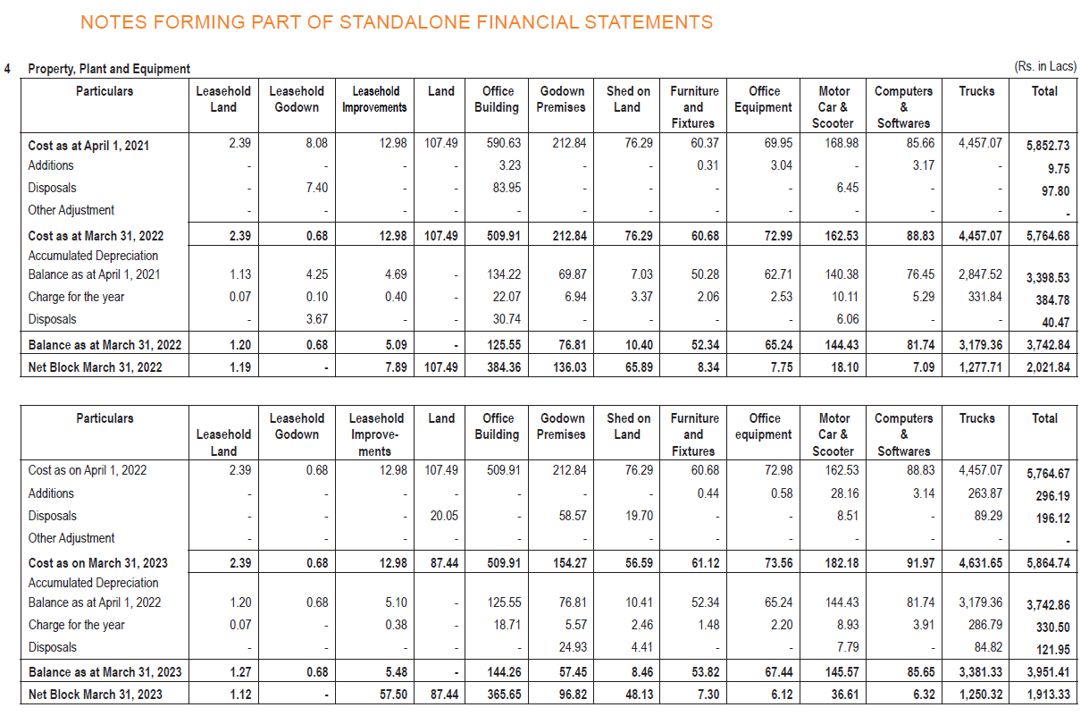
  - Unbilled revenue is being considered as trade receivables. Is it right prcatice as per account standard?

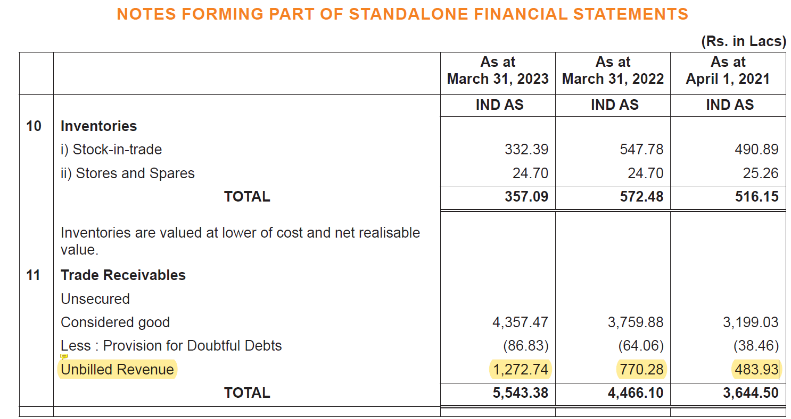

  - CARO report of subsidiary companies not issued till preparation of AR 2023.
  - Increasing short term borrowings, lion’s share of which is working capital loans given by various banks against vehicle or commercial property of the comapny.

- Valuation:

  - Logistics company avg P/E 15 to 30, @ current EPS of 3.23 share will consolidate within 48 to 100. High P/E of 40 may push up price to 130 to 150 max.

