**Jasch Industries has two divisions:**

**PU/PVC Coated Fabric (**69% in FY21 vs 73% in FY18)- The company manufactures polyurethane (PU) resin, PU and poly vinyl chloride (PVC) coated fabric, also known as synthetic leather which is mostly used in the footwear industry as a raw material for shoes – upper, lining, insole, chappal, sandal straps, in garment as lining material and in automobiles as seat cover. It is also used in furniture upholstery material, ladies and gents purses, bags, luggage and in the manufacture of sports goods & accessories. They also have in house manufacturing facility for PU Resin, which is the main raw material for PU coated Fabrics. Clients include Puma, Red Tape, Bata.

**Electronic Gauges (**31% in FY21 vs 27% in FY18)- The Co specializes in online measurement and control systems for flat sheet products, including instruments such as thickness gauge, coating thickness gauge, paint thickness gauge, and basis weight, ash, and moisture measurement gauges. These are used in measurement of thickness, grammage, moisture & ash contents in paper making industry; on line measurement of thickness & coating weight in plastics, steel, sheet rolling, galvanizing, aluminium foil & non-ferrous metal rolling industry. However, here sales are one-time and not recurring. In fact, some of their own customers have had installed systems running for 30 years.

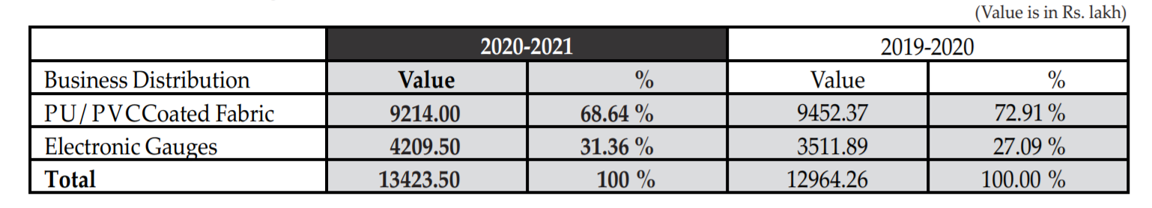

They have done significant debt reduction for a company of their size from Rs 23 Cr to Rs 3 Cr.

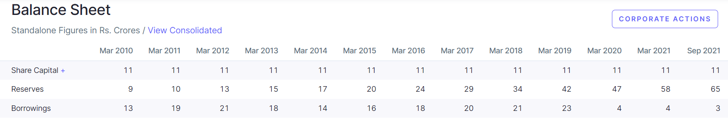



The gauge business is the higher margin and higher RoCE segment:

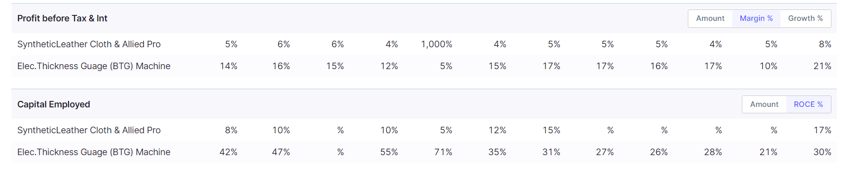

Typical selling price of various gauges on Amazon/Indiamart is Rs 8000 to Rs 25000.

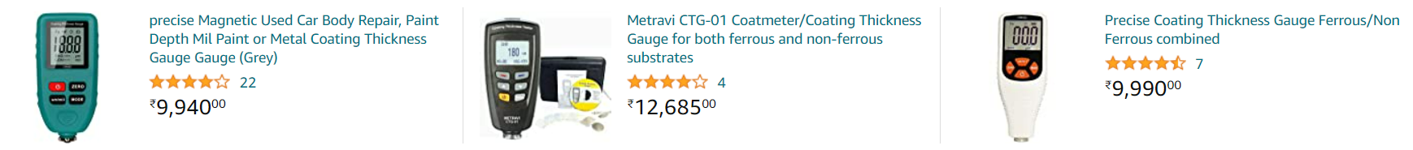

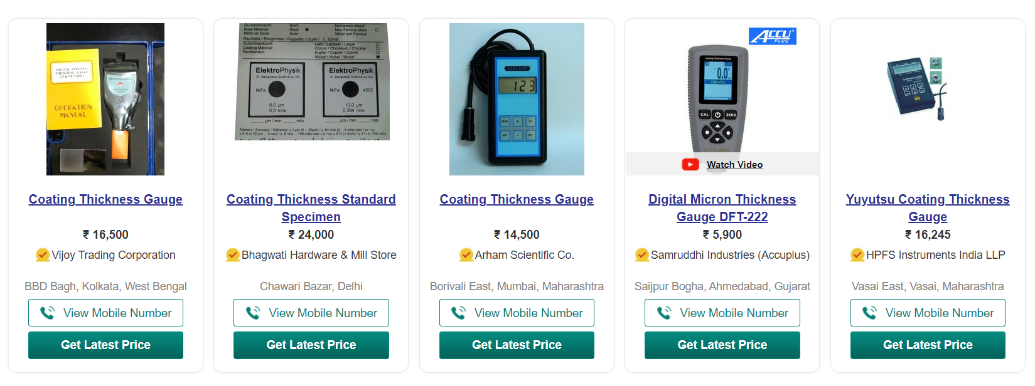

However, Jasch’s realisations seems to be around Rs 34550 in FY21 (Rs 435362000/12600)

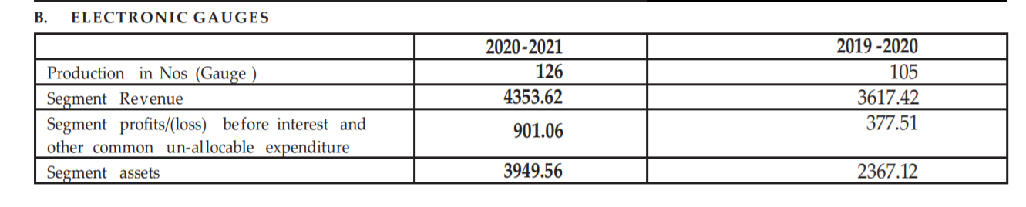

This indicates they are catering to premium gauges or there is some kind of brand advantage because of they are able to demand premium prices.

They are demerging the **Electronic Gauges** business into Jasch Gauging Technologies Ltd:

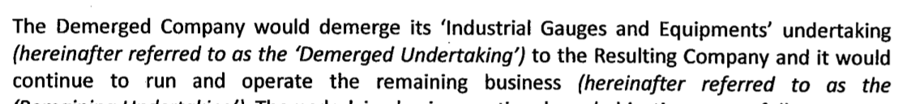

However, promoters have other unlisted businesses including Jasch Footwears Pvt Ltd:

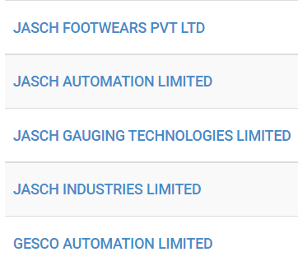



It would not be implausible to think that Jasch Footwears is procuring raw materials from the coated fabric segment of the listed entity. If so, one must consider the magnitude of such purchases (how much % they contribute to coated fabric segment sales?) and whether it is done at market prices.