SJS Enterprises is into manufacturing of decorative aesthetics components for use in consumer discretionary industries like automobiles (PVs/2-Ws etc.), consumer durables (TV/washing machine etc.), kitchen appliances, medical devices etc. Decorative aesthetic components include logos, stickers, decals, appliques, overlays, chrome plated parts, IML/IMD, IME etc. A few components such as appliques, overlays and optical plastics are also deployed for their functional attributes, besides the aesthetics function.

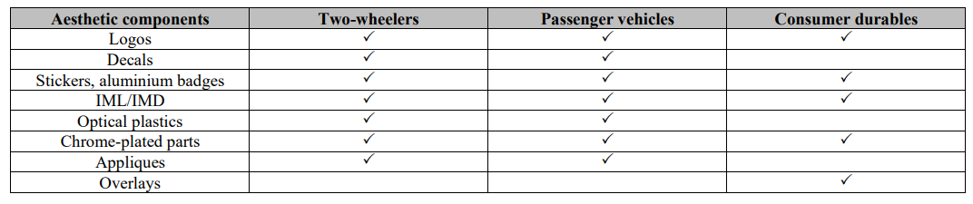

Some of SJS’s products include:

Logos

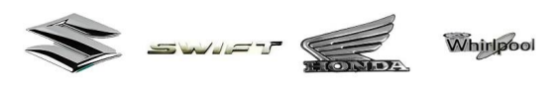

Decal Stickers/Graphic Stickers

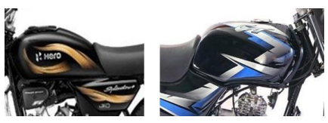

(Interestingly, OEMs see decal stickers as a cost-effective way to decorate and distinguish seemingly similar two-wheeler models, especially in the mass, economic, affordable 2-W segment. However, decals, graphics and logos are highly commoditized with very little differentiation, leading to a fragmented market.)

In-Mould Decoration (IMD)/In-Mould Labelling (IML)

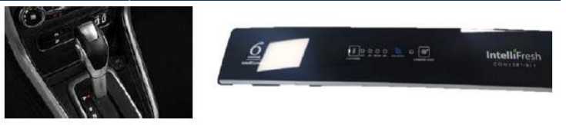

Optical Plastics: These are plastic parts that provide mechanical protection to display screens of in-vehicle infotainment systems.

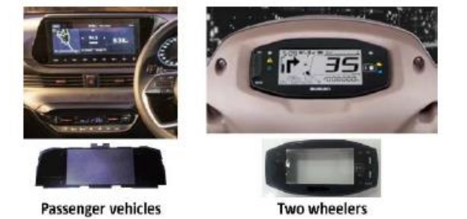

Chrome-Plated Parts

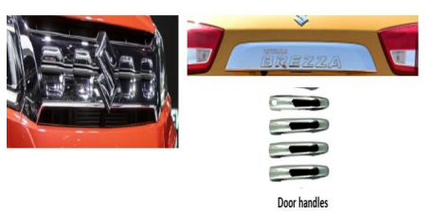

Appliques/Dials: Digital, Analogue and Hybrid. One major trend here is the shift from 2D dials to 3D dials.

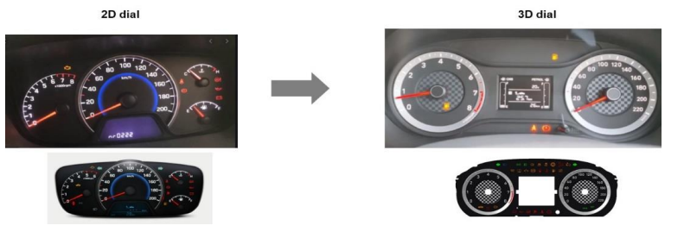

(Importantly, the realisation per unit of 3D dial compared to a unit of 2D dial is 2x to 3x.)

They are also into aftermarket accessories under the brand ‘Transform’.

This is the revenue mix of SJS by product:

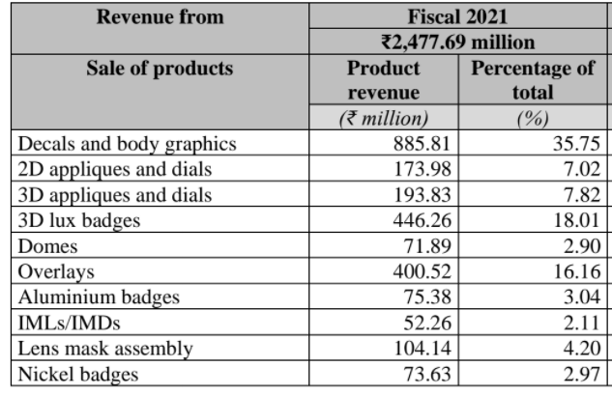

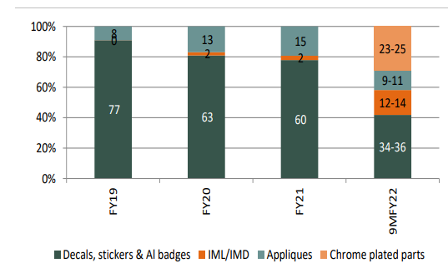

The industry is expected to grow at around 20% CAGR

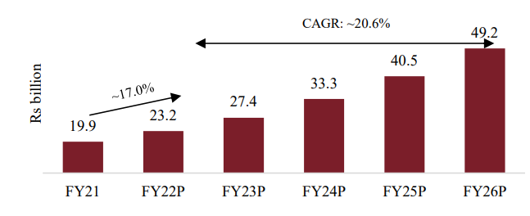

Decorative aesthetic product suppliers are expected to partner with OEMs and continuously innovate; hence, the supplier onboarding process is often stringent and time consuming, leading to entry barriers for new players.

Among the competitors, SJS is present across product and end-user categories

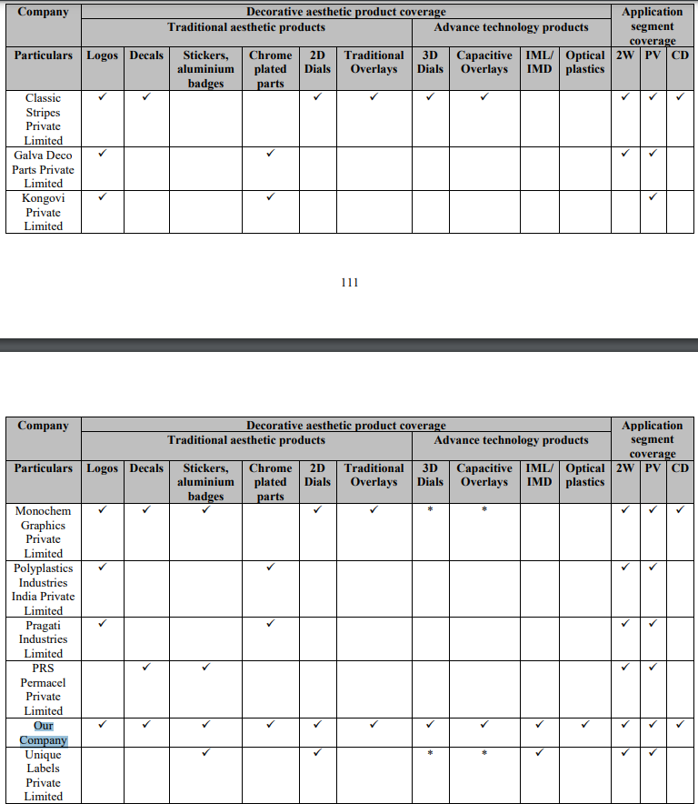

SJS is an end-to-end aesthetic design provider from design to development.

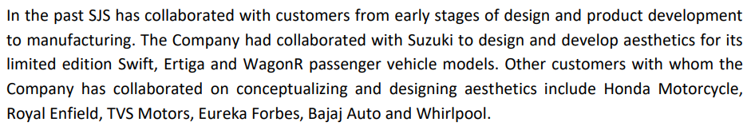

Their marquee clients include:

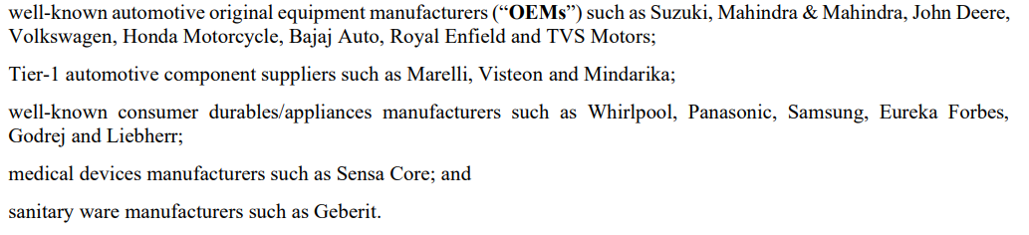

Their top ten clients have been with them for 15 years on average

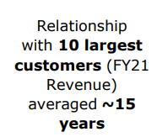

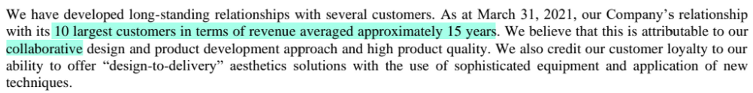

Client acquisition is a lengthy process

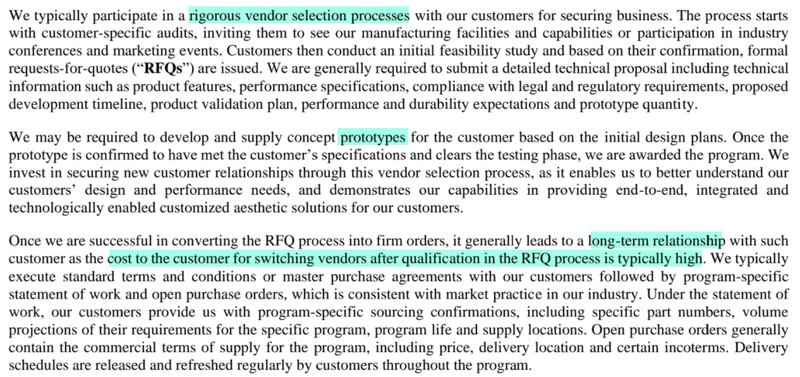

They actively purse cross-selling and account mining strategies to increase wallet share



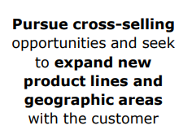



Some examples of mining:

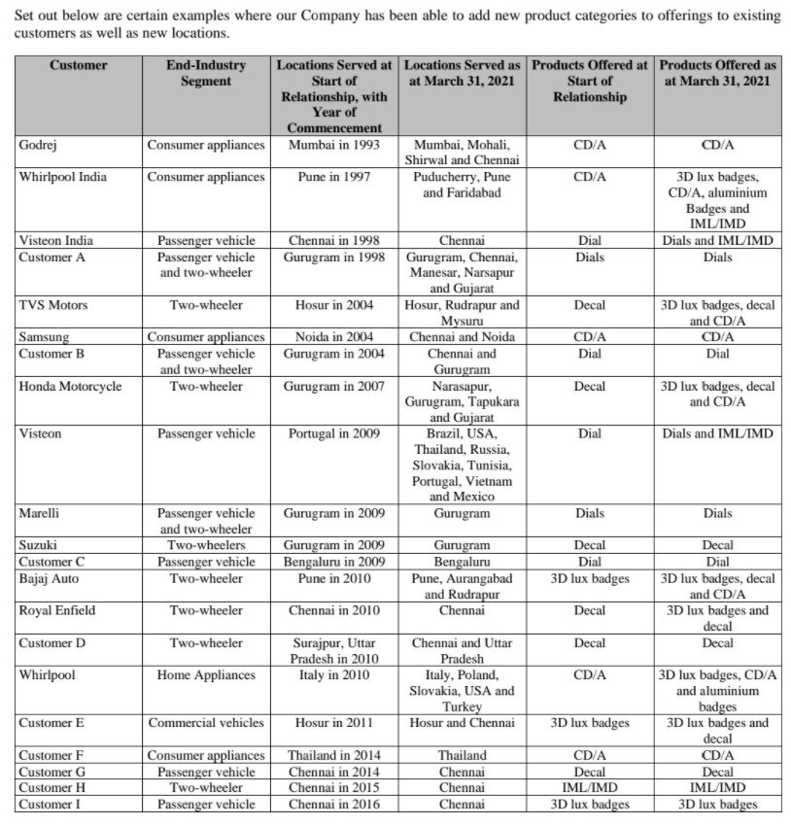

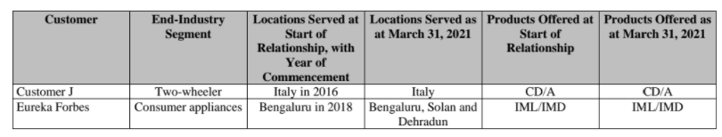

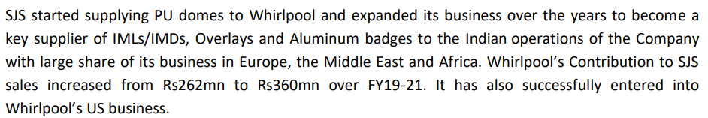

Customer concentration is as follows:

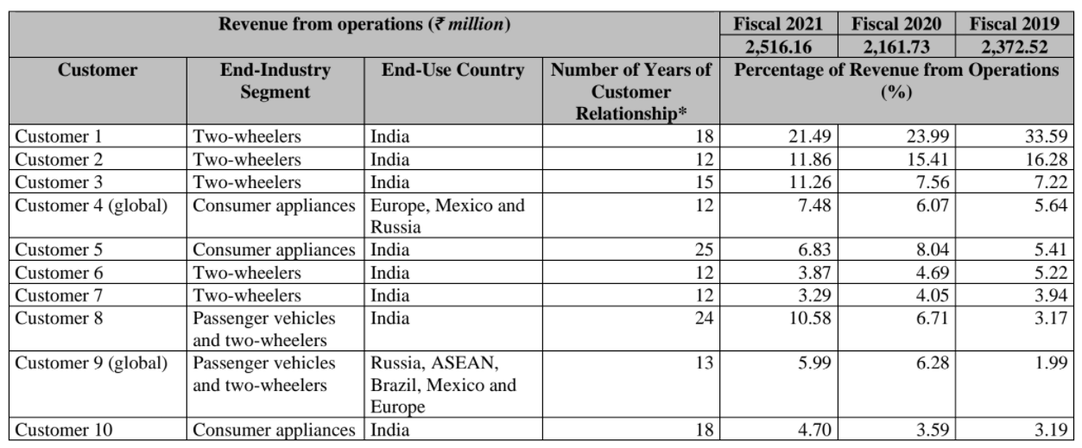

They acquired Exotech in CY2021



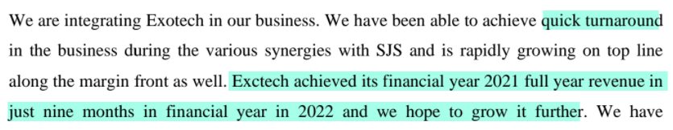

Through the Exotech acquisition, they entered chrome-plated parts. Margins are relatively lower in chrome-plated parts but RoCE is high. They also got a plant in Pune with a capacity of 29.5 million units. They paid Rs 64 Cr for Exotech, which seems reasonable given that Exotech had Rs 68.5 Cr revenue and Rs 5.2 Cr PAT when they bought it.

They continue to selectively assess inorganic opportunities.

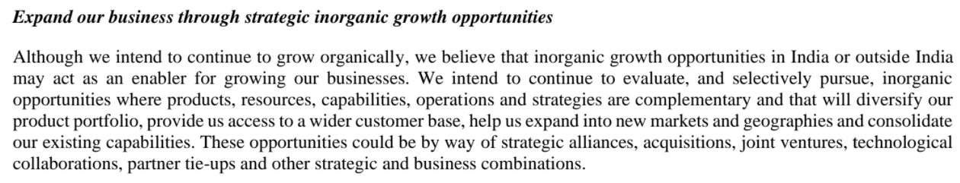

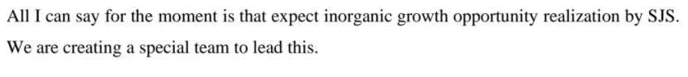

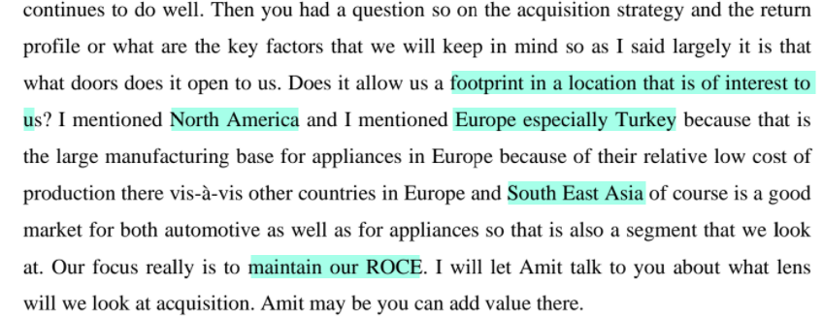

While evaluating inorganic opportunities (especially international), they try to look at using the India operations as a low-cost manufacturing hub for exporting.

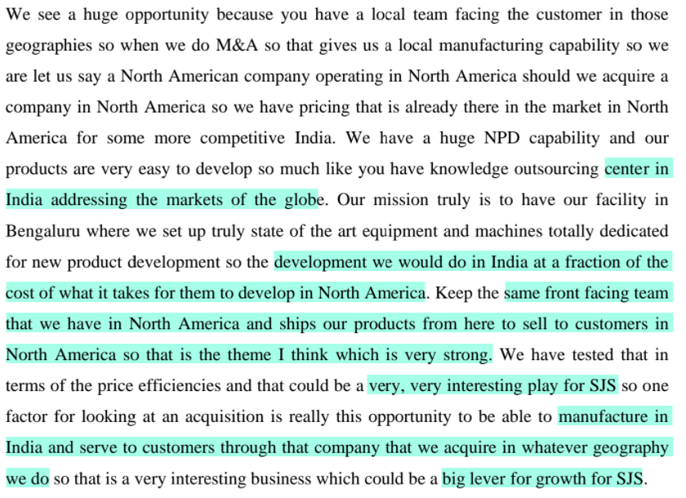

There is a shifting preference towards premium products and they are well-position to benefit from this

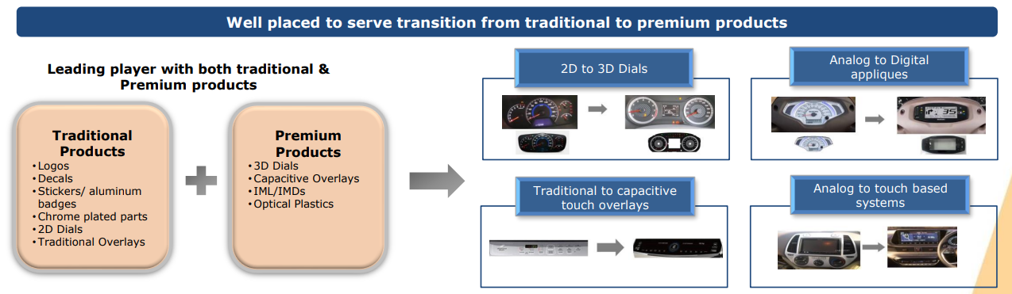

They were operating at low utilisation rates in FY21



They earned healthy return ratios despite this.

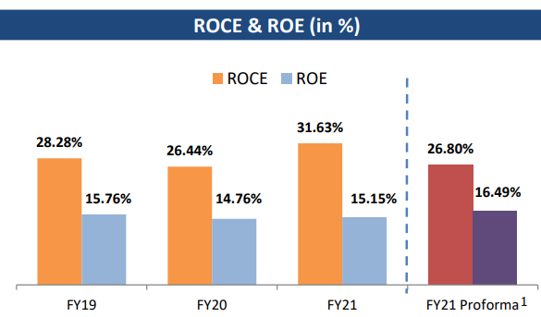

Rise in utilisation can lead to operating leverage.

Any future capex in the near/medium-term will be brownfield, since the Bangalore plant also has additional land (around 30%) to undertake further expansion, if required.



The Bengaluru factory is fungible, i.e., product manufacturing can be interchanged.

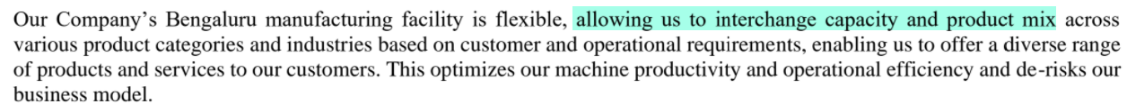

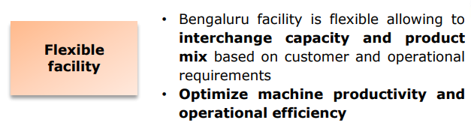

They also have a solar plant for captive use



These supply 1/3rd of the power requirements of the plant.

Exports was around 16% of FY21 revenue and they intend to increase this



Margins are better in exports than in domestic, hence rising share of domestic sales is a lever for margin expansion

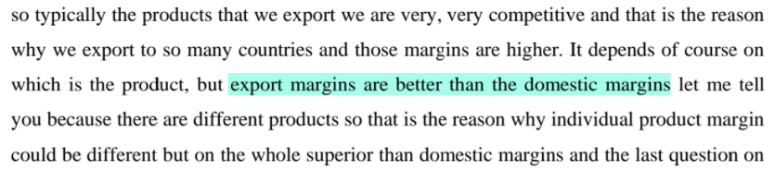

Major raw materials:

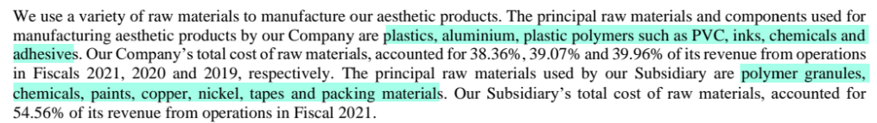

They have a competent, experienced management team. As part of the succession plan, Mr K A Joseph’s son, Mr Kevin Joseph, has joined the business.

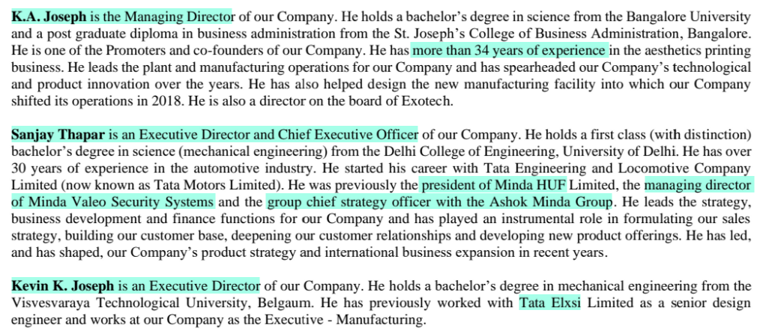

Everstone invested in the company in 2015

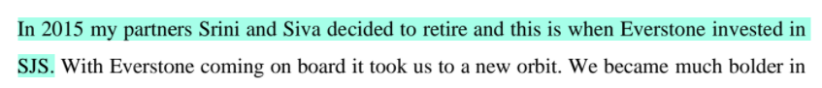

They aim to double revenue in 3 years



Financials:

