Nelcast

Variant perception of improvement in utilisations, low incremental capex required, margin improvement through exports growth and product mix change through new product launches.

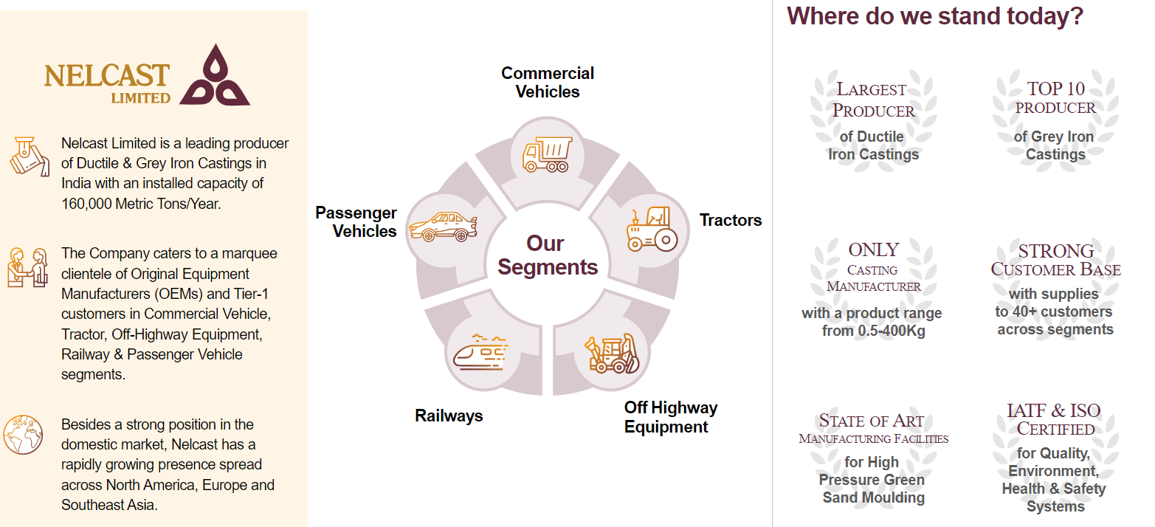

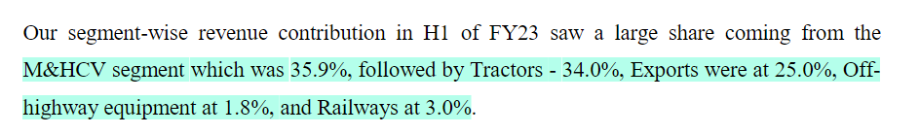

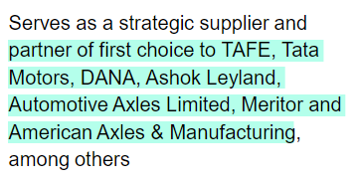

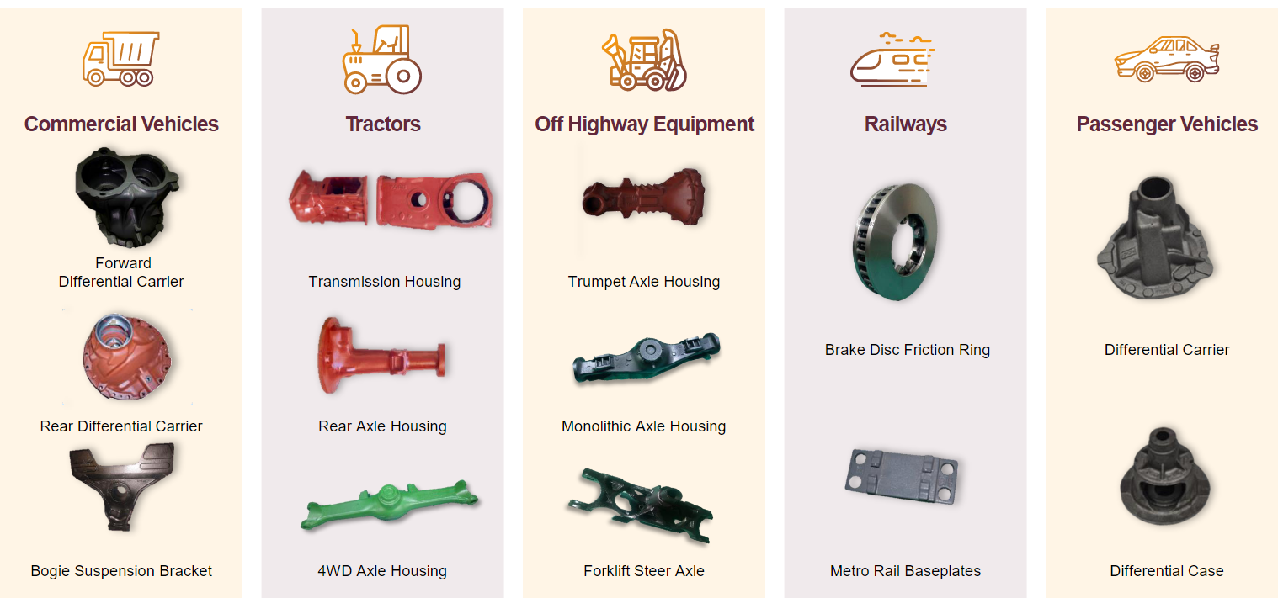

Seems like manufacturing complexity and high precision requirements are a differentiating factor

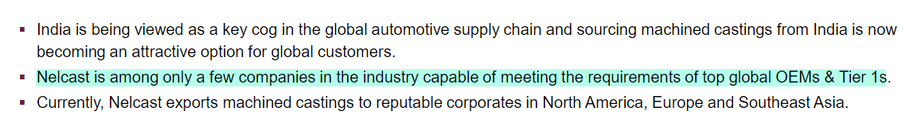

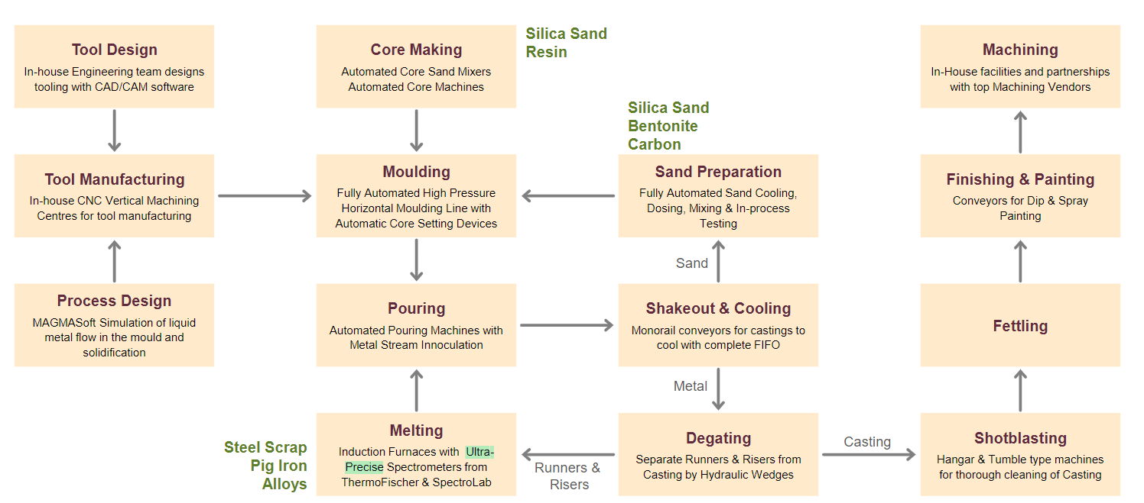

Exports growth has been very strong

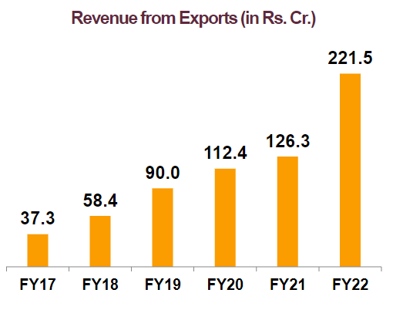

EBITDA per kg in exports is almost double of domestic

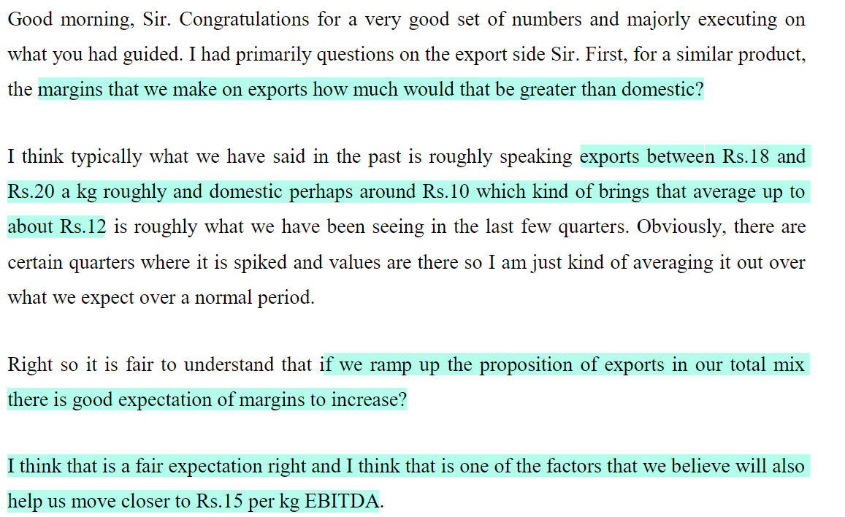

They are on track to reach Rs 300 Cr export sales in FY23



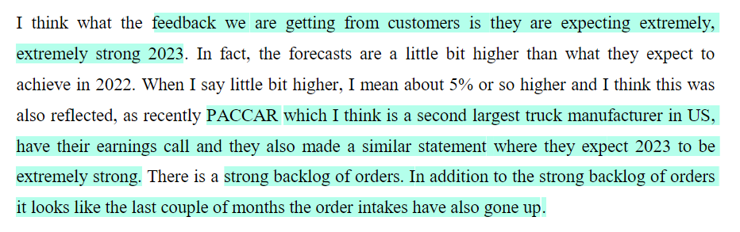

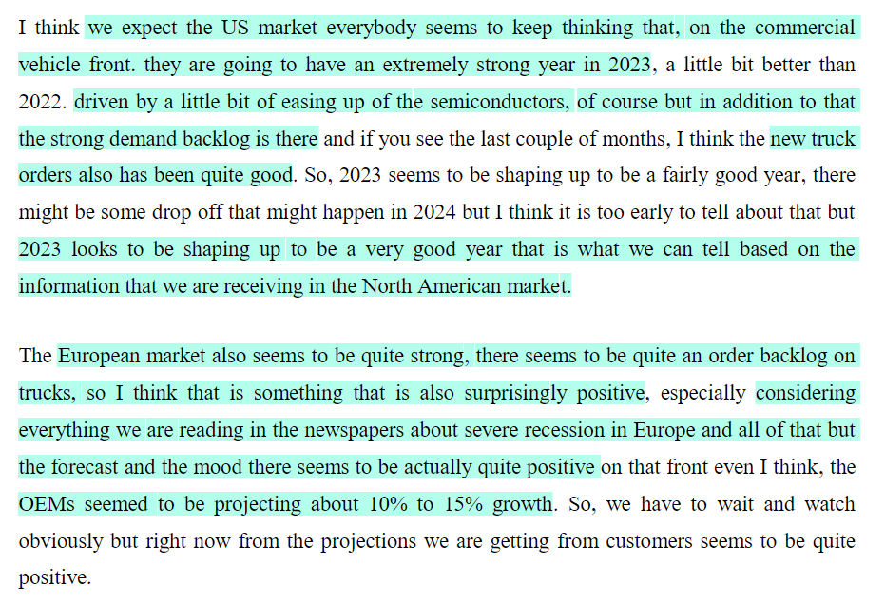

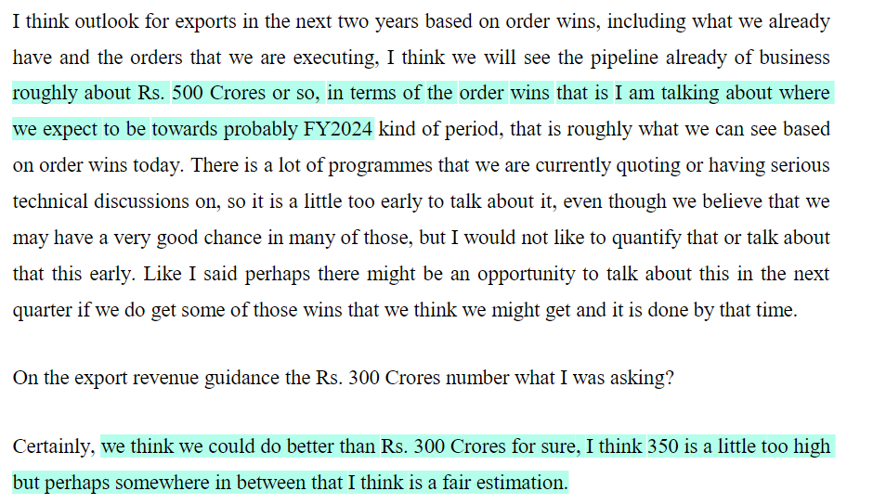

Low incremental capex is expected

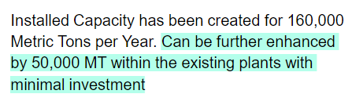

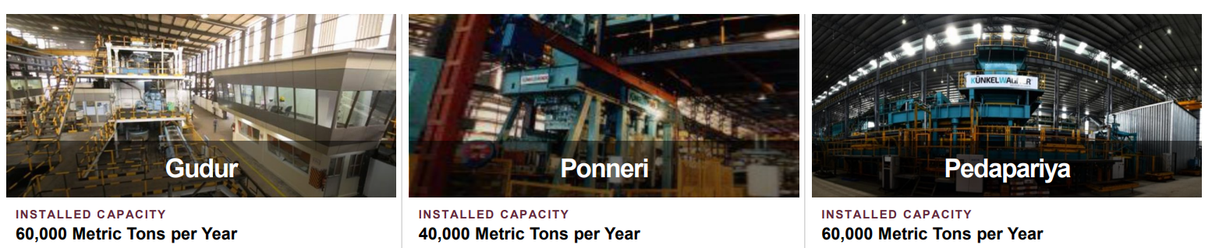

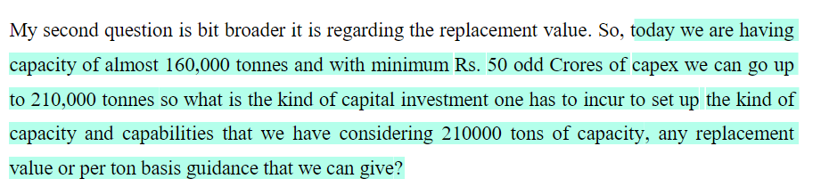

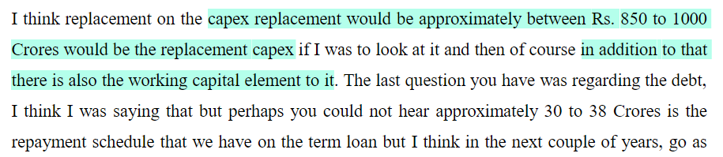

They are operating at low utilisation, and operating leverage can kick in from improvement in utilisation levels

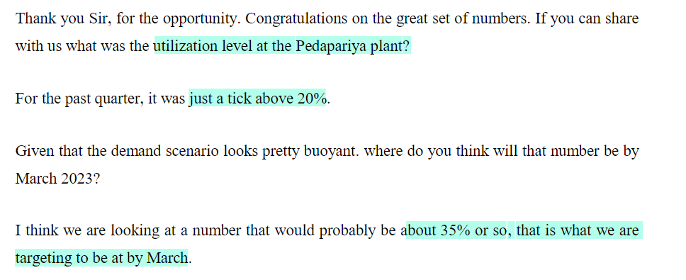

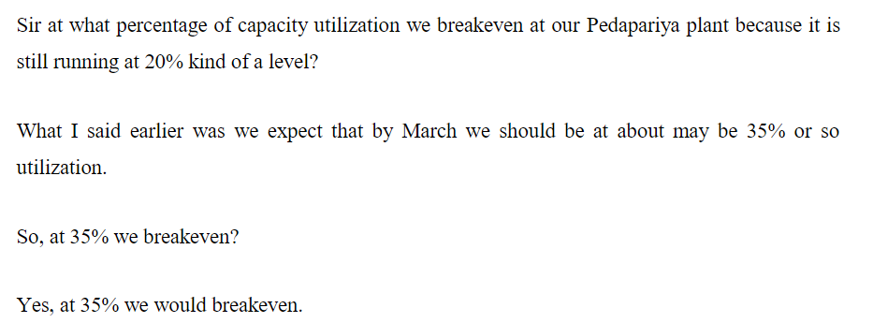

The EBITDA per kg is expected to improve from around Rs 12 to Rs 15

