Alufluoride Limited is producing high purity Aluminium Fluoride (AlF3) with technology developed by Alusuisse, Switzerland. Aluminium Fluoride is mainly used in the production of aluminium. AlF3 is used as a flux in reducing the melting point of Alumina during the electrolytic process of producing Aluminium. Adding aluminium fluoride to the production process of primary aluminium lowers the consumption of electricity required in the smelting process (due to increased electrical conductivity of alumina) and also reduces the amount of heat energy required (by lowering the melting point of alumina); AlF3 thereby considerably contributes to the reduction of production costs of aluminium. Around 25 kg of Aluminum Fluoride is needed per ton of aluminium production. With the cyclical upturn and tailwinds for the aluminium sector, Aluminium Fluoride demand is likely to be strong. Thus, Alufluoride is also a proxy/ancillary play on the aluminium industry. Their customers include National Aluminium (NALCO), Hindalco, Bharat Aluminium (BALCO) etc.

A key trigger for the company is a huge capex. They have more than doubled the gross block from March to September:  
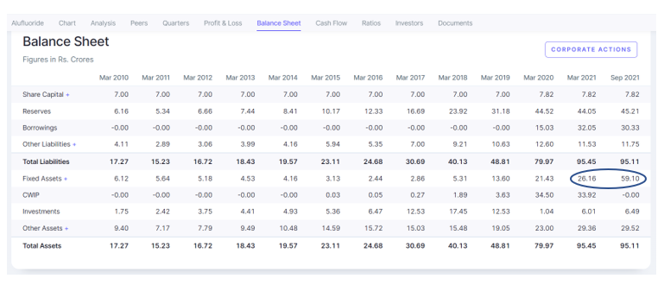  
  
  
Rise in debt is to fund capex:

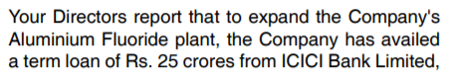

In case they use cash flows from capex to repay debt then deleveraging can also be a trigger.  
  
Commercial production was commenced on 1 May:

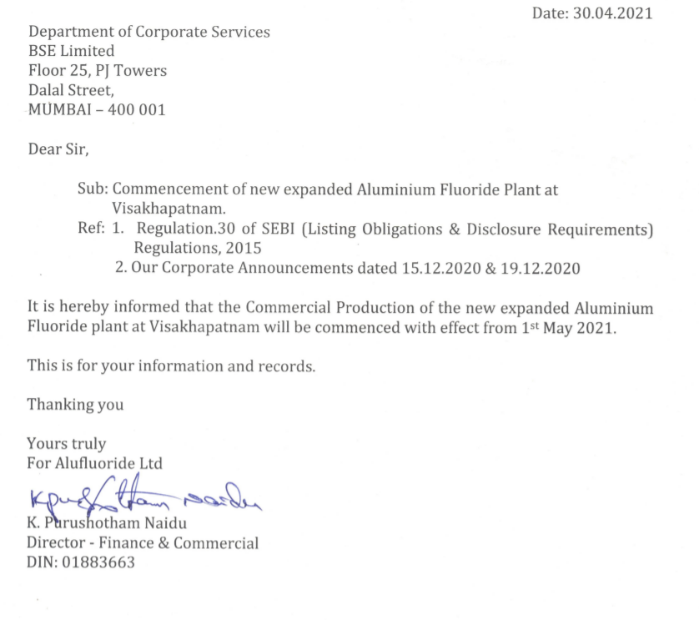  
  
Sharp rise in depreciation in Q1 and Q2 FY22 is clearly visible (due to capitalisation of new capacities hence depreciation starts getting levied on new assets):  
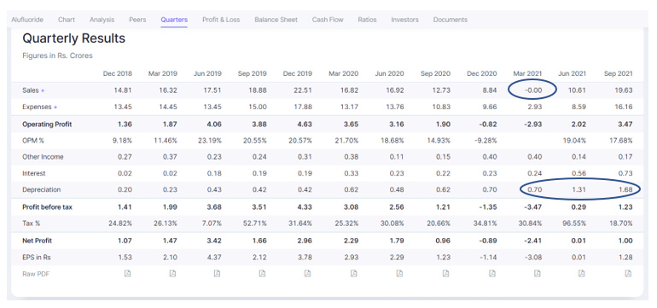  
  
March quarter (Q4 FY21) is clearly a black swan with zero sales so we need to understand what happened here. The reason is that they shut down their existing plant to synchronise with the new plant:

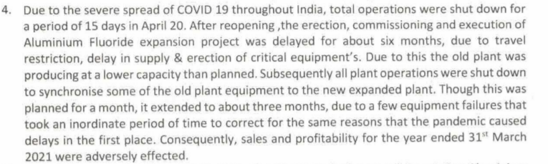  
  
Although they made a small loss in FY21 and TTM and hence FY21 RoCE is -0.2%, they have a track record of generating 20-30% RoCE in the last 5-6 years:  
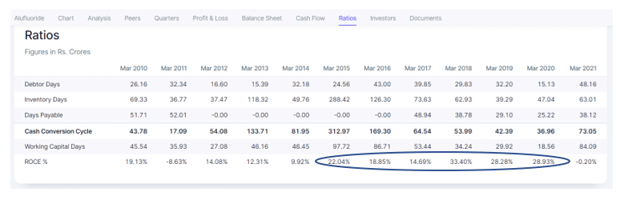  
  
They have also entered power generation for captive use. This is expected to lower energy costs:  
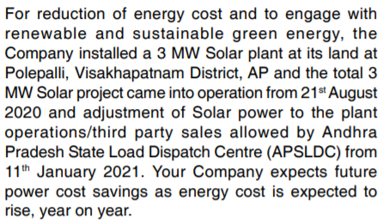

As of FY20, their capacity was 7500 TPA, which has increased to 12000 as of FY21 AR.

China is the leading manufacturer of aluminium fluoride across the globe and constitutes a significant portion of the global market share. Thus, it is also an import substitution play. They have reported repeat orders due to its quality and service, from Aluminium smelters both in India and abroad.

Tanfac Industries is a competitor in Aluminium Fluoride (though they have several other products too) and they have Swiss Davy Process technology. However, Tanfac is reducing the focus on Aluminium Fluoride as it is only 2% of their sales. Extract from Tanfac AR:

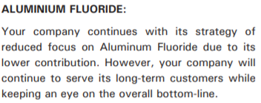

This can lead to market share gains for Alufluoride.

They also announced a joint venture with Jordan Phosphate Mines Co.:

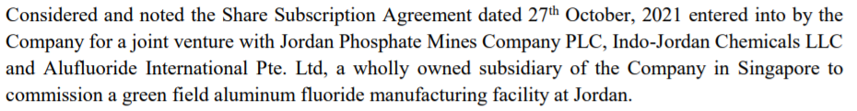

Alufluoride's production process is environmentally more sustainable and is not reliant on fluorspar (which is mostly sourced from China):

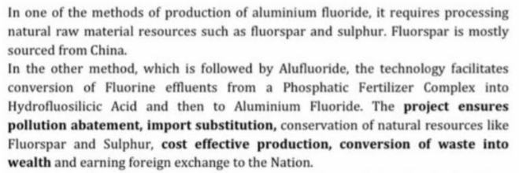

Sources for further research:

<https://www.moneycontrol.com/news/opinion/alufluoride-gains-from-the-improving-prospects-for-end-market-aluminum-2460485.html>

<https://www.statista.com/statistics/727643/india-aluminum-fluoride-production-volume/>

Disclaimer: All analysis shared is for private circulation only. Any analysis shared should not be construed as investment advice. Any analysis is not a buy/sell/hold recommendation. I am not a SEBI registered investment advisor. Please consult your financial advisor before acting on any analysis. The author shall not be liable for any losses incurred by readers while acting on any analysis. The author may have holdings (and hence a vested interest) in any companies mentioned and the analysis may be biased. The content and analysis shared are for educational purposes only.