Takeover/Promoter Change/Open Offer Cases

[malhar.manek@gmail.com](mailto:malhar.manek@gmail.com)

Safari (FY12)-

Acquisition price was Rs 170

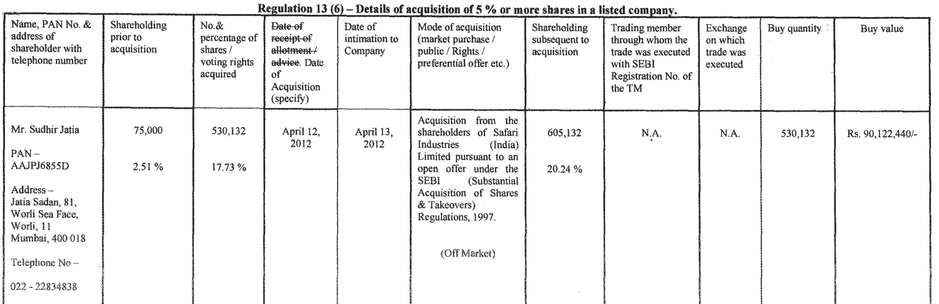

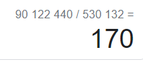

CMP was Rs 163 after adjusting for split

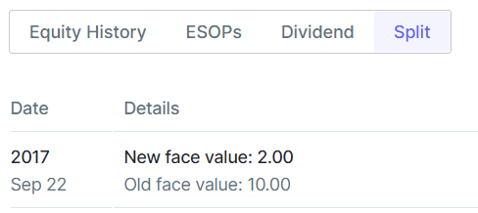

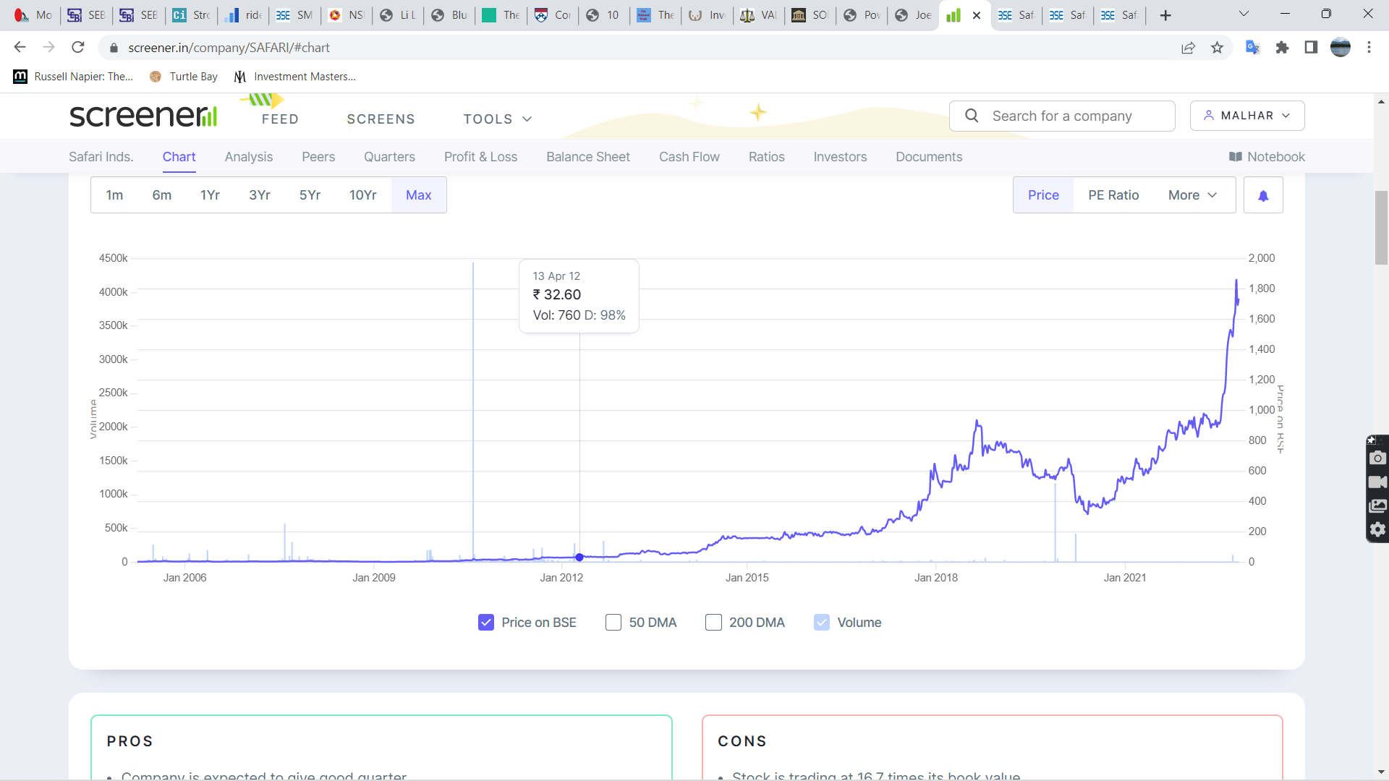

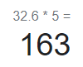

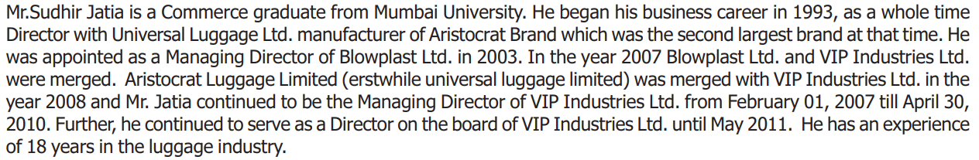

<https://www.bseindia.com/xml-data/corpfiling/CorpAttachment/2012/4/Safari_Industries_India_Ltd_160412_SAST.pdf>

<https://www.bseindia.com/bseplus/AnnualReport/523025/5230250312.pdf>

<https://www.bseindia.com/xml-data/corpfiling/CorpAttachment/2012/4/Safari_Industries_India_Ltd_190412.pdf>

Medicamen Biotech (FY16)-

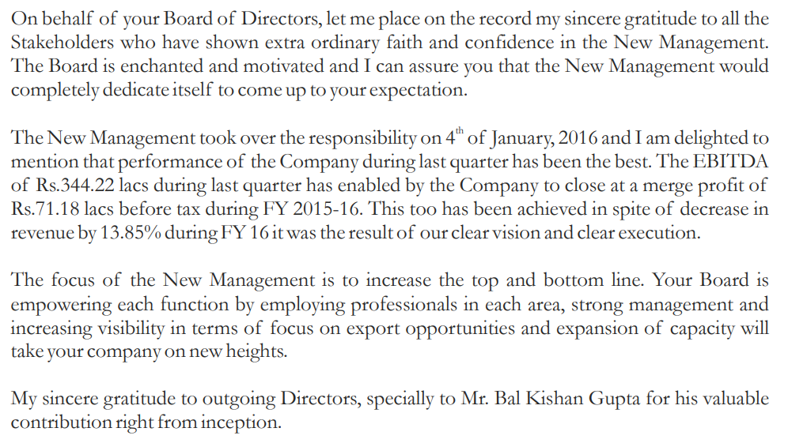

Shifting from acute to chronic-

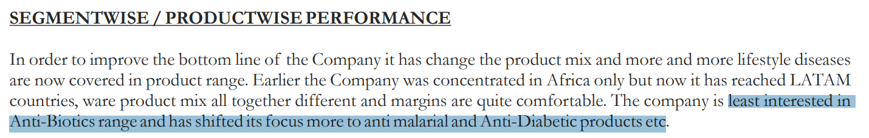

CMP was Rs 26 vs SPA price of Rs 40

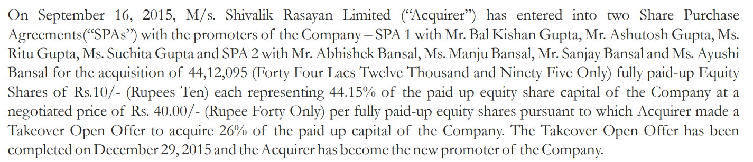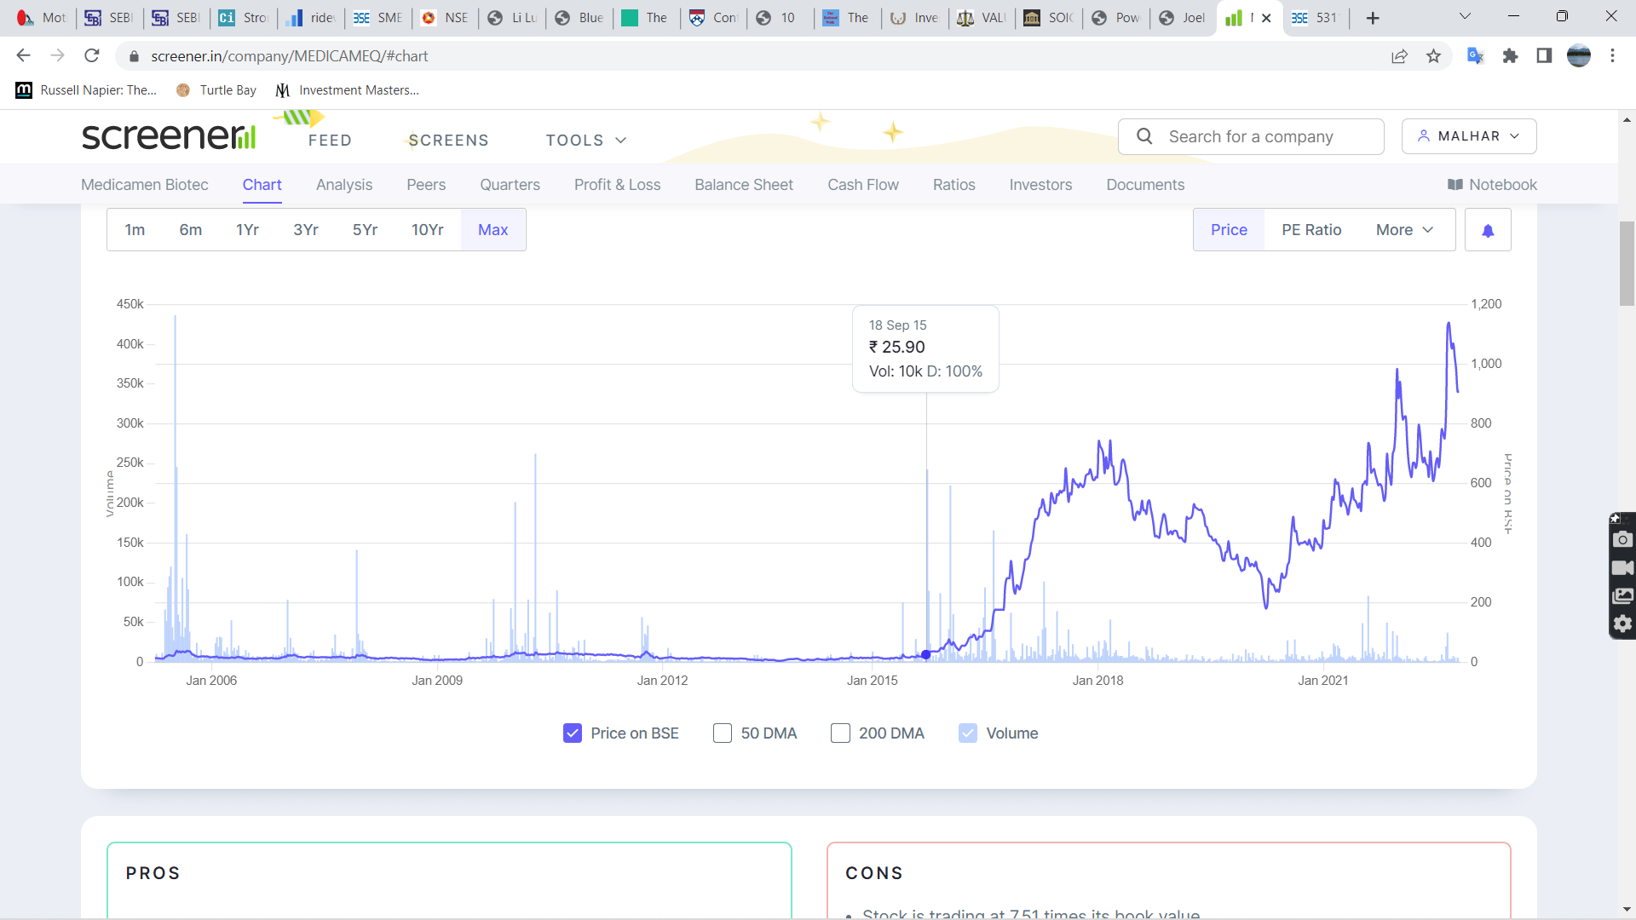

What one would have seen in Shivalik Rasayan **at that time**-

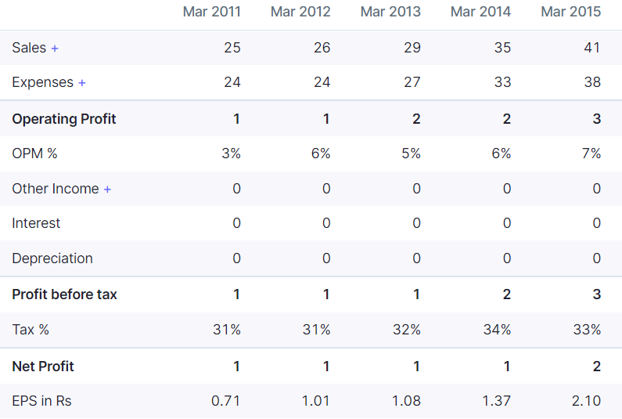

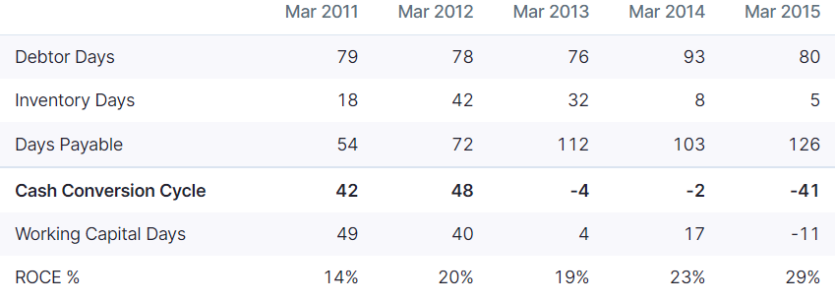

Shivalik Rasayan invested 16 Cr in Medicamen, vs its own net worth of only 14 Cr!

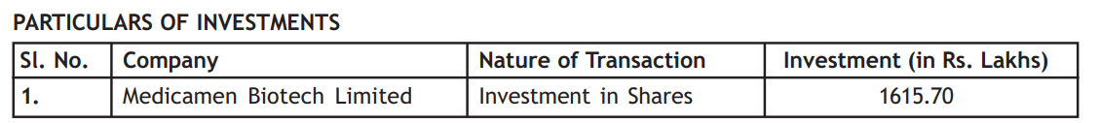

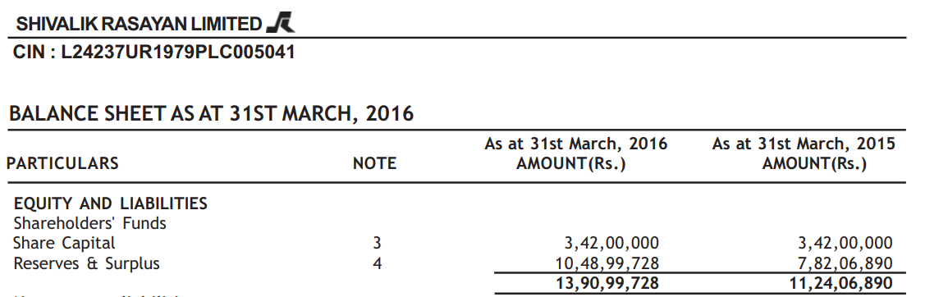

<https://www.bseindia.com/bseplus/AnnualReport/531146/5311460316.pdf>

<https://www.bseindia.com/bseplus/AnnualReport/539148/5391480316.pdf>

<https://www.bseindia.com/xml-data/corpfiling/CorpAttachment/2017/12/1f5cc49d-b9d9-435a-b87f-9dd28959e397.pdf>

HLE Glascoat (FY17)-

Rs 130 open offer

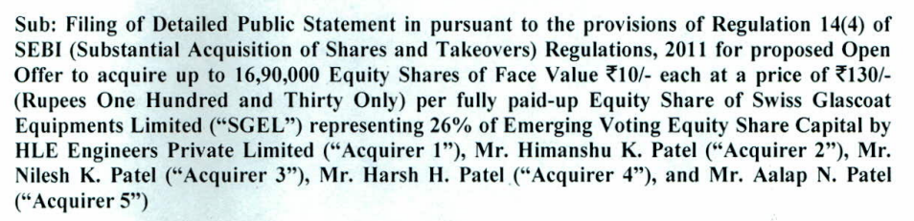

CMP was around Rs 160 adjusted for split

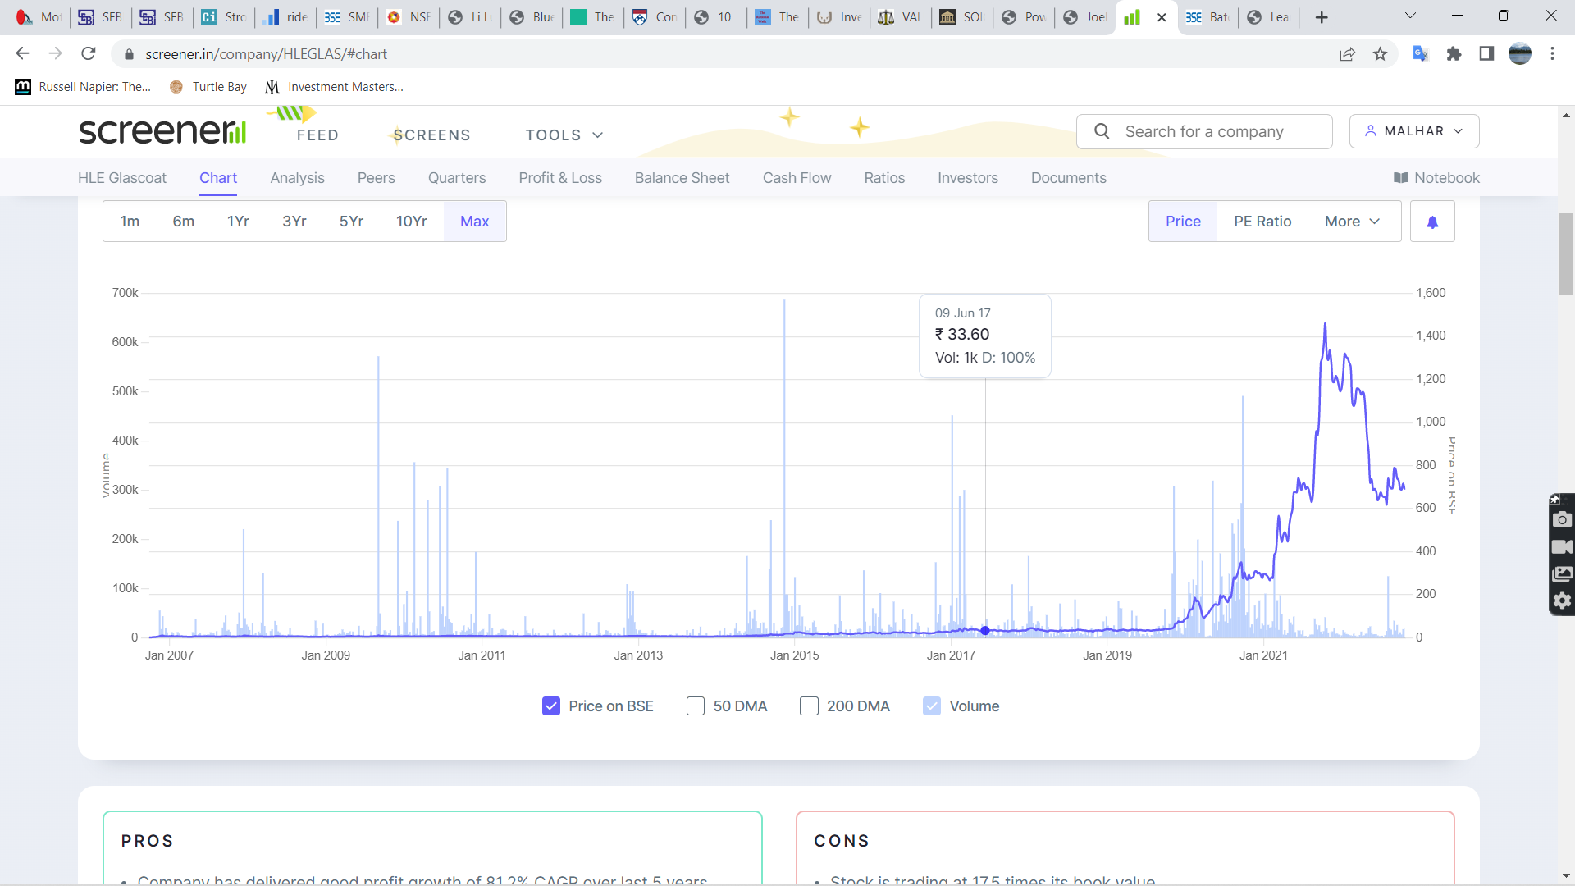

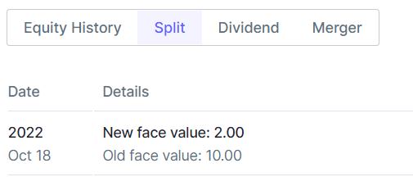

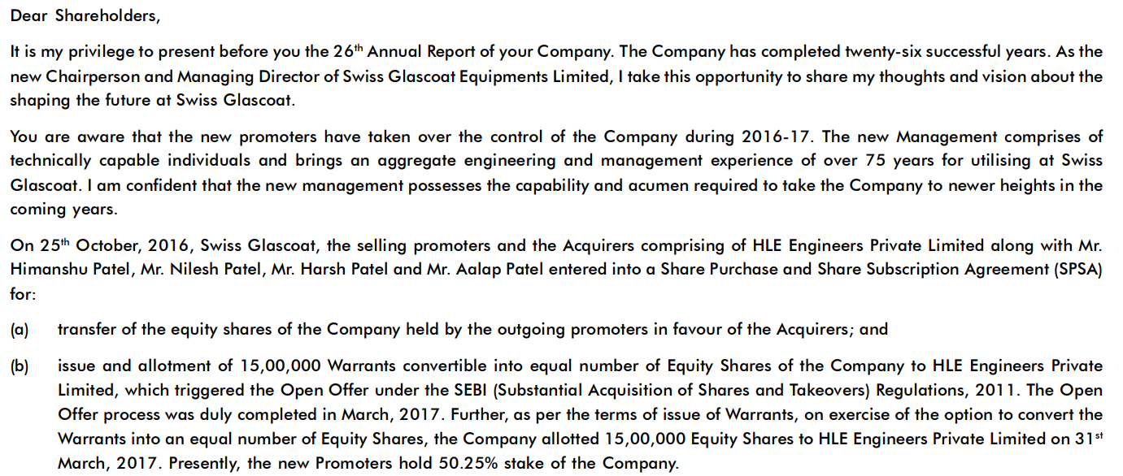

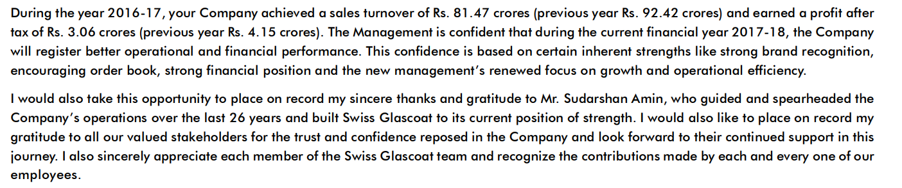

<https://www.bseindia.com/bseplus/AnnualReport/522215/5222150317.pdf>

Kingfa (FY13)-

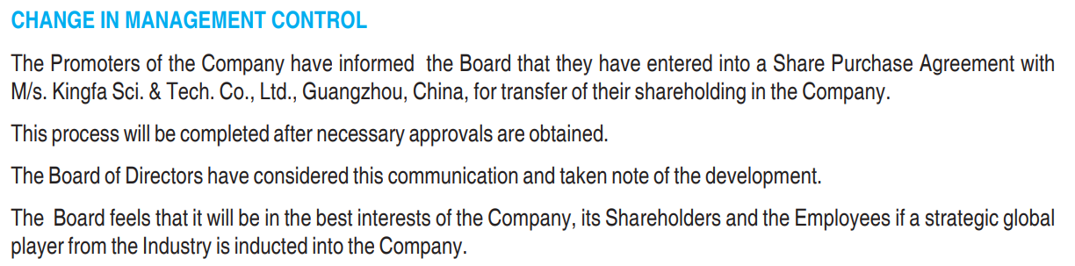

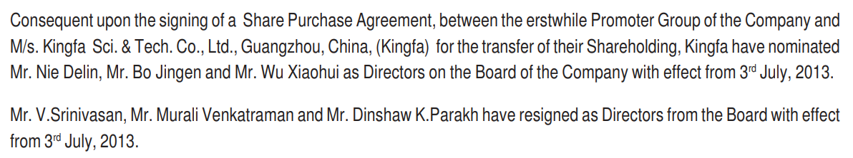

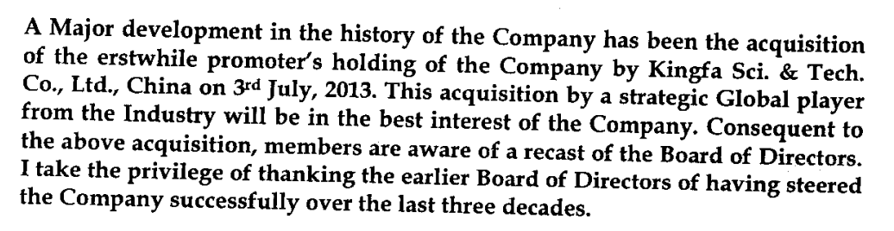



Open offer price was Rs 42.7

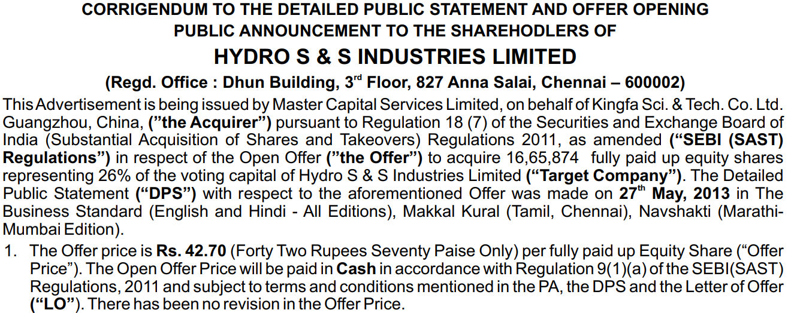

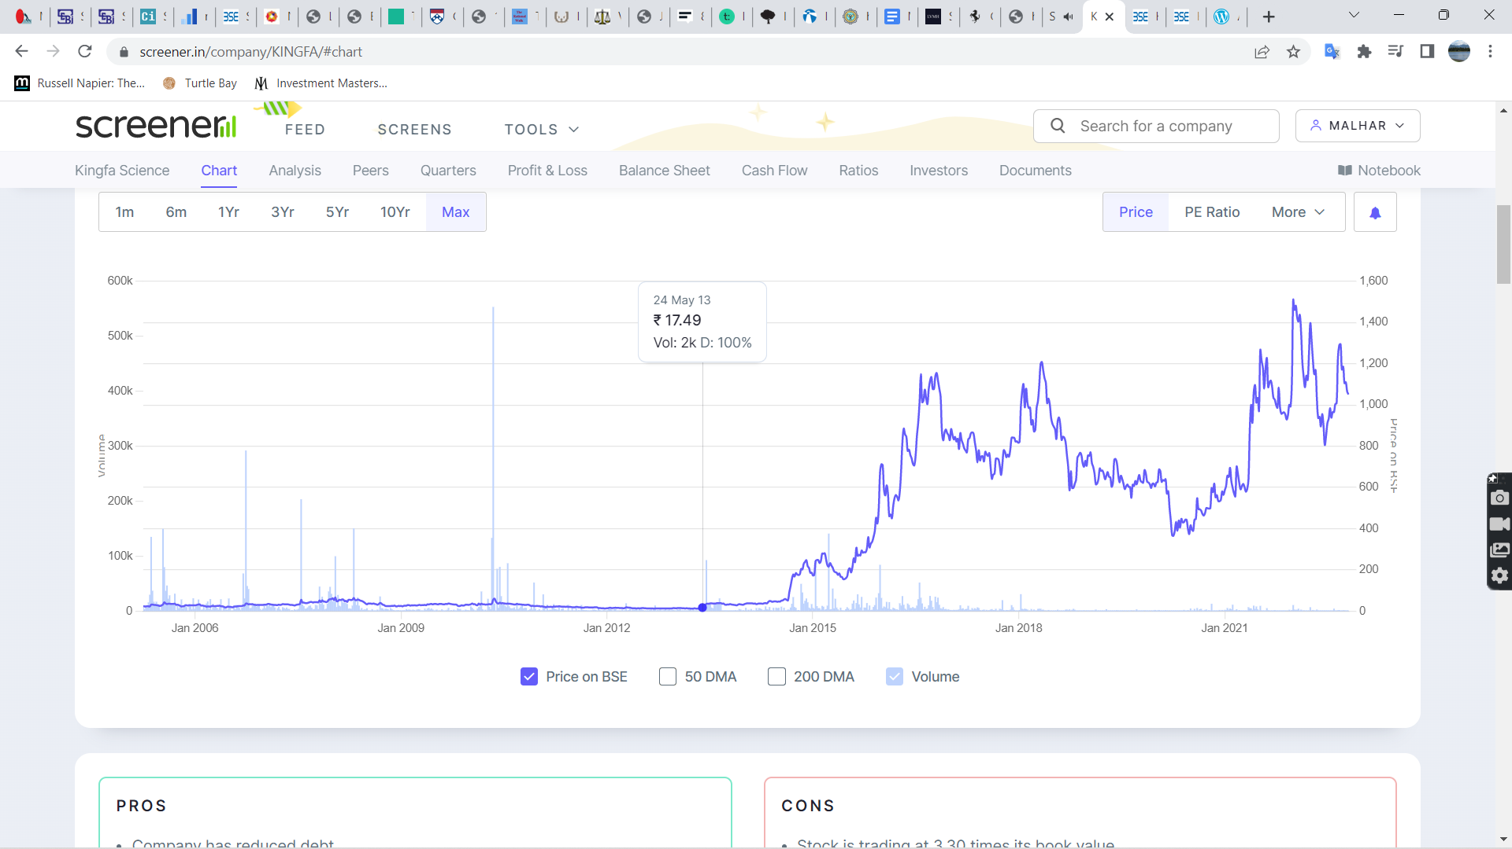

<https://www.bseindia.com/bseplus/AnnualReport/524019/5240190313.pdf>

<https://www.bseindia.com/xml-data/corpfiling/CorpAttachment/2013/8/Hydro_S_&_S_Industries_Ltd_210813.pdf>

<https://www.bseindia.com/xml-data/corpfiling/CorpAttachment/2013/9/Hydro_S_&_S_Industries_Ltd_200913.pdf>

CG Power-

Ikab Securities-

Moongipa Securities-

HG Industries-

Takeover open offer by Greenlam

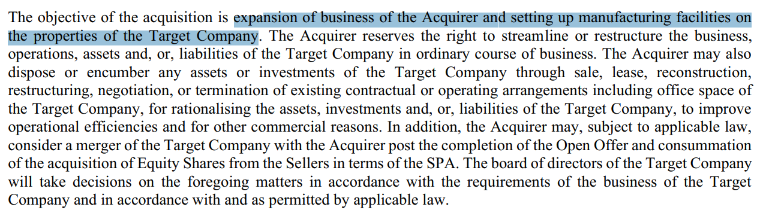

Large capex

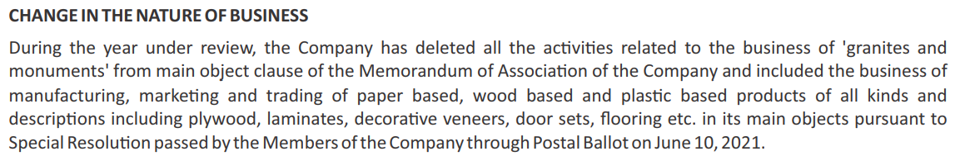



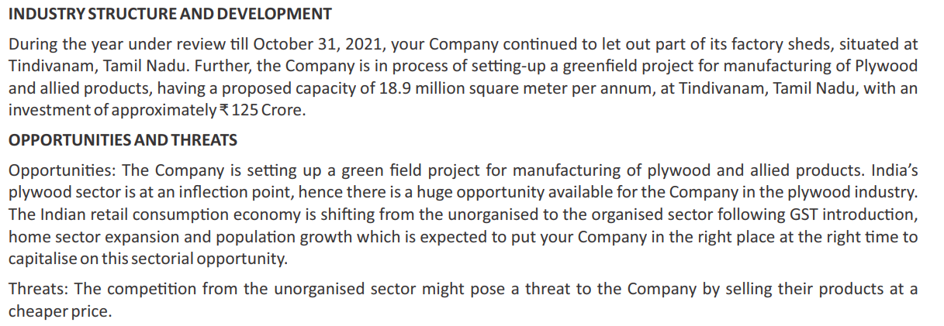

<https://www.bseindia.com/xml-data/corpfiling/AttachLive/F6BC57C1-2614-4B1C-AC81-57A93A149381-080710.pdf>

<https://www.bseindia.com/bseplus/AnnualReport/513723/76782513723.pdf>

<https://www.bseindia.com/xml-data/corpfiling/AttachLive/674b6d36-2722-41b3-a427-430bfeef74b1.pdf>

<https://www.bseindia.com/xml-data/corpfiling/AttachLive/09efa12c-b96c-436d-a13d-11ade7cb5ac6.pdf>

NIBE-

Takeover of Kavita Fabrics in Sep 2019 by Ganesh Nibe at Rs 6 per share vs CMP of <Rs 7

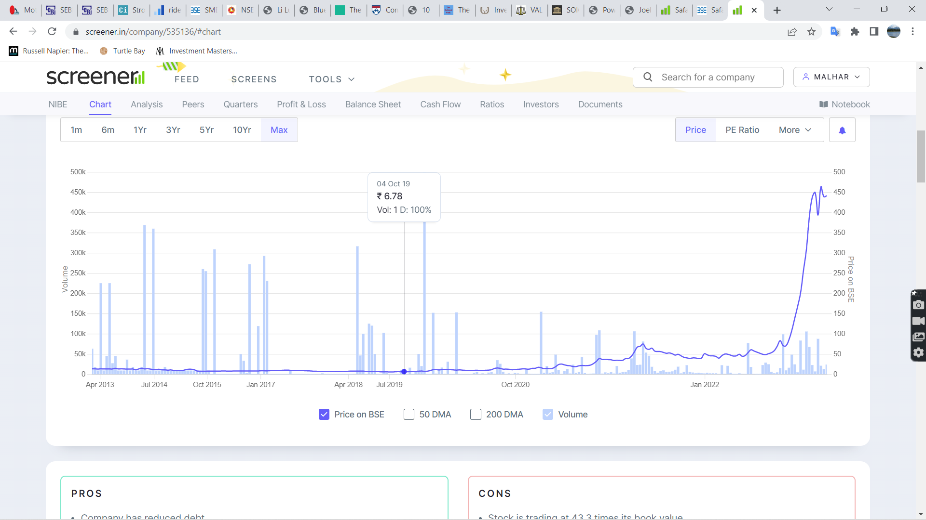

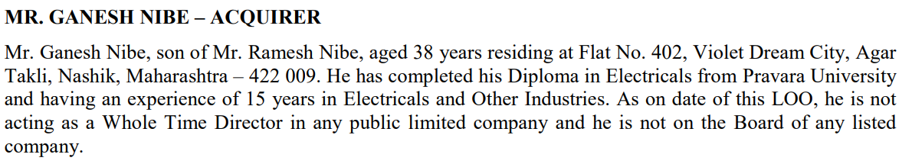

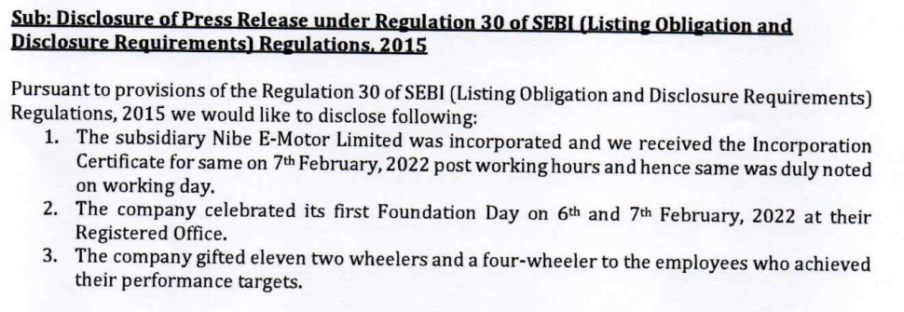

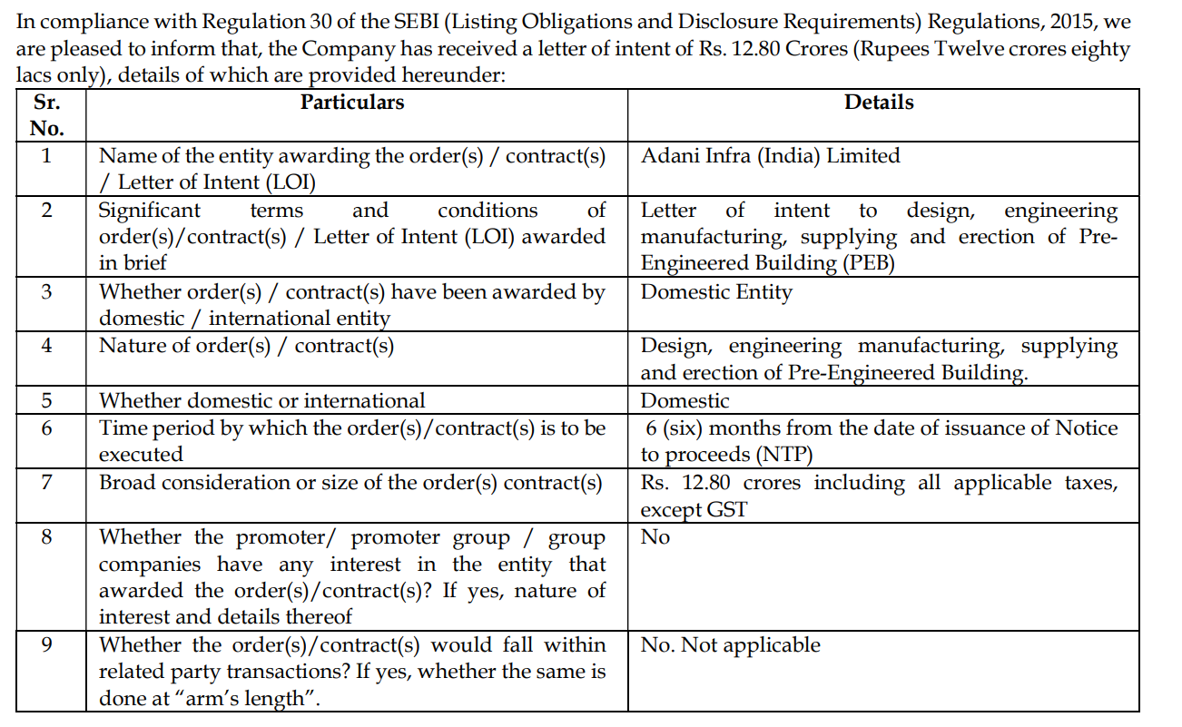

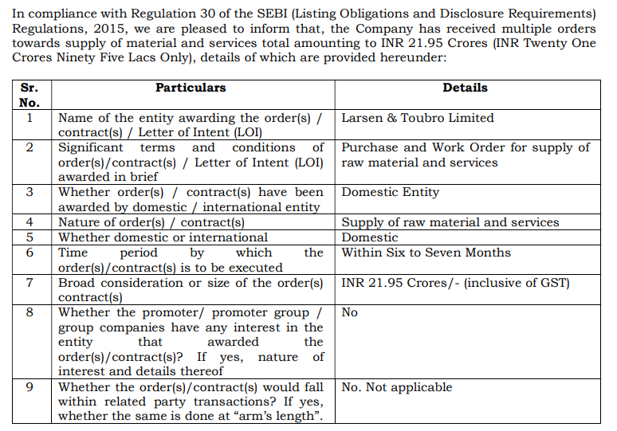

<https://www.bseindia.com/xml-data/corpfiling/AttachLive/22594f66-ff22-42cd-b9c8-9e66f0c5ff03.pdf>

<https://www.bseindia.com/xml-data/corpfiling/AttachLive/f4250548-7027-46f6-9827-454c26975538.pdf>

<https://www.bseindia.com/xml-data/corpfiling/AttachLive/398bb7b7-17f4-4fa7-8c95-10c125302448.pdf>

<https://www.bseindia.com/xml-data/corpfiling/AttachHis/832502AF_588A_4BCF_8CF4_859F6D3158DD_140231.pdf>