Geekay Wires makes fasteners with an installed capacity of 60,000 MTPA.

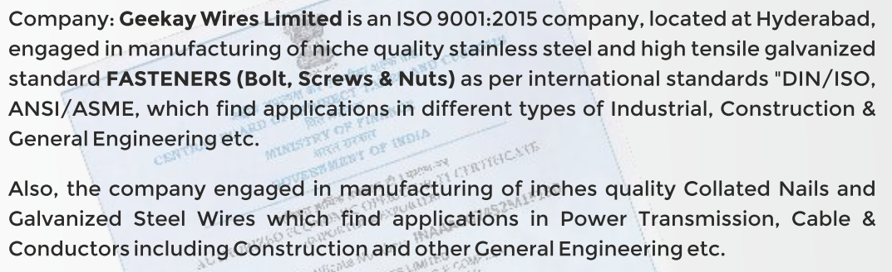

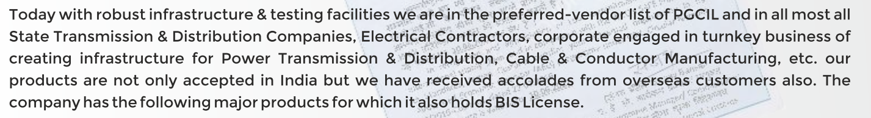

Though it seems to be a commoditised industry with many players (<https://www.recpdcl.in/tenders/AnnexureXIListofAgenciesNIT1914.pdf>) and no technical entry barriers (fasteners are not complex to make), there were only 4 techno-commercially viable bidders for this tender, of which Geekay was one (<https://admin.tpsouthernodisha.com/Docs/Tenders/2022/COR2c121f00dfc74d9bad202f406de08045.pdf>)

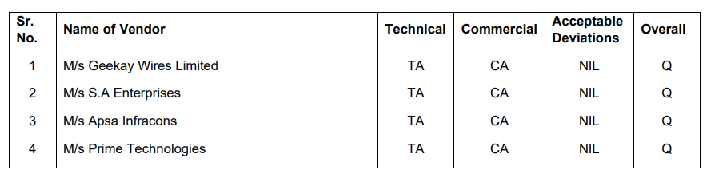

Similarly, there are only 6 vendors for GS Earthwire of which Geekay is one (<https://www.wbsetcl.in/uploads/equiparchive/MAKERS'%20LIST%20LINE%20-Dec%202017p-3-1-18.pdf>)

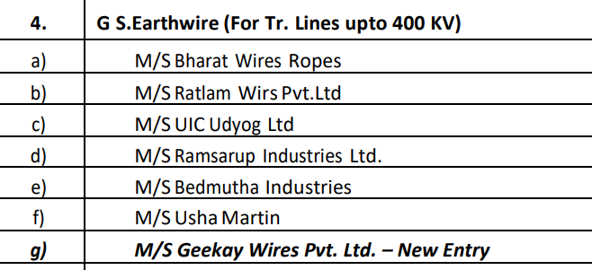

For another one, again only 8 vendors (

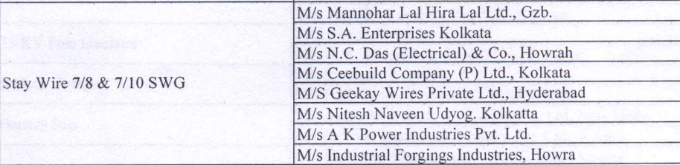

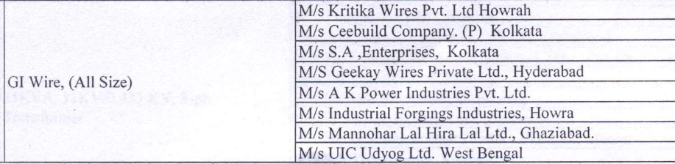

Geekay has applied for AEO T2 certification (<https://www.cbic.gov.in/resources//htdocs-cbec/deptt_offcr/aeo-progm/AEO%20GEEKAY.pdf>). It is a scheme by which importers and exporters get various benefits like waiver of bank guarantee requirements, direct port entry for export shipments etc. More information on AEO at: <https://www.cbic.gov.in/resources//htdocs-cbec/FAQs-(AEO)-1903.pdf>

There was a dumping case against Geekay and Astrotech by US Commerce department. The documents contain detailed information (<https://www.usitc.gov/publications/701_731/pub5283.pdf>)

