Eiko Lifesciences

There was a promoter change

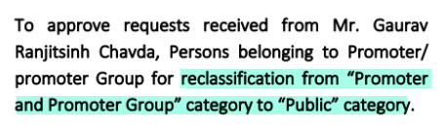

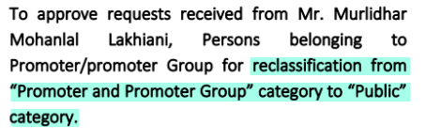

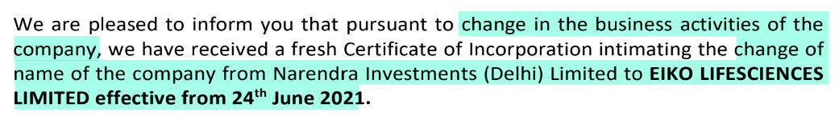

New promoters are highly experienced

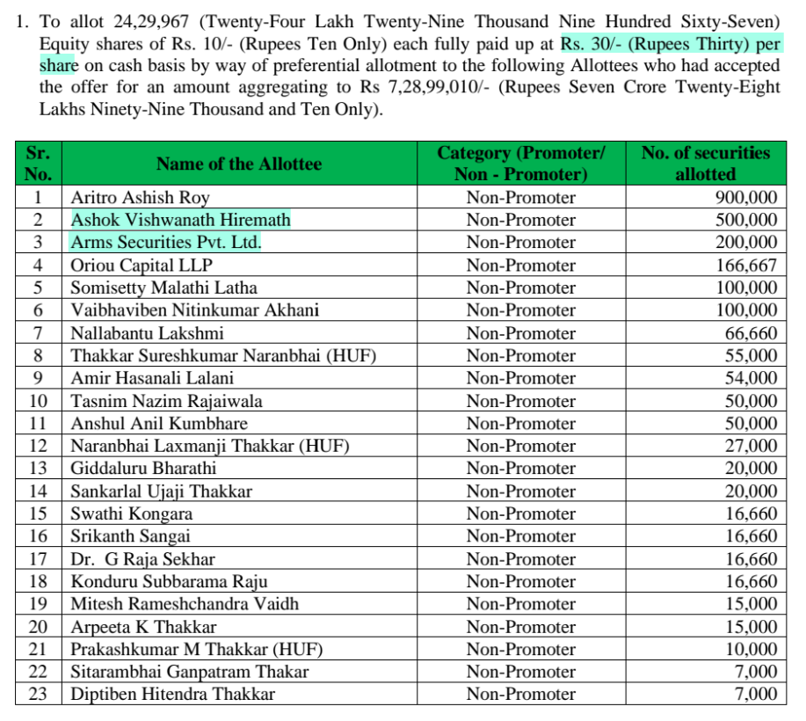

Mr Ashok Hiremath was the promoter and MD of Astec Lifesciences (who sold it to Godrej). Aggarwals from Arms Securities are directors at Avon India.

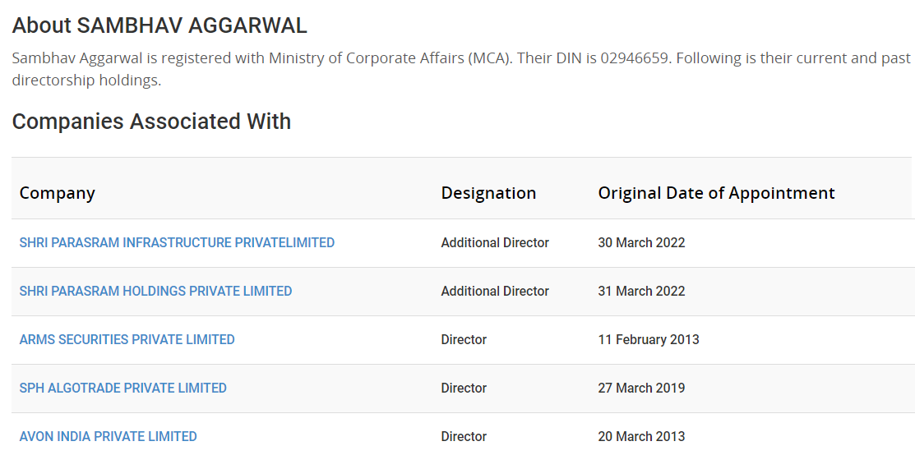

They have begun business of speciality chemicals

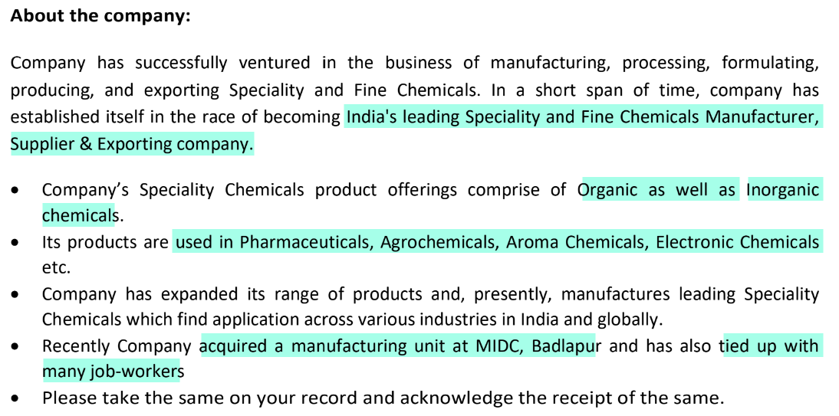

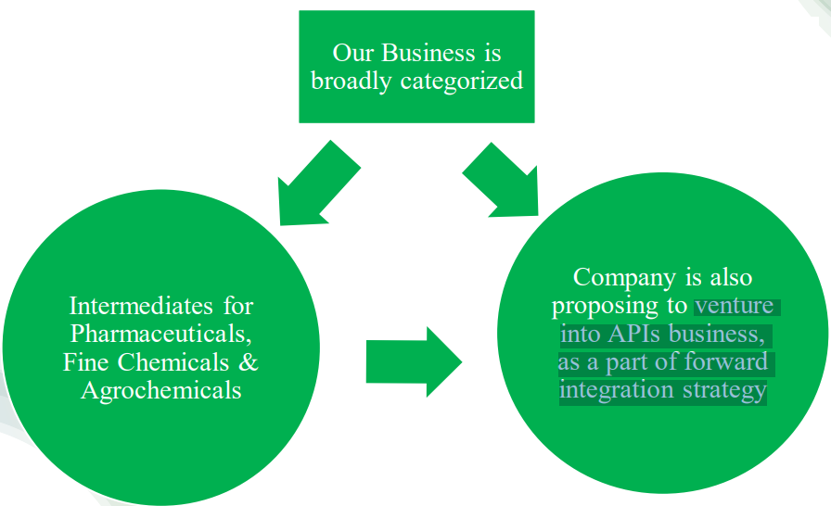

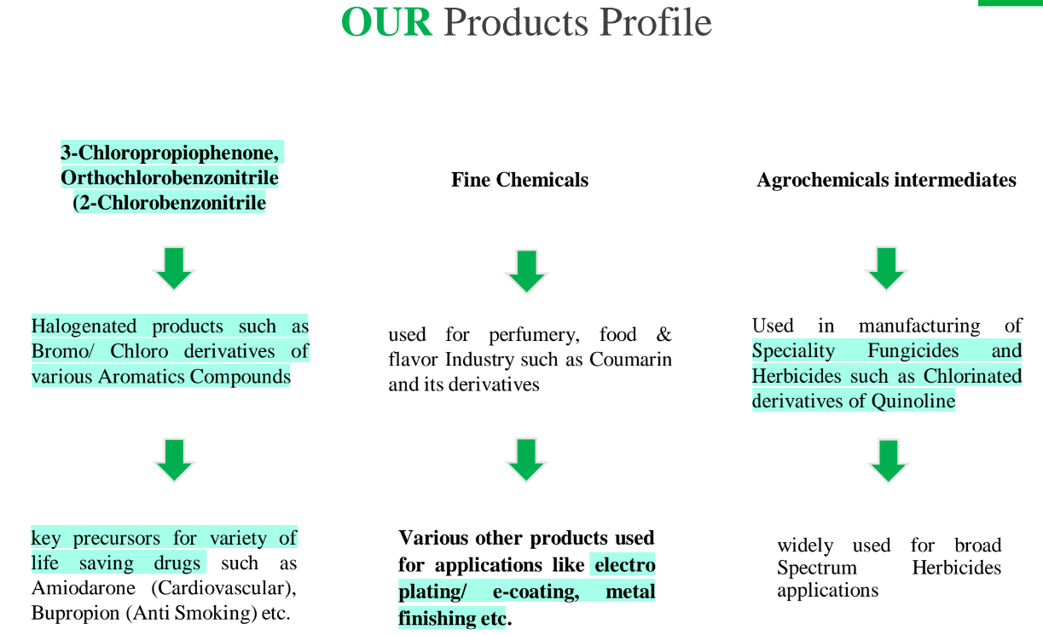

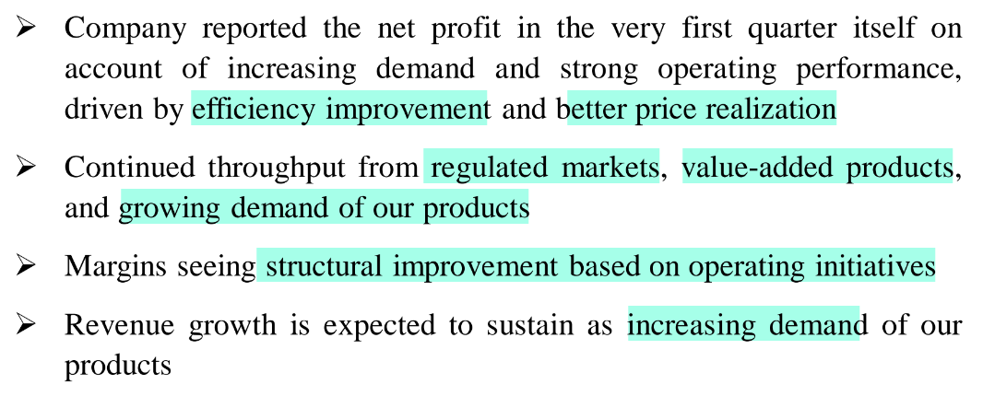

There are limited players in Eiko’s products

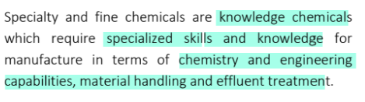

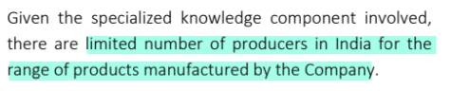

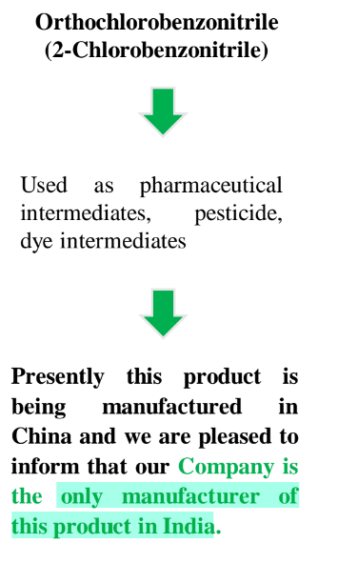

Although, there seem to be many players globally (<https://pubchem.ncbi.nlm.nih.gov/compound/2-Chlorobenzonitrile#section=Substances-by-Category>)

Their API products are:

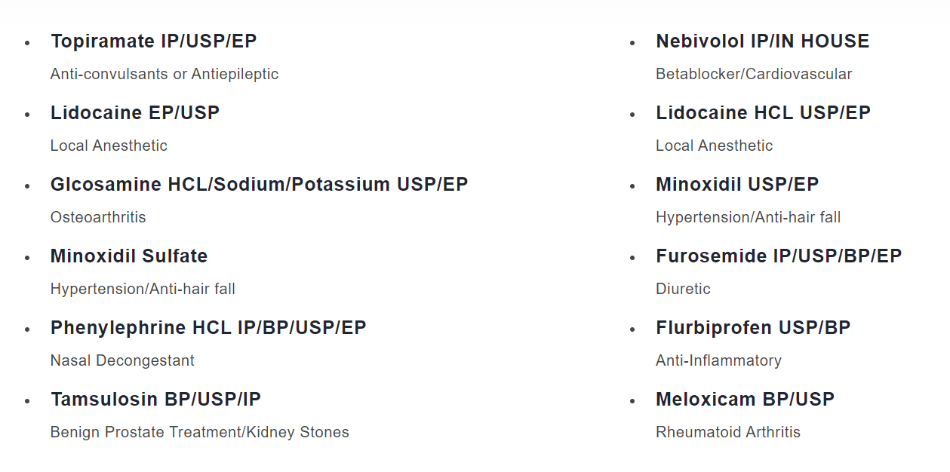

Their pharma intermediate products are:

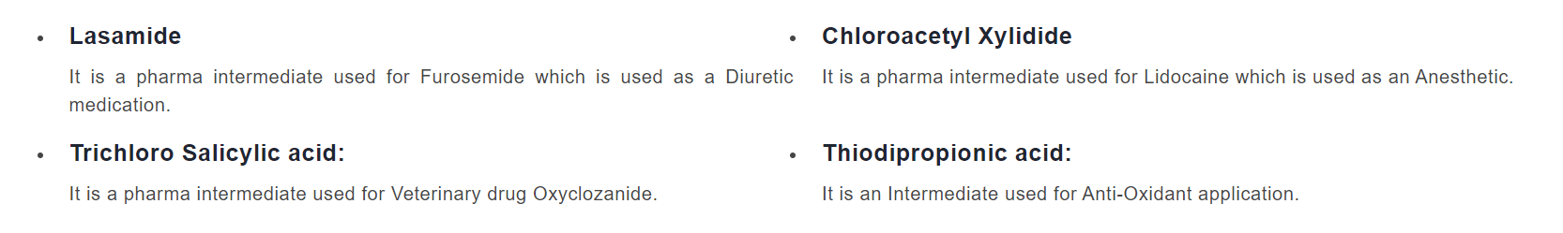

Their agrochemical intermediate product is:

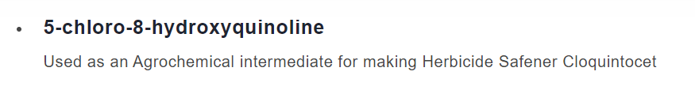

Their flavouring and fragrance products are:

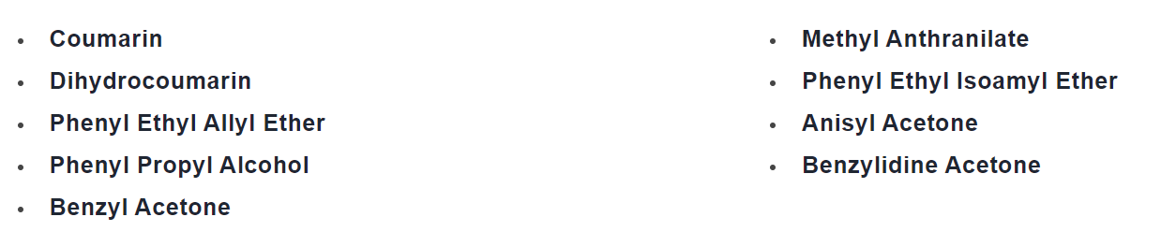

They are launching several new products

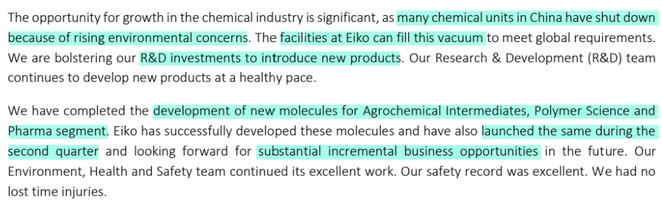

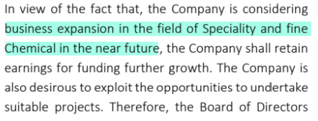

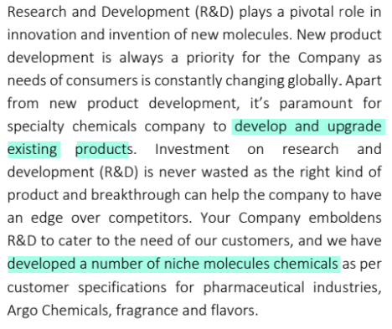

They entered into an MoU with Delicare Lifesciences

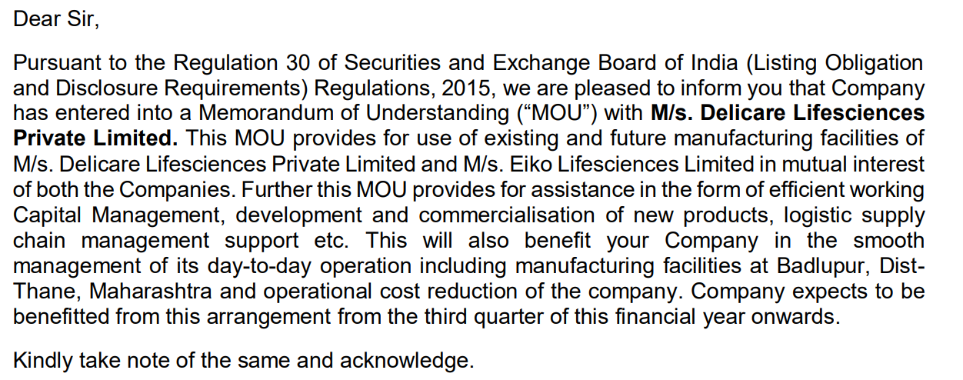

They have recently entered cosmetic emollients segment

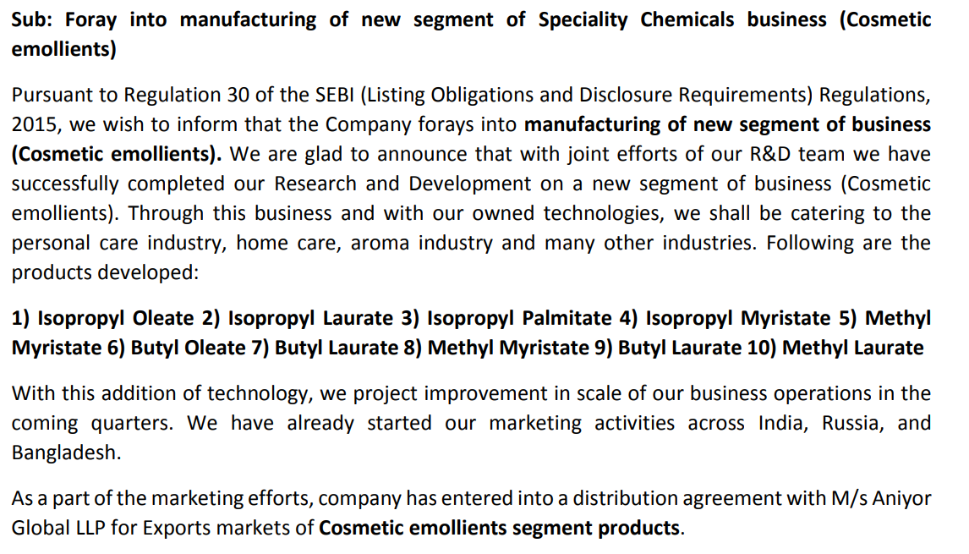

There is a large increase in net block

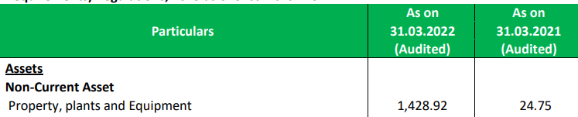

Disclaimer: Any analysis shared should not be construed as investment advice. Any analysis is not a buy/sell/hold recommendation. I am not a SEBI registered investment advisor. Please consult your financial advisor before acting on any analysis. The author shall not be liable for any losses incurred by readers while acting on any analysis. The author may have holdings (and hence a vested interest) in any companies mentioned and the analysis may be biased. The content and analysis shared are for educational purposes only.

The writer can be reached at malhar.manek@gmail.com