Fineotex Chemical (FCL) is a specialty chemicals producer with a focus on textiles chemicals. FCL manufactures over 400 specialty chemicals and enzymes to textile, garment, construction, leather, water treatment, agrochemicals, adhesives and other industries. Over the last 4 years, it has also entered into oil drilling chemicals and home care and hygiene segments. However, 94% of revenue is still textile chemicals.

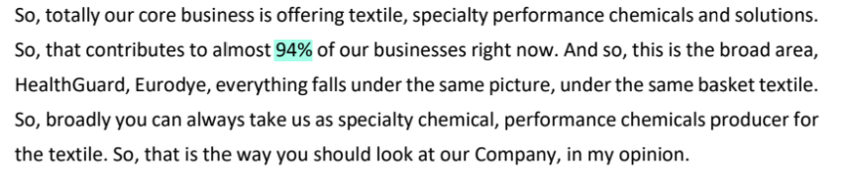

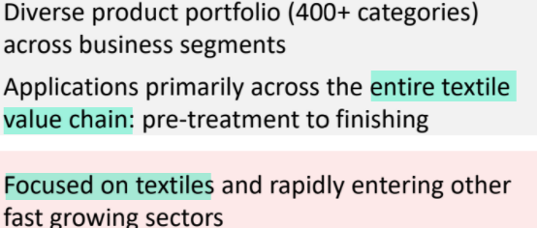

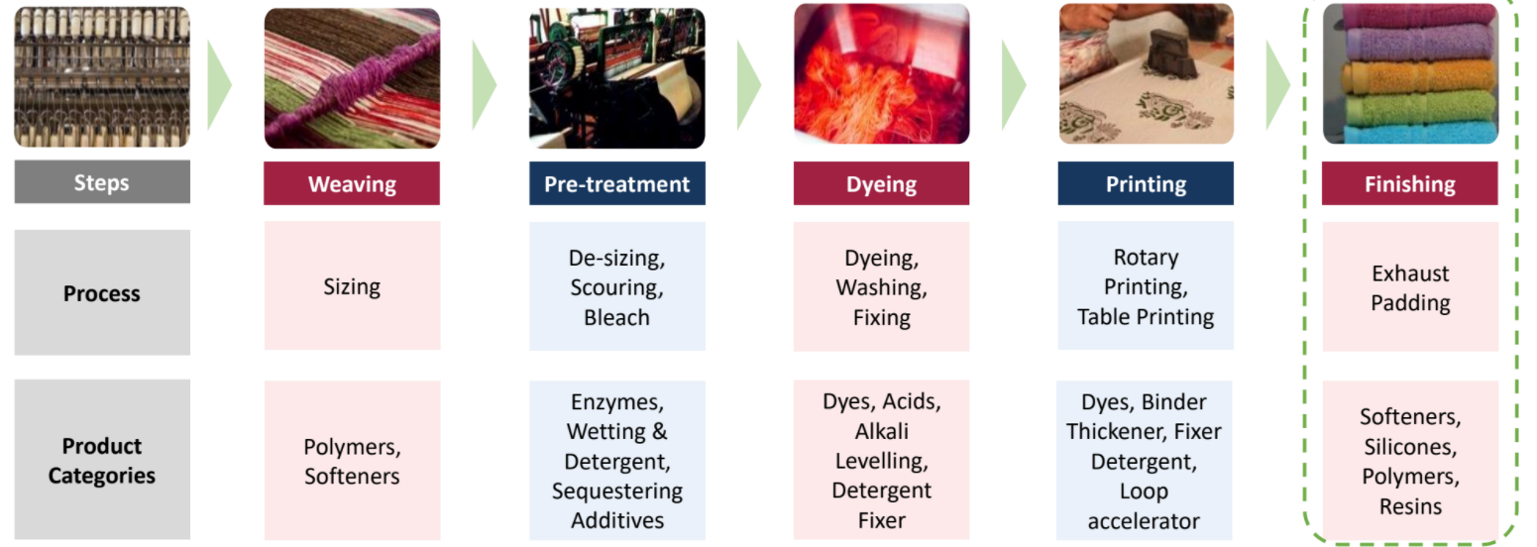

The finishing segment is a large growth driver

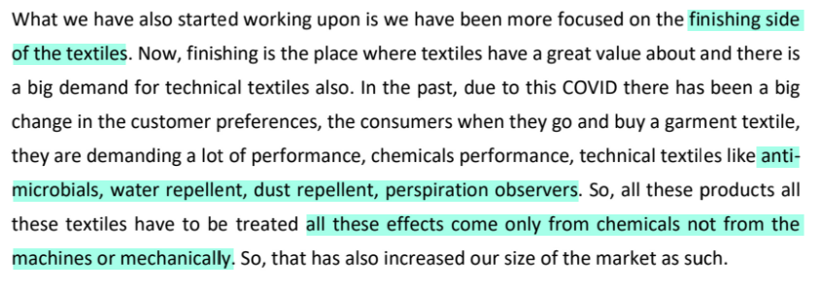

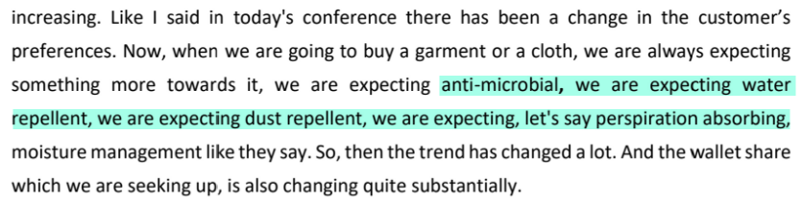

FCL’s chemicals form a very small part of the cost for textile companies

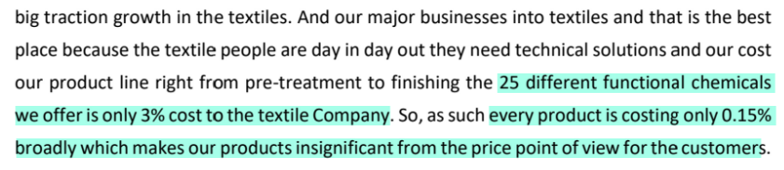

However, it is a critical application product

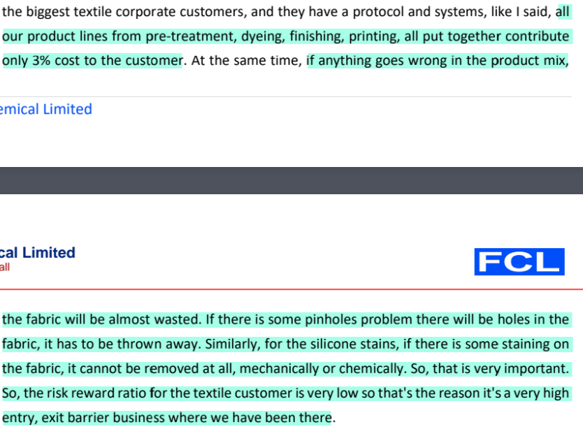

This makes it very sticky as textile companies rarely switch the supplier

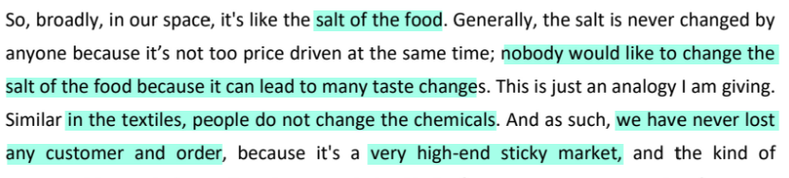

FCL’s established position also allows them to attract new clients, by using existing clients as ‘reference customers’

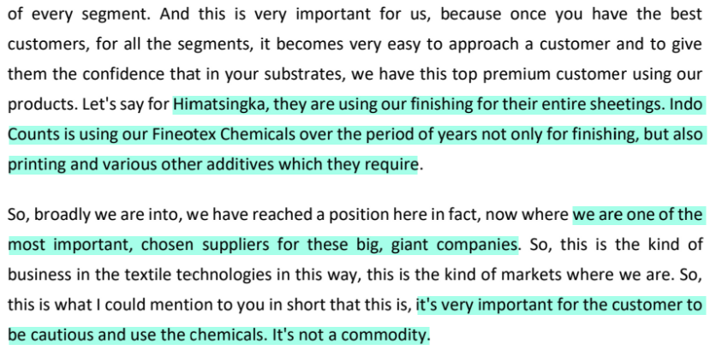

They also enable conversion of utility cost into chemical cost for the customer

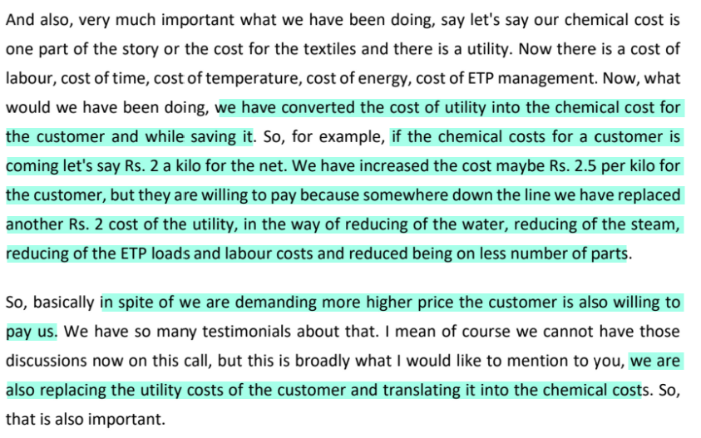

Most major textile companies are customers of FCL

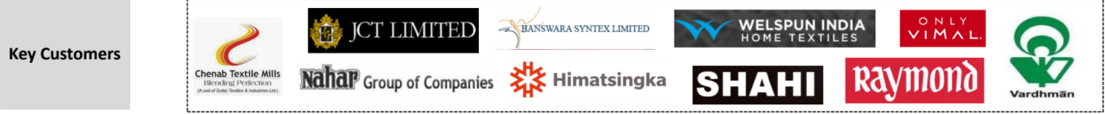

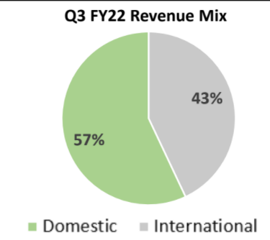

FCL had acquired Biotex in 2011

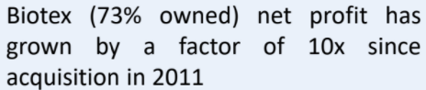



They recently did greenfield capex to take total installed capacity to 79000 MTPA from the earlier 43000 MTPA, at a cost of Rs 27 Cr

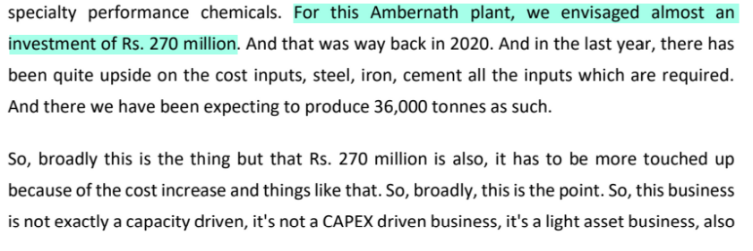

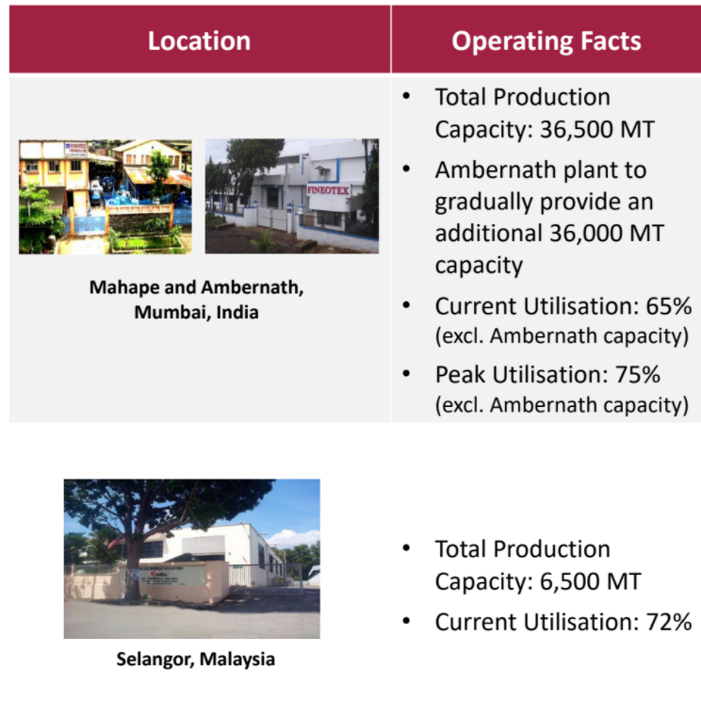

The plants (even Ambernath one) are fungible

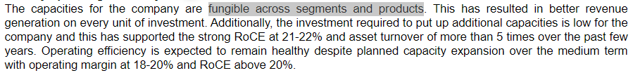

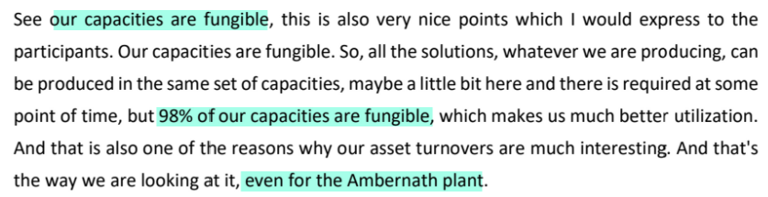

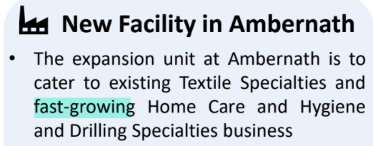



Production in Ambernath facility began in Nov 2021 and its contribution to Q3FY22 sales was low; contribution is expected to be higher in Q4FY22.

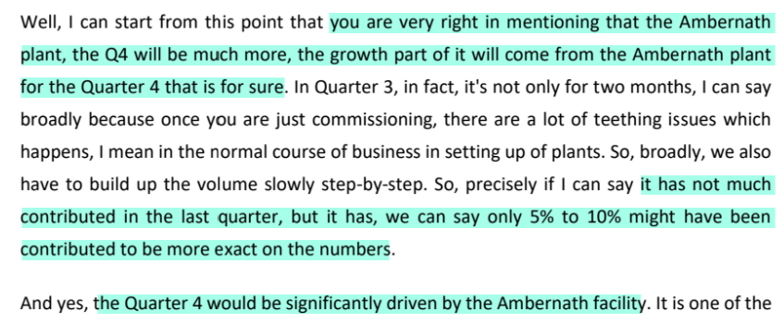

Peak utilisation in Ambernath facility is around 85%

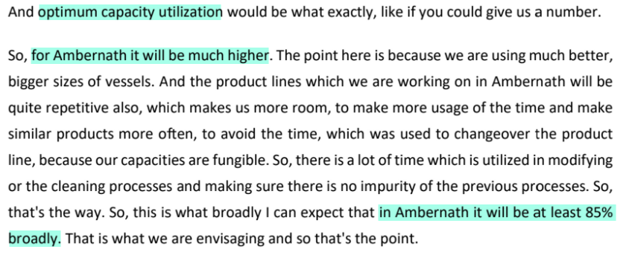

Utilisation is expected to reach optimum level around Mar-Apr 2022

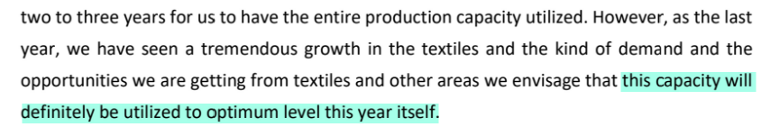

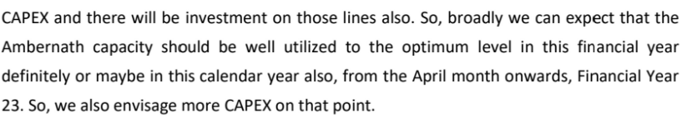

Asset turnover on this is expected to be >8x

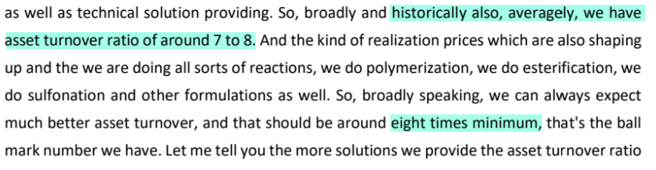





Ambernath plant itself could earn revenue of Rs 350 Cr

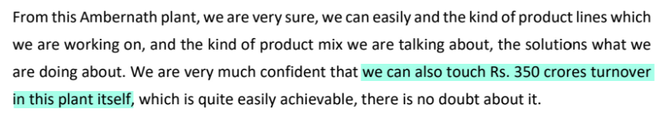

They are looking to increase higher-margin products

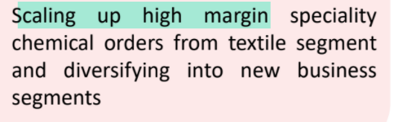

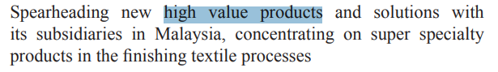



Any new expansion will be funded internally



They are looking to increase penetration and wallet share with the customers

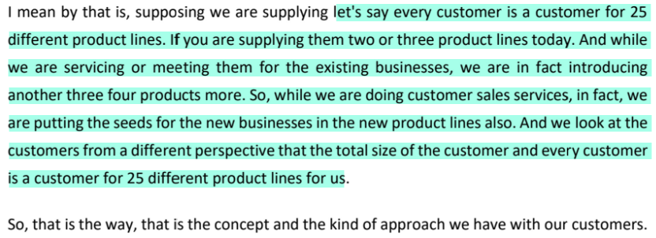

Growth rates are expected to be strong, driven majorly by volume growth but also pricing, because of a trend of increasing realisations

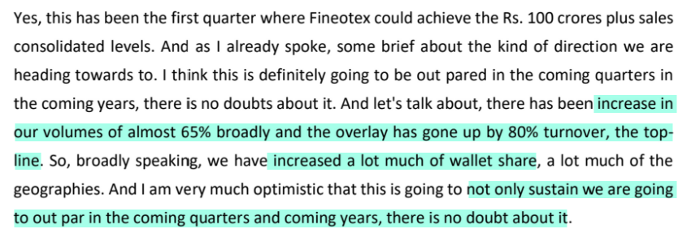

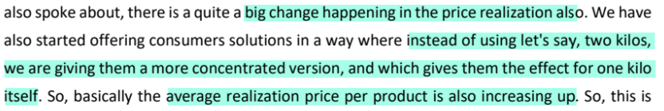



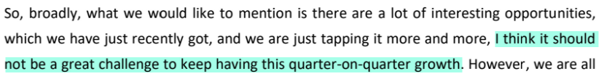

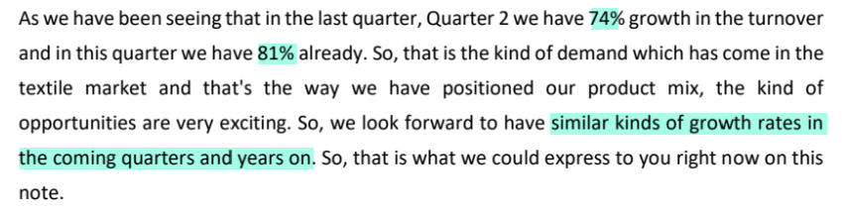

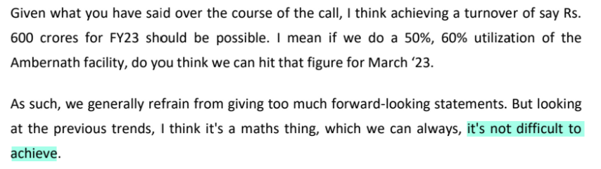

OPM is expected to be >23% on a sustainable basis

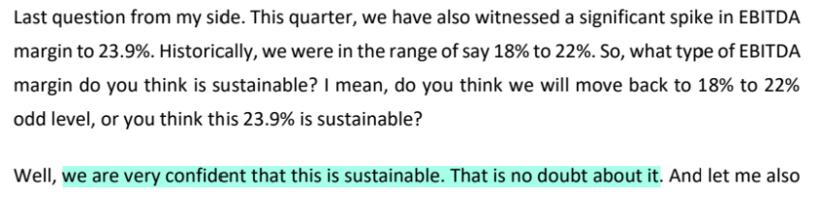





Disclaimer: All analysis shared is for private circulation only. Any analysis shared should not be construed as investment advice. Any analysis is not a buy/sell/hold recommendation. I am not a SEBI registered investment advisor. Please consult your financial advisor before acting on any analysis. The author shall not be liable for any losses incurred by readers while acting on any analysis. The author may have holdings (and hence a vested interest) in any companies mentioned and the analysis may be biased. The content and analysis shared are for educational purposes only.

The writer can be reached at malhar.manek@gmail.com