4 years to build the initial position

Once decided never looked back and kept on accumulating

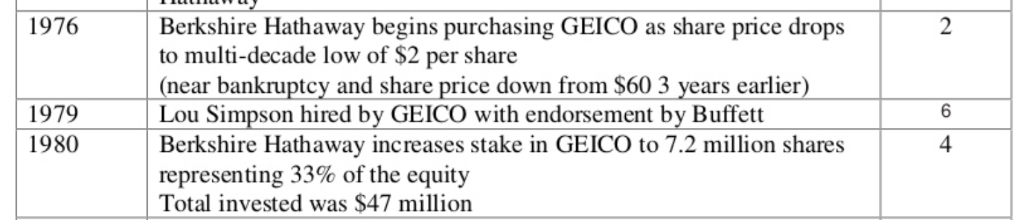

Balance 50% bought 15 years later @ 50 times the initial purchase value paid an Point to point value of 36% CAGR to claim the balance stake. Once the quality of business is understood in 15 years, he moved all in going for value rather than price

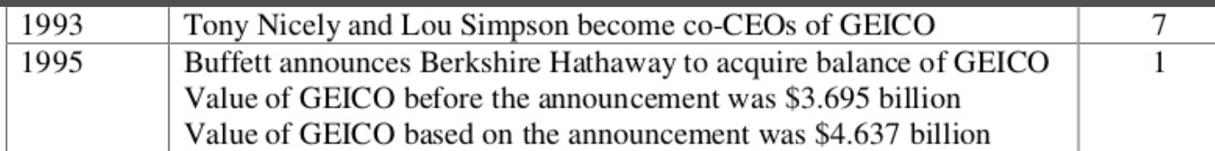

The old man knew the power of quality and the value which he was getting for what he was paying. He kept on top of the business for 2 decades while buying it wholly. too much for patience.
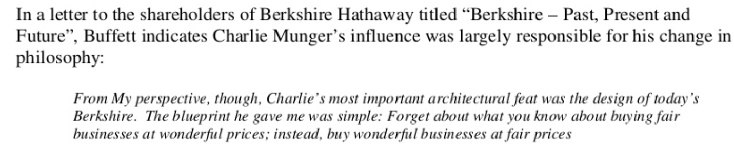

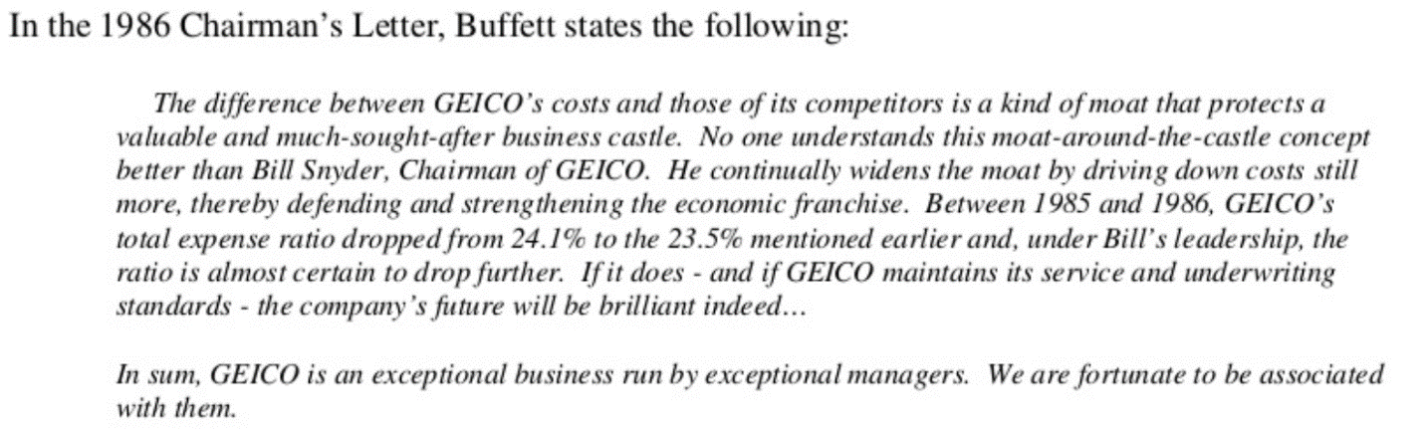

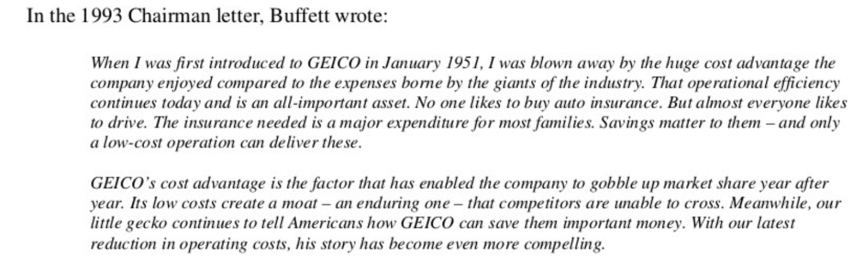

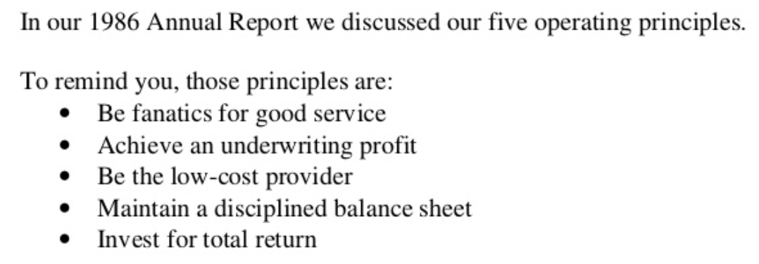

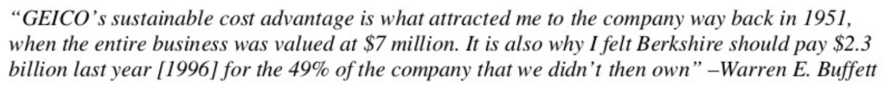

The same sustainable miniscule Cost of Capital at very high P/B ratios it is able raise with many times oversubscription repeatedly; that BFAL has just think of it as a back of envelope calculation

Initial Capital 100

40% CAGR MCap growth backed by Earning and fundamentals = 537 Mcap after 5 yrs
Now dilute 2% - Money Out = 10.74 < 10% of startup capital - otherwise substantial> +Business profits to be reinvested :)

Remaining Value for Shareholders = 525 (537-12 (rounded from 10.74))

Again, repeat same growth for 5 yrs
Mcap after 5 yrs = 2823
Again dilute 2% = 56.46 (50% of initial capital in absolute magnitude)

Remaining value for Shareholders = 2766 (2823-56.46)

So, in 10 yrs starting with 100 you generate net worth of 2766 and diluting overall only (66 - 56+10), what an easy money {FLOAT- MOAT BFAL has}

Plus, also the management keeps on increasing their stake in interim, so the overall shareholding of management stays the same

This is the BIG MOAT of the business which is not reflected in its financials. It has dirt cheap access to capital cost w.r.t growth it can generate.
It is equivalent to the free float.

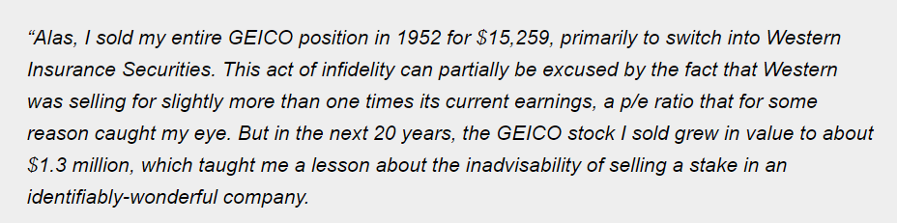

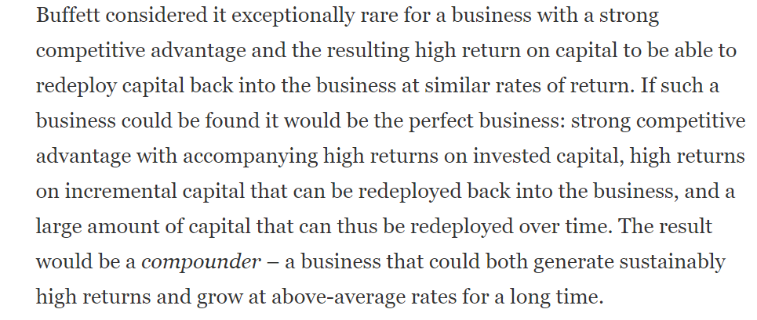

Read the above paragraph at least 5 times again and again with 2 minutes of reflection time after each read. This rests the case

BFAL has a huge runway currently only(1.6%) of country’s credit market, which gives it more than an opportunity to reinvest at excellent ROE and dropping Opex. It is a decadal opportunity at least.
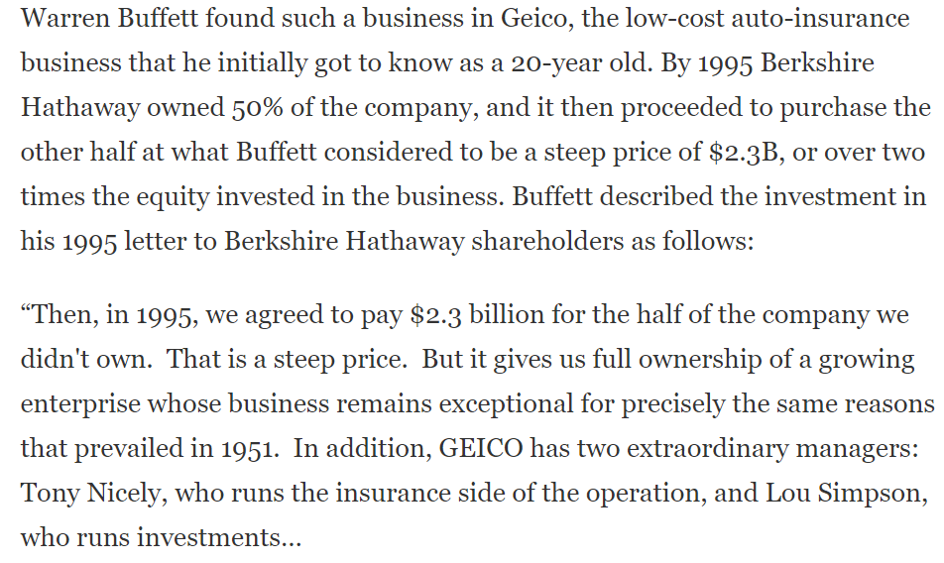

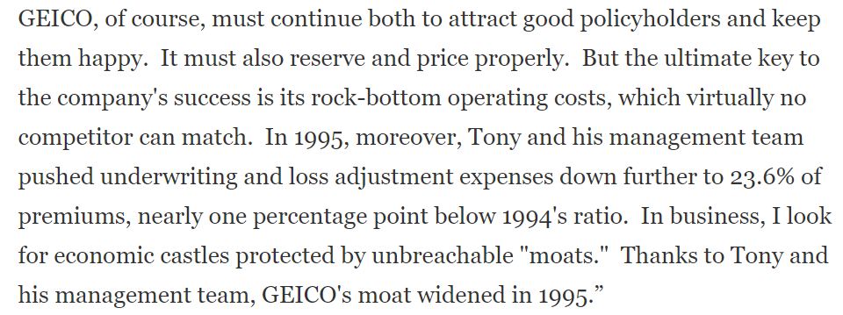

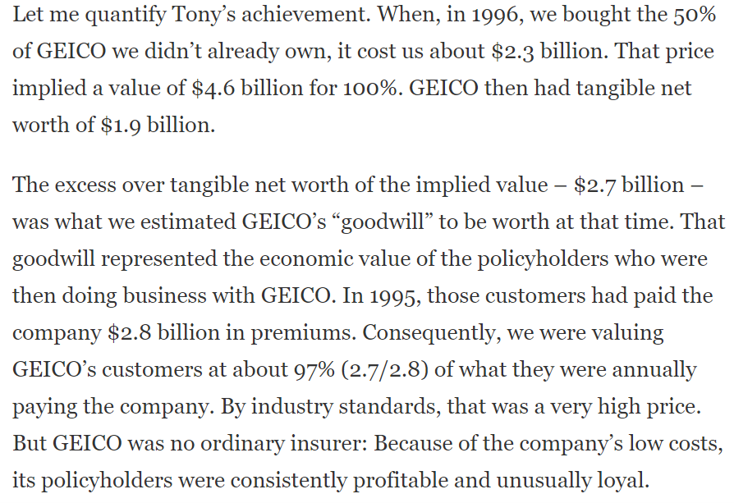

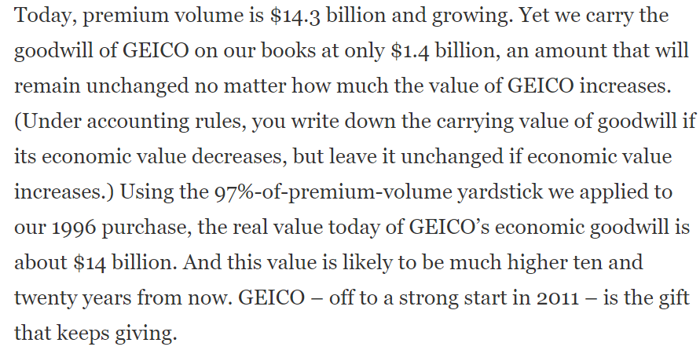

Understand the value which a business with a huge scale advantage has, granularity in reaching out to end customers it possesses, the valuation is just very optical.
It would be in pennies to a dollar in a few years’ time provided the business can scale and can keep on grabbing the market share Strongly.

