Growing sales and earnings in annual results…
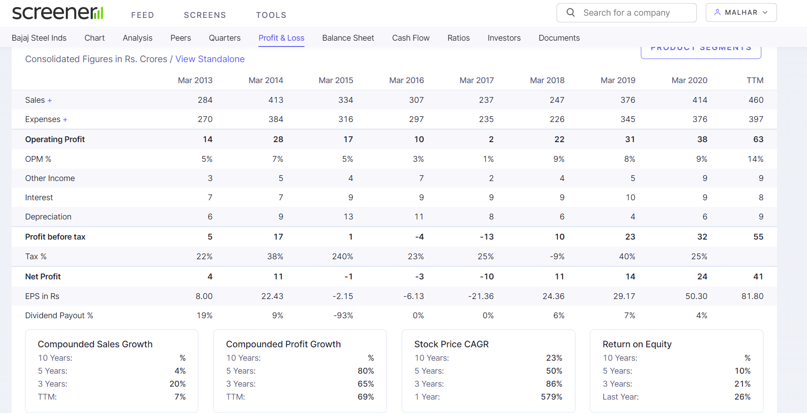
…as well as quarterly results…

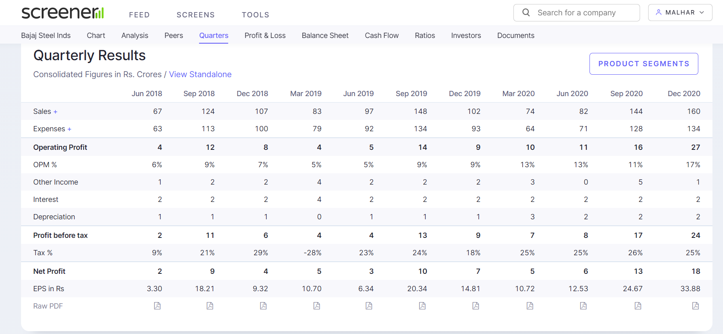

…along with rising RoCE, decreasing debtor days, increase in promoter holding and zero DII holding…
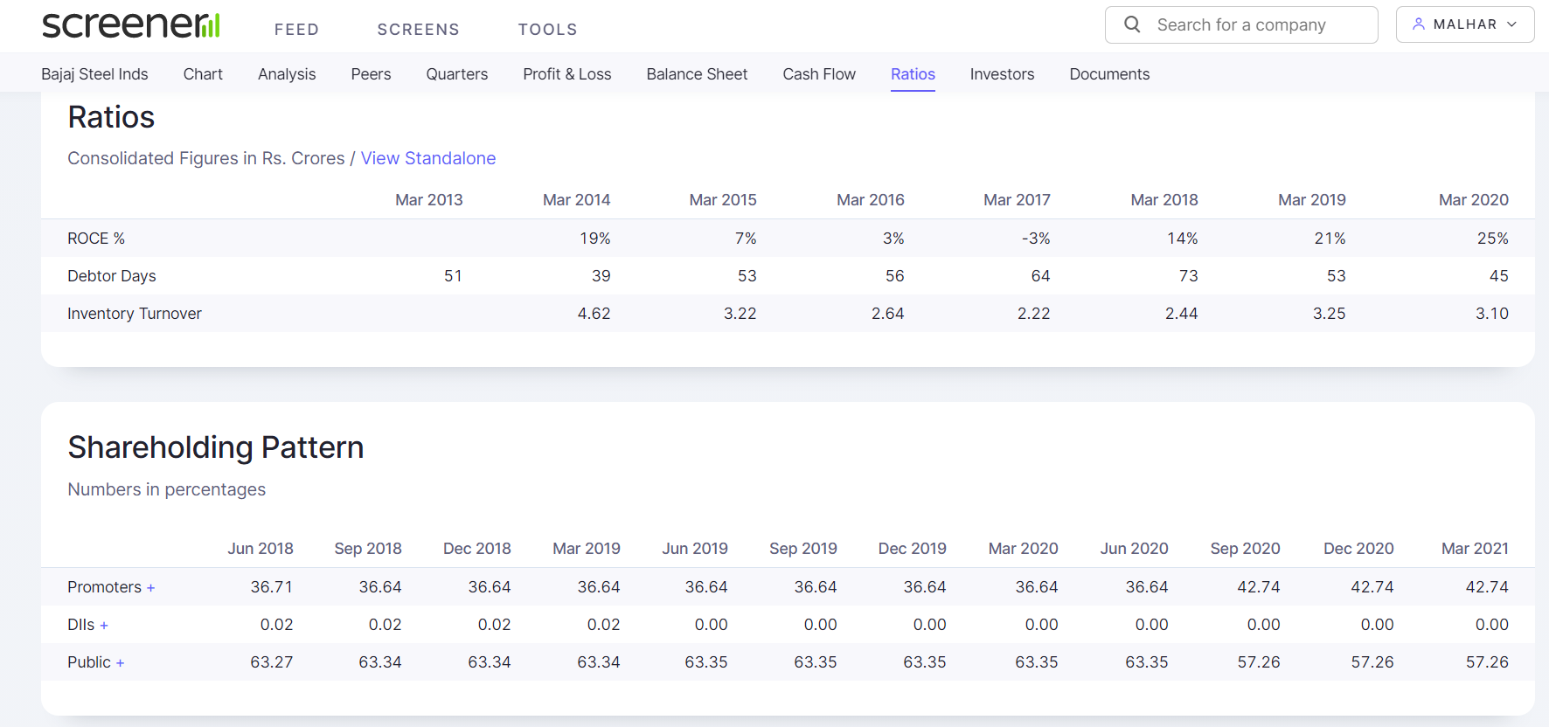
…along with decreasing borrowings…
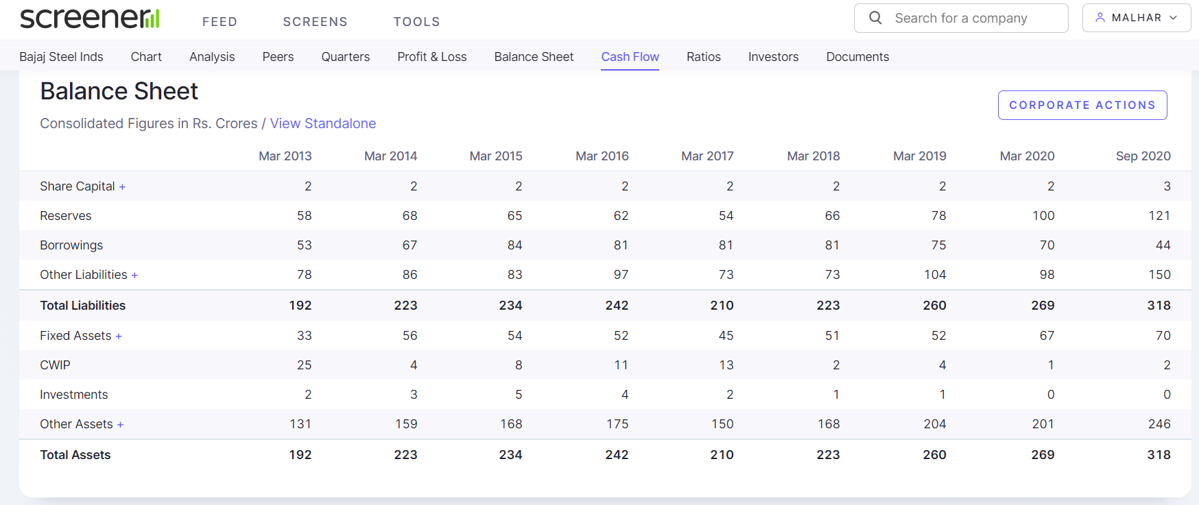
…and improvements across financial ratios…
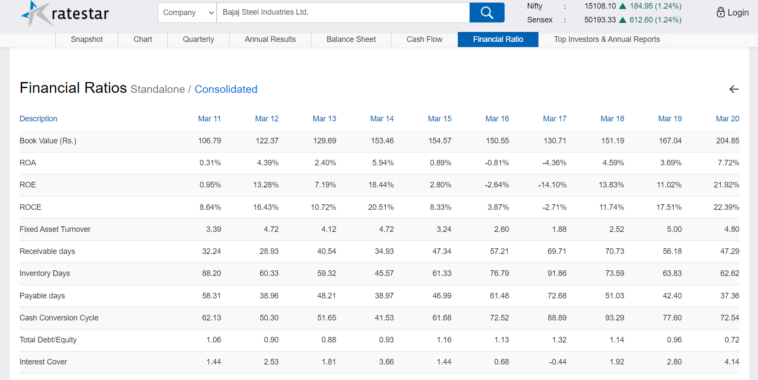

…has resulted in stock price momentum…
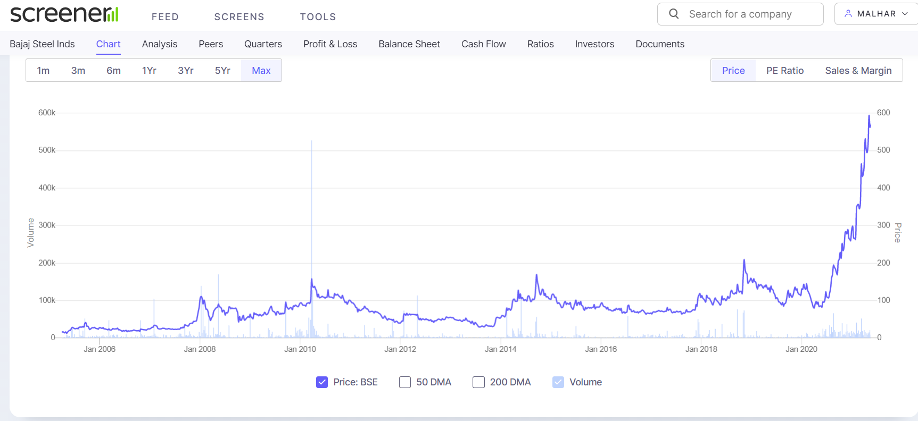

…with rising volumes, visible price trend in monthly cande chart…

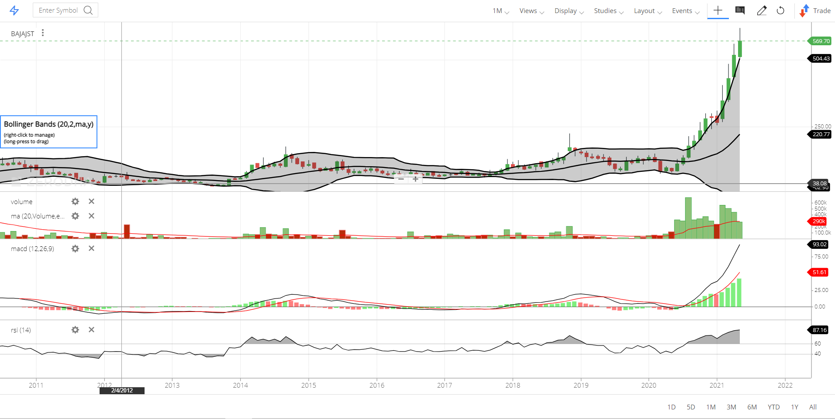
…and the stock is taking support on median of Bollinger bands (20,2) …

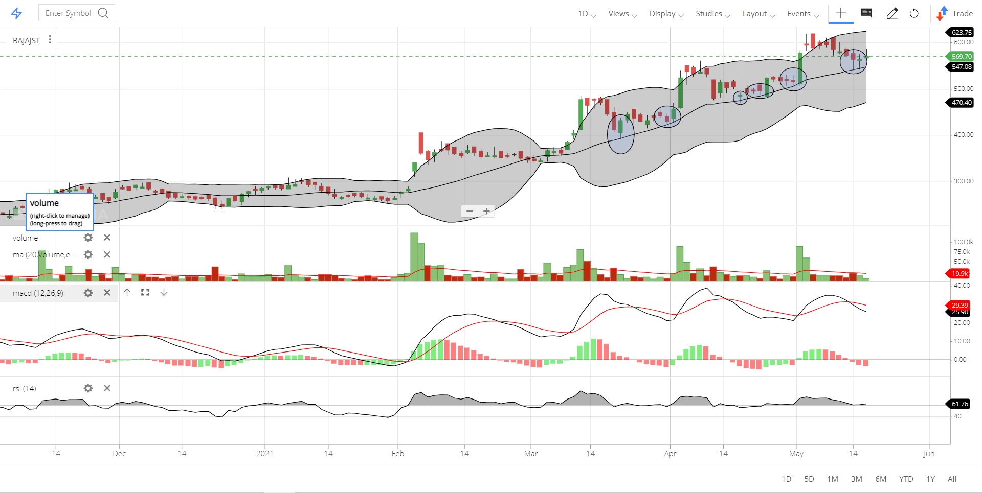
…hence the Bollinger band median around Rs 550 seems like a good entry price

