New Delhi Television (NDTV) is into business of broadcasting of news and other contents on TV. The company currently operates three channels namely NDTV 24X7, NDTV India, NDTV Prime.

There has been large-scale debt reduction

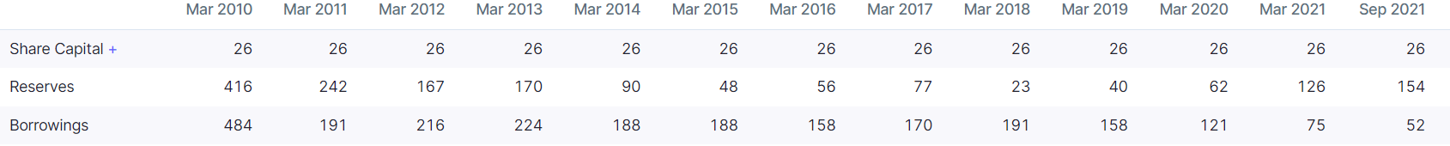



A penalty has been imposed on promoters: “The Securities and Exchange Board of India (“SEBI”) had issued a notice dated 5 September 2018 to Dr. Prannoy Roy, Mrs. Radhika Roy and RRPR Holding Private Limited (Promoter Group Company) in regard to alleged violations under Securities and Exchange Board of India Act, 1992 (“SEBI Act”) read with SEBI (Prohibition of Fraudulent and Unfair Trade Practices Relating to Securities Market) Regulations, 2003 and Equity Listing Agreement read with Securities Contracts (Regulation) Act, 1956 on account of alleged non-disclosure of the loan agreements entered in 2008 – 10 by – (i) the Promoter Group Company with ICICI Bank Limited, and (ii) the Promoter Group Company and Promoters with Vishvapradhan Commercial Private Limited.. SEBI vide its order dated 24 December 2020 imposed a penalty of INR 2,500 lakhs (INR 25 crores) on the Promoters and Promoter Group Company under Section 15HA of the SEBI Act, to be paid jointly and severally within 45 days of the receipt of the order and a penalty of INR100 lakhs (INR 1 crore) each has been imposed on the Promoters under Section 23H of the Securities Contracts (Regulation) Act, 1956, to be paid within 45 days of the receipt of the order.”