Pix Transmission manufactures rubber V-belts.

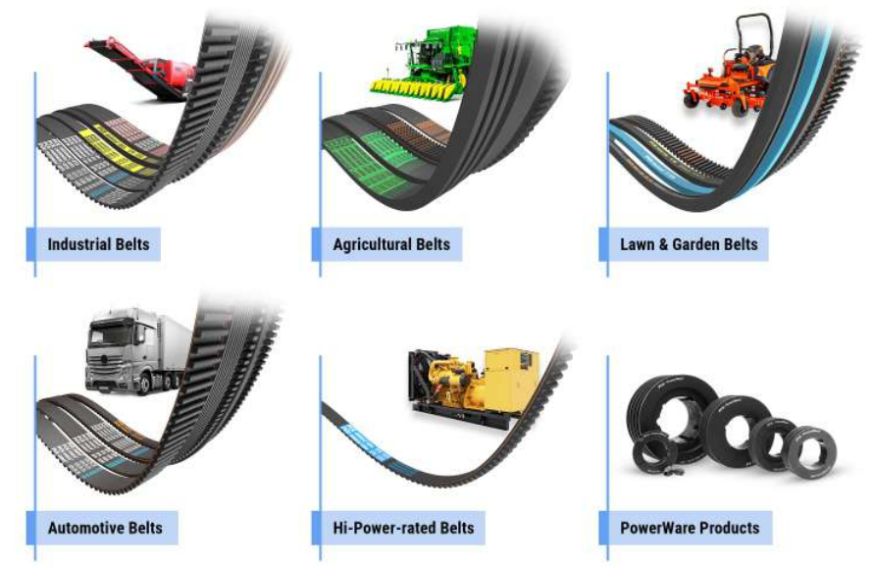

These are used in diverse industries like automotive, agriculture, ceramic, cold storage, food processing, domestic appliance, cement, machine tools, oil and gas, packaging, paper, pharmaceutical, steel, textile etc. Domestic sales account for 52% of revenue while 48% comes from exports.

Company had done capex towards technology upgradation of machinery, which is expected to be completed by Q1FY23.