Dishman Carbogen Amcis Limited (DCAL) is a fully integrated contract research and manufacturing services (CRAMS) player, providing end-to-end, integrated, high-value, niche CRAMS offerings to global pharmaceutical innovators.

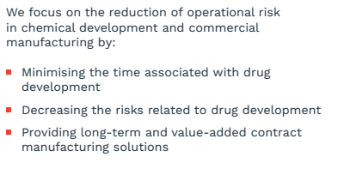

They have two segments: CRAMS and marketable molecules

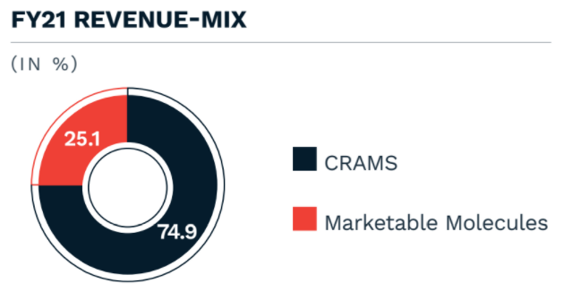

CRAMS: DCAL is an integrated CRAMS company, with a presence across the entire value chain, right from early-stage process research to late-stage clinical & commercial manufacturing. CRAMS is a high margin business segment.

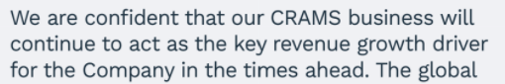

Growth in CRAMS will be driven by increase in utilisation, higher-margin contracts and capex.

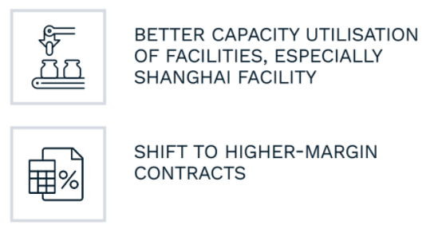

Marketable molecules: They manufacture and supply marketable molecules such as specialty chemicals, vitamins & analogues, generic APIs, and disinfectants. In this segment, they are shifting the focus towards higher-margin products, such as Vitamin D and generic APIs.

