Bajaj Steel Industries manufactures cotton ginning and pressing machinery

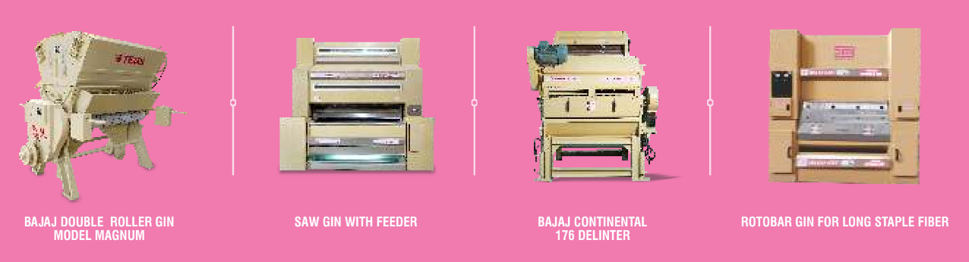

It is a leading player with >60% market share in India

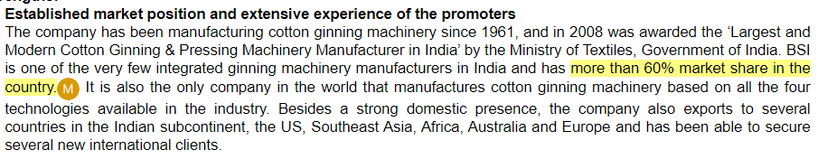

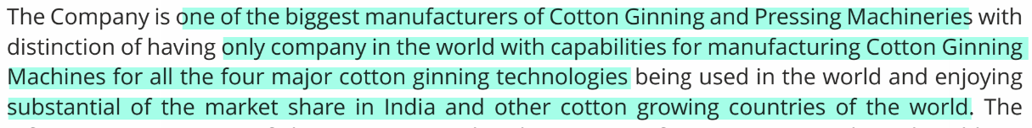

They have tie-ups with leading global players like Continental Eagle and Samuel Jackson

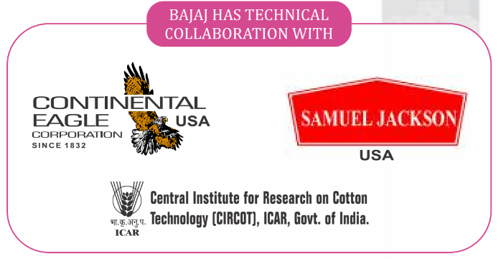

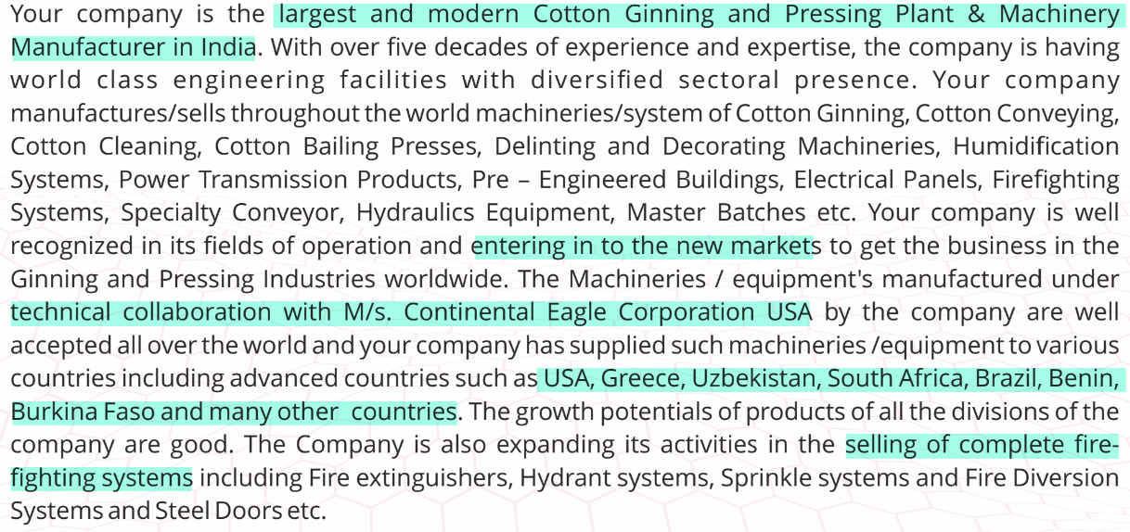

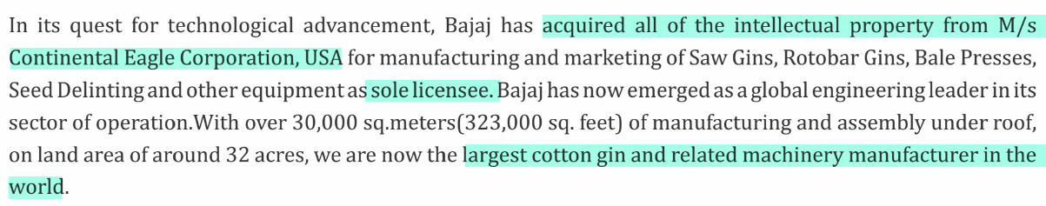

They are also into non-cotton equipment such as firefighting systems, electrical panels (cross sell to existing cotton customers), prefabricated buildings etc., and are looking to increase share of such revenue

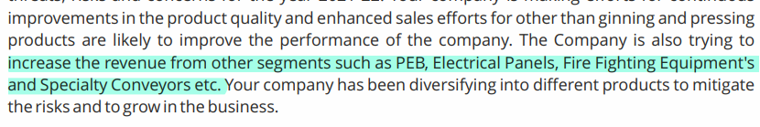

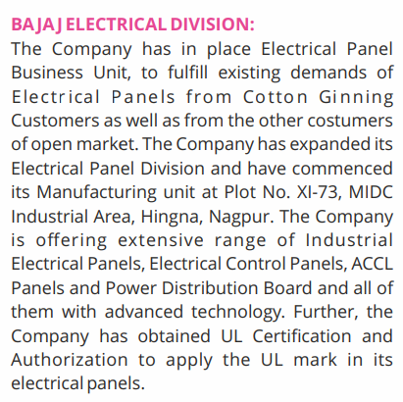

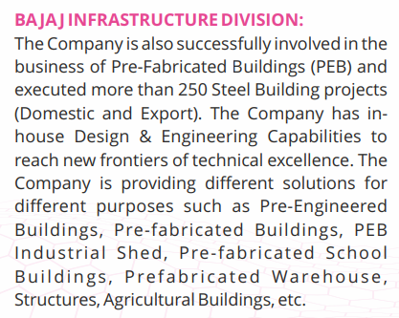

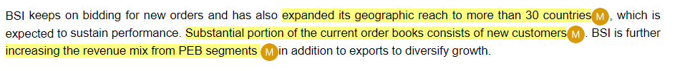

Disclaimer: Any analysis shared should not be construed as investment advice. Any analysis is not a buy/sell/hold recommendation. I am not a SEBI registered investment advisor. Please consult your financial advisor before acting on any analysis. The author shall not be liable for any losses incurred by readers while acting on any analysis. The author may have holdings (and hence a vested interest) in any companies mentioned and the analysis may be biased. The content and analysis shared are for educational purposes only.

The writer can be reached at malhar.manek@gmail.com