Ramkrishna Forgings is into manufacturing of forged and rolled components primarily for the commercial vehicle industry. Their clients include TATA Motors, Ashok Leyland, VE Commercial and Daimler in India and Dana Corp, Scania, Volvo, Mack Trucks, Iveco, Ford in the overseas markets. Exports are 40% of FY21 revenue.

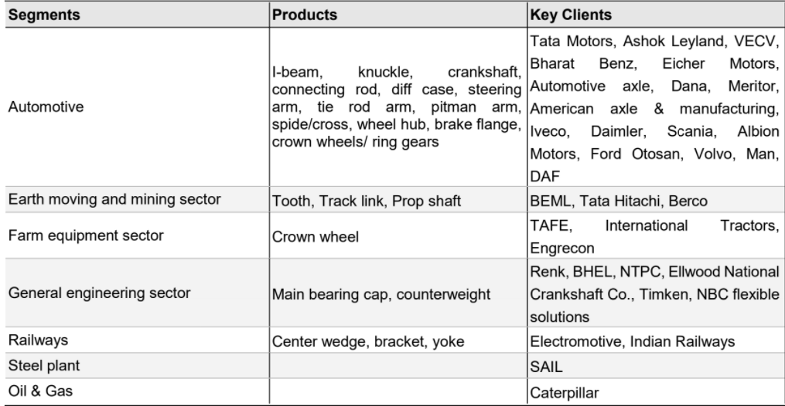

It is a picks-and-shovels play on the CV cycle recovery

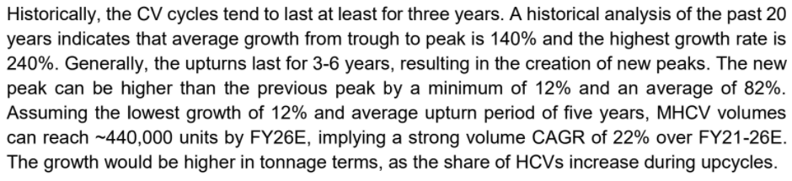

They have three segments.

Forgings and machining: FY21 production was 35,040 tons

Ring rolling: FY21 production was 20,867 tons

Press: FY21 production was 38,738 tons

Overall, FY21 capacity utilisation was 52%. This is expected to increase, leading to operating leverage.

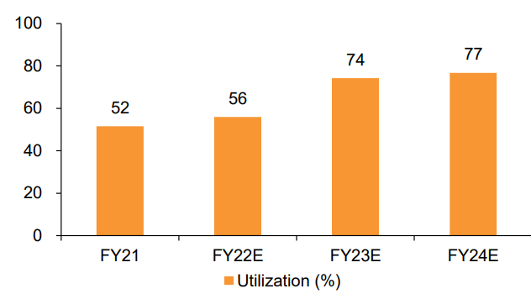

Their mix of revenue in FY21 by CV type was as follows:

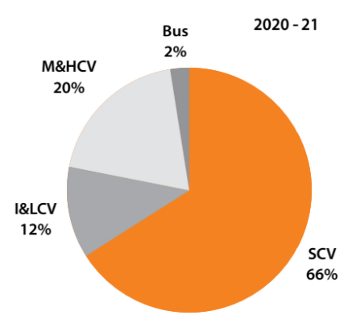

SCV is small commercial vehicle

I&LCV is intermediate & light commercial vehicle

M&HCV is medium & heavy commercial vehicle

Their quality and cost abilities are superior to competitors leading to market share gains

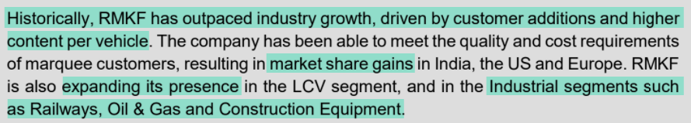

They have an Installed Capacity of 187,100 TPA.

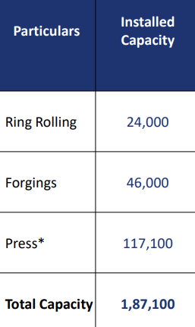

They have acquired ACIL out of NCLT. ACIL has manufacturing capabilities of high precision engineering automotive components such as crankshafts, connecting rods, wheel hubs and steering knuckles for Tractors, 2Ws, CVs and PVs. It has high-end machinery and equipment from reputed manufacturers like Toyoda and Komatsu (Japan), Heller and Landis (Germany), etc. Management expects the deal to be completed by Q4FY22.

They are increasing focus on exports.



They are planning to diversify beyond CVs and increase the share of industrial forgings.

They did capex for a new facility at Jamshedpur.



They also entered EVs with manufacturing of eAxles.



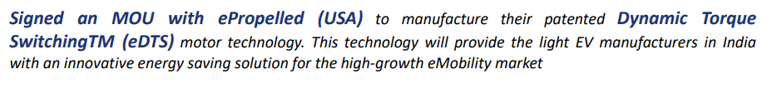

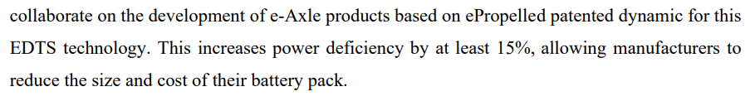

They have a target of being net debt-free in the next 3 years





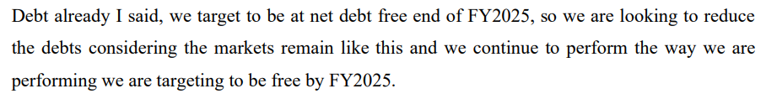

They are also considering raising equity to accelerate debt repayment

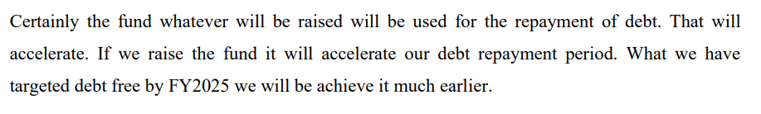

Projected EBITDA growth rate is >40% CAGR

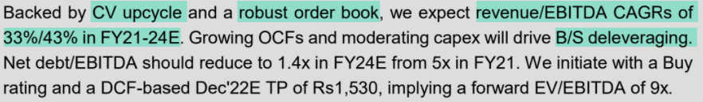

Promoters have been buying shares from open market

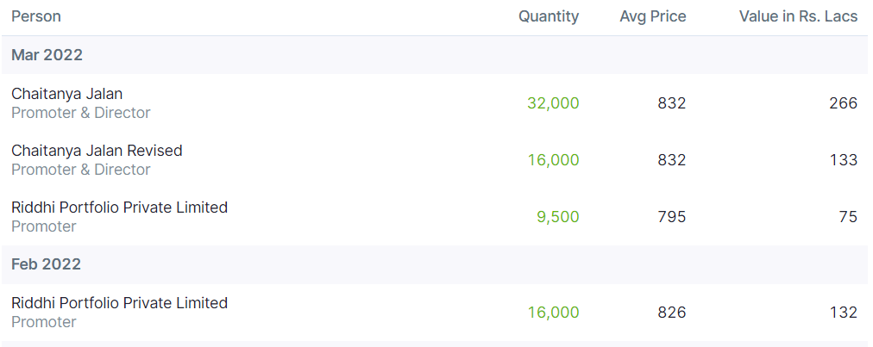



In the past, there was one instance of illegal acquisition of land by the company, by forcefully taking away land from farmers. While the validity/authenticity is unknown, it is a concern on the ESG front. (https://www.youtube.com/watch?v=LMGnDvfqJeM)