MY VIEW ON SUZLON
INDIA TOTAL WIND INSTALLATION FROM 2011 TO 2022
2011 | 2012 | 2013 | 2014 | 2015 | 2016 | 2017 | 2018 | 2019 | 2020 | 2021 | 2022
2,337 | 1,728 | 1,115 | 2,090 | 3,415 | 5,511 | 1,766 | 1,580 | 2,043 | 1,116 | 1,570 | 1,700

- We can clearly see 2016 being the best year for wind in terms of installation and from there on it was a steep fall.
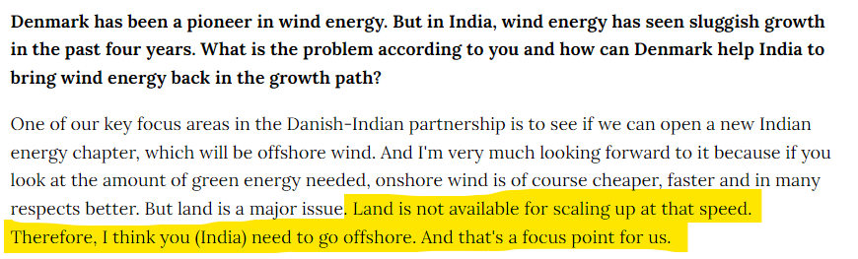
- Every New Year the land availability keeps on decreasing because the OEM would want to install wind mills on the best blowing sites to maximize their electricity generating capacity. So this means the wind sites which we had on 2016 are not there today.
This is a cut out from an interview with Lars Aagaard, Denmark's minister for climate change, energy and utilities.
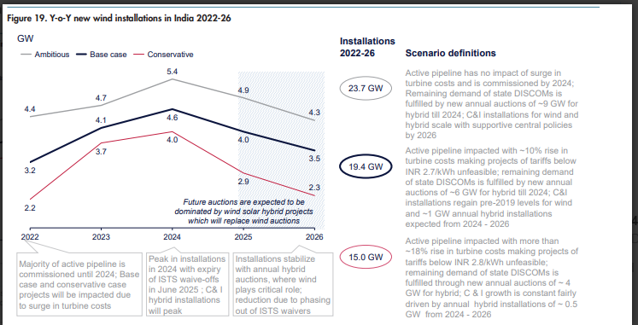
- Various industry reports suggest that the best year for wind will be 2024. If we closely see for 2022 we estimated 3.2GW installation and ended up with 1.7GW so even the numbers are overoptimistic.

- The profitability of wind OEM is very volatile. Just to explain if today I sign a PPA(Power Purchase Agreement at 3rs per KWH then it will take me 12 to 18months to install the wind mill during this period if my RAW Material cost increase then I cannot pass on the cost to DISCOM.

- The margins in this business is already 5% to 10% and on top of that with any uncertain event or rising prices eg currently steel price are rising and it is the biggest component of wind mill I cannot pass on the cost.

- The fixed cost in this business is very high( Despite suzlon reduced debt) If I don’t do minimum 500 to 600MWH I won’t be able to cover fixed cost itself.

- Can we scale in offshore wind? The cost of offshore wind would be 8 to 10rs per KWH which is 5times that of SOLAR ENERGY neither this is feasible for buyer nor developer moreover it take 3 to 4years to complete the construction double the time of onshore this means double uncertainty. Moreover india does not have the technology which EUROPE has. This is a big NO

