Jenburkt Pharma

JPL incorporated in 1985 is engaged in manufacturing and marketing of specialty pharmaceutical formulations and healthcare products. The company's registered office is in Mumbai and manufacturing unit at Sihor (Gujarat). They manufacture both prescription and over the counter drugs. They focus on branded specialty drugs for India, Asia and African markets.

Their drugs are for these areas

|  |  |
| --- | --- |
| [Anthelmintic](http://www.jenburkt.com/anthelmintic.html) | [Anti-osteoporotic](http://www.jenburkt.com/anti-osteoporotic.html) |
| [Anti-arthritic](http://www.jenburkt.com/anti-arthritic.html) | [Anti-ulcerants](http://www.jenburkt.com/anti-ulcerants.html) |
| [Antibiotics](http://www.jenburkt.com/antibiotics.html) | [Aphrodisiac](http://www.jenburkt.com/aphrodisiac.html) |
| [Anti-cough, cold & allergy](http://www.jenburkt.com/anti-cough-cold-allergy.html) | [Dermatological](http://www.jenburkt.com/dermatological.html) |
| [Antidiabetic](http://www.jenburkt.com/antidiabitic.html) | [Gastrointestinal](http://www.jenburkt.com/gastrointenstinal.html) |
| [Anti-hypertensive](http://www.jenburkt.com/anti-hypertensive.html) | [Hematinic](http://www.jenburkt.com/hematinics.html) |
| [Anti-inflammory Analgesic](http://www.jenburkt.com/anti-inflammory-analgesic.html) | [Neuropathy](http://www.jenburkt.com/neuropathy.html) |
| [Anti-malarial](http://www.jenburkt.com/anti-malarial.html) | [Protein Preparation](http://www.jenburkt.com/protein-preparation.html) |

2010 received recognition as R&D facility from DSIR located at Sihor Plant. Focus on solid dosage drug delivery system. Fixed dose combinations are developed (now Banned). They have come out with new products most years.

The company has sales revenue of 120 crores with Pat of 20 Crores with a net profit margin of 16%.

The company operates in highly price regulated environment. The Drug price is not increased more than 10% a year even the raw material cost goes up. Also, the government can put a ceiling price for the drug.

**Economic Moat**

To analyze the company’s Moat the following steps are required.

1. Evaluate the firm’s historic profitability. Is the firm able to generate return from its asses and shareholder equity.
2. Why is the company able to keep its profits firm? Why are the competitors unbale to steal its profit?
3. Estimate how long the company can hold off competitors (competitive advantage period)
4. Analyze the industry structure to know if the industry has many profitable businesses or they struggle to stay afloat.



Jenburkt has continuous positive free cash flow for the past 10 years. The free cash to sales ratio is always above 5%. It is around 10% 7 out 10 years Which is good.



The return of equity has been always above 25%. Return of Assets has improved from 14% to 19%. The net profit margin varies between 7% to and 16%. Year on year the net profit margin has grown to 16%. The company customizes the products as per market it operates. The innovation from inhouse R&D has enabled it to customize its products. The company keeps adding new products to grow market share.

The company has contingent liability of 16 Crores as penalty for not following price cap on some product. Although the lower court has ruled in favor of the company decision from the higher court is pending. However, the pricing cap does not allow the company to raise the price of the products even when the raw material prices increase. The company has few drugs which are into the price control list. The price control drug list also keeps changing and is not predictable. Because the company does not have debt no interest cost is involved increasing the profitability. Also, the company manages cost control and working capital requirement to have better profitability.

When we compare net profit margin across other pharma companies it is an average performer. The company does not hold any patent and is manufacturing generic specialty drugs with high competition. The margins are under pressure (Annual report 2017). Operating margin also shows a similar trend. If we look at the cost structure COGS reduction has caused the margins to increase.



The domestic Indian pharmaceutical market grew at 9.4% from USD 17.87 Bn in 2017 to USD 18.12 Bn in 2018. Further, the exports from Indian pharmaceutical industry stood at USD 17.27 Bn in FY18 and USD 15.52 Bn till January of FY19.

Although Jenburkt do not have pricing power it is able to maintain the margin due to reduction in raw material prices. Even if the raw material price increases the company cannot increase price by more than 10% annually making the margins difficult. In 2014 all retailers demanded higher margin even though the drugs were not in price control list leading to loss of sales for the company.

With Jenburkt in branded drugs, its efforts in brand building can be seen. 2019 it has allocated 60 sales persons in marketing only ZIX range of products limited to Maharashtra and Gujarat under new division Brenz. The company is continuously training its field service team. They participate in national, state and district level conference of super specialties like Orthopedicians, Neurologists, Pediatricians, Consulting Physicians and Dermatologists. They conduct conference and meetings with Doctors to build relationships. The company having its own distribution channel is a plus.

Fixed dose combination has been banned by the government, but the company has said that it will have negligible effect on company’s revenue. However, there is case pending in supreme court from many similar players. Any increase in list of FDC will affect the sales and profitability of the company (Annual report 2017)

Therefore we can say Jenburkt does not enjoy much economical Moat. In this case the margin of safety should be high.

**Growth:**Growth of any companies come from following four sources

1. Selling More goods
2. Raising prices
3. Selling new goods
4. Buying another company

Products Launched:

2019 Oxicojen cream and lotion in Dermatology segment and Powergesic 2X Gel in Orthopedic segment.

The company supplies to 13 countries, although it was suppling to 15 countries in 2010. (source Annual report).

2018: Four new Dermatology products. New Drugs developed by the company’s R&D (a) Tribenand Triben B Spray, (b) Eberjen and Eberjen M Cream, (c) Powergesic Spray, (d) Powergesic Plus Spray, (e) Zix Balm, (f) Lutriben Cream and Spray, (g) New Piritexyl Syrup.

2017: launched new dermatology products, during the year in India and intend to introduce more such products in future to set a strong foothold in skincare segment. New products developed by company R&D: i) Senna tablets for international business. ii) Vitamin-D chewable tablets and drops for international markets. iii) Itraconazole 100 and 200 mg capsules for domestic market. iv) Sugar free cough expectorants with a Broncho dilator for adults and also for children (with sugar) for the domestic market

Launched operation in Cameroon, Chad and Guinea.

2016: new distributor registered in Sri Lanka

2014: started operation in Tajikistan and Uganda.

Note: unable to make out what products were launched from annual reports.



Growth from international market has been at CAGR 13% and local at 9%. However in 2010 the company was exporting to 15 countries and 2019 to 13 countries.

Overall the growth for the company is coming from selling more products. They expanding their geography enabling them selling more products. They have new launches so selling new goods. They have no acquisitions.

Questioning quality of growth:

The revenue of the company has grown at staggered manner between 5 to 14%. 6% growth seen in 2019 and similar growth in TTM. 

Earnings have grown at CAGR 18%.

Earnings growth is not stable is much staggered between negative in 2012 and 37% in 2011 with 13% latest.

Earnings growth of 37% in 2011 is due to reduced COGS and sales growth.

5% growth and nil earnings growth in 2012 was due to increase in VAT, increase in excise, withdrawal of drug Zydol due to some controversy and increased cost of raw materials.

2019 appears like FDC ban has affected the company sales growth as the company is looking for alternated to its FDC drugs. However due shares buy back the earning growth is around 13%

Profitability: 

The Return on assets for Jenburkt is 13 to 22% and has maintained a healthy ROE above 25% for the past 10 years.



Jenburkt has gross margin of 68%. Employee cost has grown to 25% which could be due its own sales which is growing. Selling and admin cost has increased but now decreased and in same as 2010 level showing no cost improvement.



Free cash flow has grown from 3 crores to 12 crores, and positive cash flow every year with a total of 87 crores for the past 10 years. So Jenburkt do not require t depend on loan incase of expansion in the future. With FCF to sales above 5 % in all 10 years the company is generating excess cash. On the profitability matrix Jenburkt falls into less risky category due to its good cash flow and ROE.

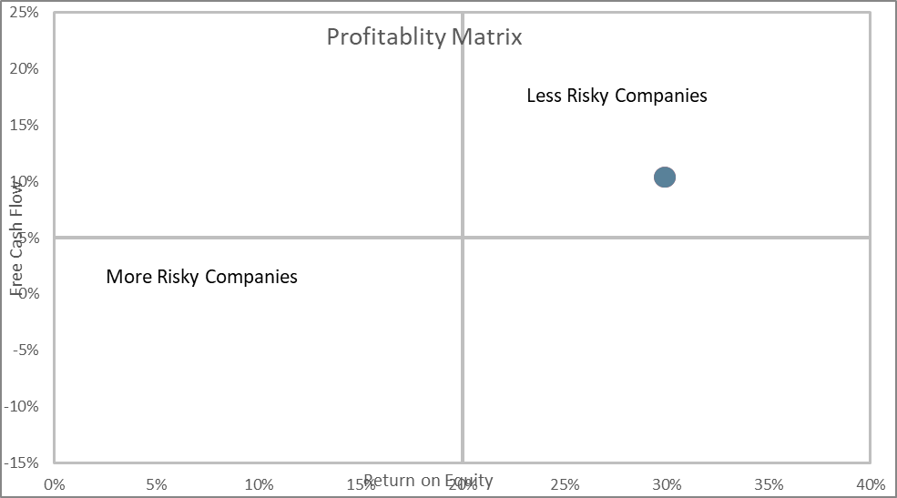



ROIC removes the effect of debt on ROE and ROA. The higher the better. ROIC remains above 15%.

Financial Health:

The company does not have any long-term debt. The company has 51 crores cash and we must see how the company is going to use the cash in the future.

Bear Case:

1. Product price control – if many of the companies are included in the price control sales and profitability could be affected
2. If more drugs are included in the FDC list the company’s revenue could be affected.
3. Increase in raw material prices can affect profitability.

Management:

Excellent management can make the difference between mediocre business and outstanding one and a poor management can run even a great business into ground.

Compensation



6 out of 10 years the managers have taken a salary higher than ceiling allowed by regulations. At least they ensure the maximum allowed is taken as compensation in the remaining years. The bonus taken as been up to 3% of net profit.

Character



There were no stock options. Loan to the employee is negligible but received back. Some of the non-executive directors hold a minimum number of shares. One non-executive Director has resigned citing no time for MCA qualification exam. The company did a buy of shares in 2018-19 at a premium of 21% when the stock price was very high. However, there is item Purchase of stock in Trade, i.e. readymade good bought by the company in the P&L. The company has not disclosed anything about such item. There is also a rental agreement with related party promoter holding company for 48Lakhs. Details of why it is rented and location of not available

Running the Business:

The Company has maintained good ROE. They have paid all long-term loan and debt free. Their communication with other shareholders is minimal. Also, there is not much information available about the company. The management is not so open in the annual report also regarding new product launches. Future targets for the company are not disclosed by the company. The company has been spending and R &D every year and can see an emphasis on R&D by the management. The company in 2010 states that they export to 15 countries whereas in 2019 say they export to 13 countries. The management has not clear that they are having a degrowth in export markets.

Financial Fakery

Cash flow

The cash flow has been increasing. No signs of cash flow decreasing.



Serial Chargers; there was no one time charges in past 10 years. However, there is item Purchase of stock in Trade, i.e. readymade good bought by the company in the P&L. The company has not disclosed anything about such item.

Serial Acquirers: Nil acquisition



Change in credit Terms

There is increase in receivables for the last two years. The receivables have doubled in the last two years.

Valuation:

Even the most wonderful business is a poor investment if purchased in for a too high a price. To invest successfully you need to buy great companies at attractive prices. Investors return come from earnings growth and dividend yield whereas speculators growth comes from rerating of PE.



With the current PE of 8 the stock has earning of 12.5% for the price. This is way higher than the treasury yield of 6%.



Cash return has reduced from 24 to 6% in 2019. But with the current price cash return is about 12% if we buy the whole company.

Estimated Intrinsic Value of the stock when discounted at 13% with a growth of 10% FCF for next 10 years and 5% into perpetuity is Rs 423. With stock price at 313 the stock is available at 26% less than the intrinsic Value plus the discount rate of 13% which 39%. In valuation point this is a good bargain.

Suppose the cash flow grows at 5% then the intrinsic value will be 297 which is -1% discount plus discount rate of 13% still providing a return of 12%.

Conclusion: Jenburkt Pharma is company growing steadily in a growing industry. The range of products the company is into may be price controlled by the government and facing ban of few drugs. The company also introduces new drugs every year. Margins could be affected by raw material prices. The company is debt free and is able to generate positive free cash flows.

The renumeration of the management is on the higher side. We must keep close watch on this. Also, If the management communicates more regarding products launch, FDC affected products and finished goods purchased there could be more clarity. Should find out reason for increase in receivables in the last two years before investing.