Integra Engineering

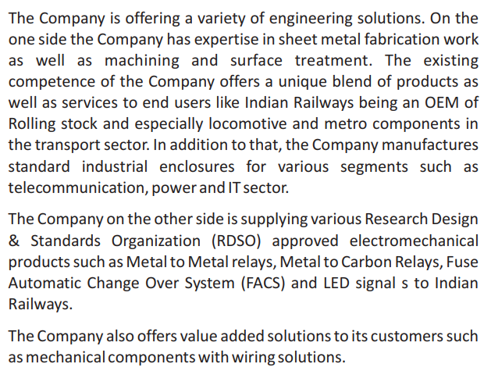

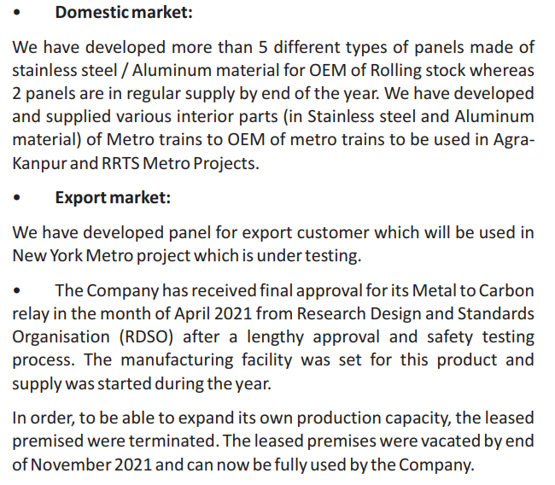

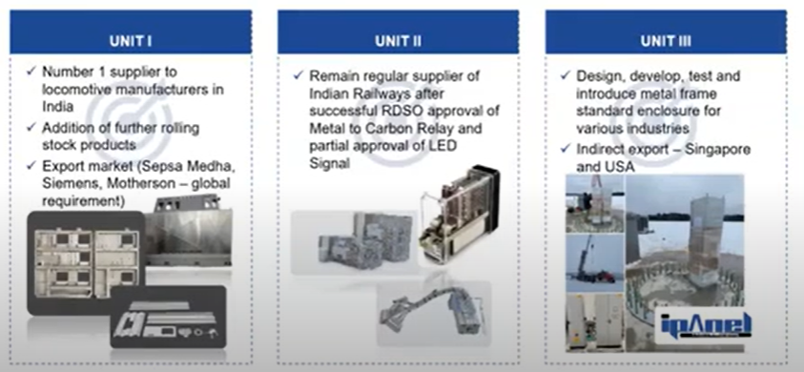

<https://5.imimg.com/data5/PQ/XM/NM/SELLER-2316007/36u-networking-server-rack.pdf>

They have capacity of 140700 units per annum for metal to carbon relays.

<https://rdso.indianrailways.gov.in/uploads/files/Integra%20MC%20Relay%20approval%20letter(1).pdf>

One of the independent directors, Mr Mahendra Sanghvi, is the promoter of Shaily Engineering Plastics.

Sales and margins have been quite consistent over the quarters.

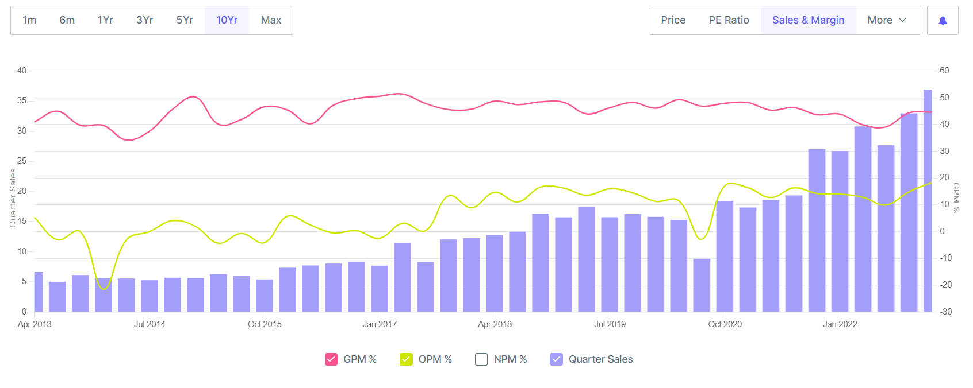

<https://www.ashvinauctioneers.com/docs/Technical_Data_for_Display,_Integra_Systems_Pvt_Ltd.pdf>

<https://5.imimg.com/data5/SELLER/Doc/2022/8/SI/IR/VA/65115328/point-contactor-unit.pdf>