ACES UP Your Sleeve
Over a longer period of time( a decade or so of holding quality franchises) it will never be about a 10% or 20% plus or minus, it will always be about having aces up your sleeve.

Now, how can you have aces up your sleeve and what do we mean by that
- Reaching a mental state where you are comfortable if even after best of your allocations strategies you can easily digest the 50% draw downs in the nominal value of your PF without affecting your daily family expenses/your peace of mind for a period of at least 6 months, means you in no way are forced to SELL/terminate/loose by magnitude your business partnerships (we refer to that for the small qty of stocks that we own in business we like). We want to operate from an impeccable frame of business owner's mindset. ONE thing we want to aloof our PF from is the FORCE SELL. This is the MOAT we seek to build around our PF. For the same we are committed to hold at least 6 months of our end to end monthly expenses as a safe cash harbor not supposed to be touched at ANY COST and grow it henceforth gradually over 1 year adjusted for inflation. Once we are able to achieve the same, we reckon we would be in a commanding position to digest the market uncertainties; well protecting our business partnerships interests.
- For those who want to debate that this (a long period of 50% + draw down) cannot happen to them and they are fine to be aggressive (deploying everything without an adequate emergency corpus), over-leveraging, deploying as a victim to FOMO are actually sitting on a landmine of emotional, mental and financial turbulence that can affect their health, relations and probably some of the important decisions they might take during the hard phases of investing span. WE strongly believe that to Finish First you must First Finish( there is no glory in perishing mid-way with sparkling eyes) Even to the best of business/people this has happened a couple of times as can be seen below

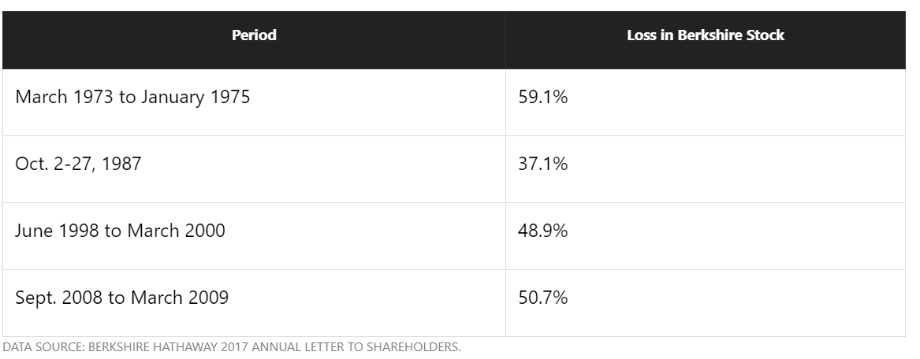

Our basic Goal is not to lose the sight/partnership with our wonderful business or in any way hamper our partnership interests in them due to such vagaries in the short terms price movements or forecasts by high IQ celebrated media analysts.

Our main goal is to focus on the long-term growth as can be seen below for the same company whose share price saw the major falls as per above table and there can be ‘n’ references of the same from Indian context too. You take Asian Paints, Kotak Bank or whatever, you dig it and you will have it.
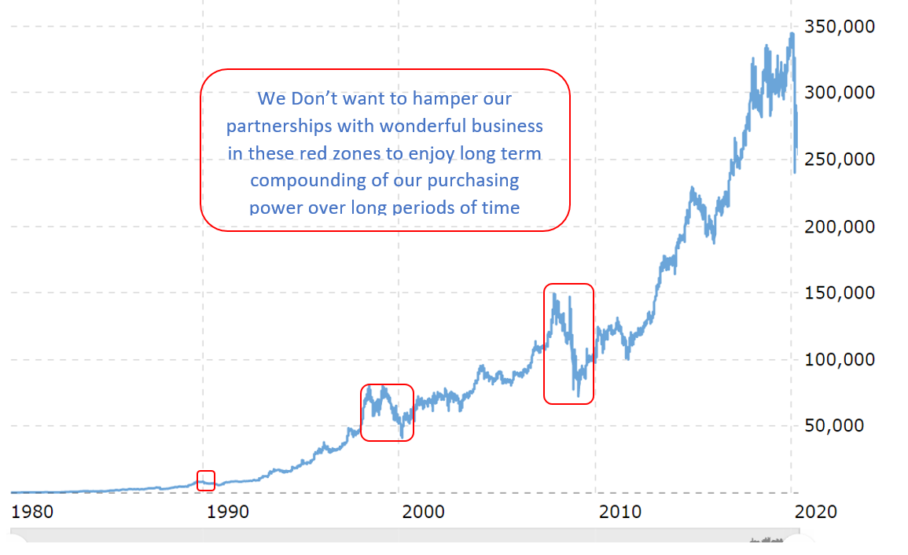
To, me it is the long-term trajectory that matters and there are reasons only a handful of business can actually exhibit these trajectories.

It is during these period(s) we would like to build our edge by creating a MOAT of free cash flows to sustain these draw downs and possibly by time diversifying able to capitulate on opportunities like these as and when they arise. We are always guided by below

- Our basic goal from investing is to attain financial independence over a period of time and we understand that the whole process will take its own sweet time and we strive(acknowledge our biases and continually work upon them) to build extreme patience as our biggest virtue seconded by discipline and gratifying desire to put in continuous hard work. WE would thus continue to hold loads of cash, deploy in a disciplined manner (or at once only in exceptional circumstances way above our IRR restricted to our framework-based percentages) . In doing so we might be slow to Start and might end up losing a couple of basis points here and there had we allocated all at once or otherwise but unless exceptional circumstances present themselves, we would like to keep time by our side and would love to time-diversify our PF build up. This might throw up some pleasant surprises for us (we might get a chance to inc. our holdings below our triggers) or unpleasant ones(we might lose a 20% upside had we deployed all at once) but the essence of this concept is not to seek any market timing opportunity but rather discipline our holdings in conjunction with the market/cash holding realities to use them better to be on our side and build our understanding and confidence about business too.

- We basically try to focus and deepen our understanding on the behavior and response mechanisms, incentives on how different target groups respond to target audiences under circumstances and we completely acknowledge:

  - The seemingly virtual umbilical cord relationship between the ticker tapes red/green flashes and the easy one-click/touch ease of terminating/altering/entering into business partnership associations by flash of a second, who gains from it actually and who losses from it. We would like to be very minimal and at the same time very simplistic to these heuristics. What people think of a trade to us is a business partnership and I don’t like to get into or out of partnerships that easily; definitely not responding to the ticker tape backgrounds flashing GREEN or RED.

  - Also, at the same time we respectfully understand the plight of many who have to do this exercise to earn their livelihoods, their bread and butter is tied strongly to this. How will they get 2% of fee if the Portfolio for this year will not outperform the Indices? What actual long-term affiliation they have or what is their SKIN in this whole GAME. They simply cannot afford a 10% holding to go down more than 40%. This will endanger their livelihood.
Thus, to me as an individual investor to make serious money the career and livelihood at the onset needs to be divorced from wealth creation from equities. 6-8 hrs. of a weeks work is more than sufficient on this side while constantly evolving and striving for your career growth.
This is how we believe that we might have ACES UP our SLEEVES

