February 2024 Concall notes:

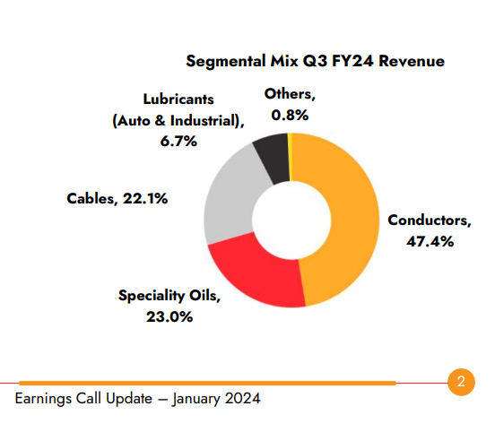
9M FY 24
Exports: 46% of revenue.
Premium products: 42.3% of revenue.

New order book: 6354 cr

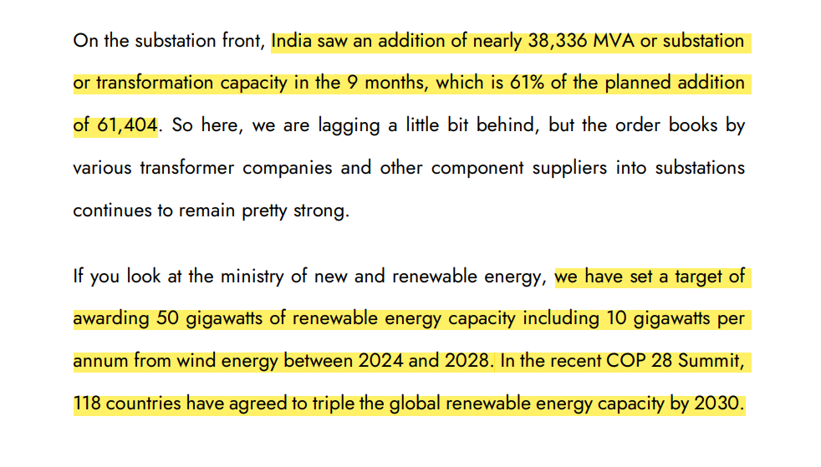

Cables: Elastomeric products and exports increased.
US and EU enquiries increased.

Increasing interest in HTLS lines:
Tenders are lined up.
Trend is positive but awarding of tenders may get delayed due to election.

High Temperature Low Sag Conductors (HTLS) can withstand operating temperatures of up to 210 °C, thus carrying higher power compared to conventional conductors.

Standardisation of conductors:
A transition is happening from ACSR to AL-59 alloys.
The upgrade in the specifications ACSR to AL-59 alloy has actually created a win-win situation for manufacturers like APAR as well as for transmission line owners. This results in a reduction in the total cost of ownership of the transmission lines. So, this effect may play out over the next few years. Few players are there in AL 59 products.
Higher technonolgy is involved in providing those products, the competitive intensity is lower. This product has lower weight and less corrosive properties. It's already become now the default product.

EBIDTA could be 28500 Rs. Per metric ton for longer term.

Conductor division : Management expects 15% Volume growth next year.

Transformer oil:
Management is expecting double digit growth from domestic and export point of view.
APAR has higher market share in power transformer oils than distribution oils. It is prefered oil in higher capacity transformers. 800 kV HVDC which is the highest voltage type of transformer, APAR has more than 90% market share.

Cable business:
Management is expecting more orders from medium volatage cables ( high value product) than building wire / simple type of cable.
25-30% out of total sales come from elastomeric cables. Used in solar, wind, railway, defence, mining etc.
10% from OFC cables and remaining from power cables.

In FY 2023, cable exports contributed for 16% of total revenue. Cable business is expected to grow 25% for next few years.

There's a big revival happening in the wind sector. And also, the government has recently come up with a new scheme where you can upgrade your old wind farms. Windmills of smaller capacity will be replaced by big capacity windmills.

Current capacity is 2,05,000 metric tons. Capacity will be added as per expected volume growth. Acquired properties/ cable manufacturers in Silvassa for scaling up business.

Red Sea crisis:
Exports to USA is less affected. Exports to west Africa and EU are taking 15-16 extra sailing days.
Deinventorization: APAR’s customers and distributors held inventory to avoid supply chain issues existed before.

APAR has kept almost 9 to 10 months of inventory, whereas the law has normally been holding 2 to 3 months. Customers are increasingly giving DDP dates. APAR is exporting that product 15-20 days early.

The DDP Incoterm, or “Delivery Duty Paid” Incoterm, states that the seller must make the goods available to the buyer at a prearranged location (buyer’s factory, warehouse etc.) and cover all associated expenses including unloading the goods from the carrier and any customs procedure costs and tariffs that may apply.

Under the DDP Incoterm, the seller bears full responsibility for all costs and risks until the goods have been unloaded at the agreed-upon location.

US Exports:
Management has confidence that US will be strategic market for them as they have received positive feedback from servicing customers. In EU still they are developing.
US imports cables worth of $19 billion. It is huge opportunity. APAR can cater to real estate sector and low voltage segment. Also approval is received for medium voltage cables upto 40,000 volts.

APAR is largest exporter to US, Polycab is close second. KEI caters to Australia.

Going forward company plans do capex of 300 Cr on annual basis. It will be Combination of brownfield expansion and debottlenecking. QIP money raised 1000 Cr will be utilised.

In Europe, APAR is focused more around the renewable energy side. In the US, there more sectors that are covering. APAR has contract with Enel (Italian utility)

Outlook for the year ahead would be conductors 15% plus, cables-20-25%.
In oils -- transformer oils double digit.

Transformer oil : Guidance of EBIDTA of 5500 Rs per KL already achieved. Current EBIDTA is 6125 Rs per KL.

Lubricant: Volume are always under pressure because of drain intervals of oil products. Volume growth could be in the range 2-3%.

Chinese competition:
In certain simple construction conductors the US market is still not flooded with Chinese products. It will not be that easy for them to sell in large quantities there.
Chinese are trying to route products through Vietnam and some of these other geographies. Moment the Chinese try to route it through another geography it adds significantly to the supply chain costs. They no longer can be as competitive as they are from China.

In January, February the profitability and the margin will come down.

