Loyal Equipments

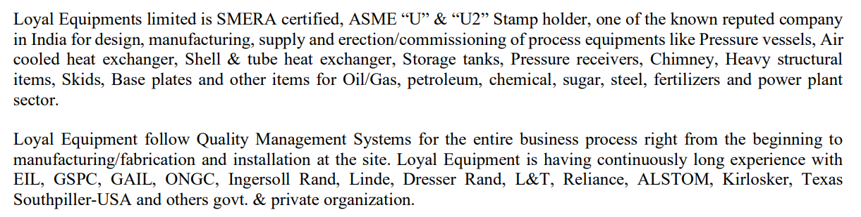

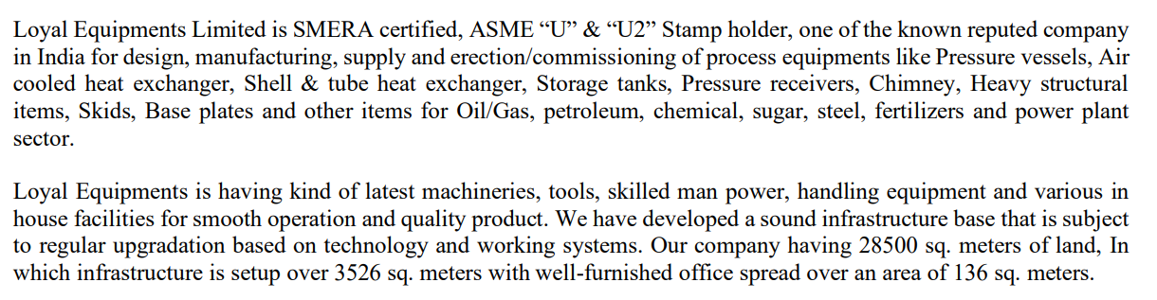

Order agreement with Linde- annual supply 20 Cr

<http://www.loyalequipments.com/data/Announcements/Annoucement%20-%20January%2024,%202020.pdf>

<https://loyalequipments.com/data/Announcements/Announcement%20-%20August%2020,%202019.pdf>

<https://www.bseindia.com/xml-data/corpfiling/AttachHis/f9e4df44-b177-4ed7-85c8-c2d1ff17cfd9.pdf>

exports

<https://www.importyeti.com/supplier/loyal-equipments>

tender

<https://admin.mrpl.co.in/img/UploadedFiles/ListOfOrder/Hindi/1574418427_Oct_19.pdf>

<https://cpcl.co.in/wp-content/uploads/2022/10/MR-Jul-2022.pdf>

vendor in nasa database through Texas subsidiary

<https://osbp.nasa.gov/vendor_database/NASA-Vendor-Database-Vendor-Registrations_12152020.pdf#page=44>

consulting with iit Gandhinagar

<https://iitgn.ac.in/assets/pdfs/connections/Vol8-Issue4.pdf#page=2>

linkedin posts and comments from atlas copco, linde India engineers etc

misc

<https://www.prclimited.co.in/pdf/odc-brochure.pdf#page=4>

<https://gpjs.org.in/wp-content/uploads/2023/03/Zak-GIDC-Company-list-PDF.pdf>