Autoline Industries is engaged in manufacturing sheet metal components, assemblies and sub-assemblies like Foot Control Modules, parking brakes, hinges, cab stay and cab tilt, exhaust systems, tubular structures, fabrications, etc. for large OEMs in the Automobile Industry. They have a product portfolio of over 1500 products including parts from 1g all the way till 400 kg.

Their major divisions are as follows:

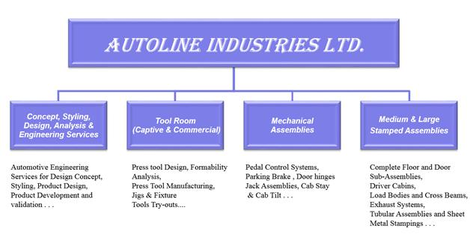

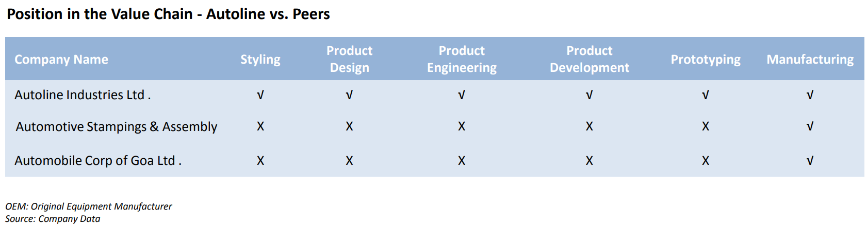

Almost 80% of company’s revenues comes from a single customer- Tata Motors. They are sole, single-source suppliers for a number of models like ACE, Bolt, Zest, Indica, Indigo etc.

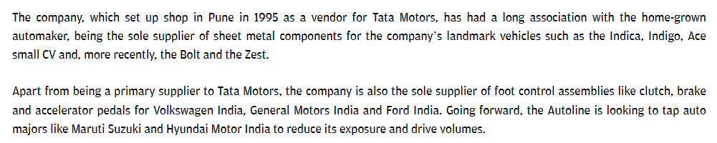Key thesis here is a potential turnaround situation.



They got into problems due to large capex, funded to a large extent by debt, followed by CV downturn around 2012 onwards.

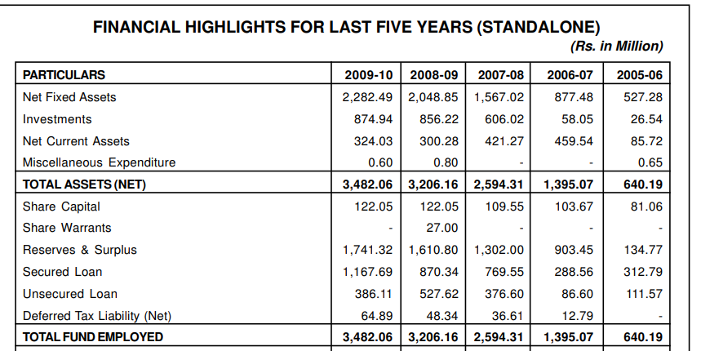

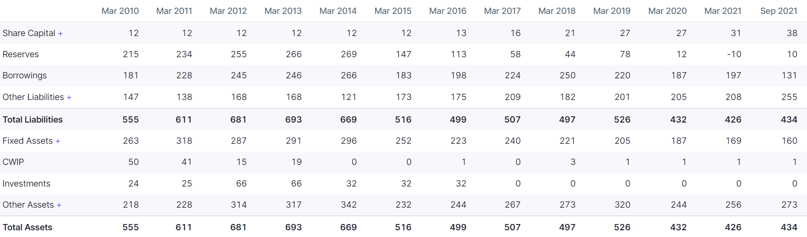

In Q2 FY22 they made their highest sales in 12 quarters and first-time positive PAT in last 12 quarters (excluding Q4 FY19 where there was 45 Cr other income). This was not a one-off, and has sustained in Q3FY22.

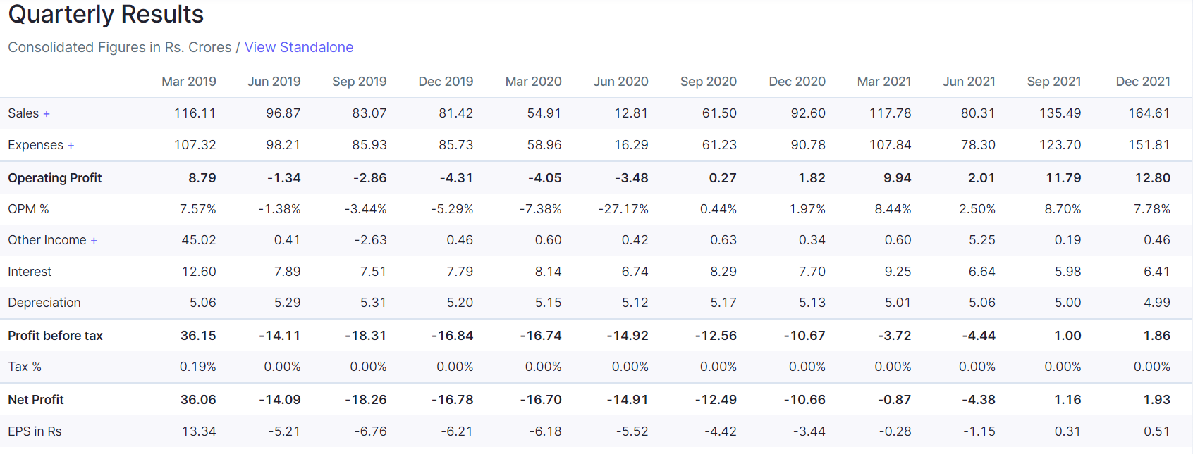

While debt to equity is still very high, it is important to note that they have already reduced debt by Rs 120 Cr in last 3 financial years.

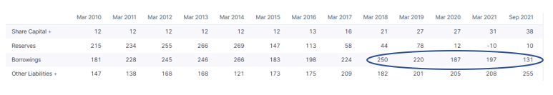

We also find that debt and interest repayment entry has been very large in cash flow statement over last several years.

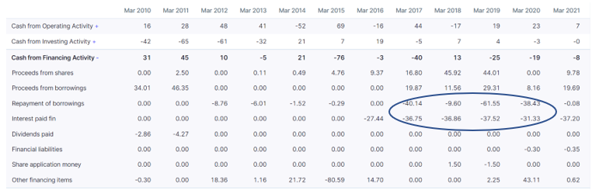



In the process of debt reduction, they have also converted debt into equity shares.

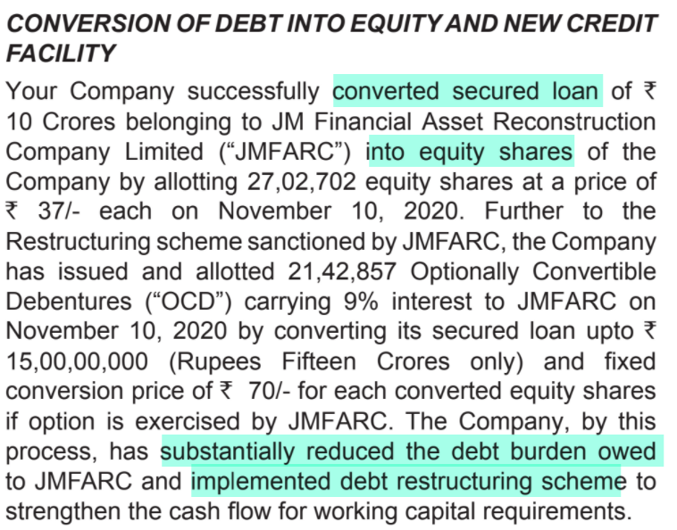

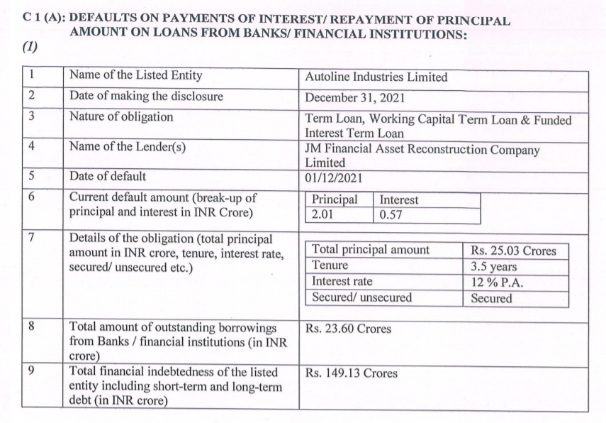

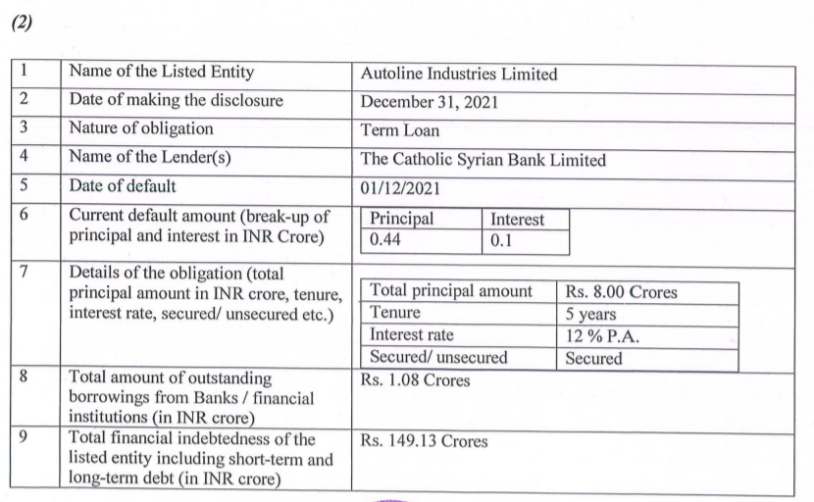

They have also sold some properties and consolidated the manufacturing facilities. Even more important, they have used part of the proceeds for repaying debt.

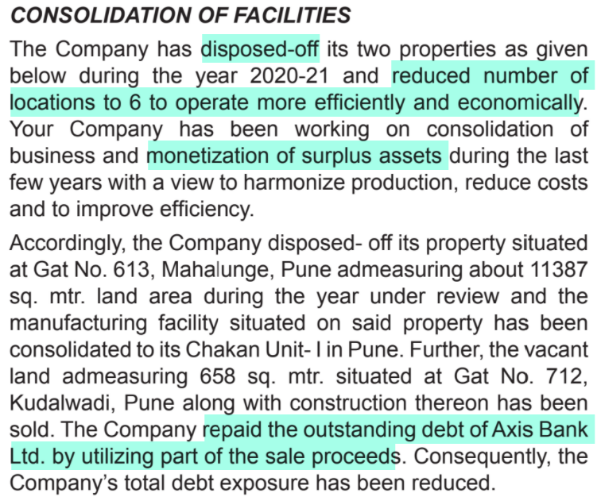

Company did a preferential allotment to marquee investors.

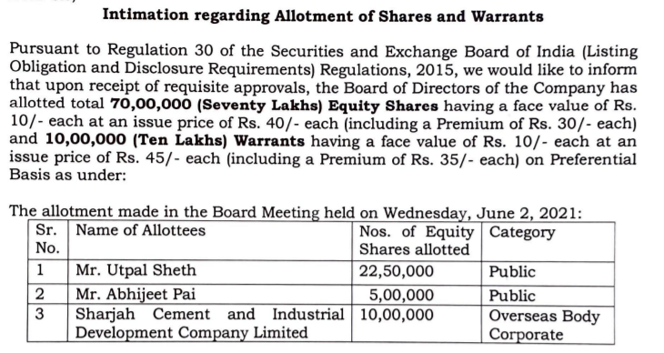

The issue price of Rs 40 seems fair since on 2 June 2021, the market price was Rs 38

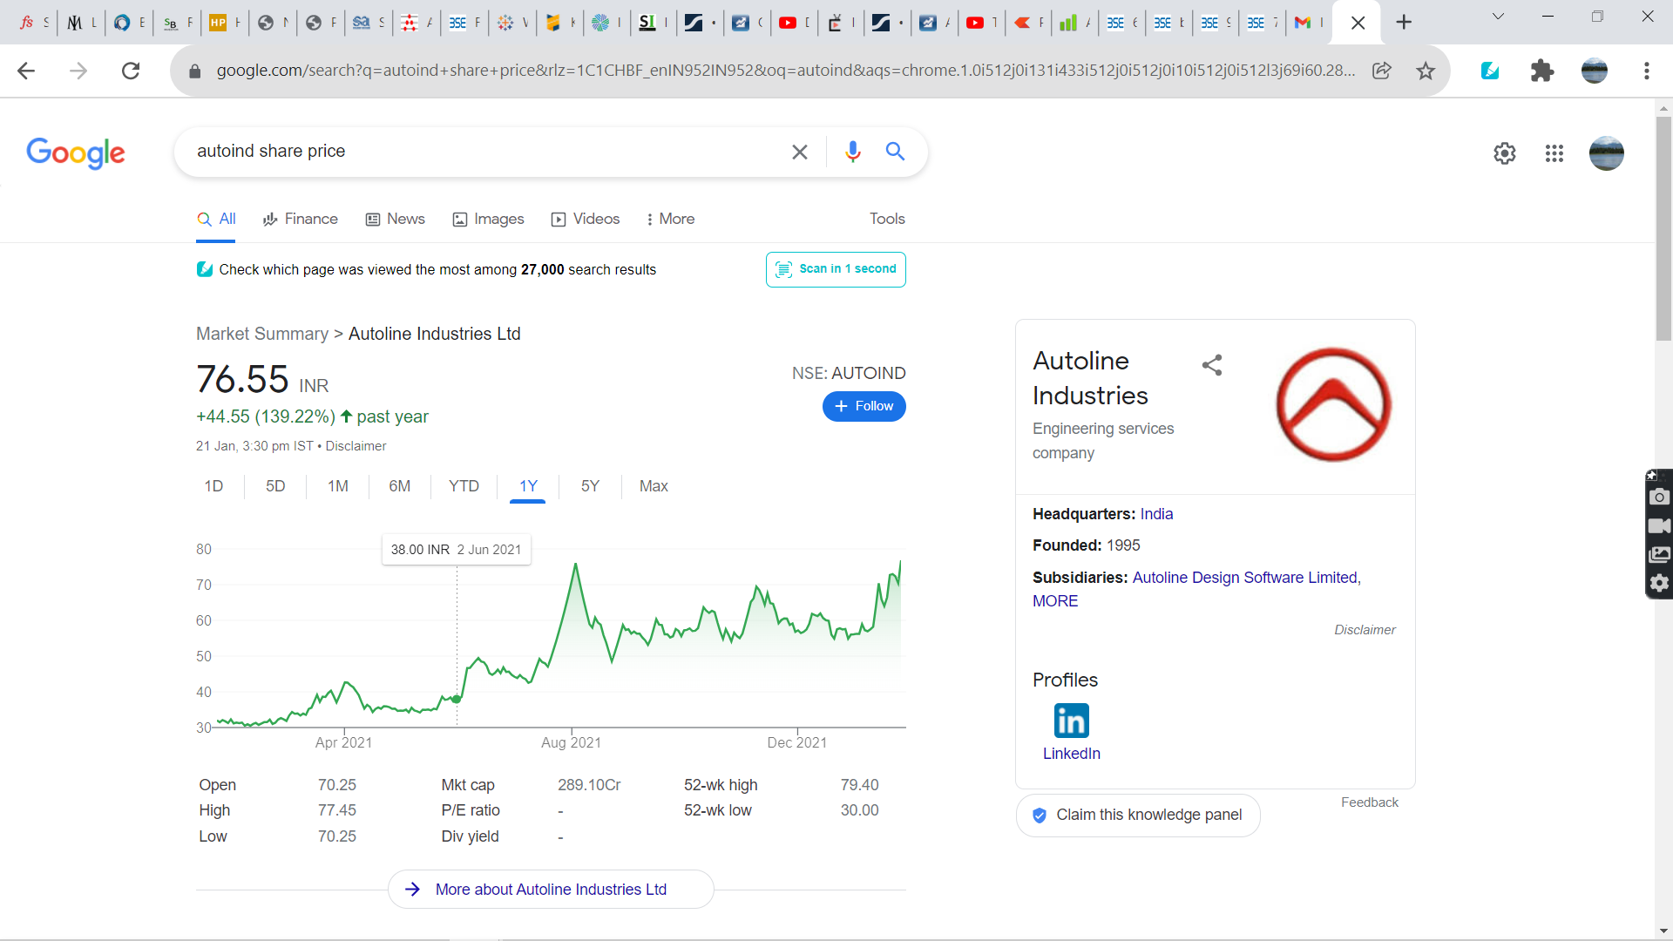

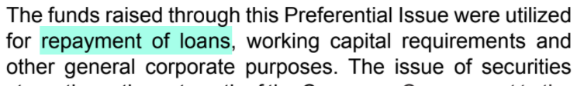

There has been a change in top management (CEO) with Mr Shivaji Akhade (who was a director since inception) becoming CEO.



They also brought in a new CFO in 2020

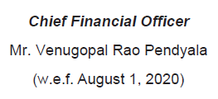

Mr Pendyala was earlier at Tata Motors for 25 years.

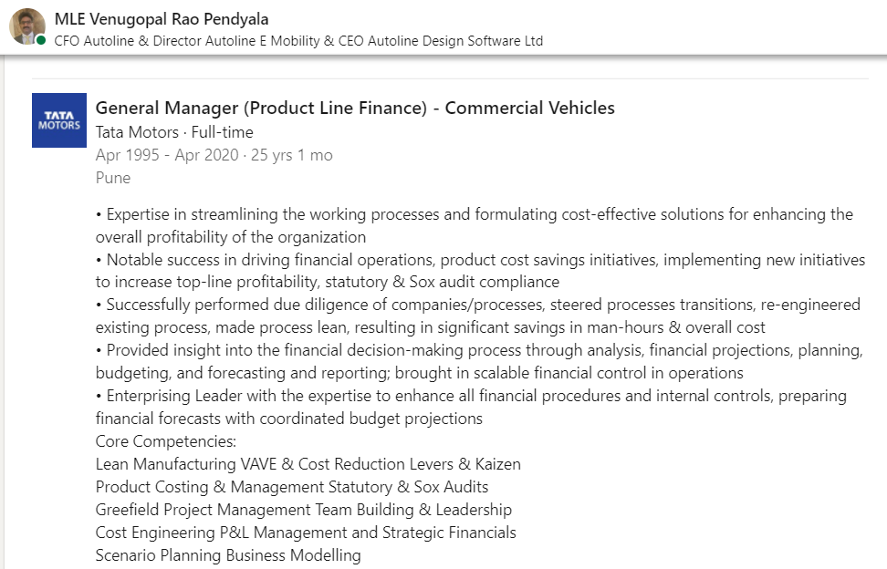

Operationally, they are doing lot of cost cutting and focusing on improving efficiency; they are also doing debottlenecking to increase capacities.

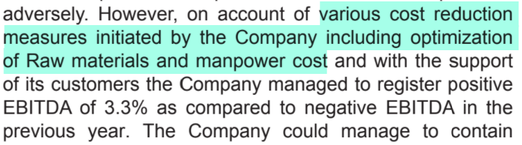

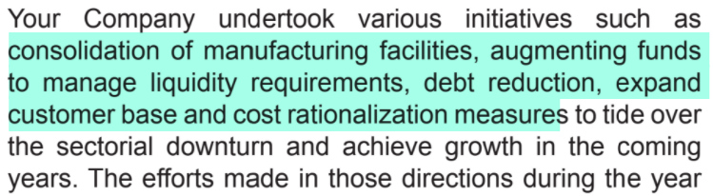



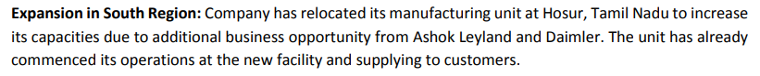

They also gave a slide in the AGM presentation outlining the scope of cost reduction in each major line item on the P&L.

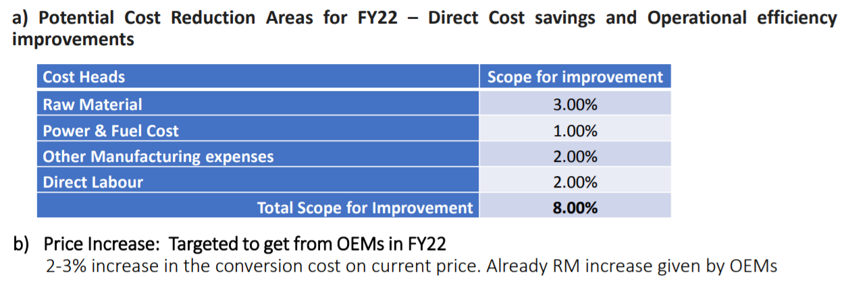

Management commentary is also positive regarding a clear intention of turnaround.

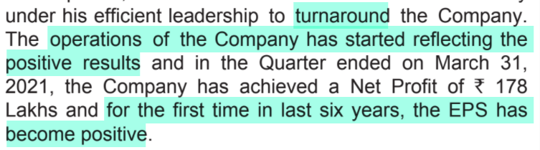

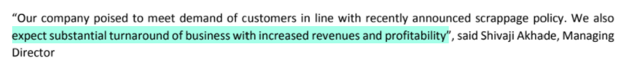

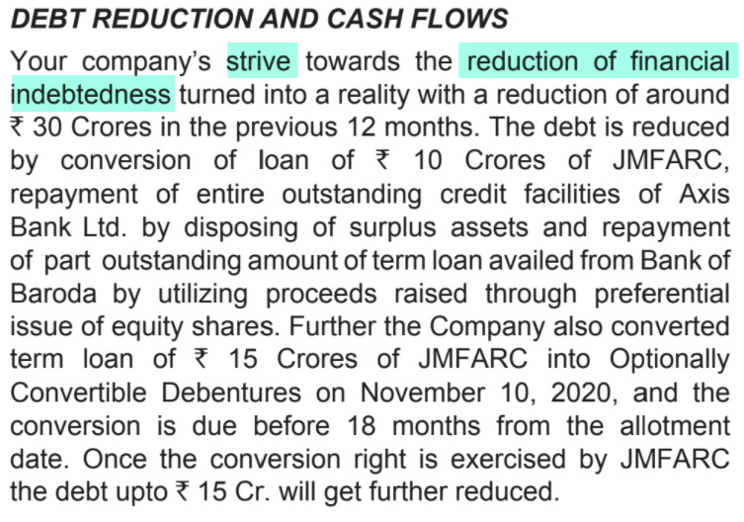

As mentioned earlier, Tata Motors is 80% of revenue so customer concentration is a big risk. They are very intent on reducing the customer concentration and also want to diversify beyond auto into railways etc.

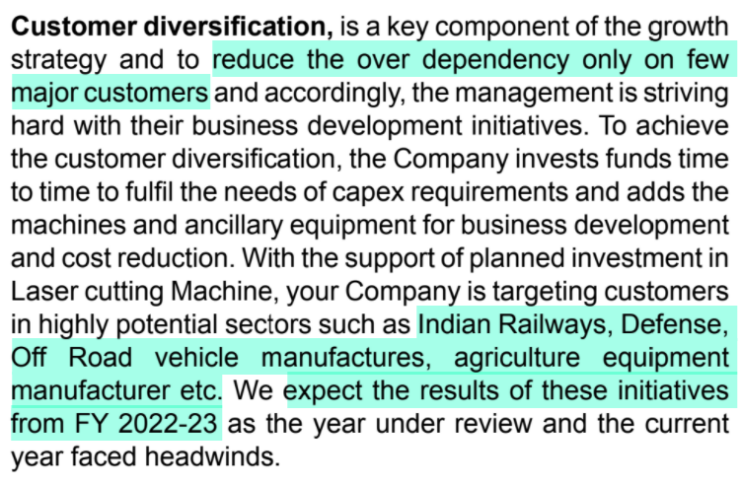



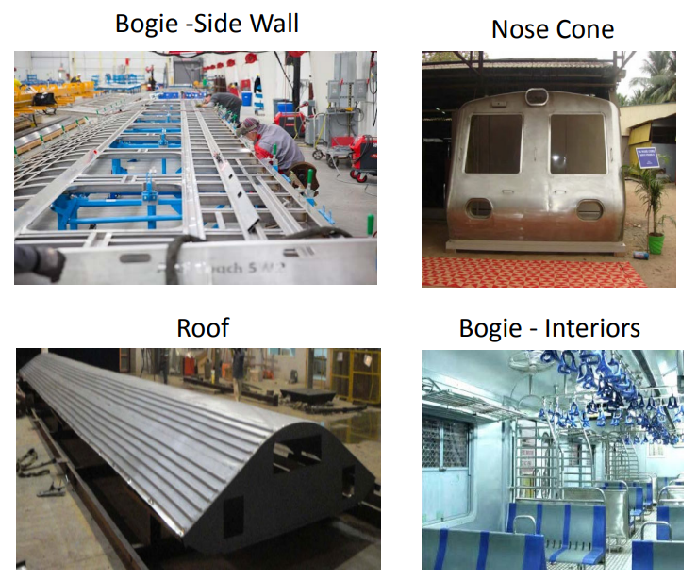

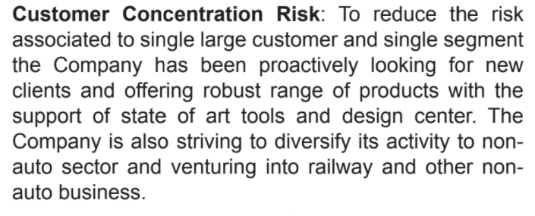

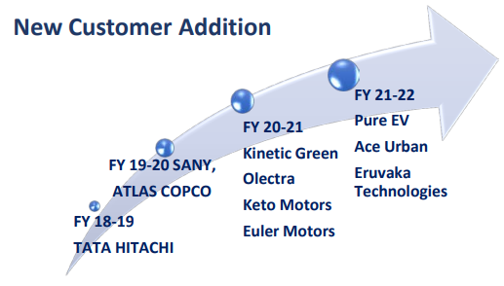

They want to bring TML share below 50% by FY23.

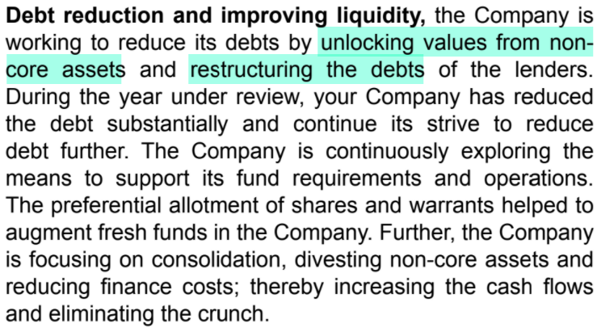

They have large land areas which they are trying to monetize. They were in talks with Poddar Habitat but it did not complete.

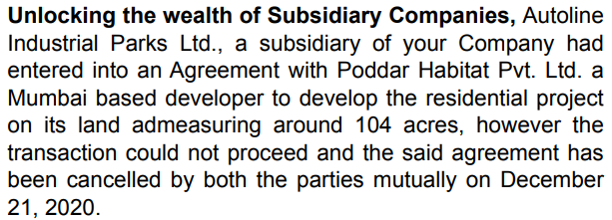

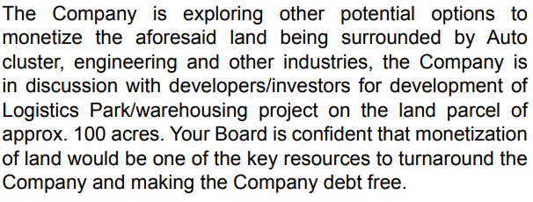

They have now signed deals with Hiranandani Developers to convert it into an industrial park.

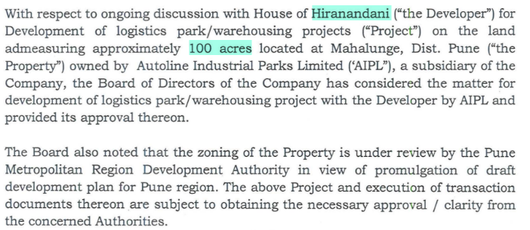

They are also making significant inroads into EVs through electric two-wheelers under the brand E-Speed.

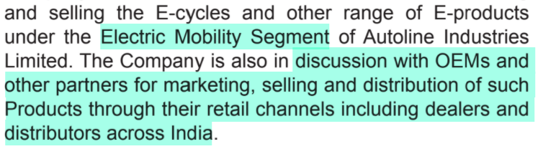

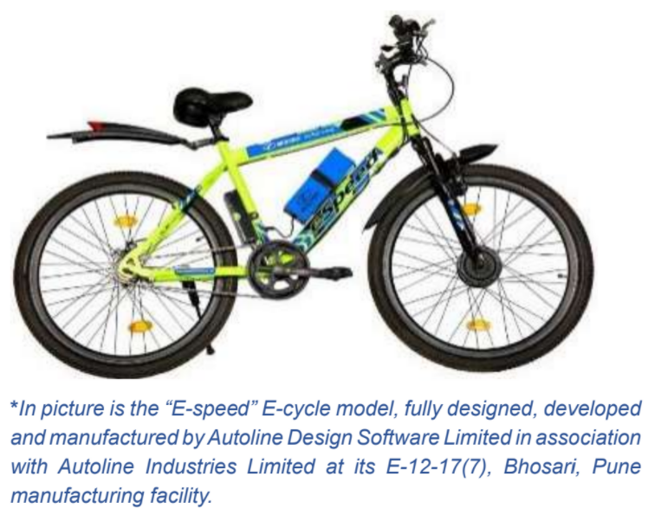

They earlier were doing e-cycles in partnership with Kinetic Green but they discontinued this

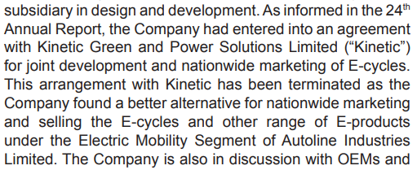

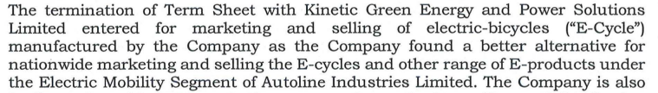

They have been quite aggressive on the marketing of e-cycles on social media platforms.



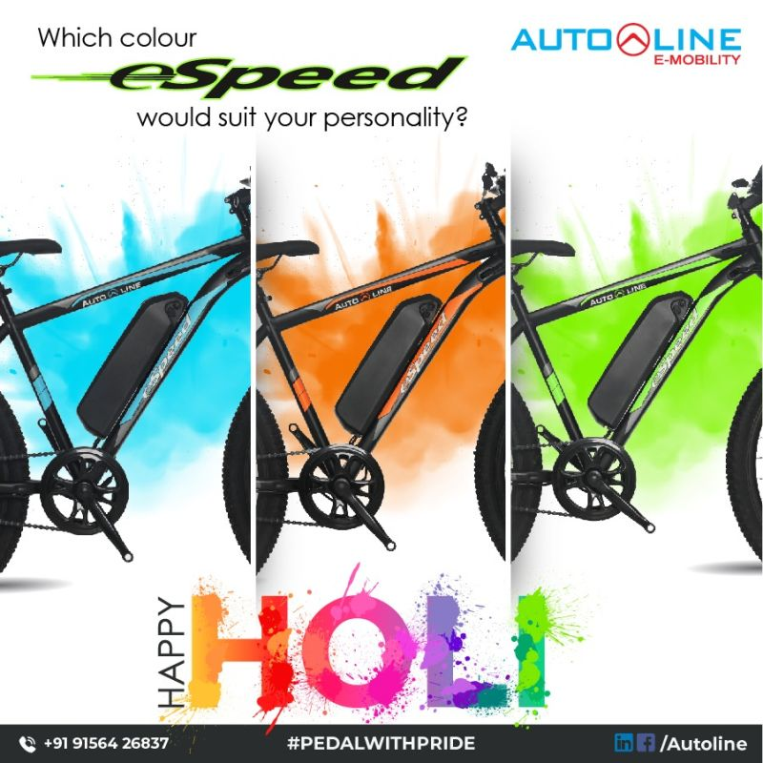



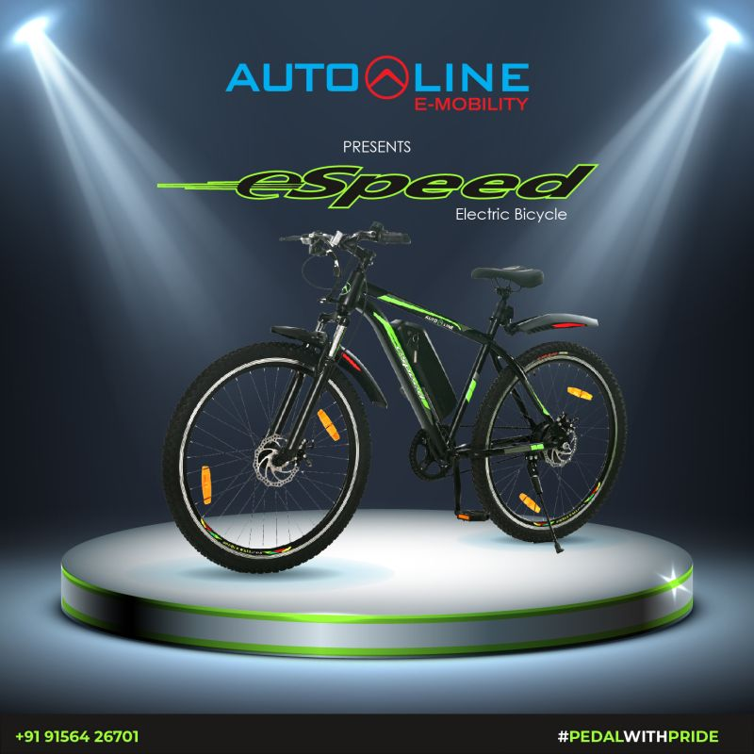

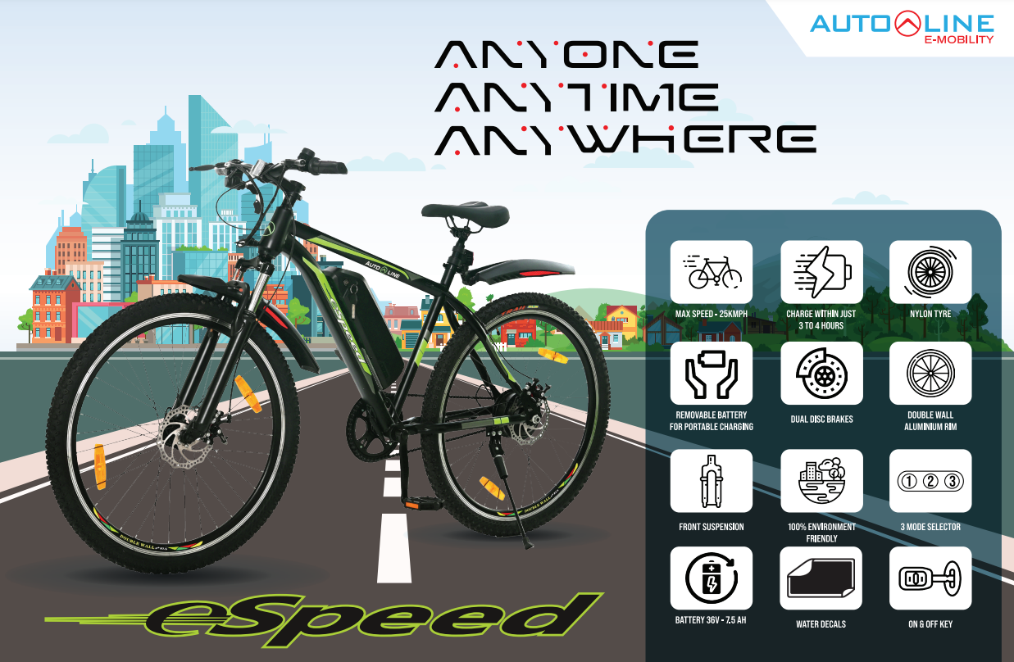

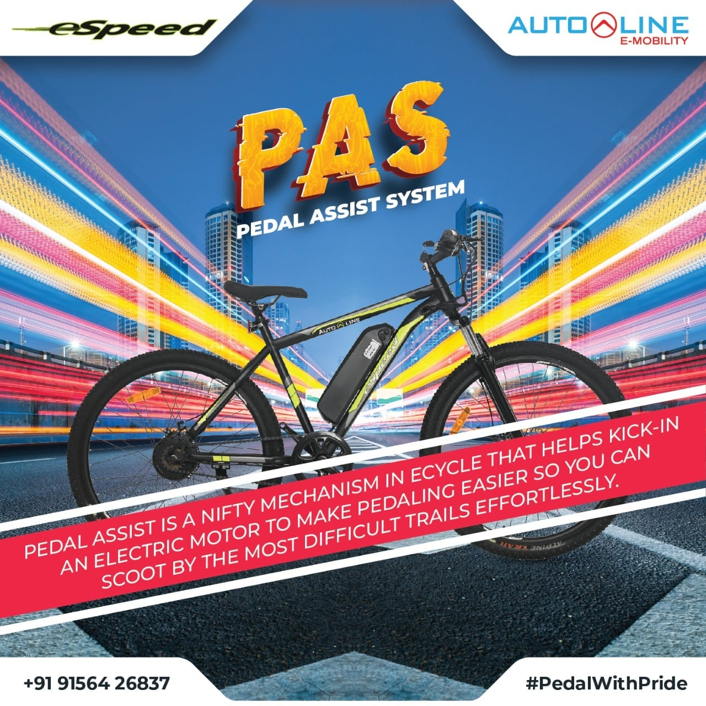

On the company website (in the public domain), they have said that e-cycles are expected to contribute Rs 200 Cr in sales per annum (although over what time frame is not mentioned).



They also have a wholly-owned subsidiary, Autoline Design Software (ADSL), which is essentially an ER&D company.

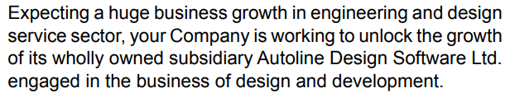

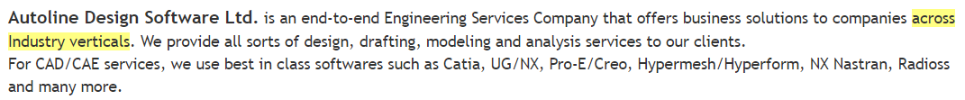

ADSL was not started by Autoline internally; it was acquired.



Since ADSL has parentage of an auto ancillary company, it has an advantage over a standalone auto ER&D company



They are also doing non-auto ER&D



They are providing ER&D services not only to Autoline but also to external clients



The capex to depreciation ratio has decreased enormously, suggesting a possible upturn in the capital cycle. Depreciation can be used as a proxy for maintenance capex. Hence, the ratio of capex to depreciation indicates the proportion of growth capex to maintenance capex. A high ratio suggests that a higher proportion of the total capex is done for increasing supply, which may be a red flag for a capital cycle analyst; on the other hand, a low ratio is typically a positive sign.

The annualized RoCE for Q2 and Q3 FY22 is 15.6% and 18.5% respectively.

Their guidance is for 650 Cr revenue in FY23 with 12% EBITDA margin.

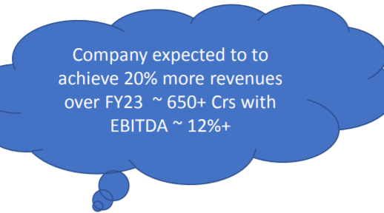

This implies expected FY23 EBITDA of Rs 78 Cr. Against this, TTM EBITDA is Rs 26 Cr. Market cap (as of 20 Apr 2022) is Rs 240 Cr and EV is Rs 350 Cr. This suggests a <5x FY23 EV/EBITDA and <4x FY23 MCap/EBITDA.

Disclaimer: Any analysis shared should not be construed as investment advice. Any analysis is not a buy/sell/hold recommendation. I am not a SEBI registered investment advisor. Please consult your financial advisor before acting on any analysis. The author shall not be liable for any losses incurred by readers while acting on any analysis. The author may have holdings (and hence a vested interest) in any companies mentioned and the analysis may be biased. The content and analysis shared are for educational purposes only.

The writer can be reached at malhar.manek@gmail.com