Growing sales and earnings in annual results…

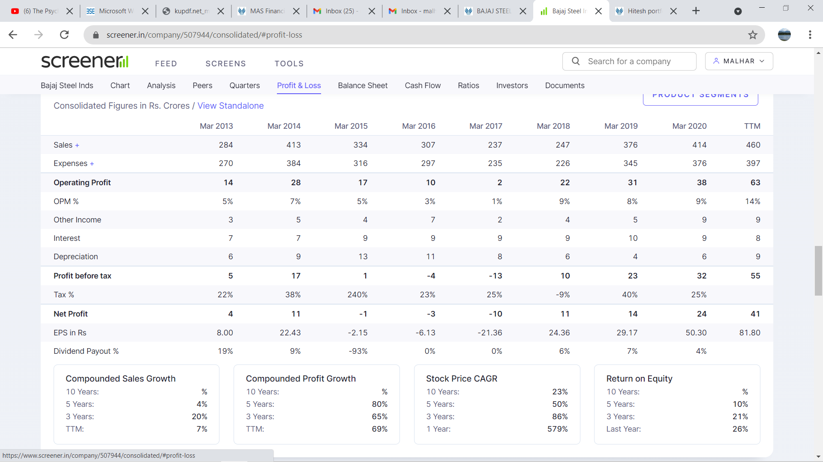

…as well as quarterly results…

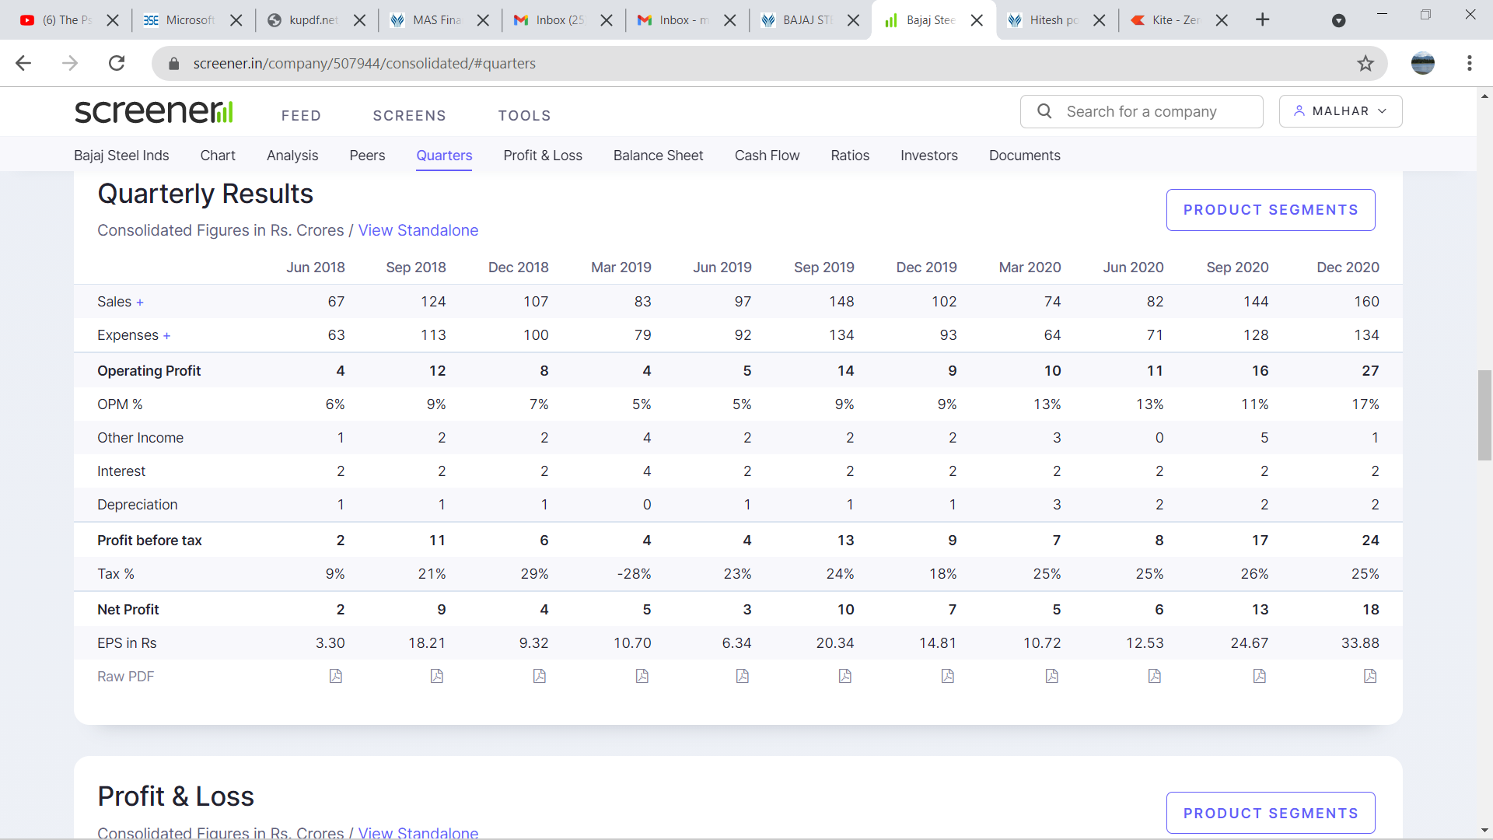

…along with rising RoCE, decreasing debtor days, increase in promoter holding and zero DII holding…

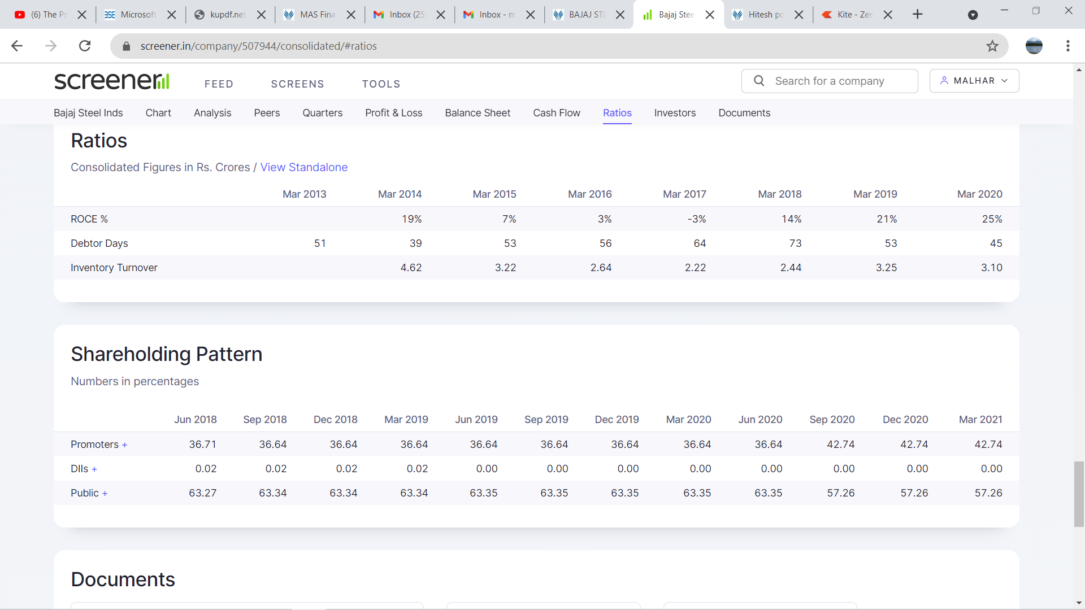

…along with decreasing borrowings…

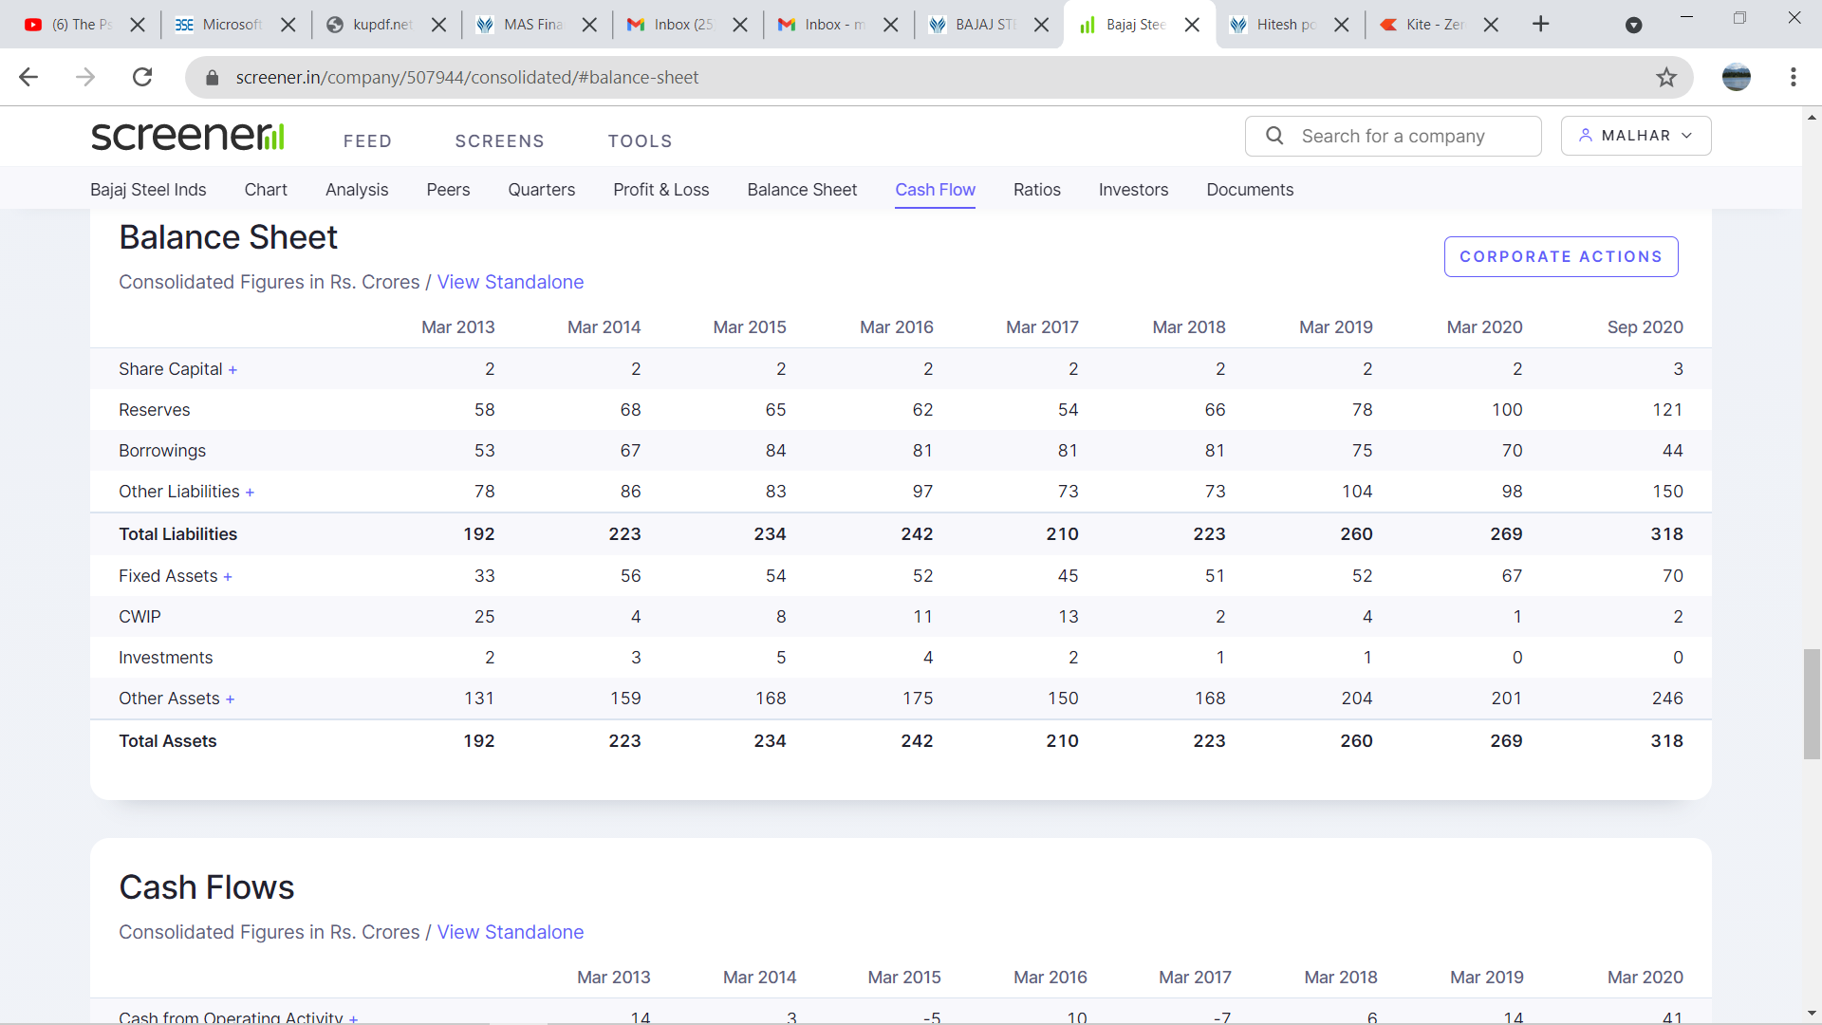

…and improvements across financial ratios…

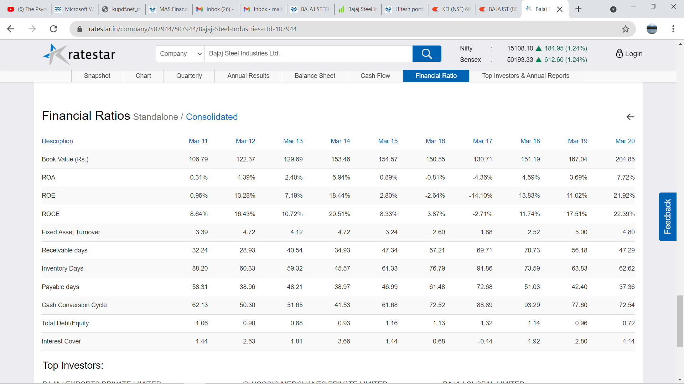

…has resulted in stock price momentum…

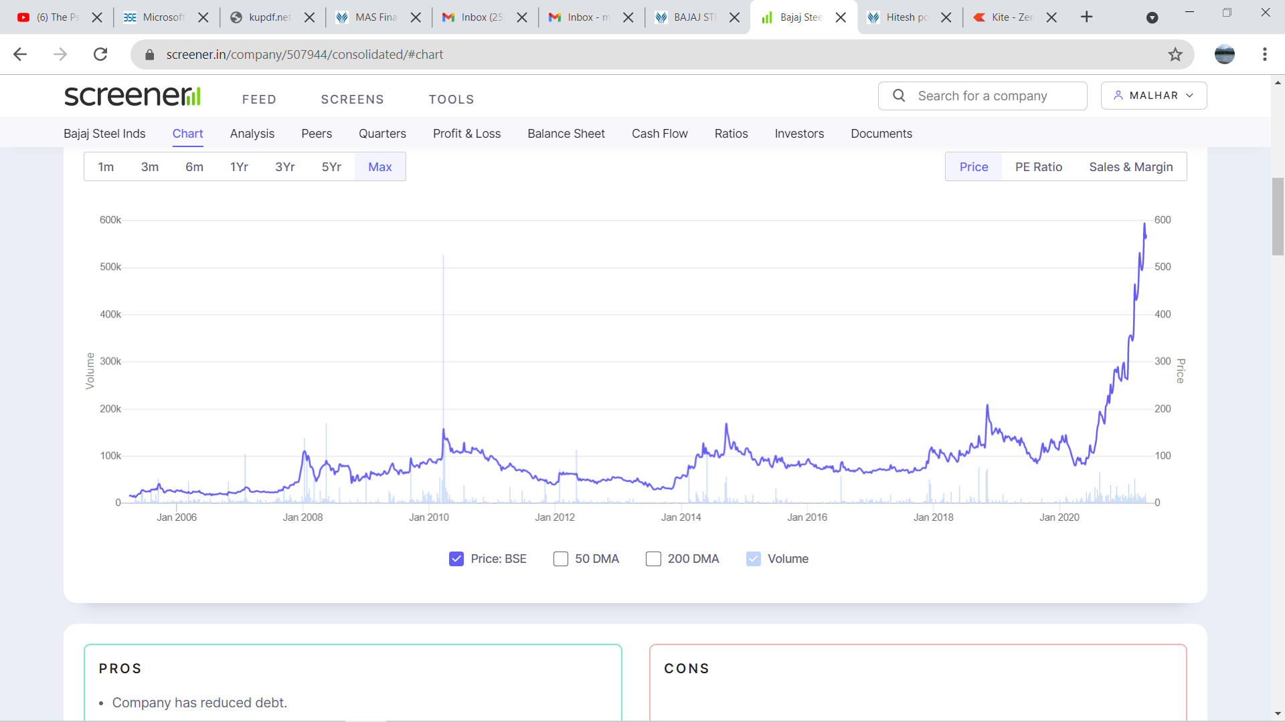

…with rising volumes, visible price trend in monthly cande chart…

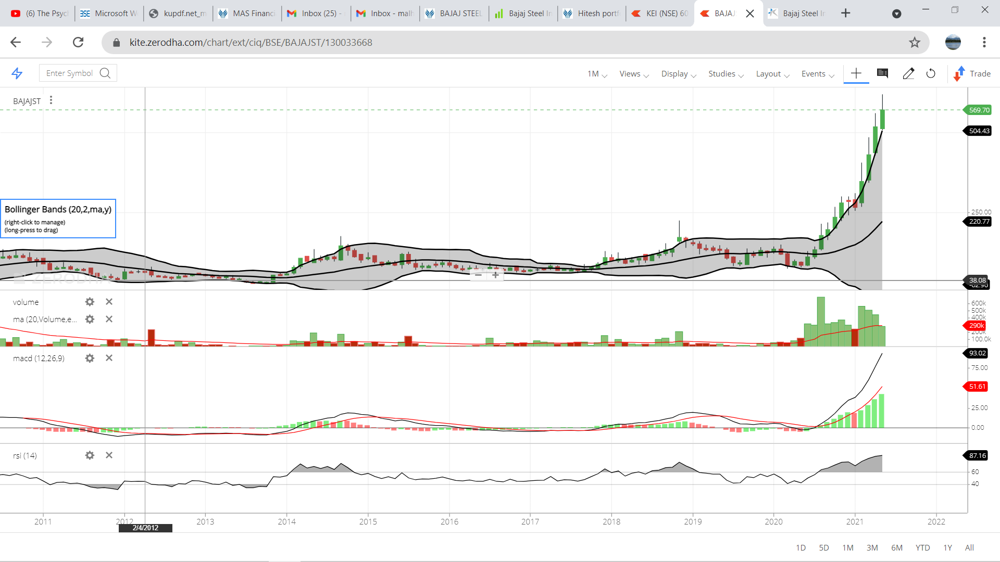

…and the stock is taking support on median of Bollinger bands (20,2) …

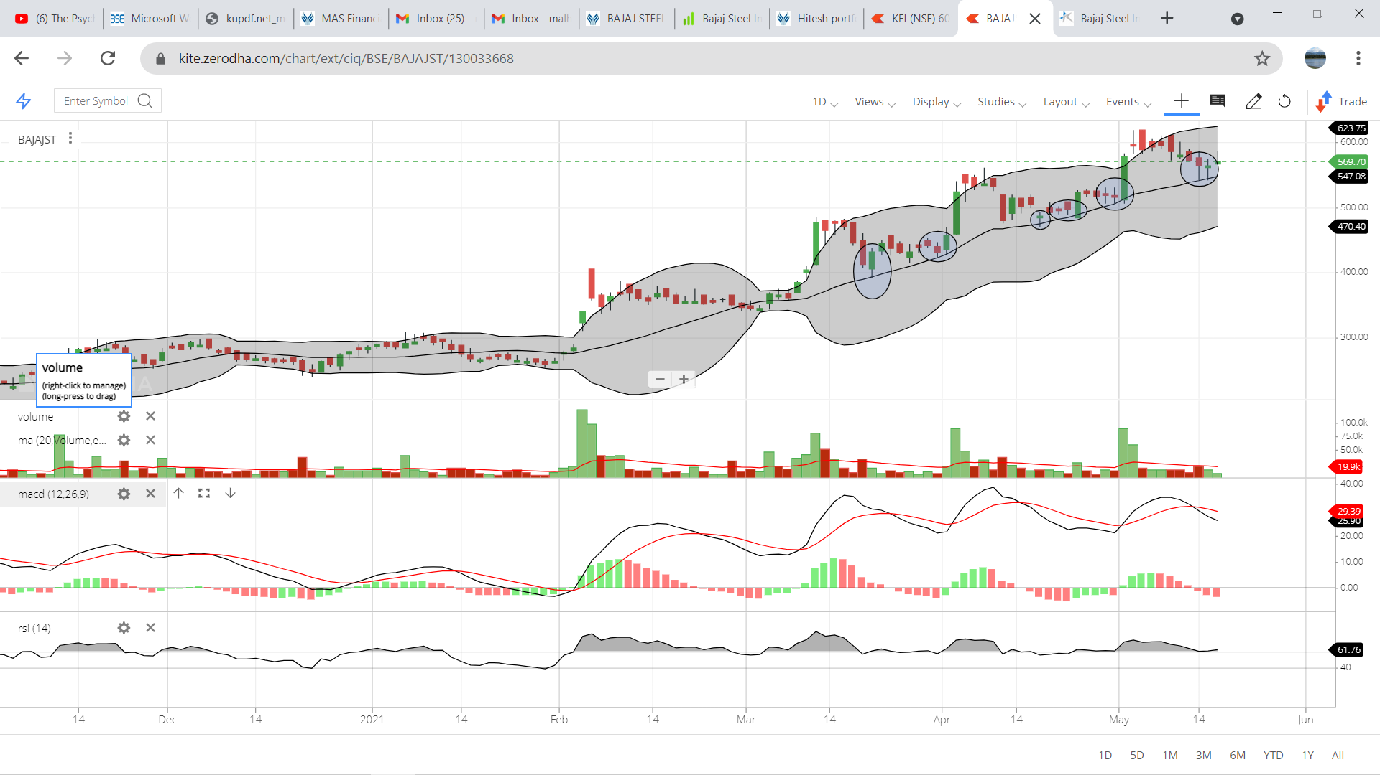

…hence the Bollinger band median around Rs 550 seems like a good entry price

Bajaj Steel Industries Limited (BSL), Nagpur, India, established in 1961, is a public limited company, listed on Bombay Stock Exchange. The company is having world class engineering setup in its various plants situated in and around Nagpur.

BSL is the largest and modern Cotton Ginning and Pressing Plant & Machinery Manufacturer in India. With over five decades of experience and expertise, the company is having world class engineering facilities with diversified sectoral presence.

The company manufactures/sells throughout the world machineries/system of Cotton Ginning, Cotton Conveying, Cotton Cleaning, Cotton Bailing Presses, Delinting and Decorating Machineries, Humidification Systems, Power Transmission Products, Pre - Engineered Buildings, Electrical Panels, Firefighting Systems, Specialty Conveyor, Hydraulics Equipment, Master Batches etc.

The company is serving the Ginning and Pressing Industries worldwide and has been well recognized for its quality and is the only company in the world producing machineries for all the Four Ginning Technologies used in the world viz. Single Roller, Double Roller, Rotobar and Saw Gin and all the Pressing Technologies viz. Down packing, Up packing & Horizontal packing.

The Machineries/equipment’s manufactured under technical collaboration with M/s. Continental Eagle Corporation USA by us, are well accepted all over the world and the company has supplied such machineries/equipment to various advance countries such as Australia, Greece, USA, Uzbekistan, etc. apart from substantial supplies to Africa.

The Company is also expanding its activities in the selling of complete fire-fighting systems including Fire extinguishers, Hydrant systems, Sprinkle systems and Fire Diversion Systems and Steel Doors etc.

The strong vision and dedication of the management and employees has put the Company as one of the biggest manufacturers of Cotton Ginning and Pressing Machineries with distinction of having \*only company in the world with capabilities for manufacturing Cotton Ginning Machines for all the four major cotton ginning technologies being used in the world and enjoying substantial of the market share in India while rapidly expanding in the other cotton growing countries of the world.\*

BSL’s wholly owned subsidiary company i.e Bajaj Steel Industries (Uganda) Limited has completed the project of Cotton Development Organization for Phase -III also in Cotton Seed Processing Plant at Pader District in Uganda. The prospects for the current year are encouraging.

The Company is also trying to increase the revenue from other segments such as PEB, Electrical Panels, Fire Fighting Equipment’s and Specialty Conveyors etc.