Eveready Industries India Limited is one of the leading manufacturers of dry cell batteries in India and offers products such as batteries, flashlights, lighting, and home appliances.

Dry cell and rechargeable batteries (64% of revenue) are sold under the brand names 'Eveready', 'Powercell' and 'Uniross'

'Eveready' and 'Powercell' Flashlights and lanterns (14% of revenue)

'Eveready' and 'Powercell' LED Bulbs and luminaires (18% of revenue)

'Eveready' Small home appliances (4% of revenue)

The company has a total capacity to manufacture 2,250 million batteries and 12.7 million flashlights per annum.

The company has around 50% market share in batteries in India and 70% market share in the domestic organised flashlights market.

There has been poor perceived corporate governance in the past (under the old promoters).

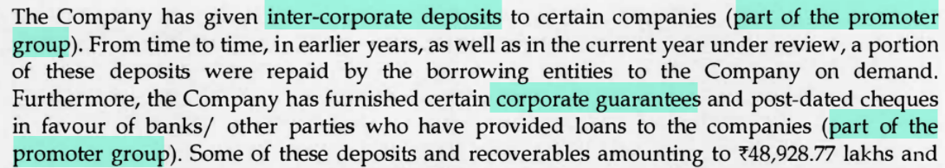

But there has been a clean-up in recent times. One of the major concerns in the past has been large inter-corporate deposits, but a provision has been made for this in FY21

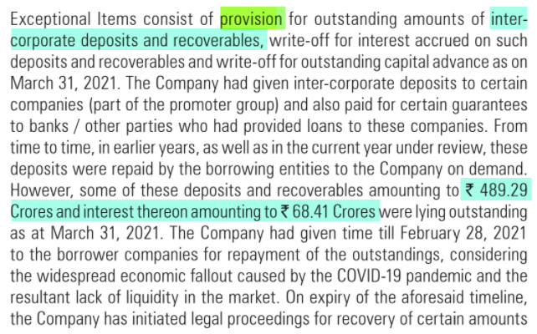

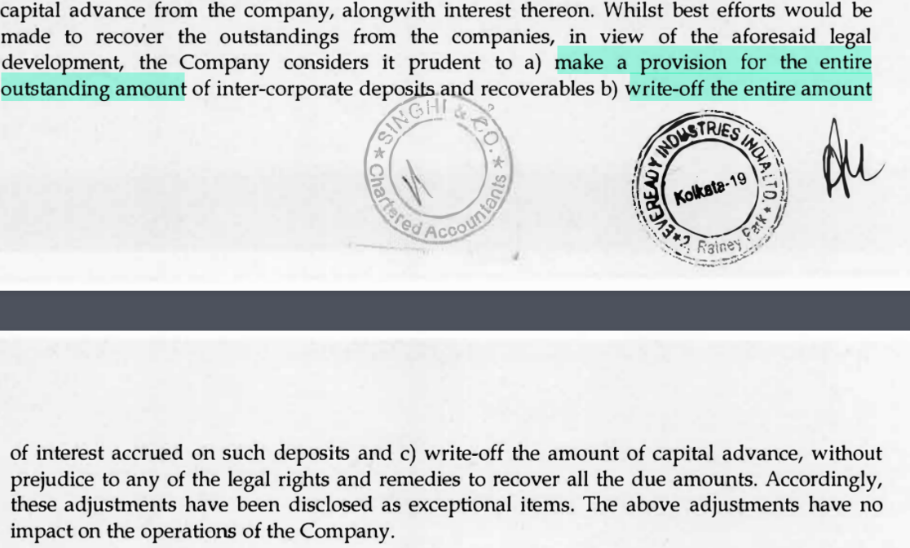

There has also been a reversal in previous accrued interest to clean up the books.

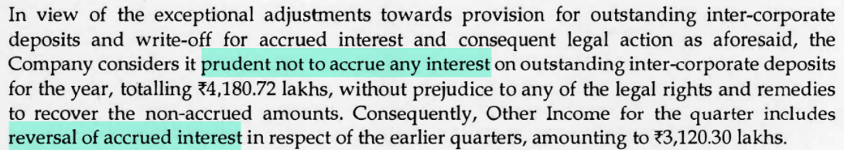

There is promoter change with Burman family (Dabur promoter group) making an open offer for acquisition of 26% stake

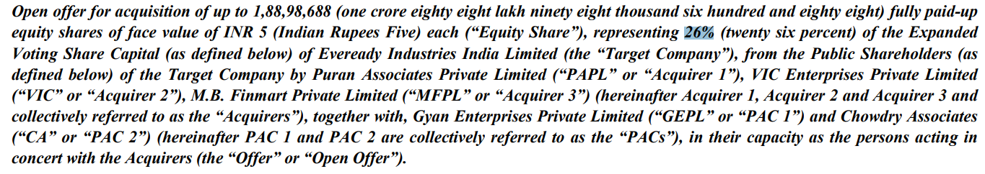

Burman group entities already hold 25%. If completed successfully, they will acquire an additional 26% stake through the open offer, taking their holding to 51%.

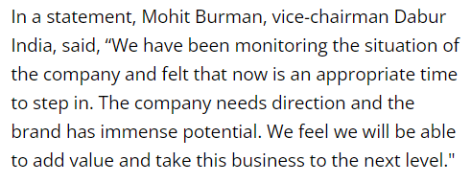

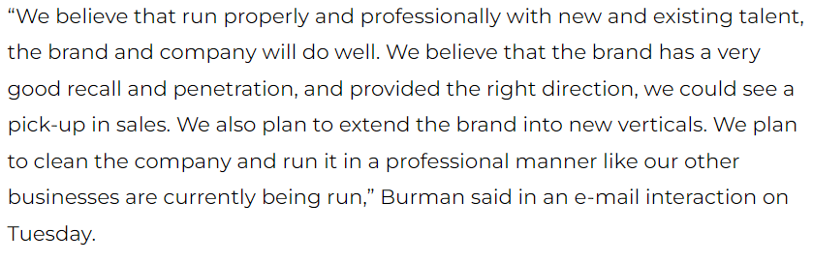

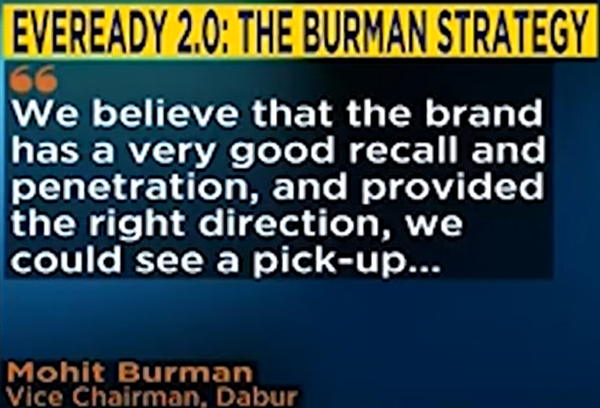

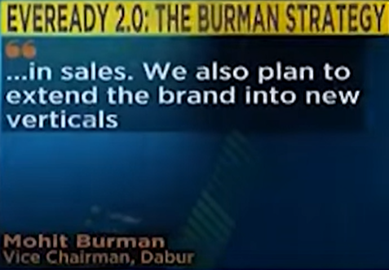

Extension of Eveready brand into other verticals can be an interesting growth trigger

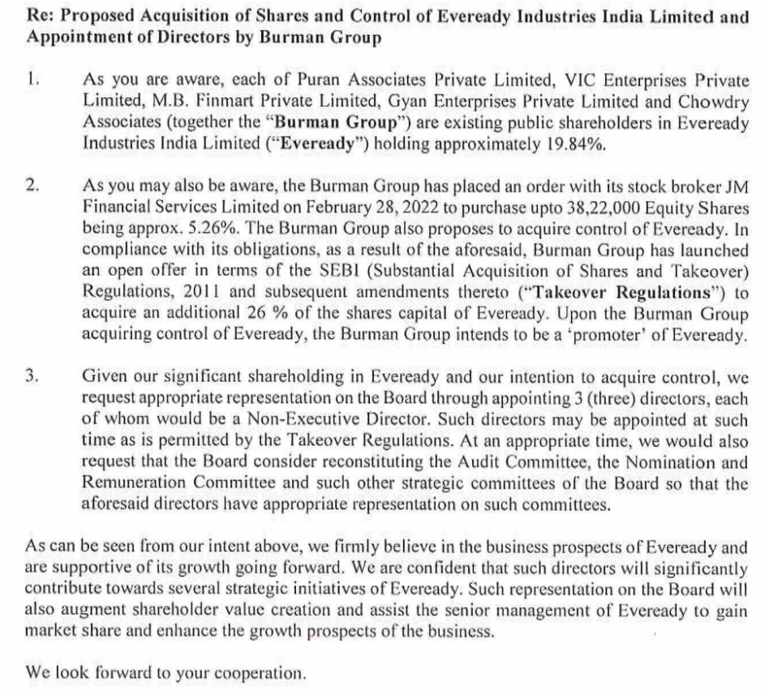

Mr Abhay Khaitan and Mr Amritanshu Khaitan (old promoters) have resigned from the board.

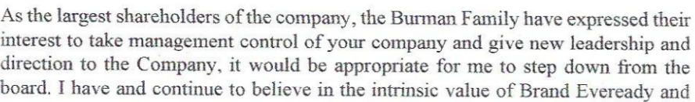

Mr Mohit Burman (vice-chairman of Dabur) is expected to join the board of directors and a total of three board seats (as non-executive directors) will be held by the Burman family.

In Q3 FY22, they have discontinued sales of low-margin appliances products.



In FY21, they refinanced the high-interest debt at lower interest rates. They also created plans to reduce debt even under the old promoters, which they have already begun, with debt being reduced from in Q4 FY21 to in Q2 FY22.

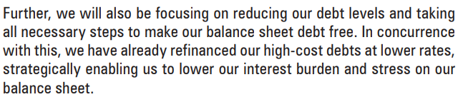

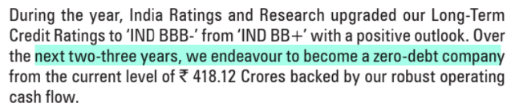

It is likely that debt reduction will be continued and accelerated under the new promoters.

Interest cost was further reduced in Q3 FY22 and was the lowest in 12 quarters, at Rs 11 Cr. This makes it likely that some debt would have been repaid in Q3 FY22 as well.

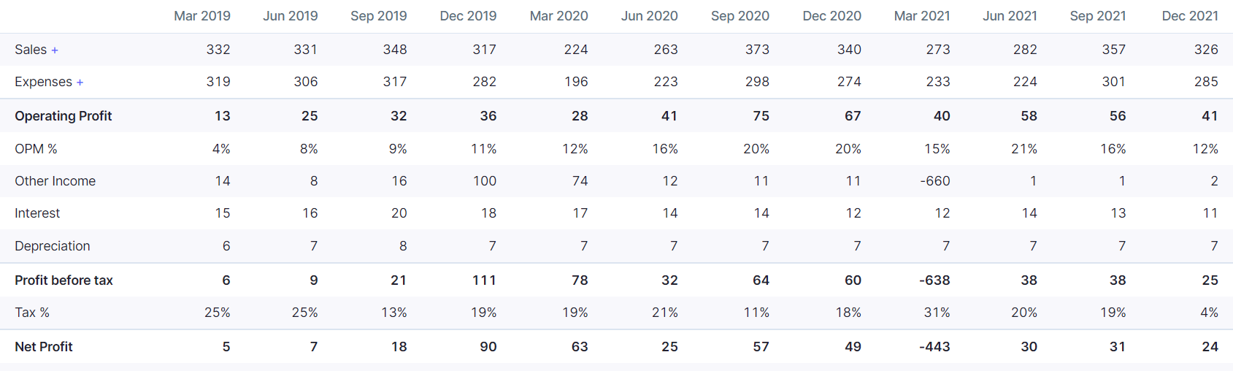



The company has also hired the services of Bain & Company as consultants



They are increasing focus on marketing



Stronger performance is expected from FY23 onwards

