Beekay Steel Industries Limited

Generally steel sector follows a demand-supply cycle and it’s difficult for the companies in the sector to maintain revenue momentum and profit margin. In the past we have seen demand in steel sector majorly depends on various macro-economic factors. Still few companies have managed to perform well in the past, Beekay Steel Industries Limited a flagship company of Beekay group is one of them. Having plant in Jamshedpur (Jharkhand), Visakhapatnam (Andhra Pradesh), Chengalpet (Tamilnadu) and Howrah (West Bengal). Company is in the secondary steel manufacturing segment and produces HR sections (TMT bars, rounds, squares, flats, hexagons and special profiles) and bright bars of different sizes and shapes with different compositions and while engaged in conversion jobs for large institutional players. To cater demand from real estate, infrastructure it has also entered in B2C segment of TMT bar. As on 31st march 2019 total capacity is 760000 MT, which includes special steel product capacity is 260000 (32000 MT added in 2019 itself), TMT plant 0f 300000 MT in Jamshedpur which is completely dedicated for job contract to TATA Steel. Balance 200000 MTPA parwada plant is in TMT bar manufacturing.
Sales growth: Sales growth of last 10 years (2010 – 2019) is 13 %, but if you see this growth is not linear on YOY basis.
Narration | Mar-10 | Mar-11 | Mar-12 | Mar-13 | Mar-14 | Mar-15 | Mar-16 | Mar-17 | Mar-18 | Mar-19
Sales | 312 | 435 | 557 | 571 | 549 | 519 | 519 | 721 | 978 | 960
 |  | 40% | 28% | 3% | -4% | -6% | 0% | 39% | 36% | -2%

In the year 2011 ( Sep 2010) capacity of plant located in Jamshedpur extended by 1 lakh MT.(total 300000 MT) Better capacity utilization lead to 40 percent sales growth on YOY basis. In the year 2012 sales increased due higher turnover from conversion business (292816 MT in 2012 vs 185969 MT in 2011). In the same year furnace oil prices increased by 31% resultant to fall in the OPM, to mitigate the same company planned to shift coal gasifier technology to use coal as alternate fuel. In next four years from 2013 to 2016 sales growth is almost flat due to various reasons like power supply shortage in Tamilnadu and Andhra Pradesh, slowdown in demand, Hudhud cyclone in AP etc.

2012-13
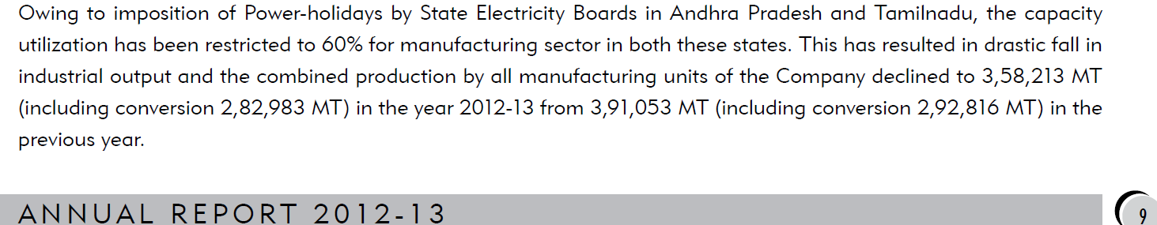

2013-14
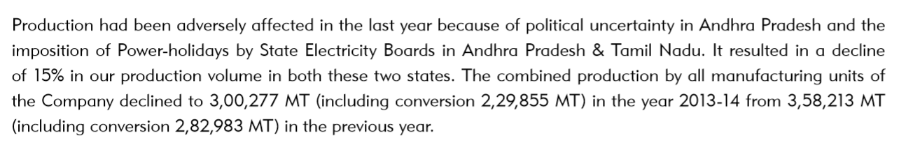
2014-15
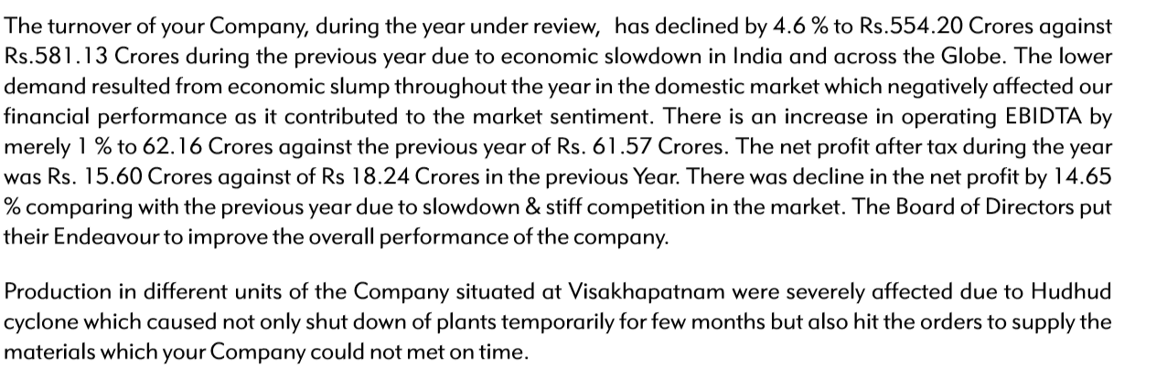
During the year 2016-17 capacity utilization of newly commissioned TMT plant located at Parwada (AP) increased drastically from 15316 MT to 116444 MT which leads to sharp up move in sales. In the year 2017-18 TMT export sales jumped from 67.75 to 237.75 crs and helped to achieve overall 36% revenue growth.
2016-17
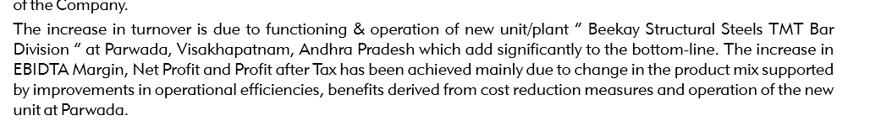
Profit Growth :

As mentioned above Beekay Steel Industries operates in three different businesses secondary steel of different types/sizes and capturing B2C market of TMT from Parwada plant . Company is also in the conversion business for large institutional players like TATA Steel, SAIL and RINL etc, this segment is fixed margin based business and not impacted from fluctuation of raw material.
Narration | Mar-10 | Mar-11 | Mar-12 | Mar-13 | Mar-14 | Mar-15 | Mar-16 | Mar-17 | Mar-18 | Mar-19
Operating Profit Margin (OPM%) | 10.92% | 10.95% | 9.47% | 9.17% | 10.83% | 11.61% | 12.57% | 11.69% | 13.65% | 18.30%
Net Profit Margin (NPM%) | 4% | 4% | 3% | 3% | 3% | 3% | 4% | 5% | 7% | 10%

NPM is in line with OPM margin. From the year 2010 to 2019 OPM is in the range of 9 to 18 % and mostly in uptrend. In the year 2012 OPM fell from 10.95 % to 9.47% and bit more down in 2013 to 9.17%, reason of that fall is mentioned in the ARs of respective year.
2012 : 31% hike in furnace oil , which is major raw material resulting in increase in production cost.
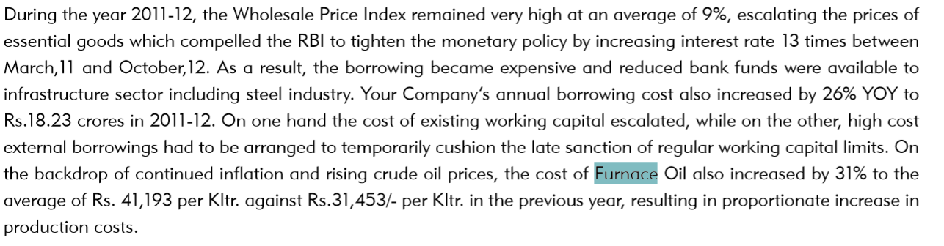
Higher furnace oil cost and increase in coal price also impacted the OPM for the year 2013-14. To mitigate the same management is planning to go with coal gasifier technology to use it as a alternative fuel when there is abnormal price change in furnace oil. From the 2011-12 AR :
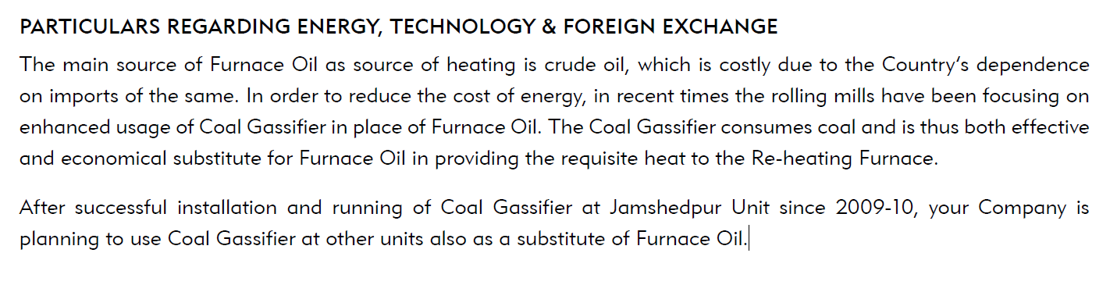
From 2014 onwards management did some changes in operation and product mix to get better OPM. Like in the year 2015-16 company has implemented Pulverising and feeding equipment in Jamshedpur plant to get better fuel efficiency.
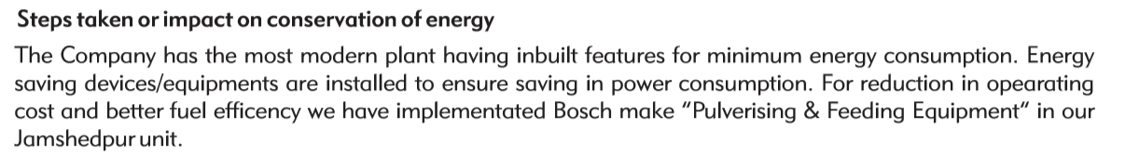
This up move in profitability benefited the company to obtain continuous upgrades in credit rating, which leads to borrowing cost down. The same is mentioned in AR of 2017-18 :
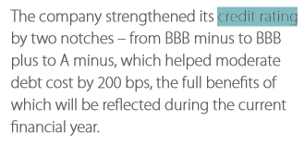

From the 2018-19 annual report :
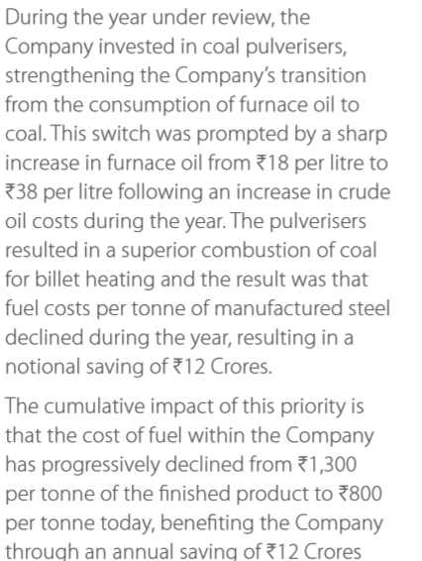

There was a sharp up move in the OPM in the year 2018-19, reason for that is better realization from B2C TMT business from parwada plant and high capacity utilization. In addition to that in last ten years (2010-2019) conversion business grew from 1,69,912 to 431265 MTPA.
Management has also mentioned about better realization and stronger trade terms in the 2018-19 annual report :
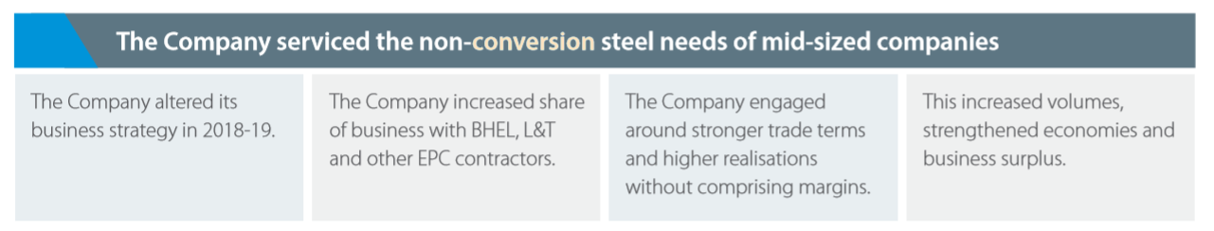
In the credit rating report form India Ratings and Research dated 27 Nov 2019 it is mentioned Beekay steel Industries is a nonintegrated player and has been able to pass on the raw material price fluctuation to the customers with a time lag. In conversion business company is getting free raw material from the customers and earns fixed conversion charges.
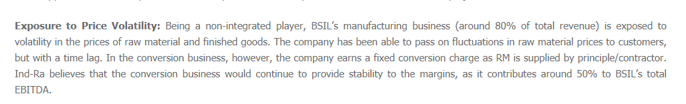
Further, better performance in last 2-3 years helped the company to reduce the debt drastically which leads to low borrowing cost and corresponding improvement in NPM.
Narration | Mar-10 | Mar-11 | Mar-12 | Mar-13 | Mar-14 | Mar-15 | Mar-16 | Mar-17 | Mar-18 | Mar-19
Interest | 11 | 14.46 | 18 | 17 | 20 | 21 | 21 | 19 | 19 | 16
Total Debt (D) | 123 | 131 | 137 | 141 | 168 | 174 | 164 | 186 | 182 | 121

Tax Rate: Company is paying standard tax 30-35%, and paying regular income tax. Recent change in tax rates will further improve the bottom line.

Other Financial Parameters:
- CFO vs. PAT: Company is able converting profit in to cash and doing regular CAPEX. After doing capex there is a free cash flow, which was used in working capital requirements and Debt interest repayment.
Narration | Mar-10 | Mar-11 | Mar-12 | Mar-13 | Mar-14 | Mar-15 | Mar-16 | Mar-17 | Mar-18 | Mar-19

Net profit after tax (PAT) | 11 | 19 | 18 | 19 | 18 | 16 | 19 | 34 | 71 | 99.09 |  | 324
Cash from Operating Activity (CFO) | - | 31 | 32 | 63 | 38 | 37 | 45 | 37 | 48 | 55 | CFO | 387
Capex (NFA+WIP change +Dep) |  | 29 | 39.8 | 50 | 42 | 18 | 12 | 11 | 16 | 35 | Capex | 253

FCF 134
B) - SSGR : In last 10 years sales growth is 13 %, SSGR indicates the source of that growth . Whether it’s funded from debt or internal accruals or equity dilution.
(INR Crores/10 Millions) |  |  | BEEKAY STEEL INDUSTRIES LTD
Narration | Mar-10 | Mar-11 | Mar-12 | Mar-13 | Mar-14 | Mar-15 | Mar-16 | Mar-17 | Mar-18 | Mar-19
Total Debt (D) | 123 | 131 | 137 | 141 | 168 | 174 | 164 | 186 | 182 | 121
Self-Sustainable Growth Rate (SSGR) |  |  |  | 10% | 7% | 4% | 1% | 2% | 11% | 25%

From the year 2017 onwards NPM of the company is improved which leads to healthy SSGR. With the help of better working capital management company is able to reduce the debt and may continue to do so. Net fixed assets turnover ratio (NFAT) is fluctuating in last 10 years from 2.67 to above 5. Reason for the same is low capacity utilization in-between and also in the past company was engaged in trading activities too with its related parties and other business entities. These entities are also operates in the same industry.

C )-NFAT :
Narration | Mar-10 | Mar-11 | Mar-12 | Mar-13 | Mar-14 | Mar-15 | Mar-16 | Mar-17 | Mar-18 | Mar-19
Net Fixed Asset Turnover (High is better) |  | 4.54 | 5.10 | 4.83 | 3.47 | 2.67 | 2.67 | 3.79 | 5.20 | 4.86

D)-Capacity Utilization:
 | 03-2010 | 03-2011 | 03-2012 | 03-2013 | 03-2014 | 03-2015 | 03-2016 | 03-2017 | 03-2018 | 03-2019
Total Capacity | 410000 | 460000 | 510000 | 510000 | 510000 | 510000 | 710000 | 738000 | 738000 | 760000
Capacity Utilization | 257210 | 286180 | 391032 | 358213 | 300277 | 303328 | 411863 | 518592 | 610575 | 606864
 | 62.73% | 62.21% | 76.67% | 70.24% | 58.88% | 59.48% | 58.01% | 70.27% | 82.73% | 79.85%

E) - Working capital Management:
Beekay deals in secondary steel sector and requires to manufacture different type and size of special section, structure etc. as per the requirement of customer. Products are used extensively for Automobile Components, Engineering Industries, Infrastructure and Railways. Inventory turnover ratio is stable and receivable days are improving over the years .
Narration | Mar-10 | Mar-11 | Mar-12 | Mar-13 | Mar-14 | Mar-15 | Mar-16 | Mar-17 | Mar-18 | Mar-19
Receivables days (Low is better) |  | 65 | 52 | 48 | 47 | 46 | 51 | 42 | 40 | 47
Inventory Turnover (High is better) |  | 6 | 6 | 6 | 5 | 4 | 4 | 5 | 6 | 5

Valuation: Stock is trading in single digit P/E. In case of Beekay Steel Industries more important thing to care about E (earning sustainability), rather than P/E mulitle. As per management’s claim in annual reports of last two year that they changed business model and credit rating report (attached above) also mentioned that fact that conversion business that generate around50% of EBITDA providing cushion to the bottom line and volume from conversion segment is increasing each year on YOY basis.

Management:
A) - Background: BSIL is the flagship company of the Beekay group. It was promoted by Mr. B L Bansal in 1957 as a partnership firm, and in 1984, it was reconstituted as a public limited company. Currently Mr. Suresh Chand Bansal is executive chairman and his brother Mr. Mukesh Chand Bansal who is managing director of the company. Till march 2015, shares of the company were listed only on Calcutta Stock Exchange Ltd and Kanpur Stock Exchange. The Equity Shares of your Company are listed on BSE Limited under direct listing route, the trading of shares have started w.e.f. 25 March, 2015. Mr Mukesh Chand Bansal is also in the board of AKC steel which is a listed associate company of the Beekay Steel Industries limited. Beekay steel is paying rent for Land use and machining charges for job work contract executed by M/s AKC steel industries limited on behalf of Beekay steel. If you see annual report of M/s AKC steel industries it is mentioned that major source of revenue is from rent from parent company.
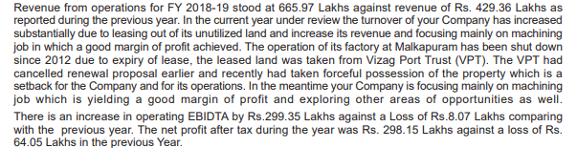
B)- Succession Plan : Next generation of Bansal family is already in the board and engaged in the business :
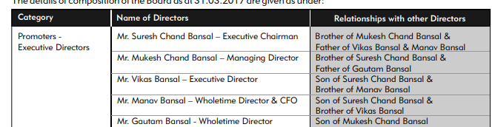

- : Remuneration: Remuneration is in range of 3% to 11 % . In the year 2014-15 remuneration increased 44% from last withdrawn remuneration, in the annual report of the year 2014-15 reason for the same recorded that Mr Manav Bansal has joined the board as WTD and later appointed as CFO of the company. In 2018-19 there was steep jump in remuneration because of higher performance related bonus (around 3 crs) specially by Mr Suresh Chand Bansal . Need to clarify this with management wherterh they will continue to do so or such remuneration was only one time requirement or so.

 | 2009-10 | 2010-11 | 2011-12 | 2012-13 | 2013-14 | 2014-15 | 2015-16 | 2016-17 | 2017-18 | 2018-19
Remuneration | 0.61 | 0.62 | 0.80 | 0.96 | 1.21 | 1.76 | 2.14 | 3.06 | 4.67 | 9.74
Other expenses | 0.29 | 0.04 | 0.04 | 0.05 | 0.05 | 0.06 | 0.11 | 0.13 | 0.14 | 0.16
Total | 0.91 | 0.66 | 0.84 | 1.00 | 1.26 | 1.83 | 2.25 | 3.19 | 4.82 | 9.90
PAT | 11.13 | 18.87 | 18.17 | 19.02 | 18.24 | 15.6 | 19.28 | 34.39 | 70.62 | 99.09
% of PAT | 5.51% | 3.26% | 4.42% | 5.04% | 6.63% | 11.31% | 11.09% | 8.89% | 6.62% | 9.83%
change in PAT |  | 70% | -4% | 5% | -4% | -14% | 24% | 78% | 105% | 40%
change in remuneration |  | -27% | 27% | 20% | 26% | 44% | 23% | 42% | 51% | 105%

D ) : Share holding pattern : It is seems that Beekay Steel industries is very closely held business, Till the year 2016-17 Promoters shareholding was constant to 69.47%, in 2017-18 it decreased by .63 % to 68.48% due to reclassification of some shareholder as public shareholding.
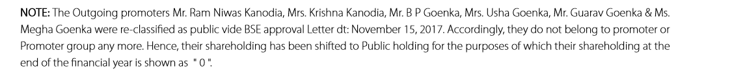
In the year 2018-19 Mr. BL Bansal transferred his holding to the other persons with in promoter group. Also 68550 shares added from market purchase/transfer and promoter shareholding increased from 68.84 to 69.2 %. :
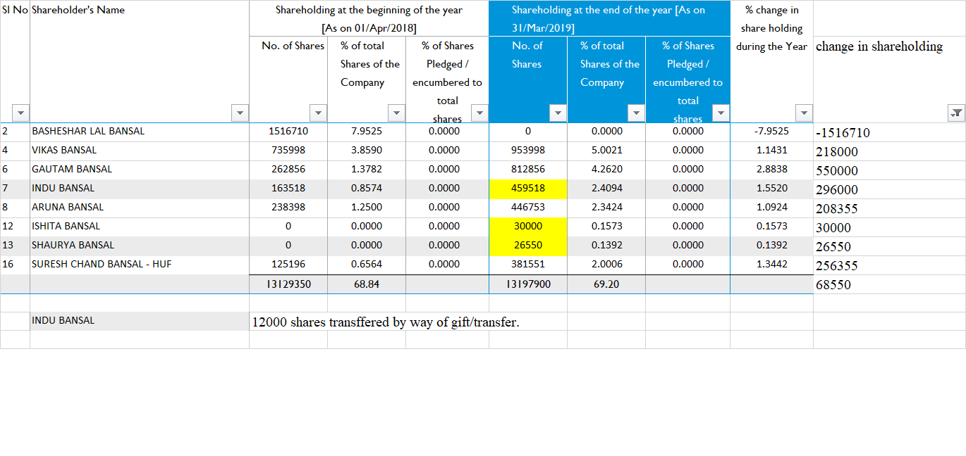
In public shareholding also there is not much retail participation , body corporates are the major shareholders in the pubic shareholders.

E)- Related parties transactions : AKC steel industries Limited which is an associate company of the Beekay Steel industries, which is also deals in the same business. Along with that few more private limited companies where KMP have influence are in business transactions with the Beekay. In the past Beekay was actively engaged with related parties for purchase and sales but at present its very low to negligible level.
 | 2009-10 | 2010-11 | 2011-12 | 2012-13 | 2013-14 | 2014-15 | 2015-16 | 2016-17 | 2017-18 | 2018-19
Purchase from related parties | 81.44 | 72.65 | 58.14 | 45.75 | 25.58 | 25.70 | 25.92 | 3.72 | 1.62 | 2.89
Total Purchase | 213.47 | 318.99 | 378.12 | 392.94 | 400.56 | 361.76 | 344.35 | 500.27 | 656.13 | 604.03
in % terms | 38.15% | 22.77% | 15.37% | 11.64% | 6.38% | 7.10% | 7.53% | 0.74% | 0.25% | 0.48%

 | 2009-10 | 2010-11 | 2011-12 | 2012-13 | 2013-14 | 2014-15 | 2015-16 | 2016-17 | 2017-18 | 2018-19
Sales from related parties | 22 | 40 | 87 | 54 | 30 | 29 | 29 | 3 | 2 | 1
Total Sales | 311.92 | 435.15 | 556.74 | 570.86 | 549.37 | 518.75 | 519.33 | 721.17 | 978.24 | 960.37
in % terms | 7.17% | 9.23% | 15.57% | 9.37% | 5.52% | 5.68% | 5.57% | 0.42% | 0.18% | 0.06%

Other than above transactions there are few transactions for machining works, rent, electricity etc. In Beekay books of accounts there is a long term borrowing of Rs 29 crs from body corporates. A clarification from management will be appreciated regarding such unsecured long term loan , rate of interest and business activities of related parties where KMPs have influence and is there any conflict of interest with beekay due to operation in the same business or not.
In the credit rating report agency has also mentioned about companies trading activites and suspect whether it will be as low as current level or will go up.

F)- Capital Allocation : There is a mix experience with regards to capital allocation in the past. Till the annual report of year 2013-14, company was mentioning about ongoing capex for TLT (Transmission line Tower) Plant, Rs 21.85 had been already incurred on the project. Afterwards there in no information about commissioning of that project .
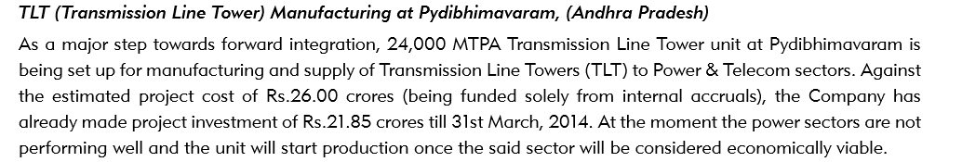
A clarification from management is required to get an idea of current status of the project.
Company has successfully commissioned and currently operating TMT plant at Parwada (AP) which helped the company to achieve growth in sales and bottom-line in last 2-3 years .
Currently Greenfield expansion is going on for 2 lakh MTPA TMT plant in Vizag, expected capex for the project is around 60 crs. In addition to that, approval to establish plant for 2 lakh MTPA in Kalinganagar Odisha is also accorded by the state govt in September 2019. These expansions will fuel the future growth.
In the year 2018-19 1.54 cr investment have written off of Bobbili project , management remark is required to get clear picture on the same.
G)- Other Points to be considered :
1. Income tax outstanding : In the year 2014-15 Auditor of the company mentioned in his audit report that there were undisputed amount payable in respect of income tax relating to year FY 2008-09 and 2010-11 amounting to Rs 1167469/- which is still outstanding. Why an undisputed amount was not paid on due date, this should be asked from management.
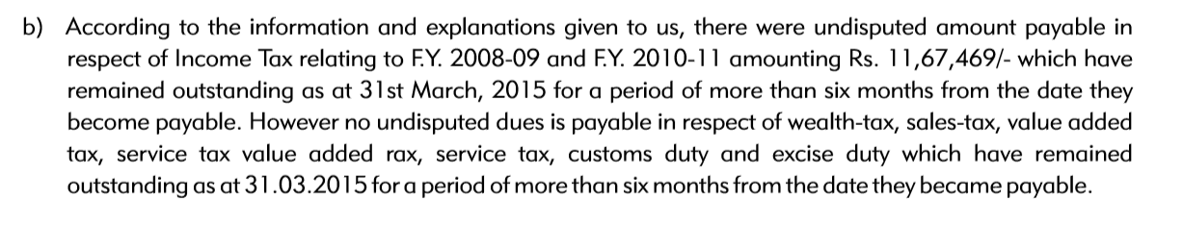
In the year 2018-19 auditor’s report indicates that there were disputed amount payable in respect of income tax which is still payable.
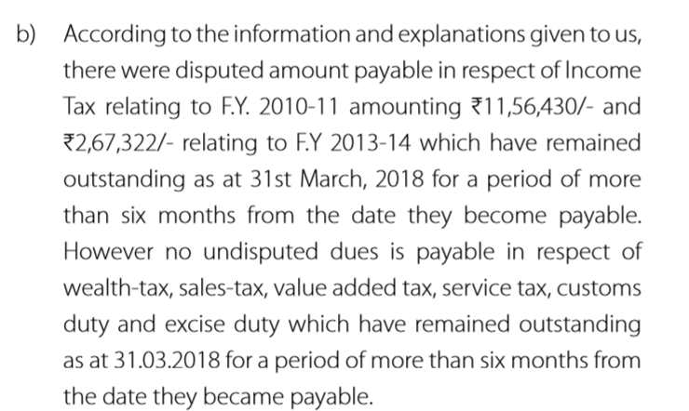
2. Unspent CSR: In the year 2014-15, 2015-16 and 2016-17 company failed to make required expenditure on CSR as required by companies act. Company stated different reasons for the same. From the year 2016-17 onwards CSR committee made few changes, and Mr. Suresh Chand bansal chaired the committee. We can see the result of that change and afterwards company is regular in CSR expense.
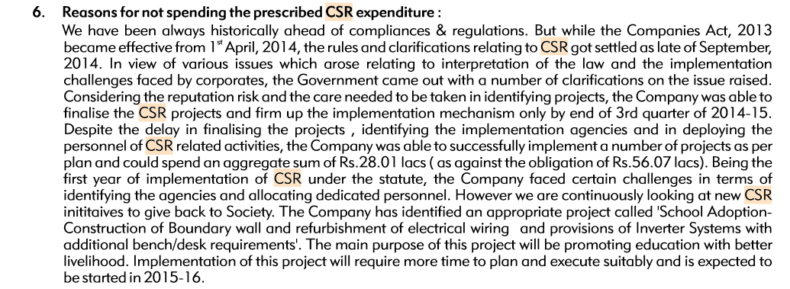
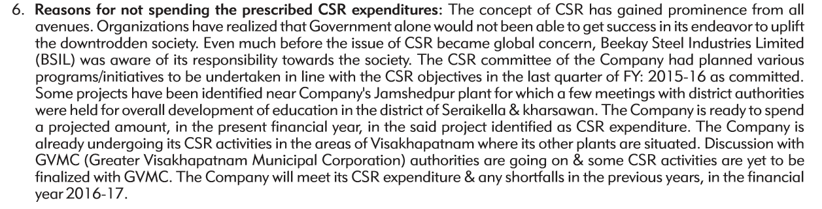

3. Export and hedging policies: Export business is a high margin business, Beekay steel industries have locational advantage to take benefit as most of the plants are located near Vizag port. From the year 2012-13 first time company made exports for 34.23 crs and from there its growing. After commixing of TMT parwada plant export volume have sharply moved up, this also benefitted from capacity shutdown in china in the year 2017-18.
2012-13 | 2013-14 | 2014-15 | 2015-16 | 2016-17 | 2017-18 | 2018-19
34.21 | 55.08 | 36.83 | 26.78 | 79.5 | 275.88 | 131.15

About hedging from foreign currency fluctuations, In the year 2017-18 mentioned mentioned about their practice of settlement of FC positions.
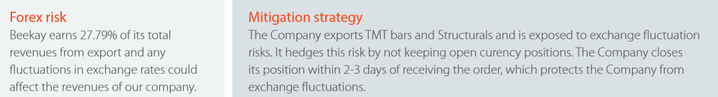

Conclusion: Beekay Steel industries is operating in a cyclical sector but doing something different from others. Consistent up move of OPM in the past indicates its advantageous position in the sector. If company will able to maintain margin in future then it will soon become debt free and future expansion plan also boost up the revenue. Quantum of trading activities( a low margin business (which is also mentioned the credit rating report) with related parties is a area where investor should be careful and may clarify from management about it .

