Frontier Springs

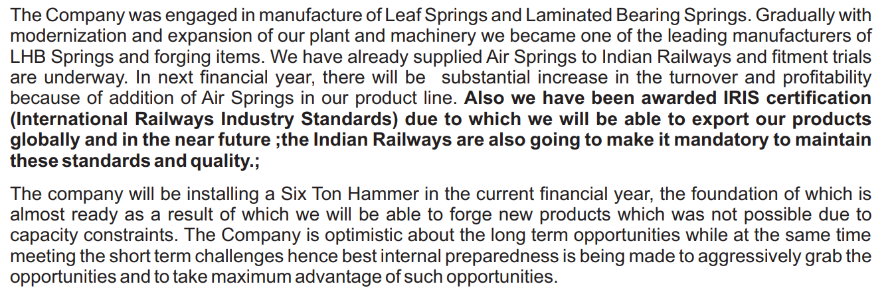

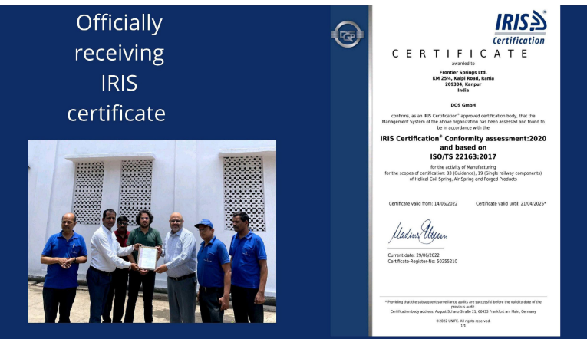





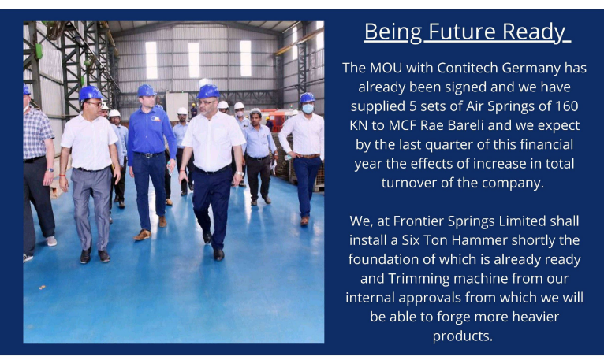

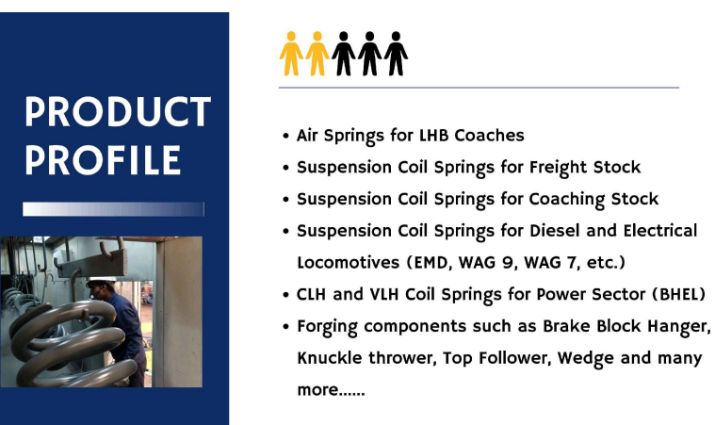



<https://www.bseindia.com/xml-data/corpfiling/AttachHis/dbc6c575-8ae5-470c-93c8-7c252e68da11.pdf>