Gulshan Polyols is into making Starch Sugars, Calcium Carbonate, Agro based Animal Feed, Alcohol business & On-site PCC plants.

Starch Sugars segment includes Sorbitol 70%, Dextrose Monohydrate (DMH), Malto Dextrine Powder (MDP) and Liquid Glucose. GPL is the biggest producer in most of these products in India.

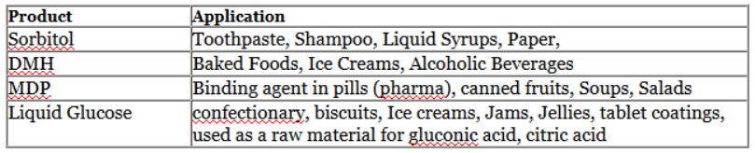

GPL manufactures different types of Calcium Carbonates using Lime stone. Premium quality Activate Calcium Carbonate (ACC), Precipitated Calcium Carbonate (PCC), which finds applications in Plastic industry, Paint, Rubber, Cosmetics and Printing ink etc.

Gulshan provides the know-how to set up an On-site PCC plant and maintains the supply of the raw material for the same. After success of its first partnership in this field, it is tying knot with other paper mills for On-site PCC technology.

Gulshan is supplying PCC for alkaline paper to Paper Mills like ITC Ltd, TNPL, BILT, Shree Krishna Paper Mills Ltd etc.