Brand Concepts is into trading of travel gear & small leather goods, handbags and accessories

They have exclusive franchise of Tommy Hilfiger and Trademark licenses of HEAD, AND and Global Desi. In addition to the licensed brands, they also have own brands i.e., Sugarush (ladies hand bags) and The Vertical (backpacks).

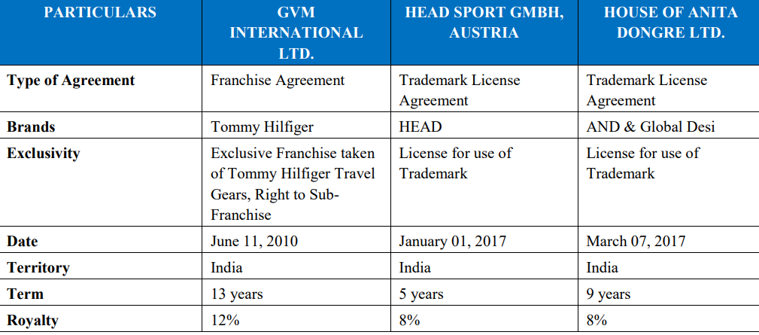

The Company enters into franchise or trademark license agreements with reputed brands.  
Analyses the brand and other factors and creates a product design, a sample is manufactured and on approval from the brand it outsources its manufacturing activities to the manufacturers located in India and China (majorly).



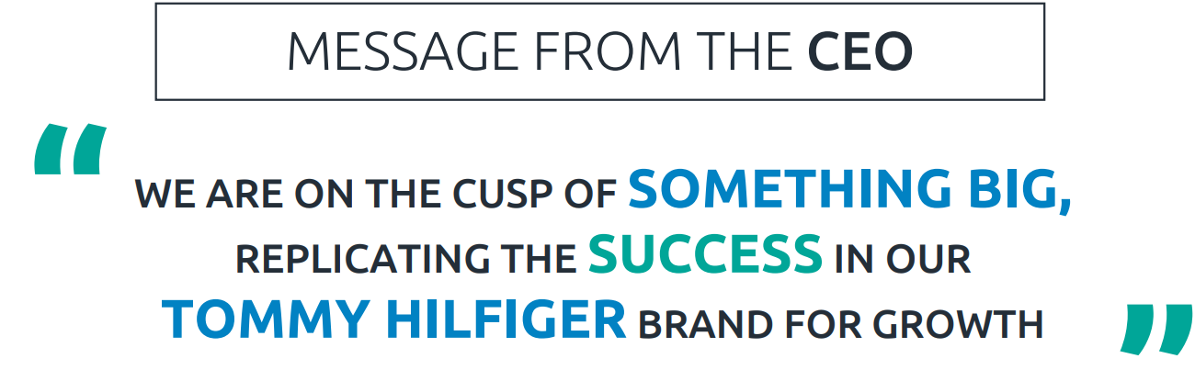

Q3FY22 was a landmark quarter

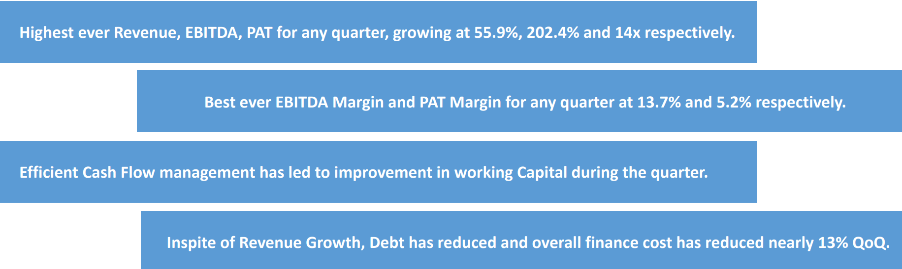



They are considering own manufacturing





