Quest Softech

There is a promoter change. New promoter is AV AC DC Renew Pvt Ltd

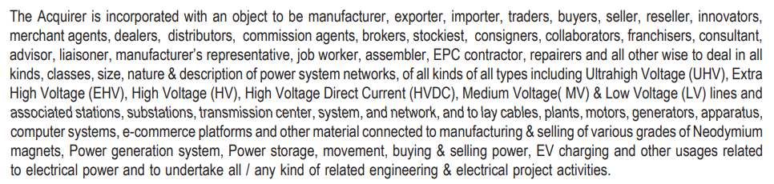

Shareholding of AV AC DC Renew Pvt Ltd:

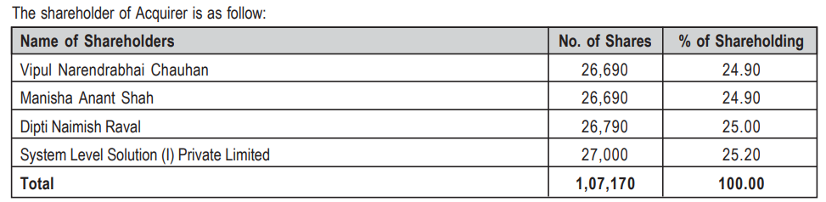

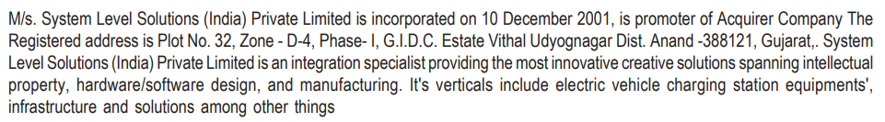

System Level Solutions is into IoT, EV charging, smart street lights etc.

<https://www.sebi.gov.in/sebi_data/commondocs/sep-2022/QSIL_LOF_p.PDF>

<https://ampvolts.com/>

