- A division of profits between the limited partners and general partner, with the first 6% per
year to partners based upon beginning capital at market, and any excess divided one-fourth to
the general partner and three-fourths to all partners proportional to their capital. Any deficiencies
in earnings below the 6% would be carried forward against future earnings, but would not be
carried back. Presently, there are three profit arrangements which have been optional to
incoming partners:
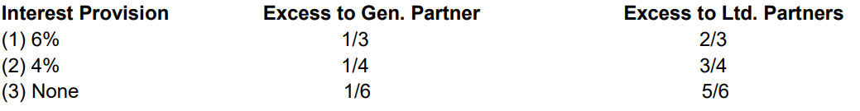
In the event of profits, the new division will obviously have to be better for limited partners than
the first two arrangements. Regarding the third, the new arrangement will be superior up to 18%
per year; but above this rate the limited partners would do better under the present agreement.
About 80% of total partnership assets have selected the first two arrangements, and I am
hopeful, should we average better than 18% yearly, partners presently under the third
arrangement will not feel short-changed under the new agreement;
- In the event of losses, there will be no carry back against amounts previously credited to me
as general partner. Although there will be a carry-forward against future excess earnings
- A provision for monthly payments at the rate of 6% yearly, based on beginning of the year
capital valued at market. Partners not wishing to withdraw money currently can have this
credited back to them automatically as an advance payment, drawing 6%, to purchase an
additional equity interest in the partnership at year end. This will solve one stumbling block that
has heretofore existed in the path of consolidation, since many partners desire regular
withdrawals and others wish to plow everything back;
- The right to borrow during the year, up to 20% of the value of your partnership interest, at
6%, such loans to be liquidated at yearend or earlier. This will add a degree of liquidity to an
investment which can now only be disposed of at yearend. It is not intended that anything but
relatively permanent funds be invested in the partnership, and we have no desire to turn it into a
bank. Rather, I expect this to be a relatively unused provision, which is available when
something unexpected turns up and a wait until yearend to liquidate part of all of a
Partner’s interest would cause hardship;
(F) An arrangement whereby any relatively small tax adjustment, made in later years on the
partnership’s return will be assessed directly to me. This way, we will not be faced with the
problem of asking eighty people, or more, to amend their earlier return over some small matter.
As it stands now, a small change, such as a decision that a dividend received by the partnership
has 63% a return of capital instead of 68%, could cause a multitude of paper work. To prevent
this, any change amounting to less than $1,000 of tax will be charged directly to me.

