LT Foods Limited By Aadesh R Chhajed
Management Discussion And Analysis
Following are key takeaways from Interview of Chairman Mr Vijay Kumar Arora and Aswani Kumar Arora
1. USA Business Updates
- Exports to 65 countries
- Royal is no 1 brand in USA and has market share of 50 %
- USA business Showing a CAGR of 30% for 5 years

2. Domestic Business and Sector Commentary
- Volatility in basmati prices hence realization affected
- Prices of basmati dropped by 17 % but realization dropped only 15 % because of brands
- Volume Growth of 25 %
- Launched Devaya and Ecolife brands
- Acquired Rozana and elephant brand from HUL ( Rozana is popular mid level brand which sells from 55rs- 80 rs per kg in retail market.Daawat is premium brand generally priced over 90Rs/ kg)
- Extensive advertising for Daawat , market share increased in key urban market
- Credit rating by CRISIL improved to “BBB+/Stable” for our long term bank loans and “A2” for our short term loans.
- Last 3 years number of Distributors doubled and no of retailers passed 150,000
- Introduced new High value products like rice staples
- Devaya Staples launched , Company expects it to become another important brand , Its available globally

3. Financial Performance
- Revenue Growth : 7 %
- EBITDA grew by 17% to `363 crores, and the EBITDA margin expanded by 106 basis points to 12.2%
- Profit before taxes excluding exceptional items grew to `163 crores, up by an impressive 47% from the previous year.
- Ended the year with a ratio of net debt to EBITDA of 4.40 times. At the close of the year, the consolidated net worth Company stood at ` 571 crores and consolidated gross debt was 1,597 crores. The cash and bank balances on a consolidated basis was ` 26.12 crores and the net debt to equity ratio was 2.80 times.
- In the near term, company aims to support growth through cash accruals
- Debt reduced by 100 Cr
- Insurance claim pending worth Rs 200Cr Approx

- 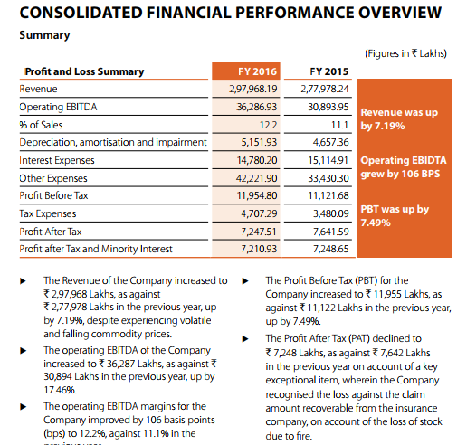

4. Strategies in FY 2015-2016
- To Create Strong Brand , Brand ambassadors Amitabh Bacchan and Sanjeev Kapoor
- organic business has been one of the fastest growing segments with a CAGR in excess of 55.3% from FY2011 to FY2016 and has contributed more than 224 crores to our topline in FY2016
- Strategy to grow our manufacturing capabilities in an asset light way. Apart from own plants, Company also contract out to more than five other 3rd party facilities
- 50-50% JV agreement with the Future Group (Kishor Biyani) during FY2016, for processing and distributing Sona Masoori and rice into the southern region of India

Financial Highlights
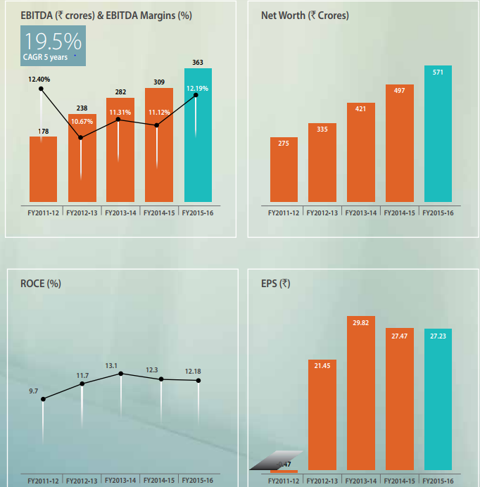

Brand Details
- Daawat : Premium Brand , 18 % Market Share of all brands , 55 % in premium brands
- Royal : No 1 brand in USA , 50 % market share
- Devaya : Launched in 2016, provides rice staples , Chakki Atta become 3rd brand in 1st year
- The “Devaaya” branded business has been one of most successful business segments, having recorded of 195% from FY2015 to FY2016. It has contributed ` 17 crores to our total revenues in FY2016.
- Launched Ecolife brand in North Atlantic
- Acquired Gold Seal Indus valley – Entered in Baharin, Qatar and Oman because of This brand
(This market is completely dominated by KRBL –Along with Saudi which is top market for Export )
- Soft launch of Saute Souces which will be launched in FY 17 in 56 cities
( haven’t seen products yet , either they delayed or was not big hit)

Management Discussion And Analysis
FY 2016 was tepid year with less demand with moderate demand
The domestic basmati rice market is estimated at 10,000 crore, while exports account for 19,000 crore. Basmati makes up 75% of the total packaged rice industry pegged at 13,000 crore
The Rabobank report sees considerable growth prospects in the domestic branded market in the future.
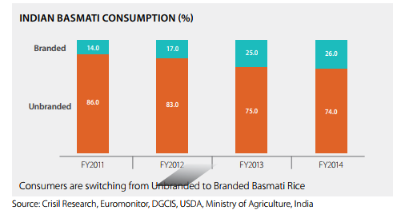
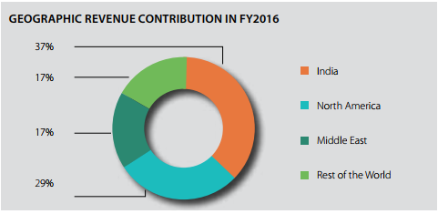
(Important point to note is that AR talks about growth in Europe, USA and Canada
While middle east growth is not mentioned, Middle east is world’s largest market for
Basmati. Its been completely dominated by competitor KRBL.
Acquisition of Indus valley brand has given them entry in Middle East, if they grow there
Then EPS will shoot up . However it is difficult task)

Capex
Going forward, the Company intends to make major Capex investments only on the Value Added segments of its business. Currently, the Company has utilised more than ~90% of its core capacities and as this fills up, it has the option to continue growing by taking an asset-light model of outsourcing from strategic supply partners.
Latest Update : Inaugurated Plant in Rotterdam Europe

New Generation Joined

Investments made by company

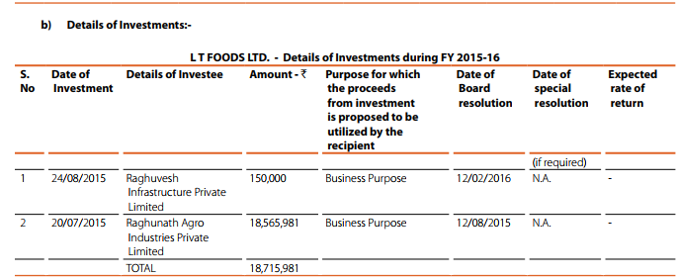

There is no mentioned in whole AR.
I need to get back to previous AR about to get idea about these
I don’t understand what Infrastructure company doing here
LT Foods holds 30 % share in this company and have marked this as associate company

Latest Developments
Dolly Khanna Entered in last quarter and added more in this quarter
India Agri business fund is systematically exiting for LT Foods and it holds 10 %
Company opened a plant in Rotterdam Netherlands

Latest Developments ( From Investor Presentation)
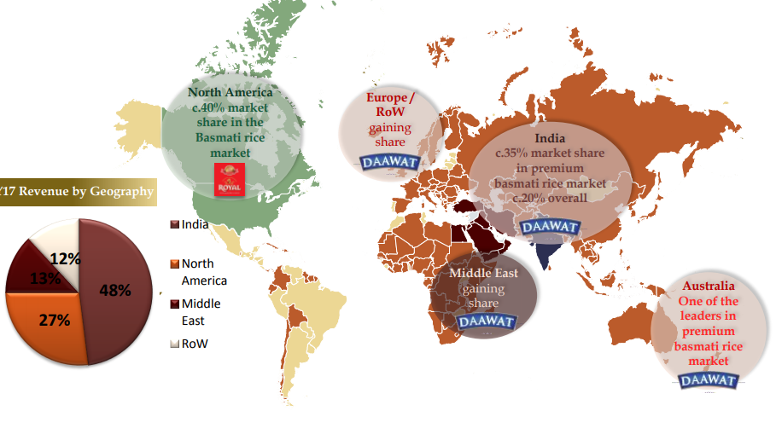
If we compare this with picture of AR , india market share is increased
Middle east is still stagnant so either new acquisition brand not able to topple KRBL
However Daawat is taking market share in india from india gate (Flagship of KRBL)

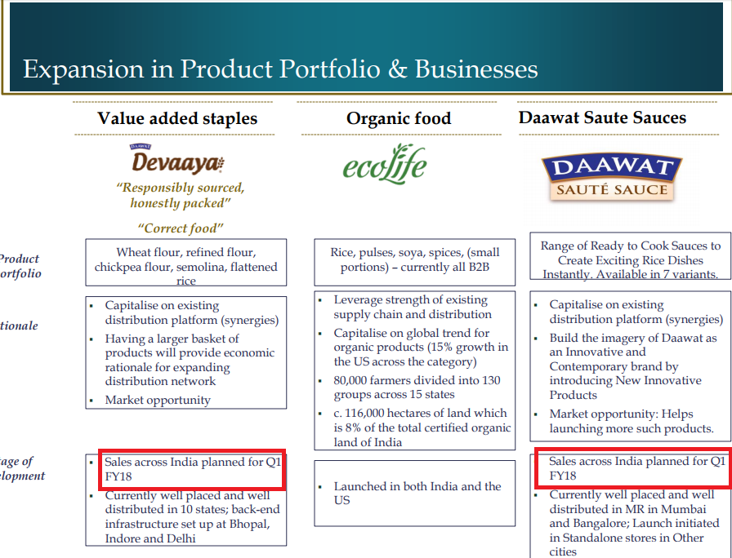

So this explains my previous doubt that I have not seen saute sauces so expecting them to be hit in local market
In Investor presentation, Management explicitly mentioned that they aim to grow by 15-20 % CAGR
And aim to cut debt and improve margins by 200bps

Concall Important Points
Concall Date : Q4 FY 2017
Key Takeaways
- As per AC Nielsen data our constant focus on strengthening our consumer focus has helped us to gain 20% market share of the branded Basmati Rice market in India. This is roughly double of the market share that we had around eight years to ten years back.
- increase branded sales by 25%
- The volume growth in Indian market was 27% and in international market was 14%
- JV with Kameda Seika ( Japanese Company ) for Rice Snacks and crackers
- The test launch of the Rice crackers is planned for August - September 2017 ( I checked for reviews on amazon for rice crackers to understand global results , reviews are very good)
The U.S. subsidiary is working on the RTE products, that is, ready to heat rice the 2-minute retort rice which is expected to be launched in the U.S. market in September
- debt equity ratio from 2.7 to 2.3.
- Iran ban : Evrey year by September to November so will be opened by November.
- GST 5 % on brands : he answered “, earlier we were not getting the offset by other services, but with GST they put on the packaged rice, will good for LT Foods. Yes, positive for LT Foods.” (didn’t get how it will be positive)
- In one of questions he said that LT Foods will be able to pass cost to consumers if prices of raw material increase ) ( I m skeptical on this)
- Regarding question about insurance claim he said its going very positive and expecting decision this year
- Inventory of 166,000 tonnes is Paddy and 132,000 tonnes is Rice. Paddy is Rs. 26 and Rice is Rs. 47.
- Regarding margins he said that “Yes, percentage margin will be maintained. If you see the last quarter the price realization has gone up and I think in the first quarter also. So, we will be able to maintain our percentage margin.”

Annual Report 2017

Following are key takeaways from Interview of Chairman Mr Vijay Kumar Arora and Aswani Kumar Arora

- LT Foods is now an emerging Global Food Company with a focus on basmati and other specialty rices, organic foods and convenience rice based product
- Promotion spends to 1% in FY2017 from 0.1% in FY2013
- In US alone, LT Foods has a market share of over 40% and is growing at a CAGR of more than 20%.
- evolving swiftly from being an established branded rice company to an emerging global Food Company, with new strategic advancements and product developments underway
- Capitalized on global trends and invested in growing our product base to include our organic range, sauté sauces and fast cooking brown rice
- setting a plant for Ready-to-Heat (RTH) organic products in the US
- India Business has been growing at a CAGR of 14% over the period FY 2012-17
- first rice processing plant by any Indian food brand in Europe (Rotterdam)
- year of strong growth with solid underlying sales growth of 27% and 14% in India and the International market respectively.
- debt equity ratio reduced from 2.77 in the previous year to 2.30
- ecoLife was recently launched in the US with a presence across all the chains of Walmart and other ethnic channels
- LT Foods is also working towards launching this brand in the Indian market with a full range of products, including Pulses, Spices, Oil, and Nuts, beside Rice and Flour
- Cooking Brown Rice and Daawat Saute Sauces. Both the products have been well accepted by the consumer and are performing exceedingly well. Daawat Saute Sauces include a range of Ready to Cook Sauces, available in seven variants to create exciting rice dishes instantly. Currently wellplaced and well-distributed in modern retail stores of Mumbai and Bangalore (Not able to find anywhere)
- plan to launch the product in standalone stores in other cities as well
- Its portfolio comprises 40 products and includes organic rice, pulses, soya and spices; launched across 13 states in India. It is the first Company in India to export certified organic basmati rice
- LT Foods augmented its product portfolio with the launch of value added staples such as wheat flour, refined flour, flattened rice, chickpea flour, and semolina under the brand ‘Devaaya’. These staples are now available in 11 countries, including India, and are witnessing growing consumer acceptance
- China agreeing to import basmati rice from 14 companies in India, including LT Foods
(This is tricky as Export policy changes and with current tensions with china ,this permission might be withdraw)
- JV with Japanese Snack Food major Kameda:
- Organic business has been one of the fastest growing segments in the Company, growing at CAGR 44% from FY2012 to FY2017, and has contributed Rs 240 crore to the top-line in FY2017.
- The Company’s dedicated organic brand ecoLife was introduced in USA and India. The brand is equipped with the certifications from various reputable national and international certification agencies, including ECO-CERT, the Control Union Certification, BIO-CERT, ONE-CERT, NPOP Standard of India, EU Organic Standard, USDA’S NOP, and Bio-Suisse Standard of Switzerland. These certifications ensure that organic products are grown to go directly from the farm to the family.
- Fortified Rice: LT Foods is working with DSM Nutritional products to introduce fortified rice as a new offering in the nutritional range. This venture will strengthen the Company’s presence in the nutritional product segment
- Modern Wheat Silos: Madhya Pradesh Warehousing & logistics Corporation (MPWLC) had awarded LT Foods two projects in Bhopal and Indore in [year], for the construction, operation, and maintenance (DBFOT) of modern wheat silos, for a period of 30 years,
- nvestments were also made towards enhancing the flour capacity (from 1 TPH to 2 TPH) and setting up a CO2 treatment plant in Bhopal. The annual milling capacity of Bhopal is 1,80,000 MT, of which 85% of the capacity was utilised during the year
- The Company is gradually moving towards an asset light model. Going forward, LT Foods will steadily outsource the manufacturing of low value items, and utilise its facility for manufacturing value added products.
- LT Foods Americas (the wholly owned North America subsidiary) has been expanding its ecoLife Brand of Organic products in North America. New products like Grains, Ancient Grains, Lentils, and Beans, were developed in organic format and launched with major retailers in USA. Going forward, five new organic ‘Ready to Heat’ retorted pouch products are planned to be launched under the ecoLife banner. Furthermore, new retort processing capability is being added at Houston site in

Brand Portfolio
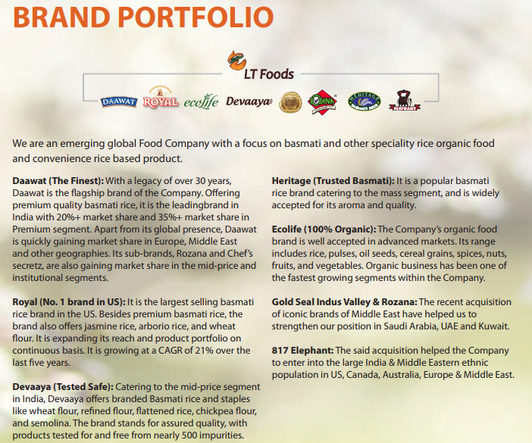

Entire new Mention related to packaged food and ready to eat food
New Products are mentioned along with sector view. Clearly its in line with what company communicated that it want to become FMCG Company

New mention about non basamati rice
Jasmine Thai
• Brown Jasmine Thai
• Arborio
•Sona Masoori
• Sona Masoori Organic
• Kerala Mata rice
• Ponni rice

LT Foods managed to reduce its inventory cycle from 234 days in FY2012 to 220 days in FY2017.

Financial Highlights
