CFF Fluid Control



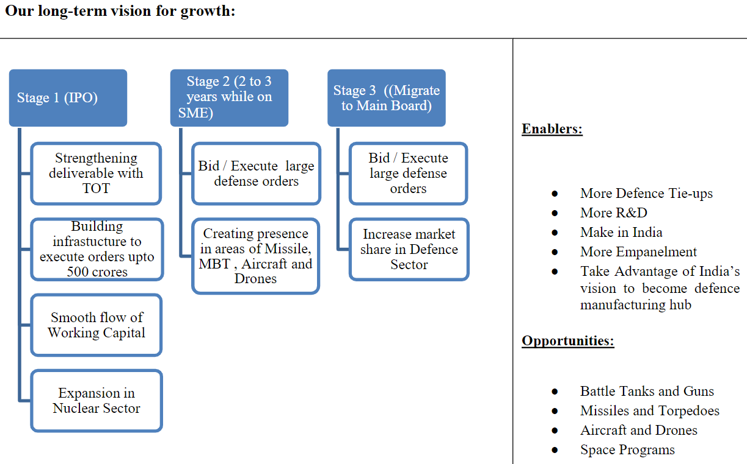

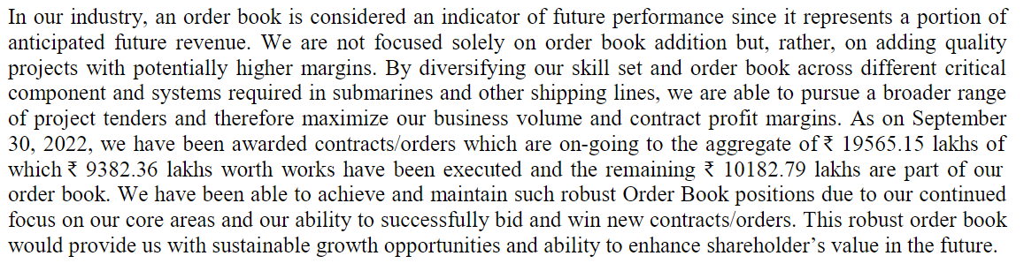



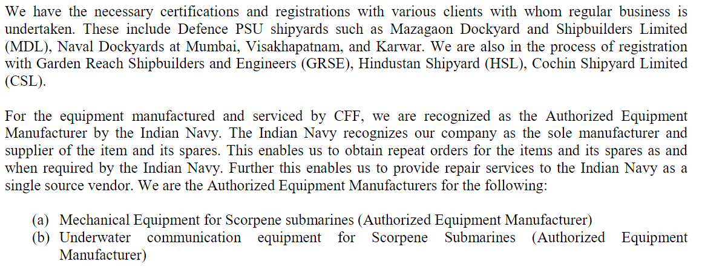

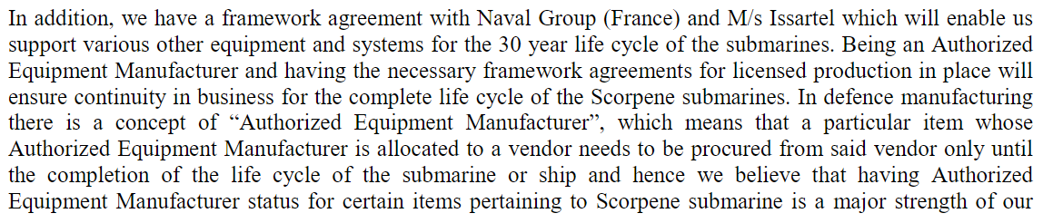

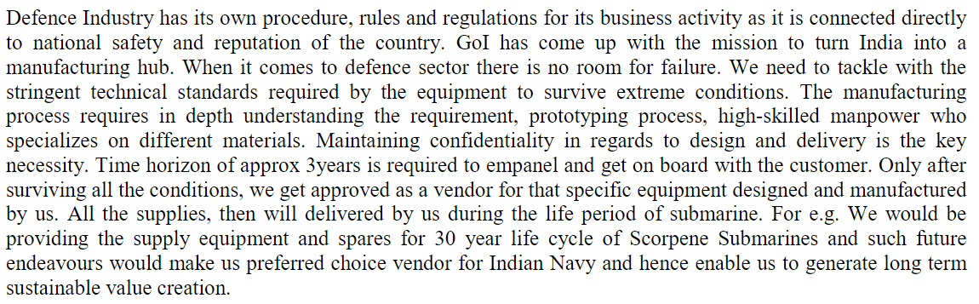





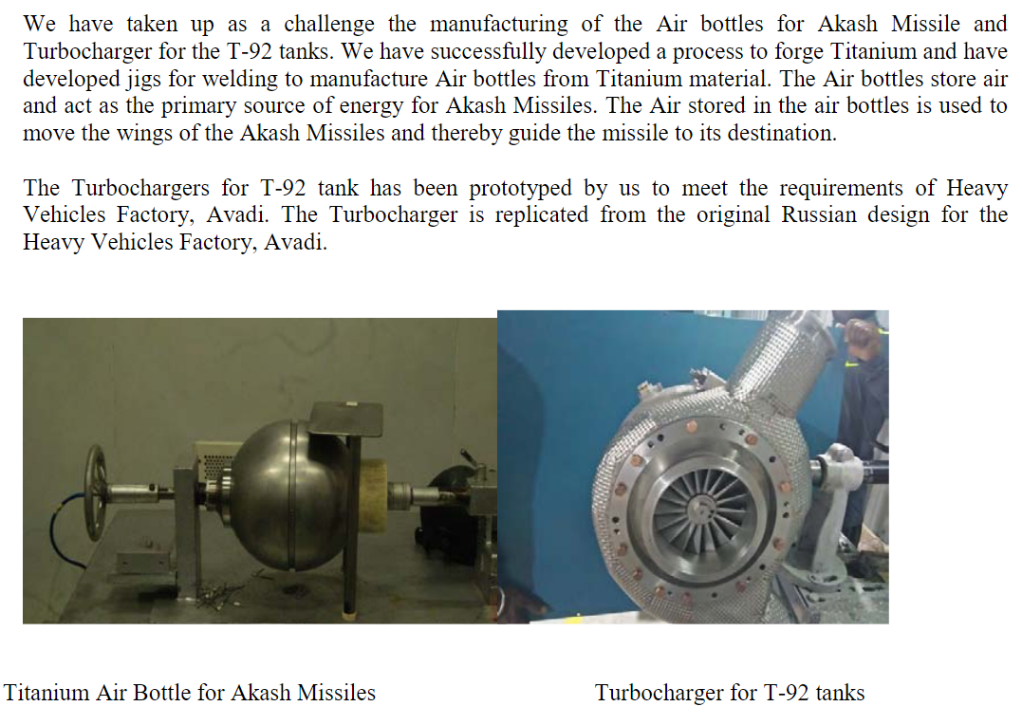

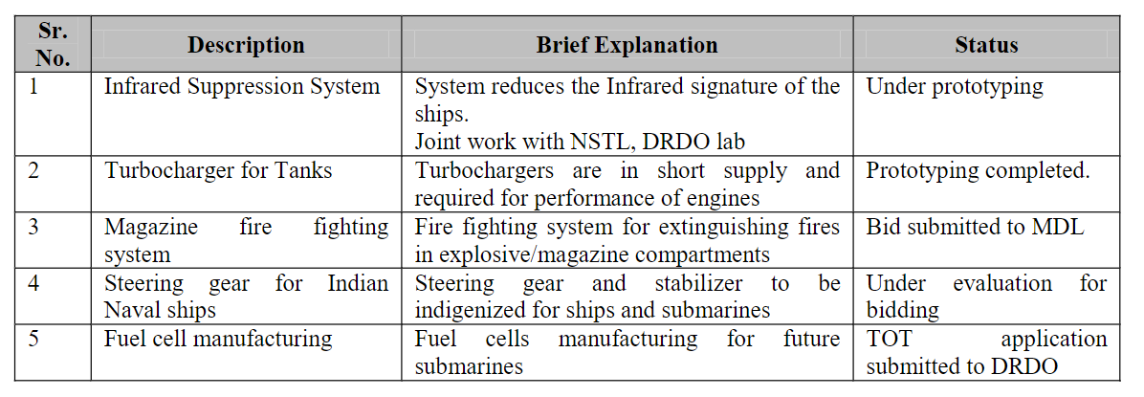

Some articles with red flags about Congress connections of promoters:

<https://www.opindia.com/2019/05/ulrik-mcknight-gautam-makkar-sonia-faleiro-congress-a-defence-deal-and-how-it-all-relates-to-rahul-gandhi/>

<https://www.republicworld.com/india-news/general-news/3-companies-3-directors-in-common-one-link-to-french-sumbmarine-maker-was-loss-making-company-taken-over-by-offset-partner-to-benefit-rahuls-partner-ulrik.html>