Laurus labs – Annual Report FY 21

Laurus Labs is a fully integrated pharmaceutical and biotechnology company, with a leadership position in generic Active Pharmaceutical Ingredients (APIs) and major focus on anti-retroviral, Hepatitis C, and oncology drugs. Four key business units: -

- Laurus Generics - API - Development, manufacture and sale of APIs and advanced intermediates across ARVs, anti-diabetic, cardiovascular, oncology etc.
  - Revenue Contribution 54%
  - Commercialized 60+ products
  - Filed 61 DMFs
  - 4 manufacturing facilities (4,186KL) and another 1,000 KL under expansion
  - Revenues in Generic API grew 61% YoY driven by
    - ARV API Sales which were up 70% YoY (high volumes for all key first line APIs and growth in second line too)
    - Oncology APIs grew 25% YoY
    - Other APIs grew 56% YoY (due to higher contract manufacturing orders from Europe)
  - Due to higher demand, expanding capacity in this segment by c. 25% (brownfield expansion)
  - Laurus is preferred API supplier in ARV segment supplying to 80% of the players participating in ARV tenders – large scale, efficient manufacturing process are key success factors.
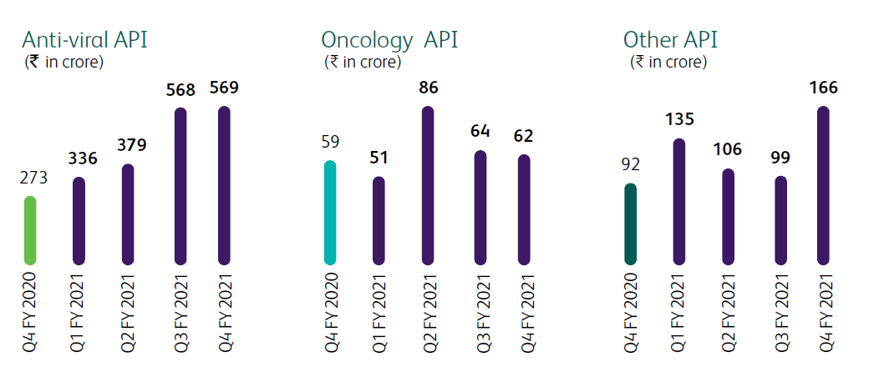
- Laurus Generics – Finished Dosage Form (FDF) - Development and manufacture of oral solid formulations
  - Revenue Contribution 35%
  - Revenues in FDF grew by 102% YoY driven by (and from 5 crs in FY 19 to 825 crs in FY 21)
    - Higher no. of launches in US and opportunities from in-licensing of products
    - ARVs - LMIC growth – participation in global tenders and various in-country African tenders. Maintained leadership in first-line treatment of drugs, moved to second-line (Lopinavir, Ritonavir and Darunavir) and progressing towards third line of treatment.
  - Capacity of 5 billion units / year, Enhancement to 10 billion units/year in tranches over next 18 months (brownfield expansion)
  - Product offering – ARV, anti-diabetic, cardiovascular, CNS etc.
  - Filed 27 ANDAs with 9 final approvals and 8 tentative approvals. Filed 12 dossiers in Canada, 9 in Europe, 8 with WHO, 2 in South Africa, 2 in India and 14 in RoW
  - FY 21 highlights
    - Commenced marketing of in-licensed products in the US by leveraging the frontend
    - Completed 3 product validations for formulation
    - Strong demand in ARV segment for LMIC – Launched TLE 400 in LMIC market (where there are only 3 suppliers)

- Laurus Synthesis - Key starting materials, intermediates and APIs for New Chemical Entities (NCEs)
  - Revenue contribution 11%
  - CDMO for global pharma, steroids and hormone manufacturing capability etc.
  - 50 active projects in CDMO, commercial supplies ongoing for 4 projects
  - Expanded client base – added 2 big pharma cos

- Laurus Bio – Recombinant products - animal origin free products for safer and viral free bio manufacturing
  - During FY 21, Laurus acquired 79.21% stake in Richcore Lifesciences and company has been renamed as Laurus Bio Pvt Ltd, Amount spent c. 247 crs.
  - Purpose – To diversify and enter high growth areas of recombinant animal origin free products, enzymes and building biologics to CDMO at scale.
  - Current promoters continue with day-to-day management of the company
  - On course to commission large scale fermentation capability
  - Acquiring additional land for further expansion to create close to million litres fermentation capacity
  - Three distinct revenue streams – biotech, enzymes and CDMO – Going forward, CDMO will be a major contributor to growth as major proportion of incremental capacities are towards this business.

To summarize,
Topline breakup | FY 16 | FY 17 | FY 18 | FY 19 | FY 20 | FY 21
Generic APIs | 1,651 | 1,734 | 1,850 | 1,948 | 1,622 | 2,621
Finished Dosage Forms (FDFs) | - | - | - | 55 | 825 | 1,664
Synthesis | 101 | 162 | 195 | 295 | 384 | 519
Total | 1,775 | 1,905 | 2,056 | 2,292 | 2,831 | 4,804
*No separate mention of Laurus Bio in the table as the acquisition completed in Jan’21
API Break up | FY 16 | FY 17 | FY 18 | FY 19 | FY 20 | FY 21
Antiviral API | 1,456 | 1,467 | 1,521 | 1,513 | 1,087 | 1,852
Onco API | 142 | 114 | 164 | 229 | 211 | 263
Other API | 53 | 152 | 164 | 206 | 324 | 506
Total | 1,651 | 1,734 | 1,850 | 1,948 | 1,622 | 2,621
Significant increase in ARV API.

Future outlook/Capex plans
- FDF
  - Key growth engine – expand ARV portfolio, robust ANDA pipeline, filing dossiers in other key markets and expansion in other therapeutic areas like diabetes, cardiology.
  - Capacity to increase capacity to 1.8-2.0x in 18 months in phased manner starting Aug’21 and will be fully operational by end of 2021-22 (Another para in AR mentioned 15% by April’21 and balance by Dec'21).
  - Entered into a partnership with European generic player for contract manufacturing.
- APIs
  - ARV and Other APIs (anti-diabetic, CNS and PPI) to be key growth drivers due to robust order book
    - Oncology – focus on high potent molecules
    - Other APIs – focus on anti-diabetic, PPIs and CNS products commercialized for contract mfg opportunities.
    - ARV APIs – Growth to be driven by introduction of second line products, launch of new first line products – Lamivudine and Dolutegravir, and supply of APIs to EU and North America.
  - Large capacity by end of next year
- Synthesis
  - Rising demand for NCE drug substances
  - Expect strong growth over next 2 years with new client additions and increasing commercialization of products.
  - Planning to add a block for High potency API (HAPI) to support growth in synthesis
  - Setting up dedicated R&D center and greenfield manufacturing capacity to support future growth

- Laurus Bio
  - Expected to grow substantially over next 4-5 years

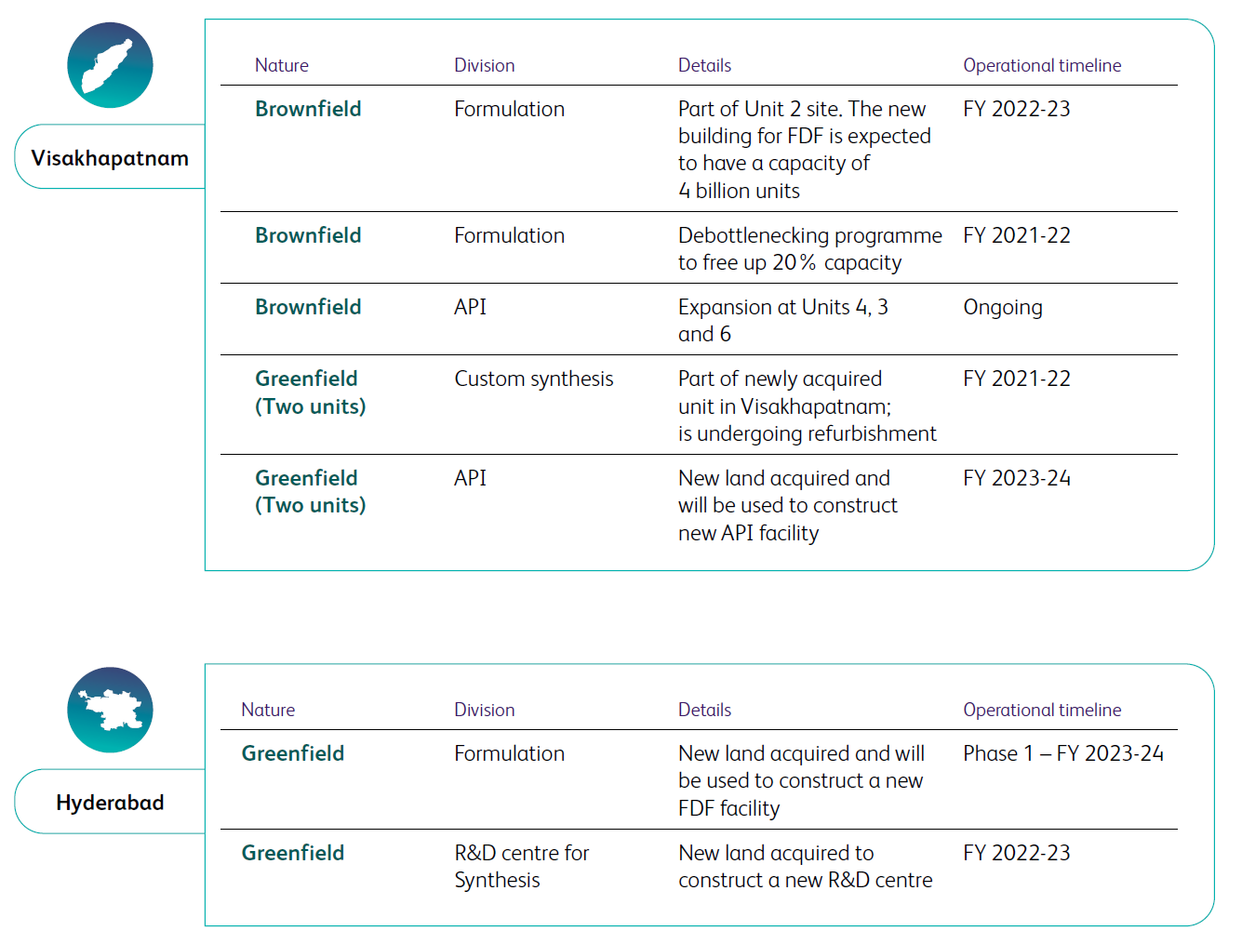
Key numbers
- Financials (FY 21): Sales Rs 4,814 crs / EBITDA 1,573 crs (33%) / Net Profit 984 crs (20%) / RoCE 40% / RoE 45% / Debt equity 0.56
  - Gross margin increased from 50% in FY 20 to 55% in FY 21
    - Change in product mix (higher FDFs where they are backward integrated, better pricing power and where new capex is coming too#)
    - High proportion of ARVs where they are lowest cost manufacturers (driven by large scale, process efficiencies)
  - Operating leverage benefits increased EBITDA Margin from 20% to 32% (3% in employee benefit expenses and 4% in other expenses)
Key PnL metrics | FY 20 | FY 21
Gross Margin % | 50% | 55%
Employee benefit expenses % | 12% | 9%
Other expenses % | 18% | 14%
EBITDA Margin % | 20% | 32%
- Organic capex done (excl acquisition) in FY 21 c. 700 crs
- Exports 3,325 crs, Imports 1,656 crs
- Cash flow from operating activities: 733 crs vs PAT 984 crs

# apart from synthesis business & Laurus bio which have even higher margin

- WC:
 | Amount (Rs crs.) |  | WC Cycle (No. of days)
 | FY 20 | FY 21 | FY 20 | FY 21
Inventory | 905 | 1,575 | 234 | 266
Debtors | 791 | 1,306 | 102 | 99
Creditors | 616 | 1,179 | 159 | 199
Net WC | 1,080 | 1,702 | 177 | 166
- Related party transactions: No major transactions
- KMP remuneration:
  - Promoter remuneration c. 26 crs FY 21 vs c. 16 crs FY 20
  - CFO remuneration: 5.8 crs FY 21 vs 3.4 crs FY 20
  - Significant increase in FY 21 vs FY 20 but profits are also up 400% in FY 21. Overall numbers as a % of PAT are acceptable.
- Dividend payout: 75 crs FY 21 vs 39 crs FY 20
- Subsidiaries audited by others: Revenue 161 crs and Total assets of 210 crs PAT (< 5% as % of consol nos)
- Auditor remuneration: 1.22 crs in FY 21 vs 0.99 crs in FY 20
- Contingent liability: Total c. 120 crs vs 102 crs in FY 20 (nothing significant)
- Workforce c. 3800 employees in FY 20 to c. 4800 employees in FY 21

15-year journey of Laurus labs
Transition from an ARV API company to an API company, to forward integration into formulations, and now synthesis business.
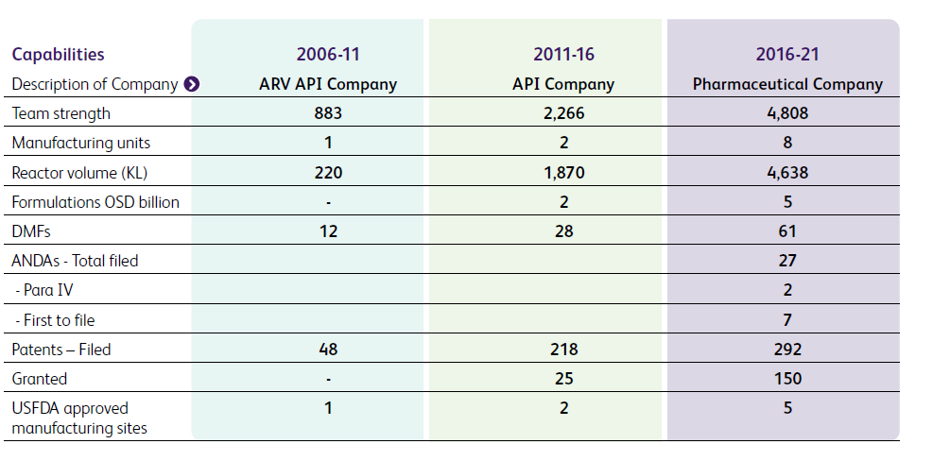

Annexure: List of manufacturing sites
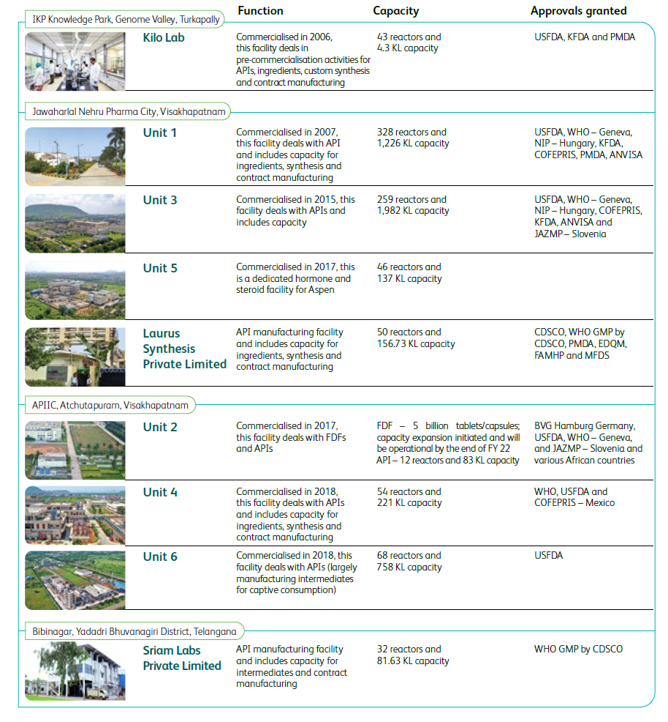
(Note: Approvals by USFDA, PMDA)

