**Company: Bharath Rasayan Ltd**

**Analyst: Ankit Gupta**

**Captured by : Vamsi Krishna**

|  |
| --- |
| **Business Slotting** |
| R B2B  B2C  Asset Heavy  Asset Light  Intellectual Prop  Price Taker  Price Setter  Oligopoly  Monopoly/ Duopoly R Customer Capex Led |

**Company Background:**

* BRL has consistently figured in top 10 agro-chemical manufacturers in India in the past years. Apart from technical grade pesticides it also manufactures intermediates grades, which is the raw material for manufacturing technical grades (Technicals are like what APIs are in pharma)
* Bharat Group established 3 decades ago - continues to derive strength from integrated operations of the group marked by its presence in the entire value chain of the pesticides (along with its group companies namely Bharat Rasayan Limited (BRL), Bharat Insecticides Limited (BIL) and BR Agrotech Limited (BRAL). Only BRL is a listed company
* Product Range **-** Insecticides, Herbicides, Fungicides, Intermediates and Veterinary Use. CRAMS product basket has been increased from 20-25 to 40-45 molecules over the last years
* Renowned customer portfolio contains – Bayer, DOW, Nissan, Sumitomo, Rallis, Indofil etc as its customers, With strong relationships from past 5-6 years
* BRL operates with 2 manufacturing plants –
  + Mokhra, Haryana (estb. 1989) Capacity – 5,000 MTPA
  + Dahej, Gujarat (estb 2012) Capacity – 12,000 MTPA
  + New plant setup in Syka, Gujarat is in process
* Technical grade pesticides accounted for 77.62% (PY: 80.33%), intermediates grades accounted for 15.99% (PY: 15.57%) and formulation grades accounted for 6.07% (PY: 2.07%) of gross sales of BRL. Total export sales of BRL constitute 28% of total sales of the company in FY19 (PY: around 24%)
* Though there is a product concentration risk as the top 9 products of BRL accounts for around ~62% of total sales of BRL in FY19 (around 52% of total sales in FY18) and around ~59% of total sales of BRL in H1FY20
* As a result of their successful track record of ramping up operations and strong relationships with large Japanese agro chemical players a JV (70:30) with Nissan Chemical Corporation has been materialised with a proposed investment of 60 M$. This can be considered as inflection point in its growth trajectory

**Elevator Pitch**

* Has the ability to produce higher order chemistry 95% to 99% purity levels (higher purity 🡪 higher margins), supported by world class plants (Design, EC, Innovative, Future ready) and strong relations with renowned customers like Bayer, Syngenta, and especially large Japanese MNCs e.g., Nissan Chemicals
* CRAMS (patented & non patented molecules) which has increased from 20-25 to 40-45 molecules in the recent past
* Successful track record of scaling up small operations to large scale e.g. Nissan JV
* BRL has ISO 9001:2008, ISO 14001:2004 and OHS 18001:2007 certification catalysing long term partnership with institutional and foreign clients

**Customer Industry Trend/Outlook ->** 🗹 Tailwinds  Headwinds  Secular

* The macro environment for the agrochemicals industry will always remain positive and will be driven by strong fundamental growth, rising domestic demand, improved export opportunities due to the tight supply from China, strategic partnerships with global counterparts, robust product launches, tie-ups with innovators for new products and substantial prospects to explore products going off – patent.
* Disruptions in China (spotted in most global supply chains) led to customers looking for better avenues for supply of agrochemical products due to twin factors of US-China Trade War (given the US had imposed tariffs on some Chinese chemical imports) and Corona Virus. India has the potential to emerge as the winner
* The Chinese government’s environmental clampdown had led to the closure of ~35% of small agrochemical manufacturing industries which resulted in the short supply of key technicals and intermediates, leading to sharp increase in the prices in the international markets. Indian players with backward integrated facilities can gain from these changing dynamics. Almost all major players have resorted to backward integration. The backward integration strategy of Indian companies is expected to effectively increase the pesticide technical production capacity in India
* Earlier China used to supply 90% of the agro-chemical requirements of the world while India contributed to 10%. The issues in China are expected to change this ratio to 66.67% in favour of China and 33.33% in favour of India. Even if China comes back but due to higher employee and environmental costs, the cost for Chinese companies will increase. However, we expect this situation to continue for 3-4 years. This is a golden period for Indian Chemical companies.
* Some signs that are there to see are some big global giants trying to partner up with domestic companies in some or other form. e.g Aaarti Industries, Navin fluroine, Bharat Rasayan, and some other companies entering long term outsourcing contracts which gives visibility for growth for many years
* The share of post patent products as compared to patent products and proprietary off-patent products has been increasing over the years. Agrochemicals worth USD 4.1 billion are expected to go off-patent by 2020. This provides significant export opportunities for Indian companies which have expertise in generic segment.

**Key Monitorables**

* Proportion of patented CRAMS to Sales
* Export sales to other geographies
* Capex progress of Nissan JV
* Standalone Business future expansion

**Business Attractiveness**

**Strongly differentiated business model -> High**

* BRL is into manufacturing of technical grade, the same requires compliance with stringent pollution control norms set by the regulatory authorities
* The business model is driven with the ability to sustain high working capital requirements and provides with good entry barrier apart from the fact that relationship building with large MNCs takes many years
* With strongly diversified product mix - BRL has around 200 international registrations and has been exporting its products (technical grade, intermediates and formulations) to more than 65 countries across the globe and is a preferred supplier for several MNCs for their global demand of several molecules
* Strong Client Relationships & Repeat Orders - BRL has continued to register a healthy growth in its revenues on the back of continued relationships with their existing clients and further addition of new customer base in both domestic as well as overseas markets and increased realisations of agrochemical products on account of increased raw material prices with healthy demand of agricultural products

**Competitive Position getting stronger/weaker -> High**

* BRL has a market leadership in many technical products including Lambda Cyhalothrin (Insecticides), Thiamethoxam (Insecticides) and Fipronil (Insecticides)
* Capability to produce raw material for technical grade leads to lesser dependency on China 🡪 strong moat in the current business environment
* Technology transfer from Nissan Chemicals through JV and strong relationships with companies like DOW and Syngenta for the past 5-7 years
* The group also has a Government approved R&D Centre based in Bahadurgarh, Haryana. Furthermore, it is eligible for weighted deduction under the income tax act in respect of expenditure incurred on R&D

**Vis a Vis other Patented CRAMS -> Medium**

* CRAMS (patented & non patented molecules) have increased from 20-25 to 40-45 molecules which is a higher margin business. As the CRAMS business grows would further add to the growth story

**Next Level of business -> High**

* JV with Nissan Chemicals 🡪 Nissan Bharat Rasayan Private Limited (NBR)
* As mentioned above, CRAMs business to scales up
* China factor has placed BRL in a great position to gain new customers owed to its excellent operational track record
* Has approximately 4,800 dealers and 30,000 distributors for supplies spread across the country and have 26 branches in all the operating states.

**Value Migration Curve -> High**

* BRL also manufactures intermediates grades, which is the raw material for manufacturing technical grades hence they are already on the right path of the value migration curve and CRAMS being the next level

**Quality of earnings -> Medium**

* Total operating income of BRL consistently grew at a healthy CAGR of 29.66% over a period of FY16-FY19 and at a healthy annual rate of 25% in FY19 to reach Rs.994.67 crores in FY19
* Healthy ROE over the past 6 years > 25%



* EPA/Sales consistent over the past 5 years at 4.5% in FY 19



* High ROE offsets the high capital turns (1.5 -1.7X) and is the advantage offered by the nature of the business where production efficiency is good but capital efficiency is poor

**Key Growth Drivers**

**Reduced China dependency 🡪 New Customers**

* Disruptions in China (spotted in most global supply chains) led to customers looking for better avenues for supply of agrochemical products. BRL with its successful track record has benefitted from this, achieved new product registration and acquired new customers and geographies while retaining existing customers

**Capacity Building JV 🡪 30% share with Nissan**

* JV with Nissan chemicals with 30% share is an recognition for their strong execution skills
* The JV plant is expected to add strongly not only to top line but also in further enhancing R&D capabilities

**Profitability Drivers**

**Product mix (low margin to high margin support + CRAMS) 🡪 High**

* Its diversifies product mix comprising of technical grade, intermediates and formulations and higher chemistry skills provides with strong margins
* Increase in patented CRAMS is strongly growing and needs to be watched for as it has potential to increase the margins considerably

**Backward Integration (Intermediates) 🡪 High**

* As discussed above, this offers both margin stability and risk management at the same time
* Dependency on china appx. 30%

**Capital Intensity**

**Capital Intensity 🡪 High**

* Working capital for MNCs sale requirement
* Low creditor days combined with higher discounts 🡪 Higher supplier loyalty
* As with the nature of the business, the ability of the management to manage high working capital requirements effectively will determine the course of growth. Till now they have been very efficient in managing it.
* High ROE offsets the high capital turns (1.5 -1.7X) and is the advantage offered by the nature of the business where production efficiency is good but capital efficiency is poor

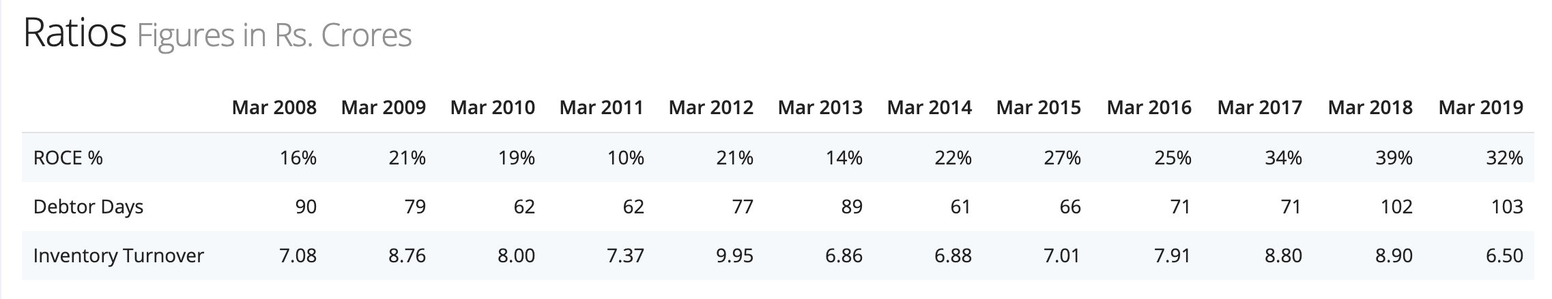

**Operating Leverage led by** 🗹 **Gross Margin** **Asset Turns** 🗹 **Product Mix** 🗹 **Backward Integration**

* **Gross Margins** 
  + Gross Margins have been increasing consistently over the past 5 years expect the downturn in FY 18-19 due to the raw material price fluctuations arising from China



* **Product Mix** 
  + As discussed above, company has a diversified product mix and has been increasing the CRAMS molecules from around 20-25 to 40-45 which is a higher margin business
* **Backward Integration**
  + Apart from technical grade pesticides it also manufactures intermediates grades, which is the raw material for manufacturing technical grades (Technicals are like what APIs are in pharma). This provides the advantage in the medium term to delink itself from China risks and win new customers

**Business Model Vulnerabilities/Strengths**

* **Single plant risk till new expansion comes by**
  + The risk exists as Dhaej Plant has the highest production capacity (most the technicals and intermediate grades too) and Mokhra’s capacity is quite less. The new plant in Syka will help reducing the risk with significant capacity addition with capex of ~ 210 crores planned.
* **Incidental that tech price increase in China mitigated by Structural**
  + The Technicals pricing was not favourable in the past years. However, with the china issues that are already discussed elaborately like closing down of factories the pricing has improved and mitigated by this structural shift.
* **Single product Revenue ~ 15%. Top 9 products ~ 60% sales**
  + Meta Phenoxy Benzaldehyde (MPB) has been the top selling product for the company over the last years. Holds almost 50% market share in India and two competitors
  + The company generates ~ 62% sales from its top 9 products (H1FY20), 62% in FY19, 52% in FY18 and 70% in FY17 and 77% in FY16 from its top 10 products.
* **China Dependency appx. 30%** 
  + With backward integration in place china dependency has been significantly decreased over last couple of years. However, the current dependency arising mainly from raw materials is app. 30%

**Management Quality**

**Special DNA of the Business**

* **Cost Efficiency Focus** 🡪 **Medium**
  + It is a typical “Baniya” company with very high cost focus even the CAPEX is planned in a staged manner and they are working with the goal of backward integration always at back of their mind
  + As supplier loyalty is key goal which is leading to low creditor days there is certain effect on the cost efficiency
* **Production Efficiency** 🡪 **High**
  + BR prides itself in operating Plant at 100% utilisation. They look to achieve this by a judicious mix of high volume (lower margin) products and high margin products (lower volumes)
* **Capital Efficiency** 🡪 **Low**
  + High capital turns (1.5X) is the result of the capital intensive business needs that were discussed above as Low Creditor Days and High Debitor Days. As far as the fixed assest turns are considered they are well placed which approves the production efficiency

|  |  |  |  |  |  |  |  |  |  |  |
| --- | --- | --- | --- | --- | --- | --- | --- | --- | --- | --- |
|  | **FY 10** | **FY 11** | **FY 12** | **FY 13** | **FY 14** | **FY 15** | **FY 16** | **FY 17** | **FY 18** | **FY 19** |
| **Sales/Invested Capital =Capital Turns** | **2.81** | **1.83** | **1.56** | **0.96** | **1.60** | **1.96** | **1.90** | **1.96** | **1.86** | **1.51** |
| **Sales/Fixed Assets= Fixed Asset Turns** | **17.75** | **4.69** | **8.74** | **1.37** | **2.53** | **3.20** | **3.32** | **4.72** | **5.36** | **6.59** |
| **Sales/Total Assets= Asset Turns** | **1.64** | **1.44** | **1.13** | **0.75** | **1.17** | **1.30** | **1.39** | **1.67** | **1.57** | **1.31** |

* **Innovations** 🡪 **Medium**
  + Patented CRAMS at 5-10% of sales
  + Domestic + MNC Crams 50-60% share
  + Innovation – higher margin products have been the focus of the company over the past years and they have already demonstrated good amount of success by increasing the no. of molecules from 20-25 to 40-45.
* **New Revenue Stream/Geographies** 🡪 **Medium**
  + China factor – will help further to acquire new customers and deepen the penetration at existing customers
  + Nissan JV will add to the top line
  + Company is focusing on export markets. Recent acquired registration in Brazil the biggest agro-chemical market in the world
* **Value Chain Migration** 🡪 **Medium**
  + BRL also manufactures intermediates grades, which is the raw material for manufacturing technical grades hence they are already on the right path of the value migration curve and CRAMS being the next level
  + **Bharat Rasayan (BR)**: Bharat Rasayan is a pure play **technical** manufacturer. Technicals are like what APIs are in pharma. They are the active component of any formulation which are in turn sprayed on crops. Its a pure play **B2B company**
  + **PI Industries**: PI Industries is into formulations and also does CRAMS for innovators. It has it own branded products like Nominee Gold and Oshin under its Indian formulation portfolio. It earlier used to import technicals for its formulation basket portfolio but is not backward integrating for manufacturing technicals for its formulation portfolio also. It’s a **mix of B2C and B2B** capabilities.
* **Strategic Thinking** 🡪 **High**
  + Plant Design
    - Plants have been strategically designed with forward planning and backward integration in mind.
    - Plants have received EC clearance and confirm to very tough standards. Have received multiple certifications
    - Plants are built to accommodate future expansions both in terms of volumes and technology
  + Forward Planning vs Backward Integration
    - Manufacturing formulations using technicals is meant by forward planning. Which is B2C activity that the company is not focused today but aspires to be like PI industries (It’s a mix of B2C and B2B capabilities)
  + Relationship Building
    - Management has demonstrated their ability of scaling up not just operations but also relations with large MNCs. Materializing Nissan JV is “walking the talk” here.
* **Ability to Manage Downturns** 🡪 **Can’t Say**
  + For the past 10 years company has been constantly growing with big CAPEX we haven’t seen their ability to handle any downturn

**Execution Skills**

* **Employer profile and workforce handling** 🡪 **High**
  + Dhaej plant is trust world class facility with emphasis on employee safety
  + Top management apart from the promoters are well paid. Seems to be Fair

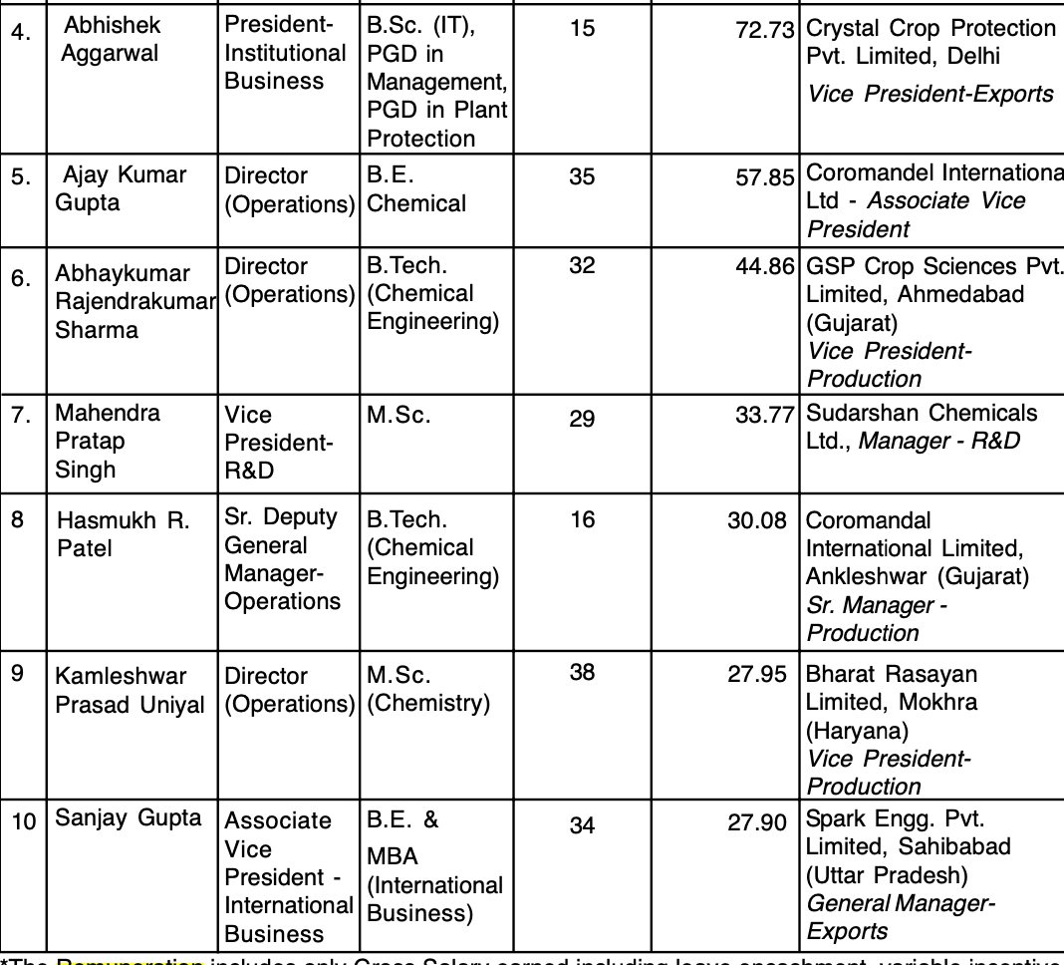

* **Customer Trust/WIN** 🡪 **High**
  + Already explained
* **Deeper/Boarder Customer Penetration** 🡪 **High**
  + Already explained
* **Supply Chain Management** 🡪 **Medium**
  + Management has identified the China risk quite early and mitigated the raw material price increase along with ensuring stable supplies with early adoption of backward integration
  + Strong focus on gaining supplier loyalty to ensure stable supply chain 🡪 Domestic sourcing very efficient
  + Adequate inventory is always ensured too

**Reputation**

* **Family Business** 🡪 **High**
  + Professional, well managed, traditional family business
* **Min. Shoulder Treatment** 🡪 **Low**
  + Dividends that are paid out to shareholders are very less
  + Management shares very less information regarding the company and its plans. It’s quite hard to get information from Annual reports alone
  + Sells Technicals to both group companies at arm’s length. That RPT (Related Party Transactions) sales are less than 15% of Sales
* **Corporate Governance** 🡪 **Low**
  + Less dividends, little information sharing and arm’s length dealings with subsidiaries needs to be questioned

**Risk Mitigation**

* **Supply/Demand Disruption** 🡪 **Medium**
  + Efficient supply chain management negates the risk
* **Single point of Failure** 🡪 **High**
  + The risk exists as Dhaej Plant has the highest production capacity (most the technicals and intermediate grades too) and Mokhra’s capacity is quite less. The new plant in Syka will help reducing the risk with significant capacity addition with capex of ~ 210 crores planned.
* **Environmental** 🡪 **Medium**
  + EC clearance received for plants
  + Cleanliness and safety of workforce is given utmost importance
* **Regulatory** 🡪 **Medium**
  + As is
* **Buyer** 🡪 **Low**
  + MNC sales provide stability in income
* **Competition** 🡪 **Low**
  + Well placed to handle competition

|  |
| --- |
| **VALUATION** |

**Undervaluation : 🞏 Screaming** 🗹 **High 🞏**  **Fair**

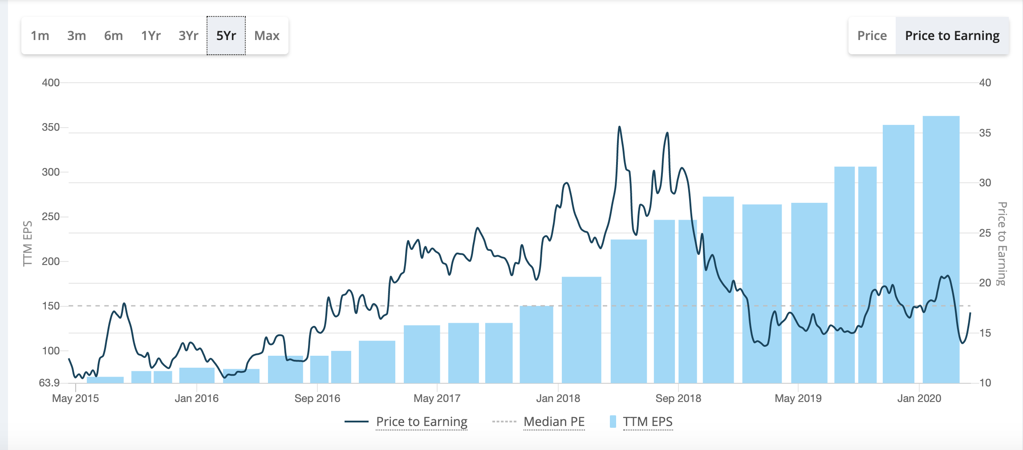

Source: Screener.in

Historical P/E over the past 5 years has been 17.7. Currently the stock is trading below the historical average. The undervaluation rating is just not about the past but also the growth projection for which the concrete levers have been discussed already and is rated as “High”.

**Valuations to be led by:**

* **Earnings Trajectory**
* 20-25% CAGR is forecasted for next 2 -3 years. Business model is improving and we will see a completely different BRL
* **Value Migration**
* Clear visibility that the business is moving upwards in the value chain
* **Re-rating**
* Highly likely, as its moving the value chain and sales from Nissan JV including growth in Exports coupled with the industry tailwinds

|  |
| --- |
| **Valuation Overhang**  🗷 PSU🗹Not Understood 🗷 Sector Apathy 🗷 Regulatory 🗷 Political 🗹 Corp. Governance 🗷Succession Planning 🗹 High Salaries linked to PBT |

* BRL is not understood despite the industry tailwinds and is relatively undiscovered stock
* Succession Planning: Mr. S.N. Gupta, Mr. M.P Gupta and Mr. R.P Gupta have been engaged with the company since over 3 decades (therefore atleast 50-60 years old), and there is no visibility of the next generation getting involved in the business as of now.
* High Salaries: The management salaries is equal to the ceiling of salaries as per the Companies Act therefore on the higher side, however the following may be noted:
  + On the part of remuneration, one must understand that it is liked to commission as % of PBT. As PBT increases, commission will also increase. On a yoy basis, it might look that commission has grown disproportionately but it is just linked to profits. Lot of companies pay remuneration to the directors as commission linked to profits
  + R.P Gupta – 7.9 Crs, S.N Gupta -4.23 Crs, M.P Gupta – 4.05 Crs salary in FY 18-19

|  |
| --- |
| **Valuation Support**  🗷 Dividend 🗹 Low Float 🗹 75% Promoters |

* **Dividend:** Due to the capital intensive industry and huge capex that been invested over the years the dividend pay-out ratio has been low at 1%
* **Low Float**: Promoter shareholding is 75% and 25% is available for general public, therefore is a case of low float.

|  |
| --- |
| **Risk Covered in Multiples**  🗷 **Every Thing** 🗹 **20% Downside** 🗹 **2-3X Upside in 2-3 years** |

The stock is trading at historic average P/E of the past 5 years at the moment. Given the upside potential based on the levers discussed above, following can be said:

* 1. Will be a winner if the business can maintain and increase growth rate to 20-25% CAGR
  2. Exit if the company is not able to realize this run rate for two consecutive quarters
  3. Staying in the company driven by the future potential of the company (big capex plans, company has relation with big MNC players, company is at inflection point)

|  |
| --- |
| **Liquidity Stress Test: Can sit tight for 1-2 years despite:**  🗹 **Execution Delay** 🗹 **Business Temporary Issues** |