Provisioning/ Expected credit loss (ECL): (Protean e-gov)
ECL: The Group assigns a risk grade to each credit exposure based on predictive data (e.g., payment timeliness, time value of money) and expert judgment. It monitors the economic environment to estimate expected credit losses. At each reporting period's end, the Group reviews customer exposures to determine incurred and expected credit losses, considering disputed or litigated dues. Historical trends show minimal credit losses, which are expected to continue. For tax authority receivables, expected credit loss allowances are based on the time value of money and management's assessment. For major clients, provisions are made based on management's assessment of recoverability.
AR’23
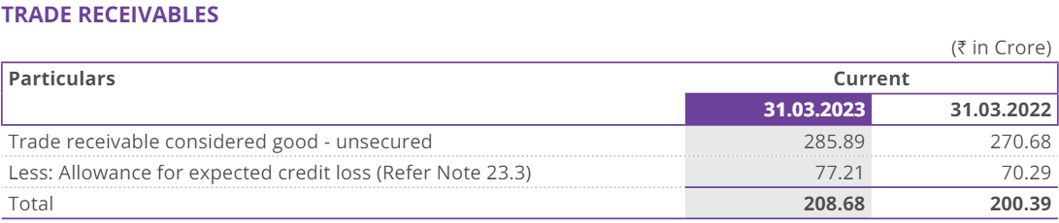
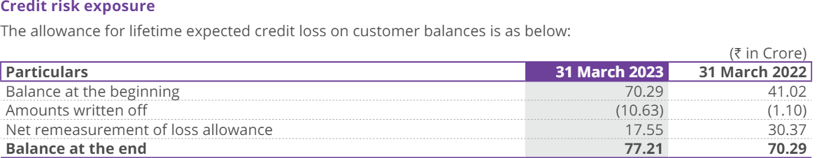
An amount of 92 Crore is receivable as at 31 March 2023 from Income Tax Department (ITD) towards physical storage of PAN applications (` 59 Crore) and towards NJRS project (software development, support and maintenance services) (` 33 Crore), of which ` 45 Crore is outstanding for more than 3 years. Approval for release of payments towards storage is under process. For NJRS payments, ITD has recently engaged National Institute of Smart Governance (NISG) for verification of SLAs which is in progress.
Based on the expected credit loss model followed as per Ind AS 109 ‘Financial Instruments’, the company has recognized provision of ` 45 Crore which covers amount overdue for more than 3 years.
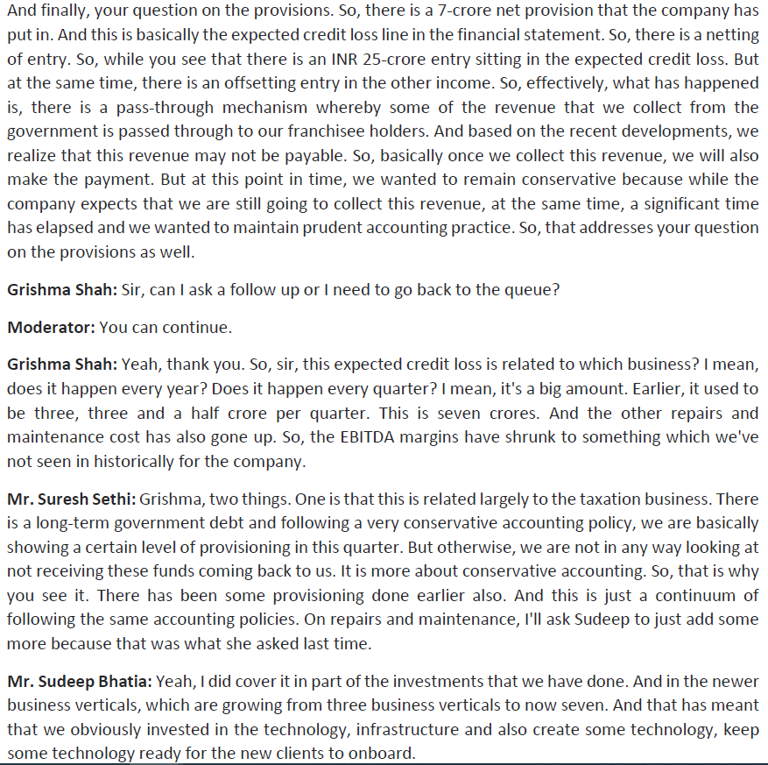
Excerpts from Q3FY24 Concall – About Expected credit loss

