Better Regulatory Risk Navigation by Sticking to Affluent Customers

What we have seen in a country like India that at times, the lenders and NBFC(s) that get into easy lending to the poor sections of the society in the guise of Micro loans get easily into trouble due to local and political intervention leading to large loan write offs and later cost absorption by the parent entities. The same has happened for Manappuram in Andhra Pradesh, TamilNadu or with a certain category of NBFC that are too heavily skewed on other spectrum of high risk lending such as Developer Financing, Corporate financing such as Edelweiss gushing the market with an 10Q QoQ 36% CAGR growth and raising funds from foreign pension funds as a result of it. The result of players at both the ends of spectrums have been pretty disappointing or not upto the mark in long term where either
- Their valuations have been de-rated sharply by the markets once the actual quality of books with time spell themselves out to the gung-ho participants
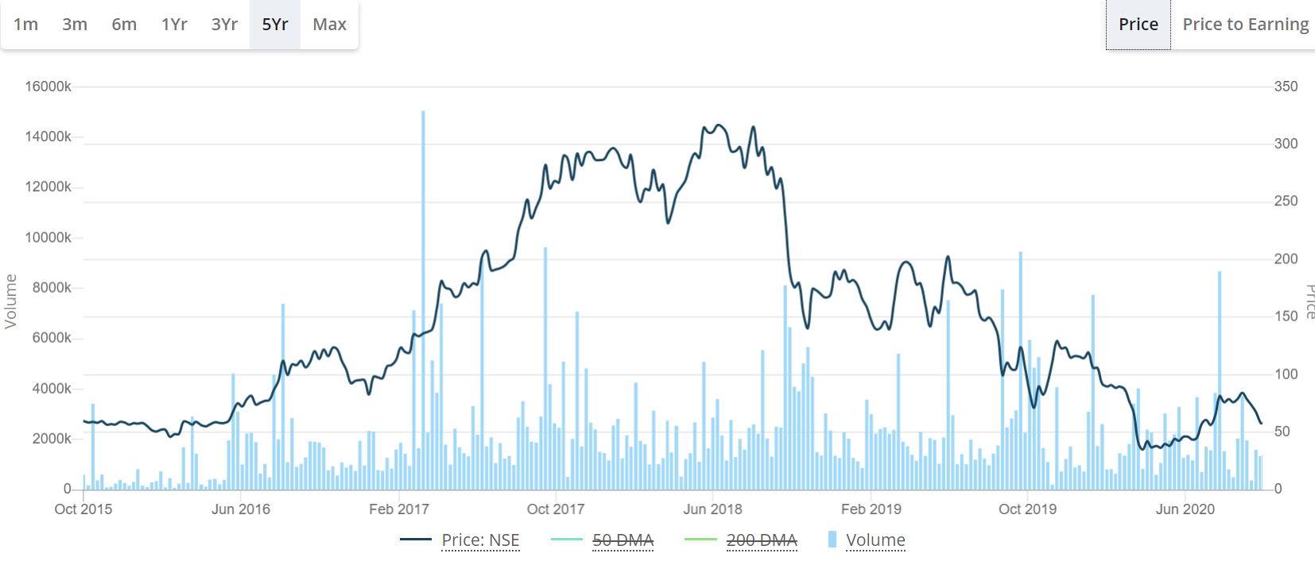
This is a five-year returns chart of Edelweiss and this is the investor presentation of Edelweiss at the peak price(Q4-FY18)

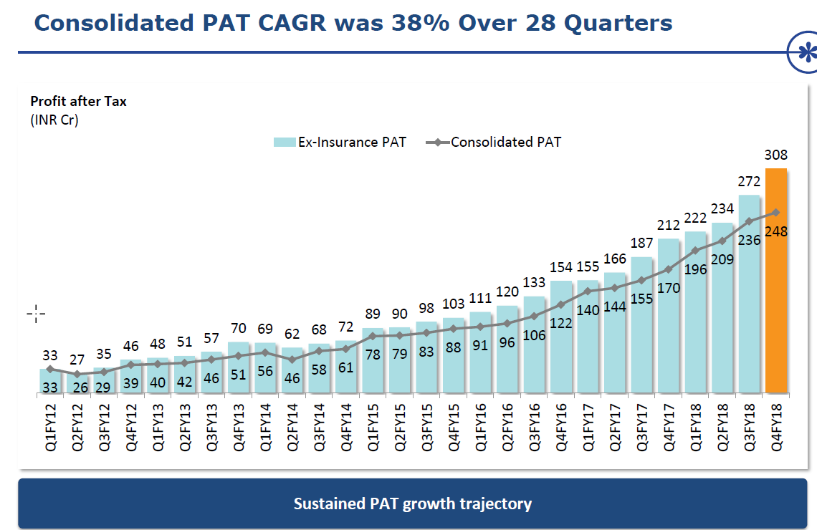
Now, oh my dear you tell me when you can grow PAT at 38% for 7 years why did the markets punish you so badly. It did so because the quality of your book was not right. Your Focus was only PAT, Asset Growth, inadequate provisioning and not underlying ROE. You kept on saying that you are doing last mile funding to the distressed real estate projects, you have special team(s) and skilled people (EXTRA COST) to take care of the same. On the other side in guise of ARC and AIF you set up special vehicles to tap this segment and then with IBC proceedings terminated for time being you were left with cold feet. This happened because you overestimated growth and profits and underestimated risks.
So, this is how market rated you.
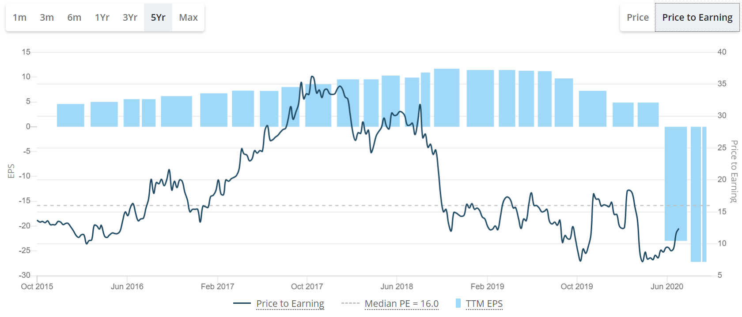
You are rated at .6 of your books , meaning the market believes that at this juncture after such a splendid 28 Q performance I will value you equivalent to 60% of your book. 40% of your book does not matters to me.
And this where you were discovered by celebrated investors as a steal deal.
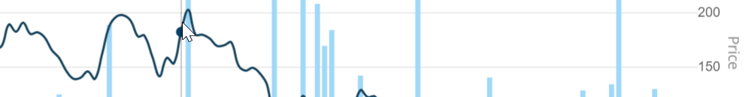
So, what it means in lending is not to just grow books and inflate profits but to have the granularity and collections to really collect back with a sustained ROE that you lent. It needs adroitness, frameworks, culture to understand, anticipate and appreciate risk not in hindsight but on real time basis. It needs conviction and mechanism to pull back and just not keep a foot on gas pedal for the sake of it.
This is where best of the investment minds makes a mistake of finding out bargains in the lending space. Lending is not a business to look out for Bargains. It is a business of discipline, frameworks, processes and most importantly agility.

- Their valuations do not re-rate themselves and gradually keep on deteriorating with an incremental threat to their business models in existence.

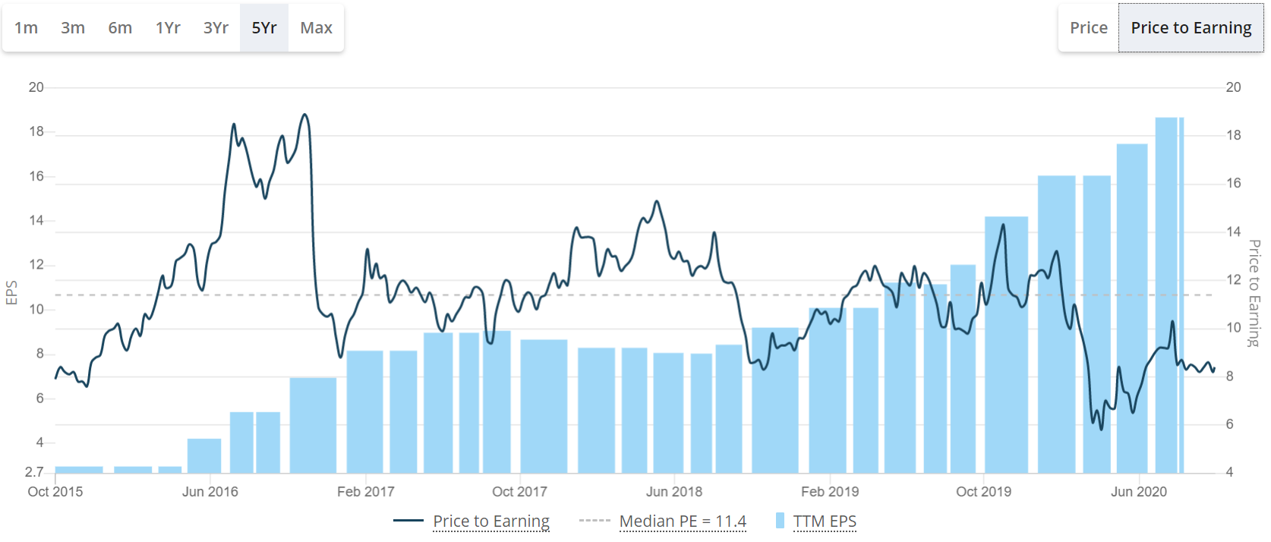
This is a 5-year chart of Manappuram finance which despite a staggering EPS increase of EPS from 2.7 to nearly 19 in 5 years has not been able to convince the market of its value. No doubt that the stock has given 5x in these 5 years but the valuation (~8 band) has been where it was 5 years ago. The market perception here thus is not that rewarding and again due to underlying risk of around 1/3 rd of book into micro loans ( susceptible to regulatory overhangs), lower quality Vehicle and Housing finance books(higher NPA). Moreover, with threat of a dominant player like BFAL in their baston of Gold Finance at the same or better rates the so called for lean EPS growth is also under threat and so are the future returns.
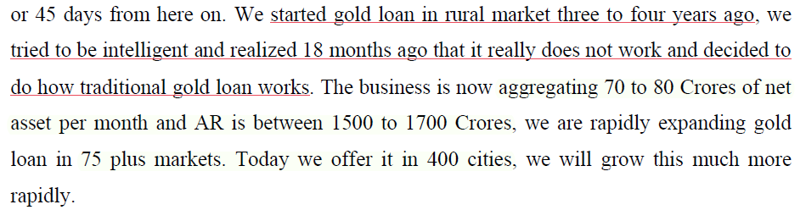

BFAL what it does with its granular retail best affluent customer base is, that it gets itself out of this highly risky business-like Asset reconstruction/developer finance (by design kept to 4-5% of Housing finance book) or Micro-lending. It forms a sticky customer base with paying capacity and keeps on incrementing the data models to better propose for the same set of customers at competitive rates with low default probability which as a pool also keeps on organically growing while at the same time growing its ROE assertive fee revenue. In case of an event like political elections or tougher times where local political interference is at its peak it to an extent is able to protect its book; as its customer base is
- More affluent
- More granular
And is backed by a proprietary and efficient collections infrastructure.
The markets thus reward such business models differently then they do the weaker ones

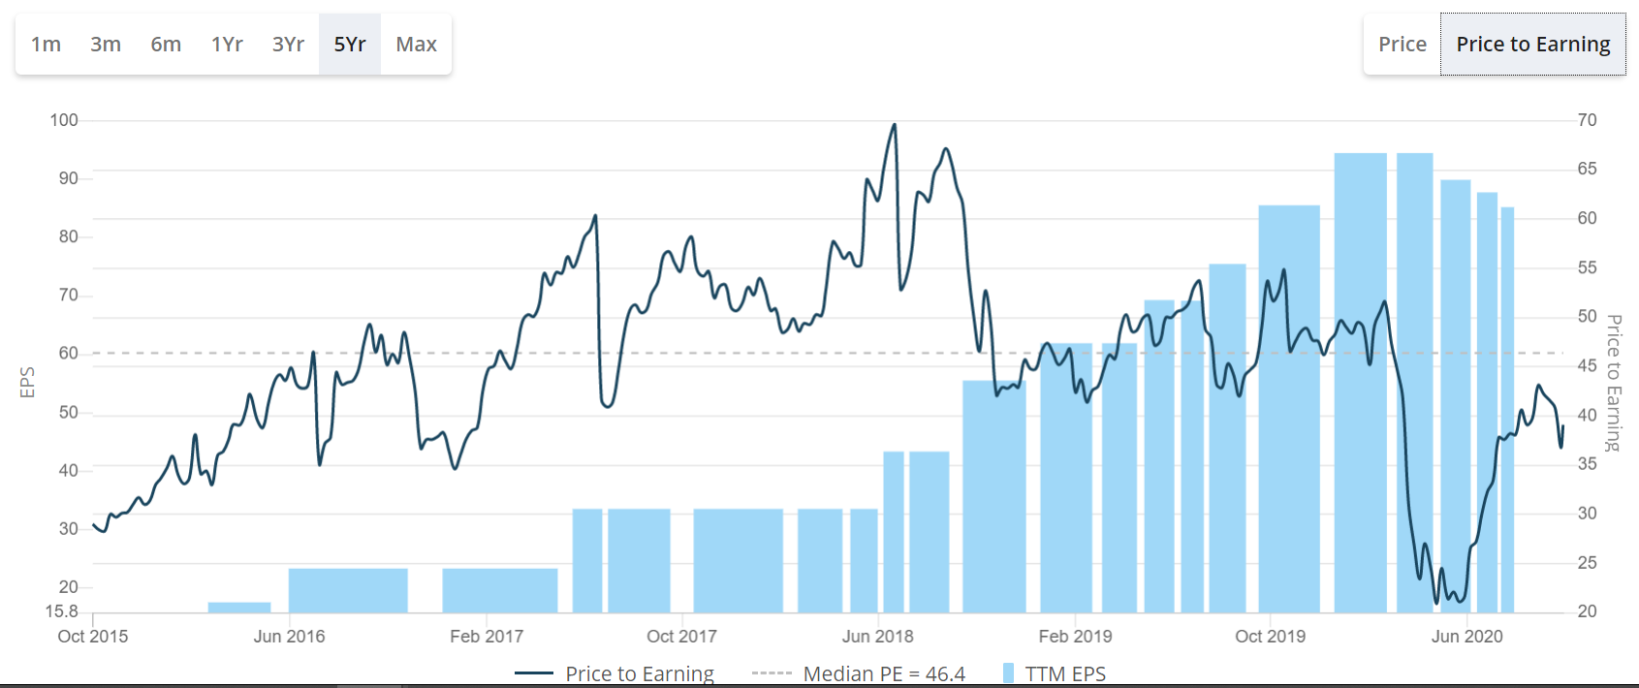
They attach more value to their books; they believe more in the quality of their books and their ability to sustain these books with right quality quotients.

It is not that in a democratic society as India these kinds of idiosyncratic risks would not present themselves to lending business models. BFAL also had its share of political interventions
https://www.financialexpress.com/industry/banking-finance/bajaj-finance-waives-emi-bounce-charges-for-auto-loan-customers-in-maharashtra/2080072/
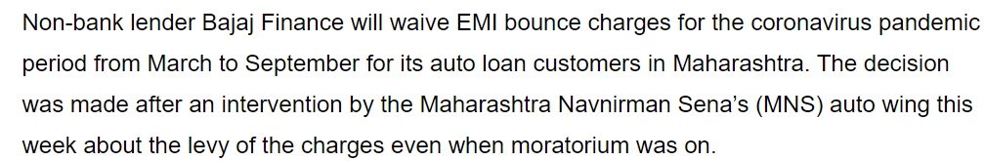
In a letter written on Wednesday, Bajaj Finance said it will waive 50 per cent of the EMI bounce and other overdue charges between March and August, and waive off the remaining 50 per cent as well if a customer remits the equated-monthly instalment (EMI) for September, October and November by due date.
But still owing its granular base and widespread presence it is able to absorb it better and on conditions that are in its favor too rather than a situation where in the parent entity had to complete write off the lending books as in case of Manappuram.

