Vidhi Specialty Food Ingredients (VSFI) is into manufacturing of food-grade colours. Food colours are ingredients that are added to food or beverage to enhance its appearance. Colours, when added to food products, impart very bright and tempting effect.

They are doing large capex

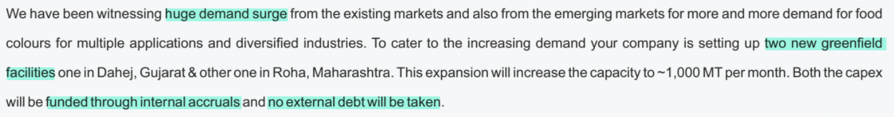

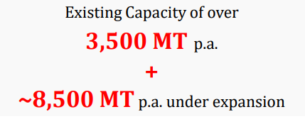

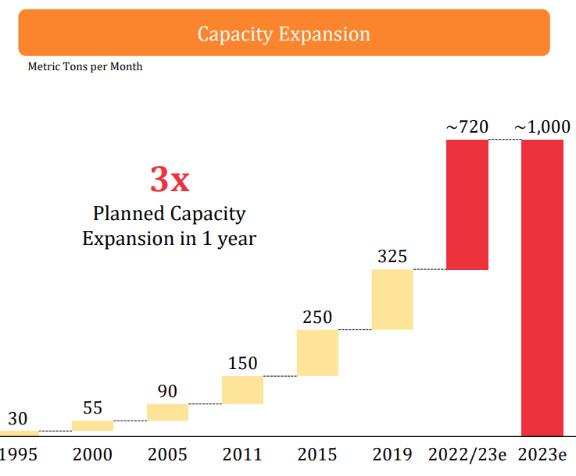

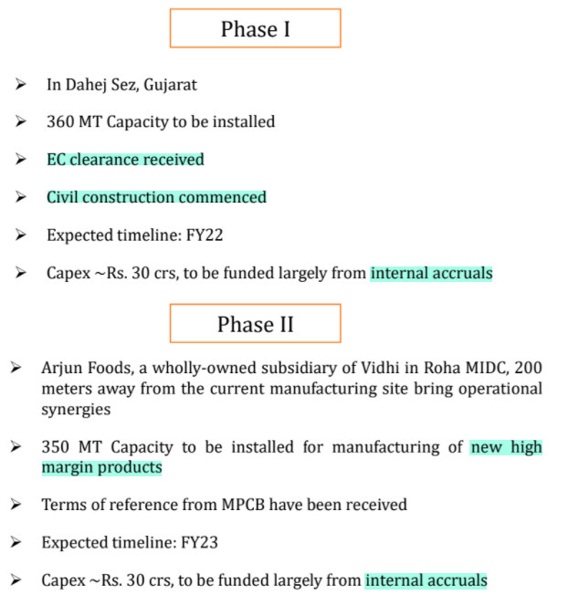

Total capacity after expansion will be 12000 MTPA

Exports are >90% of revenue

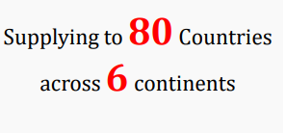

They have several marquee clients

