BFAL – Raising Equity at miniscule Cost- Benefit to Long term Shareholders

Disclaimer: Intent is purely academic and the conclusion of facts merely individual reflection

By: Sunny

Intent

The basic purpose is to demonstrate the below traits of the Bajaj Finance Management.
- Discipline
- Long term value creation mindset
- Ability to raise equity at a net to net benefit to long term shareholders
- Still able to retain the same or in-fact higher controlling interest in the Company

Case Study and Facts

I have observed over years the promoter’s shareholding pattern in BFAL and could analyze the below facts backed by the data and their disclosures to the exchanges.
Source of Information
https://www.bajajfinserv.in/shareholders-information-shareholding-pattern

Let’s go back to 2 years in 2018 to see BFAL promoters holding

We can clearly see that the promoters hold 55.14% of the Company

Now, in 2019 when their D/E started approaching 6(impeccable 40%+ AUM CAGR over a decade), then as per their internal guidelines of maintaining financial discipline they were supposed to issue fresh equity to raise that capital.
By the end of FY 2019, they had almost same promoter holding as in 2018 (55.17%)
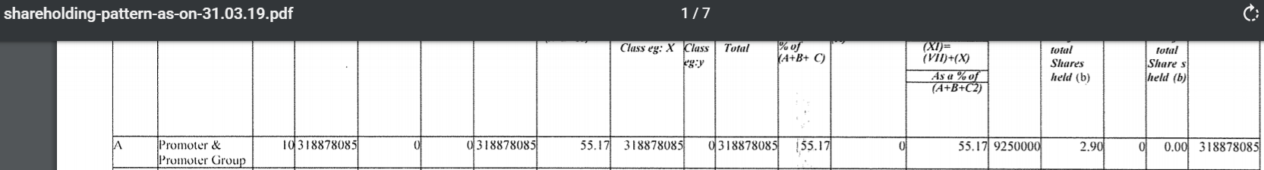
Now comes an interesting point when they before issuing the fresh equity increased their own stake in the company through open market purchases between March 2019 and June 2019 with a fact behind their mind that they would need to dilute equity to raise capital in near future.
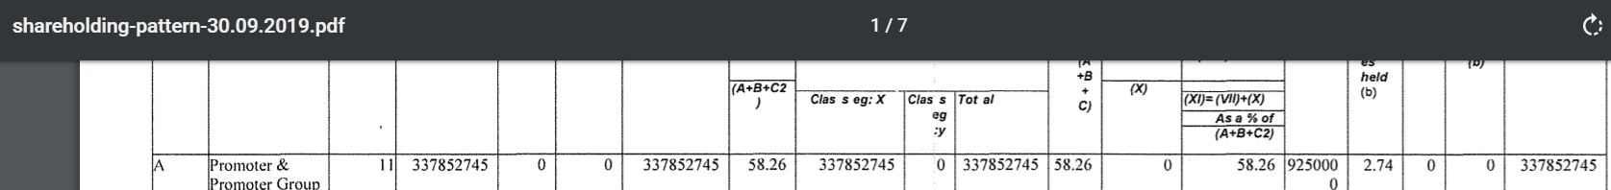
So, we can clearly see that between SHP of Mar-19 and June-19 that promoter stake is increased from 55.17 to 58.26% a whopping +3% increase.
Let’s now see the probable price at which these shares would have been acquired
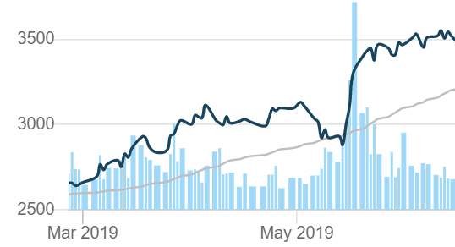
Most probably between 2500 to 3000 per share.

Now, in last quarter of 2019 BFAL did a QIP with per share value at Rs. 3900/share
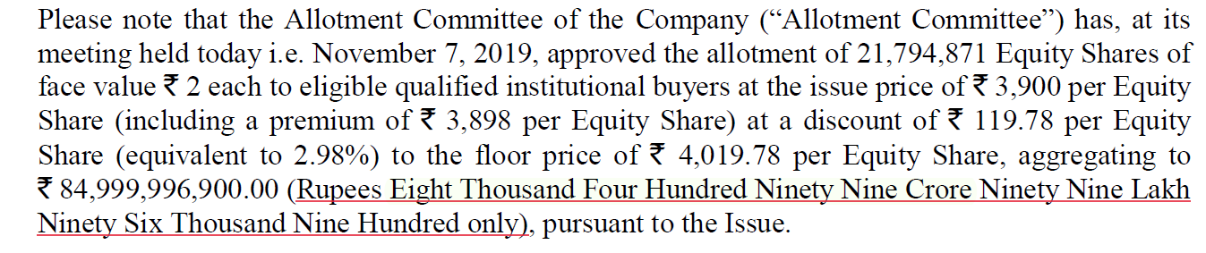
Imagine the power of equity of the franchisee and the power in demanding as well as commanding the price for its equity at 12 times P/B value in just a quarter the same equity being offered at minimum 30% premium of their own purchase price and that too oversubscribed 4 times and Infact backed by the quality of investors as Govt. of Singapore that is actually a very long term investor in some of the marquee Indian growth Stories.
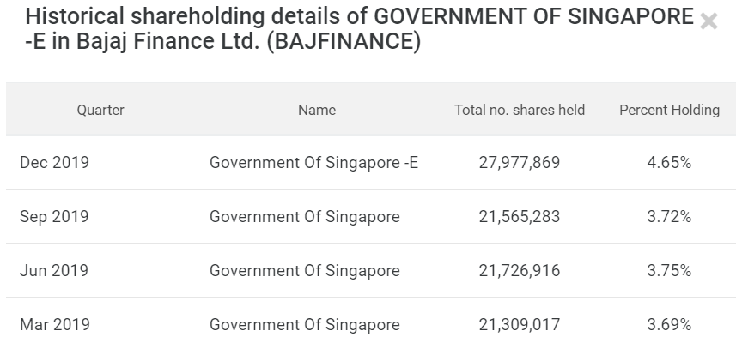
Shares also lapped by some leading MF
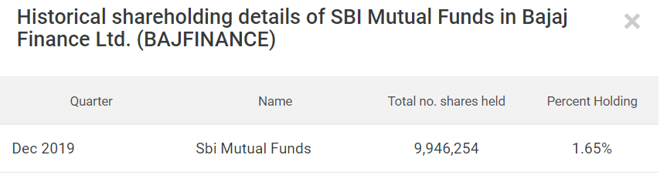
Now, consider from a long-term investor perspective the amount of value creation by the management here being a function of
- Ability to raise capital by miniscule dilutions at premium valuations
- Quality of Investors it can bring on board for long term commitment
- Finally increasing the nett. Promoter shareholding also at the same time by almost 1%
As per latest SHP for BFAL
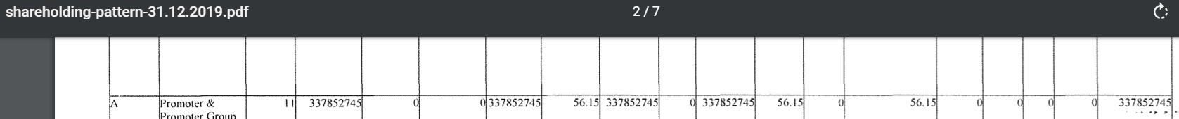
The promoter holding has increased from 55.17 to 56.15% almost a 1% increase even after able to raise 8400 Cr. Reflecting promoter’s commitment to the business and their underlying belief in it and at the same time reducing the free float from market available otherwise by 1%.
This would be a case of intelligent capital raise and value creation for long term shareholders.

Now when we juxtapose this with their ability to consistently redeploy this capital at higher ROE exceeding 20% for a longer time and no need for any further dilution for at least next 3 years, this calls for a great compounding engine working for its long-term investors.

Again, from a valuation standpoint for the valuation pundits I can draw a reference and some parallence from the below lines from Warren’s 2018 annual letter to his shareholders.
