Fluidomat is into fluid couplings

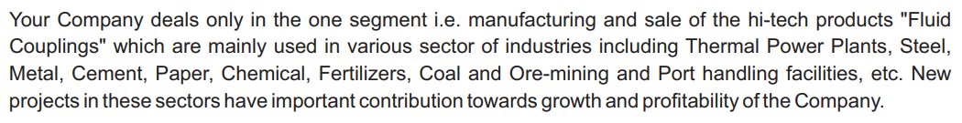



<https://www.linkedin.com/company/fluidomat/?originalSubdomain=in>

<https://www.fluidcoupling.com.au/pdf/Company-Profile.pdf>

<https://chainanddrives.com.au/wp-content/imported/media/meg/media/file/Fluidomat_SM_HF.pdf>

<https://npcil.etenders.in/tender_document/tender_2428/tech_com_doc/1421909419_2428_15050357Tech.Spec.pdf>

<http://www.mppcb.nic.in/Nov-2014/7213-Fluidomat075.pdf>

<https://practicalmaintenance.net/wp-content/uploads/Construction-Working-Operation-and-Maintenance-of-Fluid-Couplings.pdf>

<https://cciltd.in/uploaded_files/tender_img/tender_630da5a0ced2b_Supply%20of%20Fluidomat%20Make%20Fluid%20Coupling.pdf>

<https://nclt.gov.in/gen_pdf.php?filepath=/Efile_Document/ncltdoc/casedoc/2812129004072022/04/Order-Challenge/04_order-Challange_004_1669293327240997674637f650fd84b1.pdf>