ADC India Communications Ltd
25.04.2024

Data Centre Proxy Play:
The company specializes in offering data networking solutions and fiber physical connectivity within the telecommunications industry.

🔹Originally, the company was Krone India, in partnership with Krone AG, Germany.
🔹It was taken over by US-based ADC Communications in 2004.
🔹Later, in 2015, ADC was acquired by NASDAQ-listed Network Infrastructure provider, Commscope, which now owns ~72% in ADC India through its Indian subsidiaries Commscope Connectivity LLC and Commscope Technology LLC.
🔹The company specializes in providing copper and fiber physical connectivity for telecommunications and data networking, which includes structured cabling.
🔹The Company operates in two segments:
Telecommunication and IT-Networking.

🔶Products and Services:
a) Enterprise Network Solution:
ADC’s Structured Cabling System is an end-to-end, integrated portfolio of high-performance copper and fibre cable, connectivity and cable management solutions.
b) Carrier Network Solution:
ADC offers end-to-end network infrastructure solutions for central office (CO), Data centre, Outside plant (OSP) and Wireless deployments.
c) Broadcast & Entertainment Solution:
Company provides fiber and copper connectivity solutions for video, audio, and data networks and leads the broadcast industry in fiber-based 3G and HD network solutions.
d) Wireless Products:
Company provides in-building and outdoor wireless systems which enable mobile coverage in places where service providers and enterprises have difficulty delivering wireless voice and data services.

Enterprise Solutions:

Structured Cabling Solutions:
ADC’s Structured Cabling System is an end-to-end, integrated portfolio of high-performance copper and fibre cable, connectivity and cable management solutions produced by a single global manufacturer for applications from the Data centre to the desktop.
The entire passive network is warranted to be bit error-free for the entire duration of the 20 year system warranty, when installed by an ADC TrueNet Integrator. The zero bit error TrueNet warranty, guarantees full data bandwidth from any port to any port 24x7, 365 days a year across the entire portfolio of singlemode and multimode fibre, shielded and unshielded copper.

Data Centre Solutions:
Your Data centre is the most critical resource within your organization. Many organizations simply shut down when employees and customers are unable to access the servers, storage systems, and networking devices that reside there.
The most sophisticated Data centres seek Tier IV reliability of 99.995% network availability (Uptime Institute). Still, all of the redundancy and advanced power and cooling measures available are worth nothing if the cable, connectivity and cable management systems are inferior and lead to network downtime.

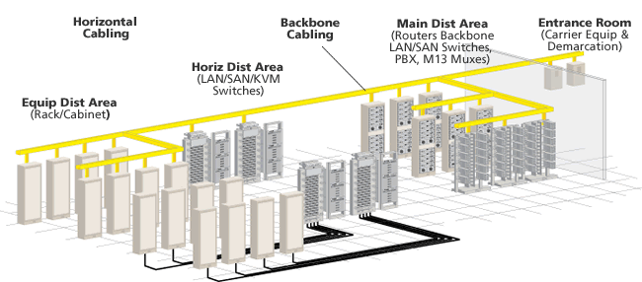

Fibre Plug-and-Play Solutions:

In the backbone or to the desk, optical networks achieve peak performance with ADC's fibre connectors, patch cords, raceways, and panels featuring integrated cable management and bend radius protection.

Proper cable management practices make fibre networks less susceptible to accidental damage, quicker to install, less expensive to own and operate over the long haul and easier to expand as needs grow. To ensure optimal network performance, ADC's fibre solutions incorporate key cable management concepts:
Bend radius protection
Adequate cable troughing with clear routing paths
Easy accessibility to installed Fibres
Vertical cable protection.

LAN Solutions:
ADC's brand of structured cabling products and solutions provides a multitude of Cable, Connectivity and Cable Management solutions from the Data centre to the desktop. In addition, all structured cabling solutions are supported by the best warranty in the business:

20-year performance and applications warranty
Industry's only Zero Bit-Error Warranty guarantees signal integrity and throughput for five years, twenty years on our 10G Augmented Category 6 Solutions.

Carrier Network Solutions:

FTTX Solutions:
(Fiber to the “x” (FTTx) is a collective term used to describe a wide range of broadband network architecture options utilizing optical fiber for some or all of their last mile connectivity. With “x” representing the fiber termination point)

ADC's Carrier Networks solutions are designed to help Carriers and Service Providers meet the challenge of bandwidth-hungry applications head on.

From design to installation, Carrier Networks combines high quality copper and fibre products and services for all areas of the public network - from the Central Office and Local Loop to the customer.

This capability is built on best-of-breed copper and fibre cable and components and unparalleled experience in providing total network solutions to many of the world's leading network operators. Under the Carrier Networks umbrella, ADC has built a total capability to deliver network solutions and provision infrastructures with high integrity design providing built-in network security. In addition, Carrier Networks solutions also integrate seamlessly with our TrueNet range of products ensuring true "End to End" Connectivity.

Legacy KRONE Copper Connectivity Solutions:
This portfolio represents the legacy KRONE products portfolio aimed primarily at solving issues in areas of the public network - from the Central Office and Local Loop to the customer. The famous KRONE module and its related accessories like the KRONE Tool, DDFs, BMFs and IPMs to name a few, have provided reliable connections for generations. The famous IDC contacts used in our legacy KRONE products are angled at 45° to the conductor, unlike other brands, which are at right angles to the cable. The 45° angle gives more contact area (meaning less resistance and greater efficiency in transmitting signals), lower stress points and more vibration resistance, so the connection can stand up to a diverse range of environmental conditions.

Copper Connectivity:
ADC has consistently presented a range of innovative leading edge connectivity products to the market. We have long been acknowledged as the de facto standard in copper solutions for Global Carriers and continue to set the technology benchmark for connectivity. The high quality connection enables Carriers to upgrade legacy networks to the Broadband delivery requirements of DSL applications and copper termination in emerging 3G Mobile applications.

Fibre Connectivity( Central Office & OSP) solutions:
New networks require a new way of thinking. As a global communications network infrastructure provider for decades, ADC connectivity solutions assure smooth integration of new equipment and technologies for the CO and OSP. As optical fibre moves closer to customers, rapid changes are underway in both the central office (CO) and the outside plant (OSP) environment. There are more optical fibre terminations and new electronics to manage in the CO or headend, and additional active electronics are being deployed deeper into the network. As new electronics are added to support high-speed voice, data and video services, ADC’s intelligent infrastructure is essential to future-proof your Central Office & OSP.

FTTX:
The race is on to deploy broadband networks that offer enhanced services and generate new revenue, resulting in significant changes in the outside plant segment of the network. New fibre-to-the-x technologies require a new approach to the outside plant. There is greater need for physical layer access and the network must be designed for future expansion and upgrades. Successful FTTX deployment requires a new approach, a new understanding.

Look to ADC: A proven partner and global network infrastructure solutions leader that delivers real-world expertise and measurable success. ADC's FTTX Infrastructure Solutions are the industry's first platforms designed from the ground up to meet the unique requirements of FTTX networks. By building network infrastructures upon ADC's solutions, service providers nationwide are accelerating deployment and maximizing operational efficiency from the central office to the outside plant.

ADC offers a complete, end-to-end network infrastructure solution for FTTX networks. From the CO to the customer premises, regional carriers, independent operators, municipalities, Multiple System Operators (MSOs), utilities, and developers worldwide have tapped the experience and innovation of ADC to build their FTTX networks.

Data Connectivity Solutions:
ADC cabling system provides uninterrupted data throughput across the network. It supports advanced applications such as 10GigE, Copper & fibre, VOIP, and WiFi.

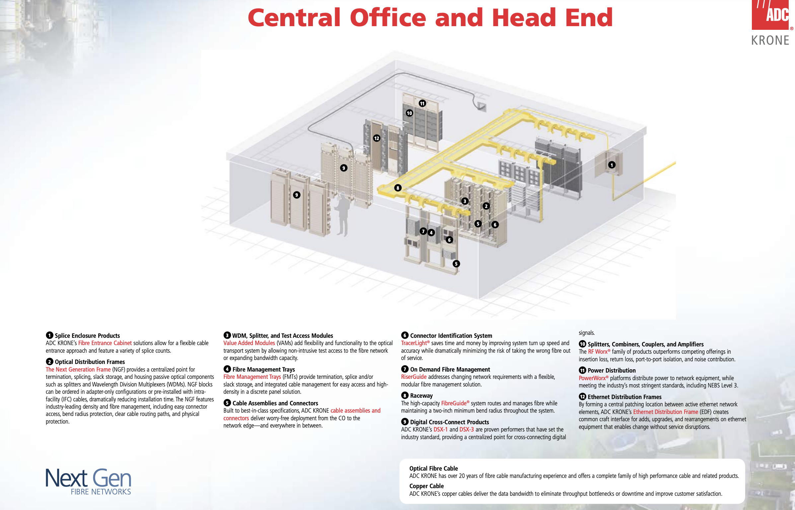

Solutions For Wireless Service Providers:

A DATA-DRIVEN WORLD COUNTS ON CONNECTIVITY
That's why mobile service providers count on us. We offer DAS (Distributed Antenna System) Solutions that increase mobile network capacity and extend the reach of service by miles around without intrusive cell towers.

Our in-building and outdoor wireless systems enable mobile coverage and capacity in places where service providers and enterprises have difficulty delivering wireless voice and data services to their customers. These locations include urban and rural canyons, subways and stadiums, tall buildings and on campuses such as universities and enterprises, in residences and neighbourhoods, and airport and subway terminals.

ADC KRONE is a wireless market leader with more than 20,000 wireless systems shipped to more than 130 countries. Our wireless portfolio offers solutions for a broad range of industries worldwide. Our advanced outdoor wireless solution combined with innovative products and market leadership in the in-building wireless market create a leading platform for serving wireless service providers and enterprises' coverage and capacity needs. Our unified architecture for every application in the micro cellular space delivers coverage and capacity to match our customers' needs.

Wireless Products:

-InterReach Spectrum Advanced Multi-band In-Building Distributed Antenna System (DAS)
-InterReach Fusion Multi-Band In-Building Distributed Antenna System (DAS)
-InterReach Unison Single-Band In-Building Distributed Antenna System (DAS)
-FlexWave Prism DAS/Compact Radio Head
-ClearGain Cell Site Amplifiers Tower and Ground-mounted Amplifiers

For more details on wireless solutions and ADC India advantage, Go thru’ this PDF:
https://www.adckcl.com/in/en/library/brochures/Wireless_Connectivity_08102013.pdf

Product Wise Sales Split - FY23:
Cables ~60%,
Connector and patch cords ~24%,
Telecom products/connectors, accessories ~3%,
Patch cords ~1%,
Other Products ~12%

🔶Industry Overview:
🔹India is the world’s second-largest telecommunications market and has registered strong growth in the past decade and half.
🔹India is the second-largest country for internet subscribers, leading in data usage per smartphone.
🔹The Indian mobile industry is poised to generate greater economic value due to growth drivers like Production Linked Incentive schemes, rising internet users, Make in India policies, and extensive optical fiber cable infrastructure across 100,000 gram panchayats.
🔹Surge in wireless and Building IoT devices boosts connectivity demand in buildings, campuses, venues, and homes.
🔹Transition to Multi-Tenant Data Centres offers scalability, flexibility, and strict service level agreements.

🔶Opportunities:
🔹India, set to become the 2nd-largest 5G market, anticipates significant opportunities in the telecom industry's future.
🔹Investments in Data Centres & broadband, supported by both government & private sectors, stimulate business sentiment & drive investments.
🔹Market poised to improve with investments in infrastructure, healthcare, defence, e-commerce, manufacturing, Digital India, and Smart city initiatives.

🔶Future Outlook:
🔹Company focused on developing new Fiber Cable designs, armoured Fiber Cords, high-density panels, and introducing Copper Panels.
🔹The company sees promising prospects ahead with the growth in the Data Centre business and broadband connectivity requirements.

From Annual Report:

INDUSTRY STRUCTURE AND DEVELOPMENTS:

As the traditional office space connectivity being reduced with number of cabling ports per desk and in turn increased number of ports with Digital Ceiling concept of connecting every IP device across the building where wireless and Building IoT devices are adding more connections like never before, with more and more connectivity requirements everywhere in building, campus, venues and Homes.
Whereas in Data Centre portion, your Company do see change in landscape of traditional Enterprise Data Centre moving to Multi-Tenant Data Centre’s or colocation DC which provides space and networking equipment to connect an organization to service providers at a minimal cost by offering high scalability, flexibility, modularity with stringent service level agreements which is need of the hour.
With Economic activities on upward despite lingering impact of Covid with growth coming from many sectors across the industry, where Government Sector fared better with Infrastructure projects investment & the Office Network especially from IT Consultancy & software industry got affected more and whereas on the other hand Data Centre segment performed better.

With all the technology changes, your company would see an impact in the copper business as we continue to see work from home adoption growing with office expansion going slow. However, Your Company do see continues growth in Fiber Business over copper due to multifold increase in Bandwidth requirements, with denser wireless & deeper fiber deployments across infrastructure projects including Data Centre expansions where the Data Centre market has been having growth faster than expected & stood as a bright spot in an otherwise gloomy year with pandemic. Data Centre projects in India has been mainly from the Colocation service providers.
Added to this, your Company do see inflationary pressure accelerating with steep increase in prices across commodities and raw materials like copper, stainless steel, plastics and many more items; towards which your company has been adjusting prices consistently across certain products and/or product lines.
Looking ahead, your Company is optimistic of the opportunities of the work your Company is doing for its clients and the approach your Company have put in place with respect to Data Centre business & Broad band connectivity requirements. With massive investments committed both by Government & Private Players towards infrastructure growth would improve the overall business sentiment and investments in next few Quarters. Market are expected to improve driven by investments in Infrastructure projects, Pharma, Healthcare, Education, Banking & Finance, Defense sector, E-commerce, Manufacturing, Digital India and Smart city initiatives where your Company will be able to favorably participate in the areas of its strength within each opportunity as the market evolves.

Growth in Data Centre business & broadband connectivity requirements with massive investments committed both by Government & Private Players towards Infrastructure growth would improve the overall business sentiment and investments in next few Years. Market is expected to improve driven by investments in Infrastructure projects, Pharma, Healthcare, Education, Banking & Finance, Defense sector, E-commerce, Manufacturing, Digital India and Smart city initiatives where your Company will be able to favorably participate in the areas of its strength within each opportunity as the market activities picks up.
With Cloud Computing Aiding Businesses (Large and SMB’s) either creating on private cloud infrastructure by way of consolidation and migration of existing compute, storage, and networks. In addition, businesses are parallelly looking to subscribe for public or private hosting services. With this, the Multi-Tenant Data Centre or Colo players in India are offering enterprises choice of better and on demand infrastructure, reliability in terms of power and availability of network and faster time to market. The Data Centre market has been having growth faster than expected & stood as a bright spot in an otherwise gloomy year with pandemic. Data Centre projects in India has been mainly from the Colocation service providers.

During the year, major focus has been on development of new design of Fiber Cable, Armoured Fiber Cords, High Density Panels to meet upcoming customer requirement for different applications and introduced Copper Panels and cable assemblies.

==================================================

Very little information is available, Company gives no presentations, no communications.

==========================================================================

From Anant Raj Data Centre Presentation:
Commscope is One of the Vendors.
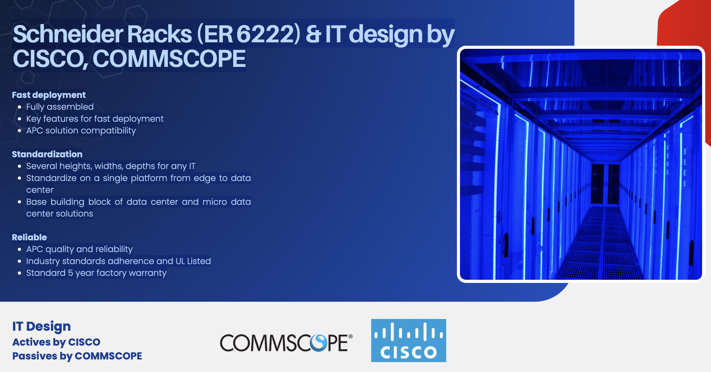

Fundamentals:
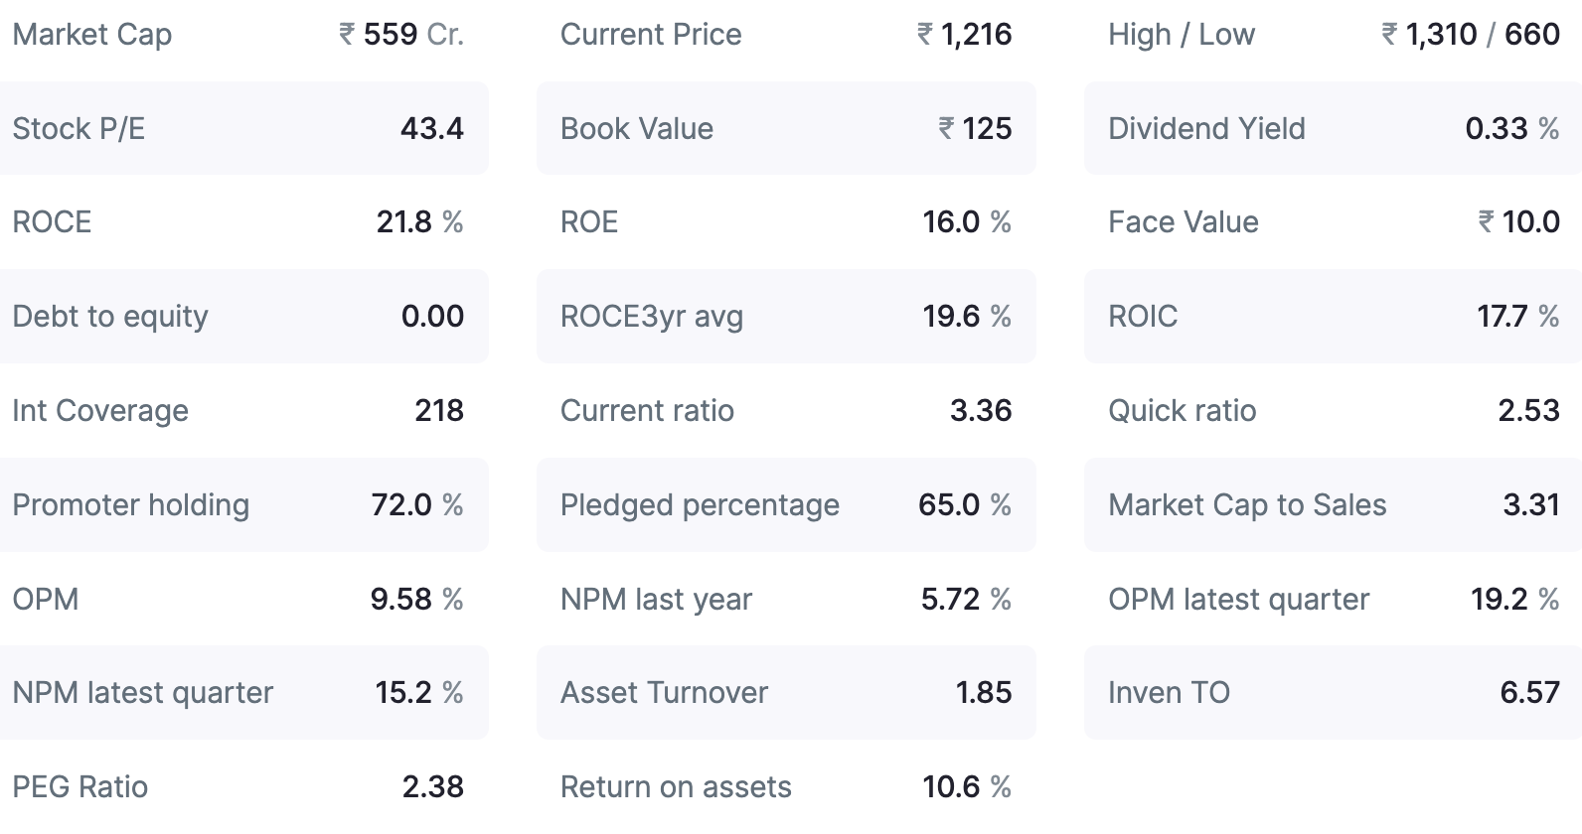

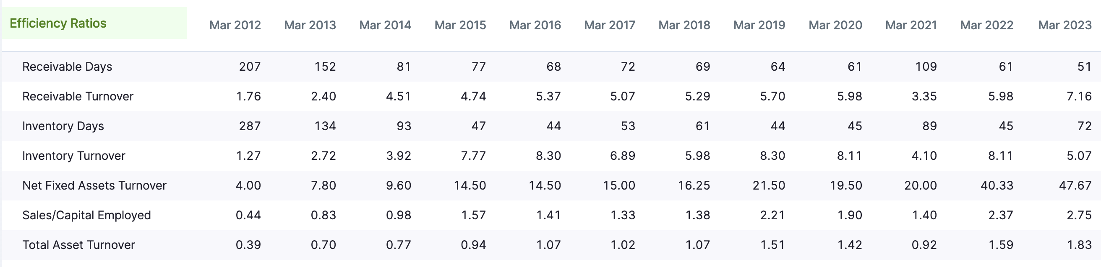

Technicals :
According to MarketsmithIndia, 8% from Pivot, Stage 1, Cup without Handle

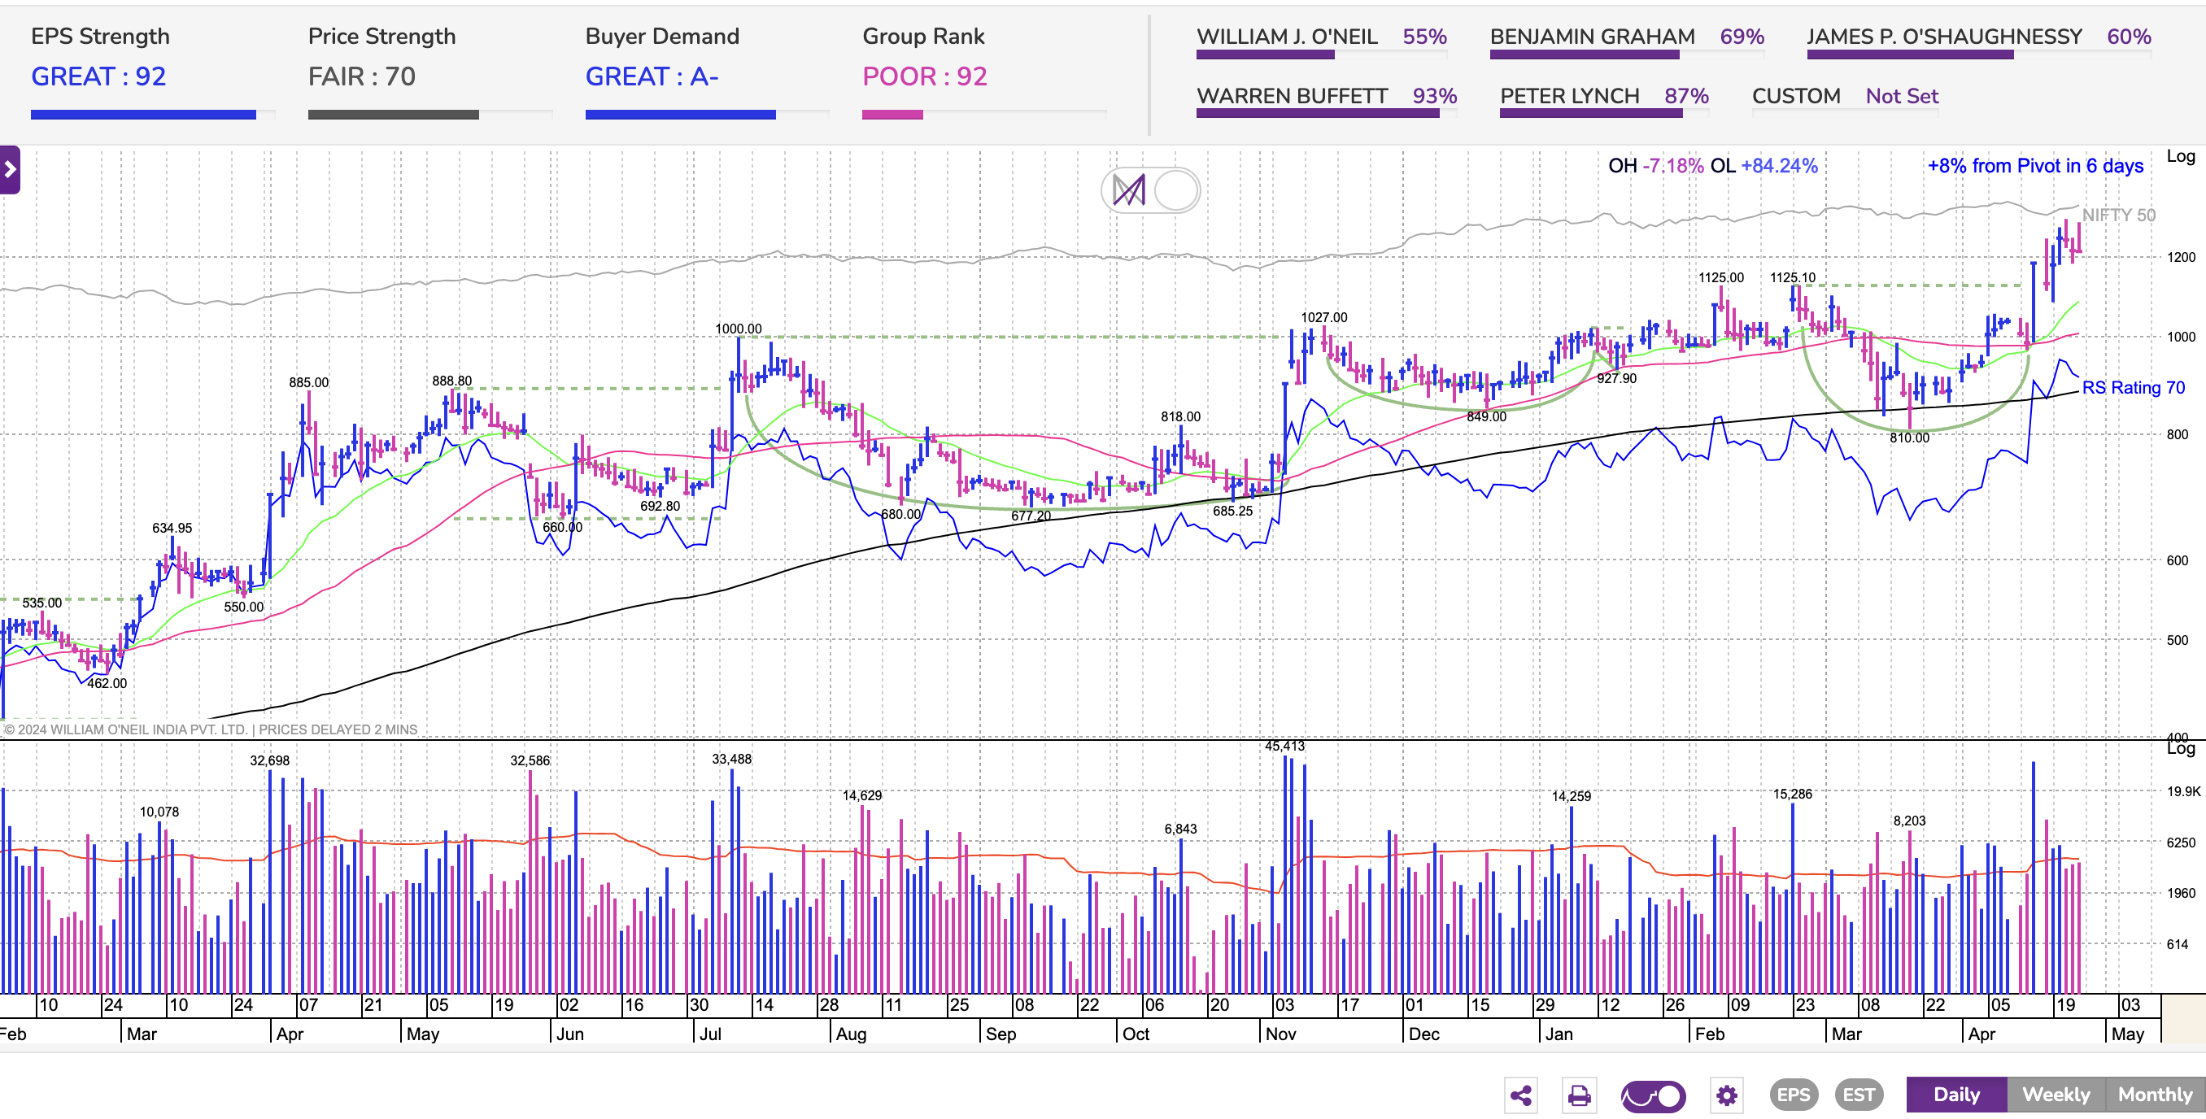

Compiled Notes from here & there

